Geological Magazine

Evidence of frugivory and seed dispersal in Oligocene tortoises from South Dakota
Alan O. Marron and Jason R. Moore

Supplementary Material

Parameters
Average Fruit Mass= 0.00018 kg
Average Fresh Seed Mass= 0.00013 kg
Average Dried Seed Mass= 0.00009 kg

Average Fruit Radius=0.00 407 m (Diameter= 0.00814 m)
Average Fresh Seed Radius= 0.00293m (Diameter= 0.00586 m)
Average Dried Seed Radius= 0.002555 m (Diameter= 0.00511 m)

Assuming fruits and seeds to be spheres, volume is calculated by
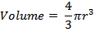
Average Fruit Volume= 2.82 x10⁻⁷ m³
Average Fresh Seed Volume= 1.05 x10⁻⁷ m³
Average Dried Seed Volume= 6.98 x10⁻⁸ m³
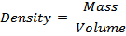
Average Fruit Density= 638 kg m⁻³
Average Fresh Seed Density= 1238 kg m⁻³
Average Dried Seed Density= 1289 kg m⁻³

Average Sediment Grain Diameter= 18.92µm
Sediment Grain Density= Density of Quartz= 2660 kg m⁻³

Density of Water= 1000 kg m⁻³
Density of Air= 1.2 kg m⁻³
Viscosity of Water= 8.9 x10⁻⁴ kg m⁻¹ s⁻¹
Viscosity of Air= 1.73x10⁻⁵ kg m⁻¹ s⁻¹

Equations
Stokes Equation (used to calculate settling velocity of sediment grains):

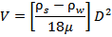

Heywood Table Equations (used to calculate settling velocity of fruit and seeds):
The equation
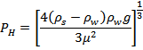

is used to calculate log(P_{H}D) for first Heywood Table. The corresponding value from the first table is then used to obtain a value for log(V/Q_{H}). Q_{H} is calculated via the equation:
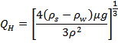

Terminal settling velocity can then be obtained from:

V= Terminal Settling Velocity
ρ_{s}= Density of Sphere (Sediment Grain/Fruit/Fresh Seed/Dried Seed)
ρ_{w}= Density of Liquid (Air or Water)
µ= Viscosity of Liquid (Air or Water)
D= Diameter of Sphere (Sediment Grain/Fruit/Fresh Seed/Dried Seed)
g= Acceleration due to Gravity (=9.8 m s⁻¹)

Calculations
Sediment Grains in Water

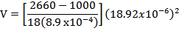

V=0.03ms⁻¹

Sediment Grains in Air
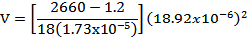

V=0.0003ms⁻¹

Fruit in Water

Negative Value of ρ_{s-} ρ_{w} (= -362) means that fruits will float in water

Fruit in Air
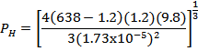

P_{H}= 32203.23
P_{H} x Diameter =32203.23 x 0.00814 = 262.13
log₁₀ (P_{H} x Diameter) = 2.42

log₁₀(V/Q_{H})= 1.42 (from Heywood Table 1)
V/Q_{H}= 26.3

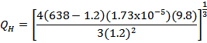

Q_{H}= 0.464
V= 26.3 x 0.464
V= 12.2 m s⁻¹

Fresh Seed in Water
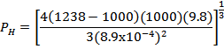
P_{H}= 15781
P_{H} x Diameter =15781 x 0.00586 = 92.48
log₁₀ (P_{H} x Diameter) = 1.97

log₁₀(V/Q_{H})= 1.16 (from Heywood Table 1)
V/Q_{H}= 14.45

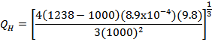

Q_{H}= 0.014
V= 14.45 x 0.014
V= 0.2 m s⁻¹

Fresh Seed in Air
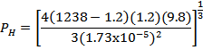

P_{H}= 40178.92
P_{H} x Diameter =40178.92 x 0.00586 = 235.45
log₁₀ (P_{H} x Diameter) = 2.37

log₁₀(V/Q_{H})= 1.392 (from Heywood Table 1)
V/Q_{H}= 24.66

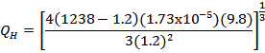
Q_{H}= 0.579
V= 24.66 x 0.579
V= 14.28 m s⁻¹

Dried Seed in Water
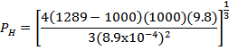
P_{H}= 16836.1
P_{H} x Diameter =16836.1 x 0.00511 = 86.03
log₁₀ (P_{H} x Diameter) = 1.93

log₁₀(V/Q_{H})= 1.132 (from Heywood Table 1)
V/Q_{H}= 13.55

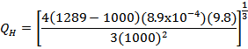
Q_{H}= 0.015
V= 13.55 x 0.015
V= 0.02 m s⁻¹

Dried Seed in Air
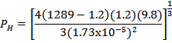

P_{H}= 40723.77
P_{H} x Diameter =40723.77 x 0.00511 = 208.1
log₁₀ (P_{H} x Diameter) = 2.32

log₁₀(V/Q_{H})= 1.369 (from Heywood Table 1)
V/Q_{H}= 23.39

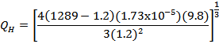
Q_{H}= 0.587
V= 23.39 x 0.587
V= 13.73 m s⁻¹

