Geological Magazine

The first ophthalmosaurid ichthyosaur from the Upper Jurassic of the Umbrian–Marchean Apennines (Marche, Central Italy)

ILARIA PAPARELLA, ERIN E. MAXWELL, ANGELO CIPRIANI, SCILLA RONCACÈ, & Michael W. Caldwell

Supplementary Material

Text S1. Characters used in the phylogenetic analysis to assess the position of Gengasaurus nicosiai gen. et sp. nov., within Ophthalmosauridae. The list of characters is the same of Roberts et al. (2014), with the addiction of three characters from the data matrix of Maxwell et al. (2012).

Characters from Roberts at al. (2014):
- Crown striation: presence of deep longitudinal ridges (0); crown enamel subtly ridged or smooth (1).
- Base of enamel layer: poorly defined, invisible (0); well defined, precise (1).
- Root cross-section in adults: rounded (0); quadrangular (1).
- Processus postpalatinis pterygoidei: absent (0); present (1).
- Maxilla anterior process: extending anteriorly as far as nasal or further anteriorly (0) ; reduced (1).
- Descending process of the nasal on the dorsal border of the nares: absent (0), present (1).
- Processus narialis of the maxilla in lateral view: absent (0); present (1).
- Processus supranarialis of the premaxilla: present (0); absent or reduced (1).
- Processus narialis of the prefrontal: present (0); absent (1).
- Anterior margin of the jugal: tapering, running between lacrimal and maxilla (0); broad and fan-like, covering large area of maxilla ventrolaterally (1).
- Anterior margin of the jugal: terminates prior to anterior end of lacrimal (0), reaches or surpasses anterior end of lacrimal (1).
- Posterior margin of the jugal: articulates with the postorbital and quadratojugal (0); excluded from the quadratojugal by the postorbital (1).
- Sagittal eminence: present (0); absent (1).
- Processus temporalis of the frontal: absent (0); present (1).
- Supratemporal-postorbital contact: absent (0); present (1).
- Broad postfrontal-postorbital contact, absent (0), present (1).
- Squamosal shape: triangular (0); squared (1); squamosal absent (2).
- Quadratojugal exposure: extensive (0); small, largely covered by squamosal or supratemporal and postorbital (1).
- Basipterygoid processes: short, giving basisphenoid a square outline in dorsal view (0); markedly expanded laterally, being wing-like, giving basisphenoid a marked pentagonal shape in dorsal view (1).
- Extracondylar area of basioccipital: wide (0); reduced but still present ventrally and lateral (1); extremely reduced, being nonexistent at least ventrally (2).
- Basioccipital peg: present (0); absent (1).
- Ventral notch in the extracondylar area of the basioccipital: present (0); absent (1).
- Shape of the paroccipital process of the opisthotic: short and robust (0); elongated and slender (1).
- Stapes proximal head: slender, much smaller than opisthotic proximal head (0); massive, as large or larger than opisthotic head (1).
- Stapedial shaft in adults: thick (0), slender and gracile (1).
- Angular lateral exposure: much smaller than surangular exposure (0), extensive (1).
- Posterior dorsal/anterior caudal centra: 3.5 times or less as high as long (0); four times or more as high as long (1).
- Tail fin centra: strongly laterally compressed (0); as wide as high (1).
- Neural spines of atlas-axis: completely overlapping, may be fused (0), never fused (1).
- Chevrons in apical region: present (0); lost (1).
- Glenoid contribution of the scapula: extensive, being at least as large as the coracoid facet (0); reduced, being markedly smaller than the coracoid facet (1).
- Prominent acromion process of scapula: absent (0); present (1).
- Anteromedial process of coracoid: present (0); absent (1).
- Plate-like dorsal ridge on humerus: absent (0); present (1).
- Protruding triangular deltopectoral crest on the humerus: absent (0); present (1).
- Humerus distal and proximal ends in dorsal view: distal end wider than proximal end (0), nearly equal or proximal end slightly wider than distal end (1).
- Humerus anterodistal facet for preaxial accessory element anterior to radius: absent (0); present (1).
- Posteriorly deflected ulnar facet: absent (0); present (1).
- Humerus/intermedium contact: absent (0); present (1).
- Shape of the posterior surface of the ulna: rounded or straight and nearly as thick as the rest of the element (0); concave and edgy (1).
- Manual pisiform: absent (0), present (1).
- Notching of anterior facet of leading edge elements of forefin in adults: present (0); absent (1).
- Posterior enlargement of forefin: number of postaxial accessory “complete” digits: none (0); one (1), two or more (2).
- Preaxial accessory digits on forefin: absent (0); present (1).
- Longipinnate or latipinnate forefine construction: one (0); two (1) digits directly supported by the intermedium.
- Zeugo- to autopodial elements: flattened and plate-like (0); strongly thickened (1).
- Tightly packed rectangular phalanges: absent, phalanges are mostly rounded (0), present (1).
- Digital bifurcation: Absent (0); frequently occurs in digit IV (1).
- Ischium-pubis fusion in adults: absent or present only proximally (0); present with an oburator foramen (1); present with no obturator foramen (2).
- Ischium or ischiopubis shape: plate-like, flattened (0); rod-like (1).
- Prominent, ridge-like dorsal and ventral process demarked from the head of the femur and extending up to the mid-shaft: absent (0); present (1).
- Ventral process on femur: smaller than dorsal process (0), more prominent (1).
- Astragalus/femoral contact: absent (0); present (1).
- Femur anterodistal facet for accessory zeugopodial element anterior to tibia: absent (0); present (1).
- Tibia peripheral shaft in adults: notched (0); straight (1).
- Postaxial accessory digit: absent (0); present (1).

Characters from Maxwell at al. (2012):
- Supraoccipital: exoccipital processes parallel (0), exoccipital processes divergent (1).
- Exoccipitals: exoccipitals make up the largest lateral contribution to the foramen magnum (0), supraoccipital contribution almost equal to that of exoccipitals (1).
- Mandibular symphysis: splenial playing a more extensive role in the mandibular symphysis than the dentary (0), splenial participating in the mandibular symphysis but restricted to the posterior half (1).

Text S2. Character-taxon matrix used for the phylogenetic analysis, consisting of 24 taxa and 59 characters. The data matrix is derived from that of Roberts et al. (2014), plus three characters resumed from Maxwell et al. (2012), and with the addition of Gengasaurus nicosiai gen. et sp. nov., and Ophthalmosaurus natans. The codings of Undorosaurus gorodischensis are based on Arkhangelsky & Zverkov (2014), and characters 1 and 2 for Maiaspondylus lindoei are re-coded based on personal observations.

#NEXUS

BEGIN TAXA;
TITLE Taxa;
DIMENSIONS NTAX=24;
TAXLABELS
Temnodontosaurus_sp.
Malawania_anachronus
Ichthyosaurus_communis
Stenopterygius_quadriscissus
Ophthalmosaurus_icenicus
Brachypterygius_extremus
Maiaspondylus_lindoei
Undorosaurus_gorodischensis
Arthropterygius_chrisorum
Mollesaurus_periallus
Acamptonectes_densus
Caypullisaurus_bonapartei
Aegirosaurus_leptospondylus
Platypterygius_australis
Platypterygius_hercynicus
Athabascasaurus_bitumineus
Leninia_stellans
Sveltonectes_insolitus
Palvennia_hoybergeti
Cryopterygius_kristiansenae
Janusaurus_lundi
Gengasaurus_nicosiai
Ophthalmosaurus_natans
PMO222.667
;

END;

BEGIN CHARACTERS;
TITLE Character_Matrix;
DIMENSIONS NCHAR=59;
FORMAT DATATYPE = STANDARD GAP = - MISSING = ? SYMBOLS = " 0 1 2";
MATRIX
Temnodontosaurus_sp.
00000000000000000000000000000000000000000000000000000000000
Malawania_anachronus
??????????????????????????????00??110000?0001?00???????????
Ichthyosaurus_communis
0000100(01)00000011(12)1000000000000(01)000010000(01)110101100000010101
Stenopterygius_quadriscissus
1001100000000001010001010011?1110000000010(01)0000110??0000001
Ophthalmosaurus_icenicus
010111110100100101(01)1(01)01101101101010111011111110010100010001
Brachypterygius_extremus
011?0100?110??????1211???1?????101?1001011111100????????010
Maiaspondylus_lindoei
101?1?01?10???????0???????0??????1?100101?1?0?10????10?????
Undorosaurus_gorodischensis
011?????????0??????1??11??01??00010111001101010000110010???
Arthropterygius_chrisorum
??????????????????0211????11?1??01001100?1?1010???1100?????
Mollesaurus_periallus
11??1?0111????00111111010?0????????????????????????????????
Acamptonectes_densus
11???1??????1?????1111111100?10101(01)111011??1??0?????????100
Caypullisaurus_bonapartei
????00000?10??1?10???????10???111111100011210110??1?0?11???
Aegirosaurus_leptospondylus
000?11011100?10001???????1???????1?1001011111?1021??0011???
Platypterygius_australis
01100010011001012012110101011101111110001121011020110111010
Platypterygius_hercynicus
011?100?01??110??1?2?1?10??1?1011111100011210110??11101?01?
Athabascasaurus_bitumineus
10??0011?101100110?2???1110?1???????????????????201?????10?
Leninia_stellans
?????10?010010?0(01)1?1?0???1?????????????????????????????????
Sveltonectes_insolitus
101?1101110111?1??0211?1?100?1110111000??111111021110111???
Palvennia_hoybergeti
11??00?11???10112??211??11??????????1??????1????????????011
Cryopterygius_kristiansenae
111?0001?0001?1121?2?????1????0101010000011111100011001???1
Janusaurus_lundi
11??010?10011?1121?211??11??????0100110001?11100201100?????
Gengasaurus_nicosiai
??????????????????011?1???0?1??1???01000?1?1?10?20??????011
Ophthalmosaurus_natans
0??111010000000101?1?011110?0?110110110??1?1(01)?00????????011
PMO222.667
111??0????????????1211????????011100110001?1110????????????

;

END;
BEGIN ASSUMPTIONS;
TYPESET * UNTITLED = unord: 1 - 59;

END;

Table S1. List of autapomorphies and synapomorphies recovered in all trees resulting from the phylogenetic analysis. The node numbers and the character numbers of the strict consensus tree are illustrated in Figure S1. The character state of the taxon for each apomorphy is given in brackets.

Node | Apomorphies
Temnodontosaurus sp. | No autapomorphies
Malawania anachronus | 35: protruding triangular deltopectoral crest on the humerus present (1).
Ichthyosaurus communis | 42: notching of anterior facet of leading edge elements of forefin in adults absent (1);  43: number of postaxial accessory “complete” digits one (1);  47: tightly packed rectangular phalanges present (1);  48: digital bifurcation frequently occurs in digit IV (1).
Stenopterygius quadriscissus | 27: posterior dorsal/anterior caudal centra four times or more as high as long (1);  31: glenoid contribution of the scapula reduced, being markedly smaller than the coracoid facet (1);  48: digital bifurcation frequently occurs in digit IV (1);  49: ischium-pubis fusion in adults present with an obturator foramen (1).
Ophthalmosaurus icenicus | 7: processus narialis of the maxilla in lateral view present (1);
Brachypterygius extremus | 39: humerus/intermedium contact present (1).
Maiaspondylus lindoei | 45: one digit directly supported by the intermedium (0);  53: astragalus/femoral contact present (1).
Undorosaurus gorodischensis | 32: prominent acromion process of scapula absent (0);  36: humerus distal and proximal ends in dorsal view nearly equal or proximal end slightly wider than distal end (1).
Arthropterygius chrisorum | 20: extracondylar area of basioccipital extremely reduced, being nonexistent at least ventrally (2);  27: posterior dorsal/anterior caudal centra four times or more as high as long (1).
Mollesaurus periallus | 16: broad postfrontal-postorbital contact absent (0).
Acamptonectes densus | 25: stapedial shaft in adults slender and gracile (1);  57: exoccipital processes of supraoccipital divergent (1);  59: splenial playing a more extensive role in the mandibular symphysis than the dentary (0).
Caypullisaurus bonapartei | 15: supratemporal-postorbital contact present (1);  31: glenoid contribution of the scapula reduced, being markedly smaller than the coracoid facet (1).
Aegirosaurus leptospondylus | 1: presence of deep longitudinal ridges on crown (0);  3: root cross-section in adults rounded (0).
Platypterygius australis | 7: processus narialis of the maxilla in lateral view present (1);  17: squamosal absent (2).
Platypterygius hercynicus | 53: astragalus/femoral contact present (1).
Athabascasaurus bitumineus | 2: base of enamel layer poorly defined, invisible (0);  7: processus narialis of the maxilla in lateral view present (1);  18: quadratojugal exposure extensive (0);  57: exoccipital processes of supraoccipital divergent (1);  58: exoccipitals make up the largest lateral contribution to the foramen magnum (0).
Leninia stellans | 16: broad postfrontal-postorbital contact absent (0).
Sveltonectes insolitus | 12: posterior margin of the jugal excluded from the quadratojugal by the postorbital (1);  54: femur anterodistal facet for accessory zeugopodial element anterior to tibia present (1).
Palvennia hoybergeti | No autapomorphies
Cryopterygius kristiansenae | 37: humerus anterodistal facet for preaxial accessory element anterior to radius absent (0);  47: tightly packed rectangular phalanges present (1);  49: ischium-pubis fusion in adults absent or present only proximally (0).
Janusaurus lundi | 6: descending process of the nasal on the dorsal border of the nares present (1).
Gengasaurus nicosiai | No autapomorphies
Ophthalmosaurus natans | 22: ventral notch in the extracondylar area of the basioccipital present (0);  31: glenoid contribution of the scapula reduced, being markedly smaller than the coracoid facet (1);  35: protruding triangular deltopectoral crest on the humerus present (1).
PMO222.667 | 33: anteromedial process of coracoid absent (1).
Node 25 | 36: humerus distal and proximal ends in dorsal view nearly equal or proximal end slightly wider than distal end (1);  45: two digits directly supported by the intermedium (1).
Node 26 | No synapomorphies
Node 27 | 4: processus postpalatinis pterygoidei present (1);  22: ventral notch in the extracondylar area of the basioccipital absent (1);  24: stapes proximal head massive, as large or larger than opisthotic head (1);  30: chevrons in apical region lost (1);  32: prominent acromion process of scapula present (1).
Node 28 | 22: ventral notch in the extracondylar area of the basioccipital present (0).
Node 29 | 40: shape of the posterior surface of the ulna concave and edgy (1);  58: exoccipitals make up the largest lateral contribution to the foramen magnum (0).
Node 30 | 19: basipterygoid processes markedly expanded laterally, being wing-like, giving basisphenoid a marked pentagonal shape in dorsal view (1).
Node 31 | 29: neural spines of atlas-axis never fused (1);  49: ischium-pubis fusion in adults present with no obturator foramen (2).
Ophthalmosauridae (Node 32) | 2: base of enamel layer well defined, precise (1);  6: descending process of the nasal on the dorsal border of the nares present (1);  8: processus supranarialis of the premaxilla absent or reduced (1);  20: extracondylar area of basioccipital reduced but still present ventrally and lateral (1);  21: basioccipital peg absent (1);  23: shape of the paroccipital process of the opisthotic elongated and slender (1);  26: angular lateral exposure extensive (1);  34: plate-like dorsal ridge on humerus present (1);  37: humerus anterodistal facet for preaxial accessory element anterior to radius present (1);  42: notching of anterior facet of leading edge elements of forefin in adults absent (1);  44: preaxial accessory digits on forefin present (1);  46: zeugo- to autopodial elements strongly thickened (1);  58: supraoccipital contribution almost equal to that of exoccipitals (1).
Node 33 | 1: presence of deep longitudinal ridges on crown (0);  8: processus supranarialis of the premaxilla present (0);  11: anterior margin of the jugal reaches or surpasses anterior end of lacrimal (1).
Node 34 | 14: processus temporalis of the frontal present (1);  35: protruding triangular deltopectoral crest on the humerus present (1).
Node 35 | 20: extracondylar area of basioccipital extremely reduced, being nonexistent at least ventrally (2).
Node 36 | 9: processus narialis of the prefrontal absent (1);  17: squamosal shape squared (1);  23: shape of the paroccipital process of the opisthotic short and robust (0).
Node 37 | 39: humerus/intermedium contact present (1).
Node 38 | 2: base of enamel layer poorly defined, invisible (0);  19: basipterygoid processes short, giving basisphenoid a square outline in dorsal view (0);  50: ischium or ischiopubis shape rod-like (1).
Node 39 | No synapomorphies
Node 40 | 18: Quadratojugal exposure extensive (0).
Node 41 | 6: descending process of the nasal on the dorsal border of the nares absent (0);  33: anteromedial process of coracoid absent (1);  43: number of postaxial accessory “complete” digits two or more (2);  45: one digit directly supported by the intermedium (0).
Node 42 | 6: descending process of the nasal on the dorsal border of the nares absent (0);  25: stapedial shaft in adults slender and gracile (1).
Node 43 | 10: anterior margin of the jugal tapering, running between lacrimal and maxilla (0);  15: supratemporal-postorbital contact present (1);  17: squamosal absent (2).

Figure S1. Map of synapomorphic characters (in blue, below the branches) and node numbers (in black, above or besides the branches) recovered in the phylogenetic analysis to assess the position of Gengasaurus nicosiai gen. et sp. nov. within Ophthalmosauridae.

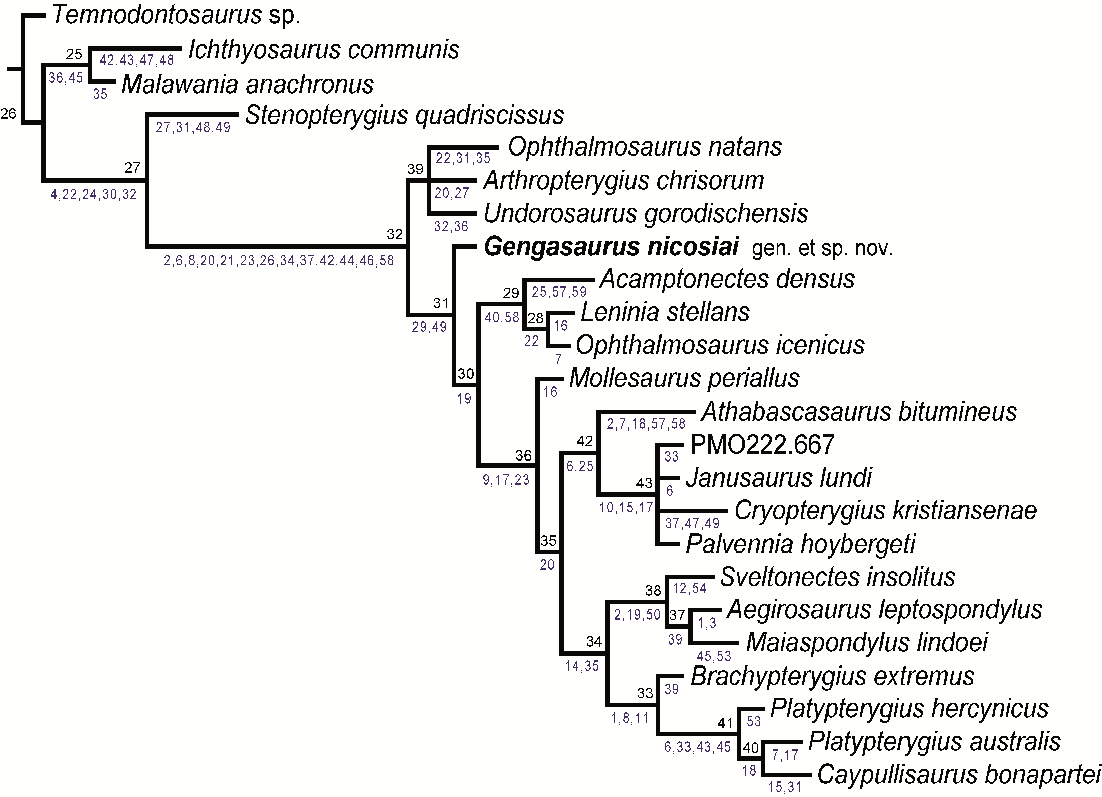

Literature cited

Maxwell, E. E., Fernández, M. S., & Schoch, R. R. 2012. First Diagnostic Marine Reptile Remains from the Aalenian (Middle Jurassic): A New Ichthyosaur from Southwestern Germany. PLoS ONE 7, e41692.
Roberts, A. J., Druckenmiller, P. S., Sætre, G.-P., & Hurum, J. H. 2014. A New Upper Jurassic Ophthalmosaurid Ichthyosaur from the Slottsmøya Member, Agardhfjellet Formation of Central Spitsbergen. PLoS ONE 9, e103152.

