Online Supplementary Material
Geological Magazine
Crouching theropod at the seaside. Matching footprints with metatarsal impressions and theropod authopods: a morphometric approach
M. ROMANO & P. CITTON
Scatter plot of Principal Component II and III
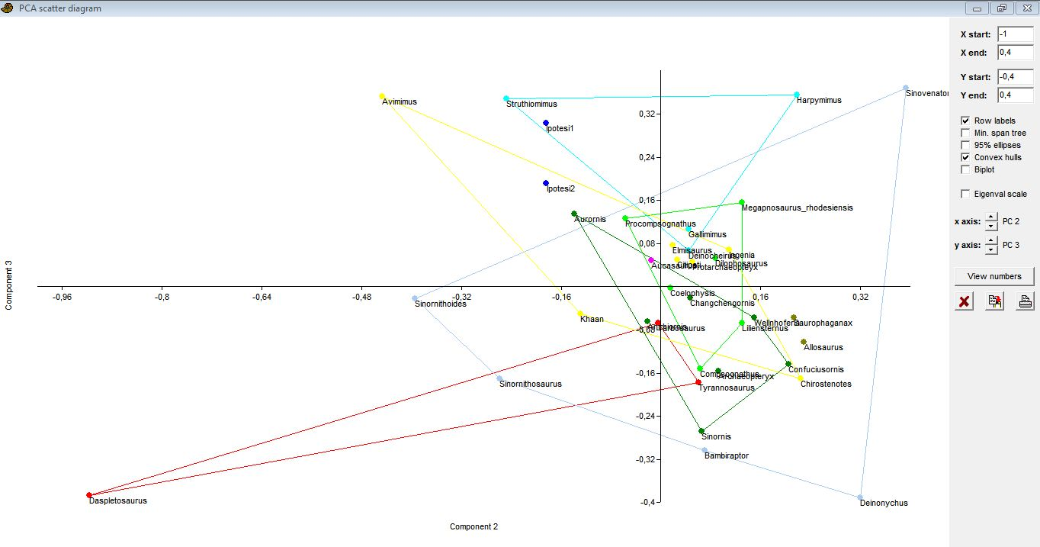
Figure S1. Scatter plot of Principal Components II and III. In this case all groups are confusedly overlap, with no possibility of interpreting differences related to important morphological characters. This is totally expected, since the second and third principal components account together only for the 1.31% of the total variance.
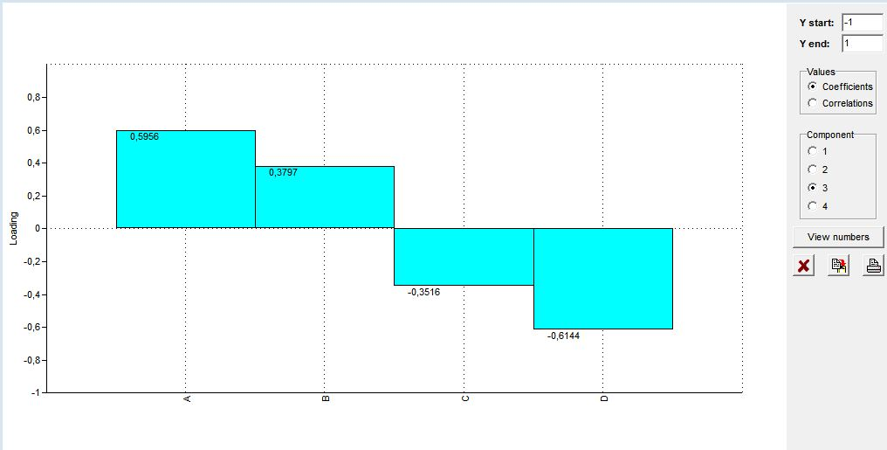
Figure S2. Loadings for Component III.

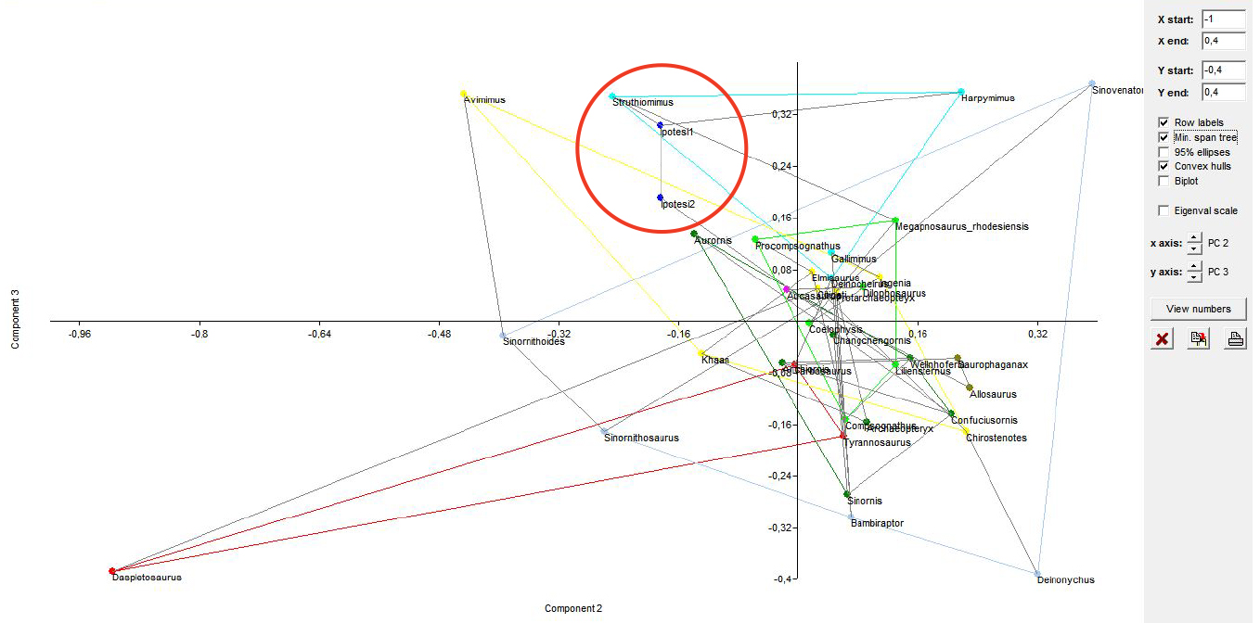
Figure S3. Scatter plot of Principal Components 2 and 3 showing ‘min. span tree’ (red circle). The min span tree, i.e. the tree that connects the specimens overall closest morphometrically, shows as the studied footprints (Hypotheses I and II) are still connected to one another, and once again together connected to Struthiomimus (red circle), further supporting the thesis reported in the manuscript.

