Geological Magazine

Controlling factors for differential subsidence in the Sonoma Foreland Basin (Early Triassic, western USA)

Gwénaël Caravaca¹, Arnaud Brayard¹, Emmanuelle Vennin¹, Michel Guiraud¹, Laetitia Le Pourhiet², Anne-Sabine Grosjean¹, Christophe Thomazo¹, Nicolas Olivier³, Emmanuel Fara¹, Gilles Escarguel⁴, Kevin G. Bylund⁵, James F. Jenks⁶, Daniel A. Stephen⁷.

Supplementary material

Appendix 1

Synthetic facies table of the main lithologies present in Lower Triassic Sonoma Foreland Basin and associated depositional environment, and estimated Paleobathymetric ranges, as used in the backstripping analysis. References are given in the table accordingly.

Appendix 2

List of studied sections, with GPS coordinates and references when data are taken from literature. An asterisk (*) indicates a minimum thickness value. Initials for sections illustrated in the manuscript are also indicated.

Locality | GPS coordinates (approximate for literature data) | PTU-Smithian interval thickness | Notes | References | Retrodeformation sector (Table 1)
Gros Ventre Canyon | 43.775185°  -110.333094° | 241* | Dinwoody and Woodside Fm. only, misses Smithian part of Thaynes Fm. | Kummel, 1954, 1957 | 1
Wind River Canyon | 42.767269°  -109.217611° | 36* | Dinwoody Fm. only, Woodside Fm. not measured (Red Peak Fm.) | Newell & Kummel, 1942 | 1
Brush Creek | 40.598932°  -109.463689° | 123 |  | Field measurement | 1
Lake Fork | 40.517877°  -110.435441° | 207* | Woodside Fm. only, misses Smithian part of the Thaynes Fm. | Kummel, 1954, 1957 | 1
White Rocks | 40.574083°  -109.820793° | 158* | Woodside Fm. only, misses Smithian part of the Thaynes Fm. | Kummel, 1954, 1957 | 1
Duchesne River | 40.436090°  -110.817317° | 242* | Woodside Fm. only, misses Smithian part of the Thaynes Fm. | Kummel, 1954, 1957 | 1
Bourdette Draw | 40.373293°  -109.209247° | 114* |  | Heckert et al., 2015 | 1
San Rafael Swell | 38.872793°  -110.558438° | 70 |  | Goodspeed & Lucas, 2007 | 1
Torrey area (T; Beas Lewis Flats) | 38.283606°  -111.313631° | 57 |  | Field measurement (Olivier et al., 2015) | 1
Circle Cliffs | 37.992881°  -111.128166° | ~15 |  | Field measurement | 1
Kannaraville | 37.519590°  -113.181241° | ~80 |  | Field measurement | 1
Virgin Dam | 37.196480°  -113.234689° | 55 |  | Field measurement (Olivier et al., 2014) | 1
Black Rock Canyon | 37.099110°  -113.294606° | ~35 |  | Field measurement | 1
Rock Canyon (RC) | 36.976783°  -113.261400° | 23,5 |  | Field measurement | 1
Trapper Creek | 45.683504°  -112.762157° | 194* | Dinwoody Fm. only | Kummel, 1954, 1957 | 2
Greenstone Gulch | 45.374291°  -112.704205° | 214* | Dinwoody Fm. only | Kummel, 1954, 1957 | 2
Dalys Spur | 45.072219°  -112.692223° | 288* | Dinwoody Fm. only | Kummel, 1954, 1957 | 2
Hogback Mountain | 44.865113°  -112.130820° | 255* | Dinwoody and Woodside Fm. only, misses Smithian part of Thaynes Fm. | Kummel, 1954, 1957 | 2
Fossil Creek | 44.764825°  -111.852615° | 192* | Dinwoody and Woodside Fm. only, misses Smithian part of Thaynes Fm. | Kummel, 1954, 1957 | 2
Little Water Canyon | 44.660495°  -112.747416° | 332 |  | Kummel, 1954, 1957 | 2
Hawley Creek | 44.625504°  -113.143714° | 300* | Only Smithian part of the Thaynes Fm. | Paull & Paull, '91 | 2
Odell Creek | 44.561568°  -111.863906° | 310* | Dinwoody and Woodside Fm. only, misses Smithian part of Thaynes Fm. | Kummel, 1954, 1957 | 2
Little Sheep Creek | 44.523573°  -112.696346° | 296* | Dinwoody and Woodside Fm. only, misses Smithian part of Thaynes Fm. | Sadler, 1981 | 2
Bear Gulch | 43.312260°  -110.730134° | 294* | Dinwoody and Woodside Fm. only, misses Smithian part of Thaynes Fm. | Kummel, 1954, 1957 | 2
Grays Range | 42.935617°  -111.366417° | 450* |  | Field measurement | 3
Sheep Creek (SC) | 42.868187°  -111.372443° | ~500 | Dinwoody Fm. measure from geologic map, Smithian part of Thaynes Fm. from Kummel | Kummel, 1954, 1957; Rioux et al., 1975 | 3
Fort Hall Reservation | 42.841336°  -112.584126° | 360 |  | Kummel, 1954, 1957 | 3
North Piney Creek | 42.637904°  -110.325953° | 345* | Dinwoody and Woodside Fm. only, misses Smithian part of Thaynes Fm. | Kummel, 1954, 1957 | 3
Montpellier Canyon | 42.344409°  -111.203904° | 337* | Dinwoody and Woodside Fm. only, misses Smithian part of Thaynes Fm. | Newell & Kummel, 1942; Kummel, 1954, 1957 | 3
Paris Canyon | 42.220270°  -111.415473° | ~460 | Smithian part from correlative Georgetown section | Field measurement; Kummel, 1954, 1957 | 3
Hot Springs (HS) | 42.112226°  -111.255145° | 540 |  | Field measurement | 3
Cokeville | 42.074825°  -110.817294° | 345* | Misses limestones part of Smithian Thaynes Fm. | Kummel, 1954, 1957 | 3
Rex Peak | 41.654641°  -111.095798° | 374* | Dinwoody and Woodside Fm. only, misses Smithian part of Thaynes Fm. | Chamberlain et al., 1980 | 3
Lower Weber Canyon (LWC) | 41.063626°  -111.570078° | 210* |  | Field measurement | 4
Diamond Fork | 40.030004°  -111.508545° | 130-235* | Woodside Fm. only, misses Smithian part of the Thaynes Fm. | Constenius et al., 2011 | 5
Pahvant Range (PR; Dog Valley) | 38.674360°  -112.521926° | 185 |  | Field measurement (Brayard et al., 2013) | 6
Star Range | 38.357141°  -113.129252° | 110* | Lower boundary not visible | Field measurement (Brayard et al., 2013) | 6
Minersville (M) | 38.225545°  -112.888220° | 105 |  | Field measurement (Vennin et al., 2015) | 6
Crittenden Springs | 41.546087°  -114.184977° | 300* |  | Field measurement | 7
Terrace Mountain | 41.454115°  -113.487207° | 534 |  | Doelling, 1980 | 7
Pequop Mountain | 40.500000°  -114.750000° | ~20 |  | Lucas & Orchard, 2007 | 7
Palomino Ridge | 40.240326°  -114.858275° | ~70 |  | Field measurement | 7
Confusion Range (CR) | 39.232513°  -113.686809° | 120 |  | Field measurement (Brayard et al., 2013) | 7
Appendix 3

Subsidence analysis data with complete set of initial parameters and results of the analysis. A. Data and results from the Confusion Range (CR) section. B. Data and results from the Pahvant Range (PR) section. C. Data and results from the Sheep Creek (SC) section. D. Data and results from the Hot Springs (HS) section. E. Synthesis of the tectonic subsidence results for each sections. For location of the analyzed sections, see Fig. 3b and Appendix 2. Radiometric ages after Burgess et al. (2014) and Galfetti et al. (2007); age interpolation of ammonoid biozone durations after Brühwiler et al., (2010). Sea level curve after Haq et al. (1988).

Subsidence analyses were performed using “OSXBackstrip” software and performing 1D Airy backstripping (after, Allen & Allen, 1990, and Watts, 2001; available at: http://www.ux.uis.no/~nestor/work/programs.html).

Parameters:

Base and top: depth (in km) of the limits of the considered members from top of the section. Age (base and top, in Ma): radiometric or estimated ages for the limits of considered members. Sea level (base and top, in km): estimated paleo-sea level compared to present day, as depths (negative values are above present-day sea-level). Water depth (base and top, in km): paleobathymetry estimated after facies and paleoenvironments characterization. Rho (in g.m⁻³): density of the dominant lithology. C (in .10⁻⁵ cm⁻¹): coefficient of exponential relation between depth and porosity (Sclater & Christie, 1980). Phy0 (in %): estimated final porosity of the dominant lithology. Type: 0 for marine deposits, 1 for continental deposits.

A. Data and results from the Confusion Range section (CR in Figs. 3b, 9a, 9e and 9f).

Name | Base (km) | Age base (Ma) | Sea Level base (km) | Water depth base (km) | Top (km) | Age top (Ma) | Sea Level top (km) | Water depth top (km) | Rho (g.m^-3) | C | Phy 0 | type
Moenkopi red beds | 0,255 | 251,88 | -0,05 | 0,0025 | 0,225 | 251,019 | -0,01 | 0,001 | 2650 | 0,27 | 50% | 0
Thaynes shales (Smithian) | 0,225 | 251,019 | -0,01 | 0,001 | 0,135 | 250,751 | 0,2 | 0,05 | 2750 | 0,51 | 60% | 0
Thaynes shales (Spathian) | 0,135 | 250,751 | 0,2 | 0,05 | 0 | 250,55 | 0 | 0,09 | 2750 | 0,51 | 60% | 0
 | 0 | 250,55 | 0 | 0,09
 | 0 | 0 | 0 | 0
Results |  | Age (Ma) | Compacted thickness (m) | Total subsidence (m) | Tectonic subsidence (m)
 |  | 251,9 | 0 | 0 | 0
 |  | 251 | 30 | 32 | 36
 |  | 250,8 | 120 | 130 | 108
 |  | 250,6 | 255 | 256 | 260

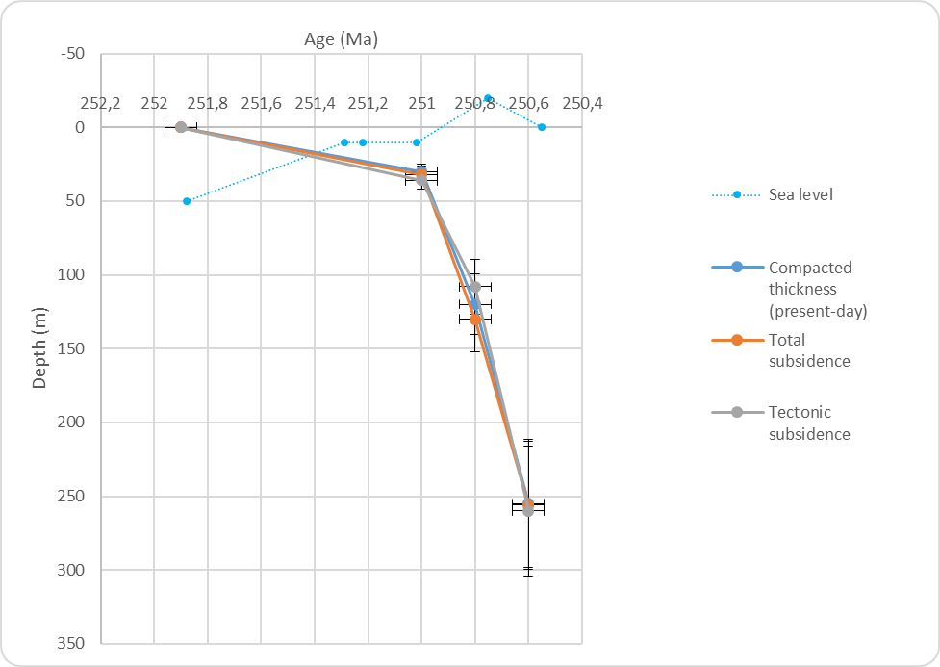

B. Data and results from the Pahvant Range section (PR in Figs. 3b, 9b, 9e and 9f).

Name | Base (km) | Age base (Ma) | Sea Level base (km) | Water depth base (km) | Top (km) | Age top (Ma) | Sea Level top (km) | Water depth top (km) | Rho (g.m^-3) | C | Phy 0 | type
Moenkopi red beds | 0,295 | 251,88 | -0,05 | 0,0025 | 0,235 | 251,287 | -0,01 | 0,0025 | 2650 | 0,27 | 50 | 0
Thaynes carbonates | 0,235 | 251,287 | -0,01 | 0,0025 | 0,11 | 250,751 | 0,02 | 0,05 | 2750 | 0,71 | 25 | 0
Spathian red beds | 0,11 | 250,751 | 0,02 | 0,05 | 0 | 250,55 | 0 | 0,0025 | 2650 | 0,27 | 50 | 0
Results |  | Age (Ma) | Compacted thickness (m) | Total subsidence (m) | Tectonic subsidence (m)
 |  | 251,9 | 0 | 0 | 0
 |  | 251,3 | 60 | 64 | 58
 |  | 250,8 | 185 | 190 | 114
 |  | 250,6 | 295 | 296 | 161

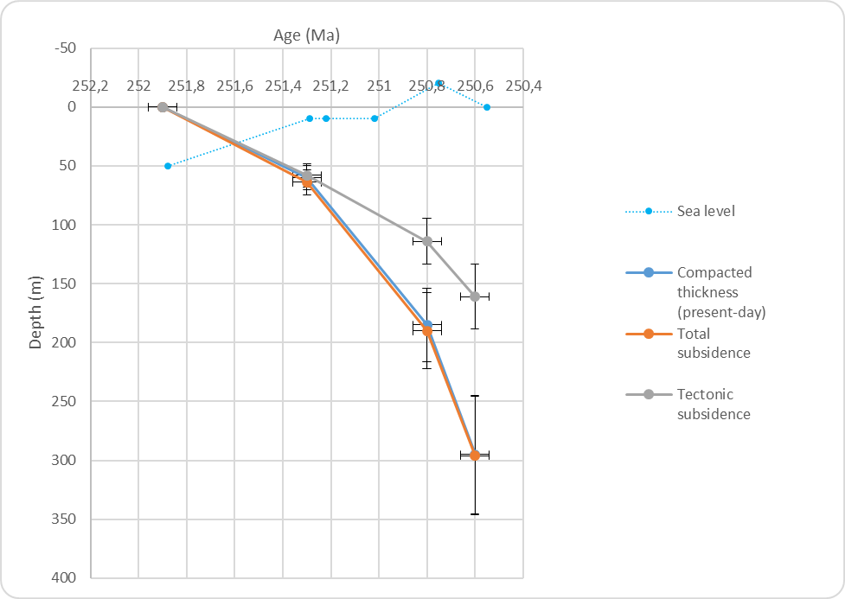

C. Data and results from the Sheep Creek section (SC in Figs. 3, 89c, 9e and 9f).

Name | Base (km) | Age base (Ma) | Sea Level base (km) | Water depth base (km) | Top (km) | Age top (Ma) | Sea Level top (km) | Water depth top (km) | Rho (g.m^-3) | C | Phy 0 | type
Dinwoody + Woodside siltstones | 0,732 | 251,88 | -0,5 | 0,005 | 0,182 | 250,751 | 0,02 | 0,005 | 2650 | 0,27 | 85% | 0
Thaynes carbonates | 0,182 | 250,751 | 0 | 0,005 | 0 | 250,55 | 0 | 0,025 | 2750 | 0,71 | 25% | 0
Results |  | Age (Ma) | Compacted thickness (m) | Total subsidence (m) | Tectonic subsidence (m)
 |  | 251,9 | 0 | 0 | 0
 |  | 250,8 | 550 | 627 | 505
 |  | 250,6 | 732 | 733 | 554

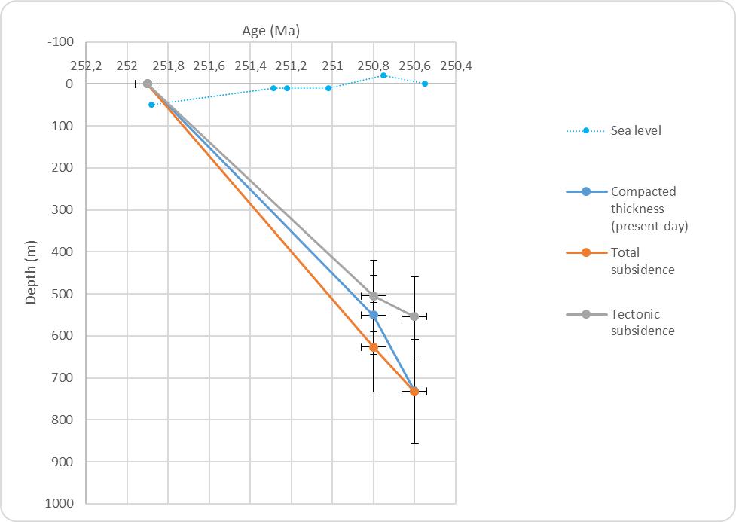

D. Data and results from the Hot Springs section (HS in Figs. 3b, 9d, 9e and 9f).

Name | Base (km) | Age base (Ma) | Sea Level base (km) | Water depth base (km) | Top (km) | Age top (Ma) | Sea Level top (km) | Water depth top (km) | Rho (g.m^-3) | C | Phy 0 | type
Dinwoody siltstones | 0,79 | 251,88 | -0,05 | 0 | 0,435 | 251,22 | -0,01 | 0,01 | 2650 | 0,27 | 85% | 0
Woodside (?) siltstones | 0,435 | 251,22 | -0,01 | 0,01 | 0,23 | 250,751 | 0,02 | 0,03 | 2650 | 0,27 | 85% | 0
Thaynes carbonates | 0,23 | 250,751 | 0,02 | 0,03 | 0 | 250,55 | 0 | 0,025 | 2750 | 0,71 | 25% | 0
Results |  | Age (Ma) | Compacted thickness (m) | Total subsidence (m) | Tectonic subsidence (m)
 |  | 251,9 | 0 | 0 | 0
 |  | 251,2 | 355 | 488 | 441
 |  | 250,8 | 560 | 657 | 559
 |  | 250,6 | 790 | 792 | 578

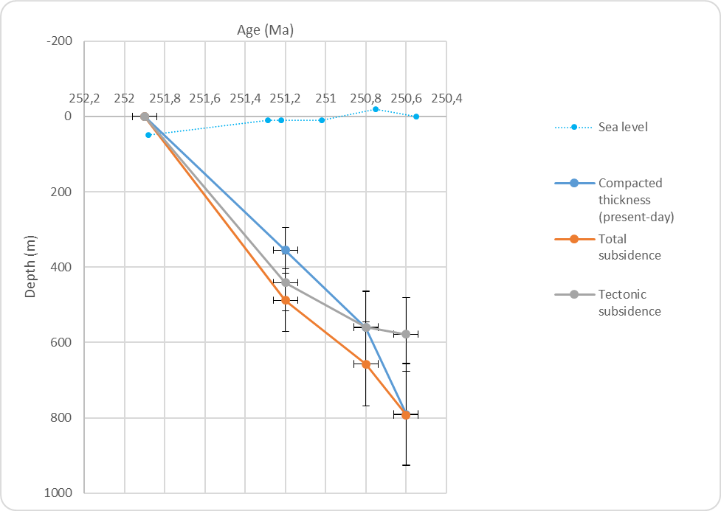

E. Synthesis of the tectonic subsidence results for each section (as presented in Fig. 9e).

 | Depth (m) (tectonic subsidence only) |  |  |  | Sea level
Age (Ma) | Confusion Range | Pahvant Range | Sheep Creek | Hot Springs
251,88 | 0 | 0 | 0 | 0 | 50
251,287 |  | 58 |  |  | 10
251,22 |  |  |  | 441 | 10
251,019 | 36 |  |  |  | 10
250,751 | 108 | 114 | 505 | 559 | -20
250,55 | 260 | 161 | 554 | 578 | 0

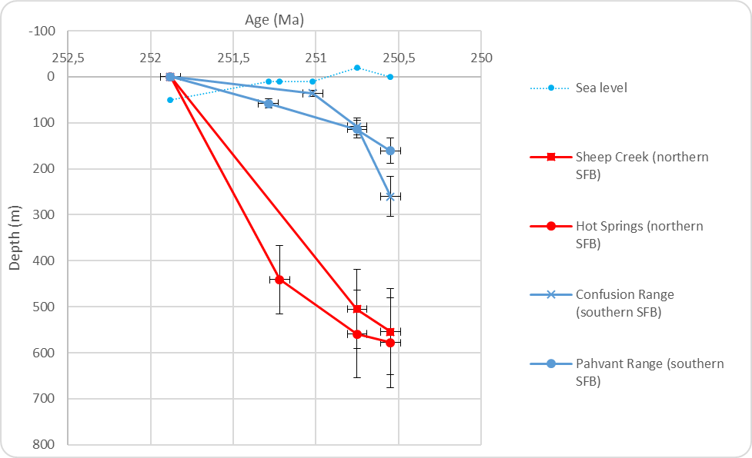

Appendix 4

Preliminary isopach map obtained by 3D interpolation and triangulation of georeferenced (and retrodeformed after palinspastic reconstruction) sedimentary thickness data for the PTU/Smithian interval, under the Global Mapper v.16.2.3 GIS software.

