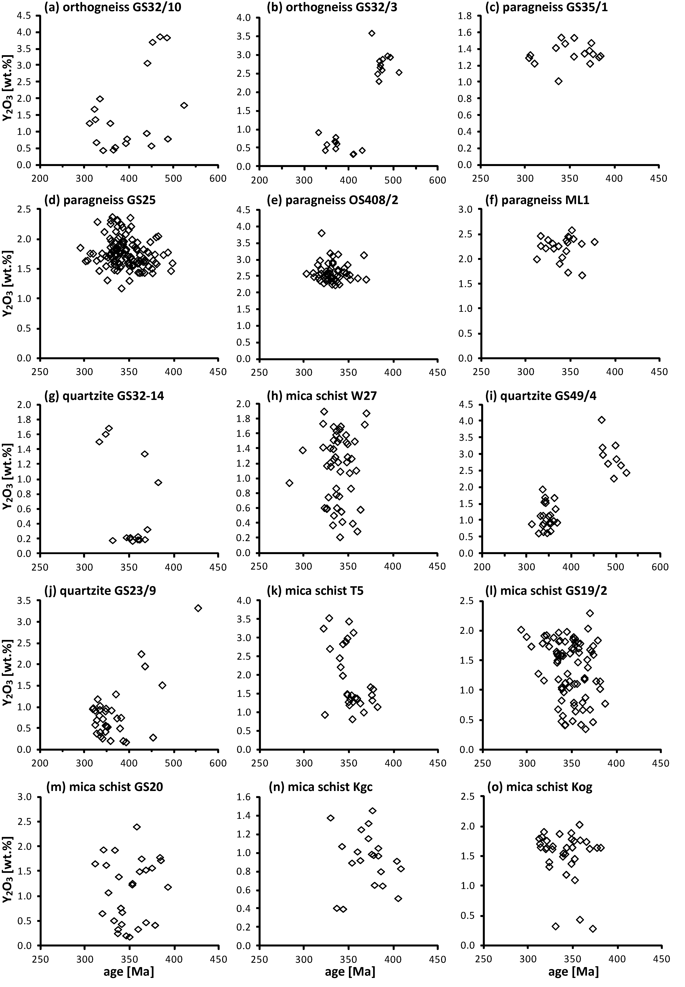

Appendix III. Diagrams presenting correlation patterns of monazite ages [Ma] versus concentrations of Y₂O₃ [wt.%].

