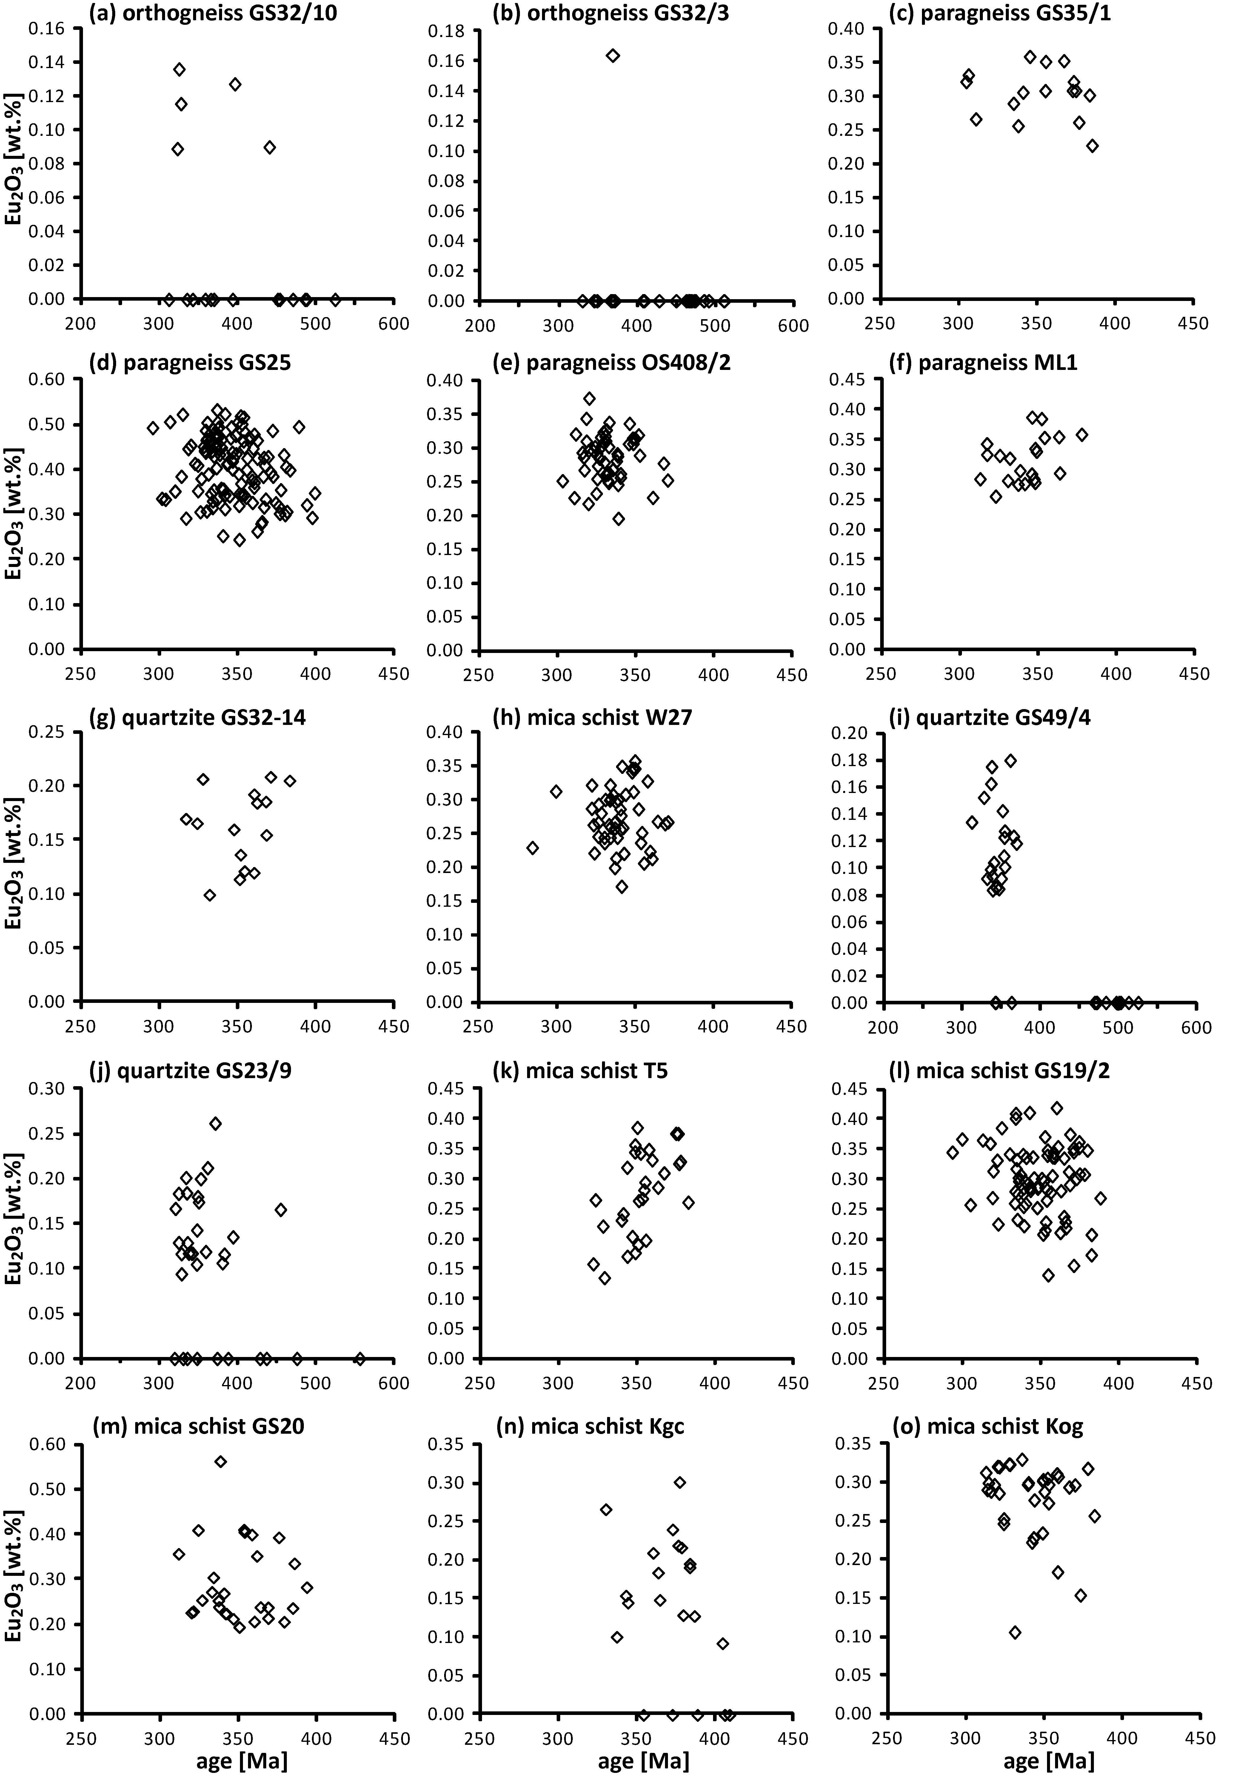

Appendix IV. Diagrams presenting correlation patterns of monazite ages [Ma] versus concentrations of Eu₂O₃ [wt.%].

