Geological Magazine
Life is everywhere in sinters: examples from Jurassic hot-spring environments of Argentine Patagonia.
Diego M. Guido, Kathleen A. Campbell, Frédéric Foucher, Frances Westall
SUPPLEMENTARY MATERIAL
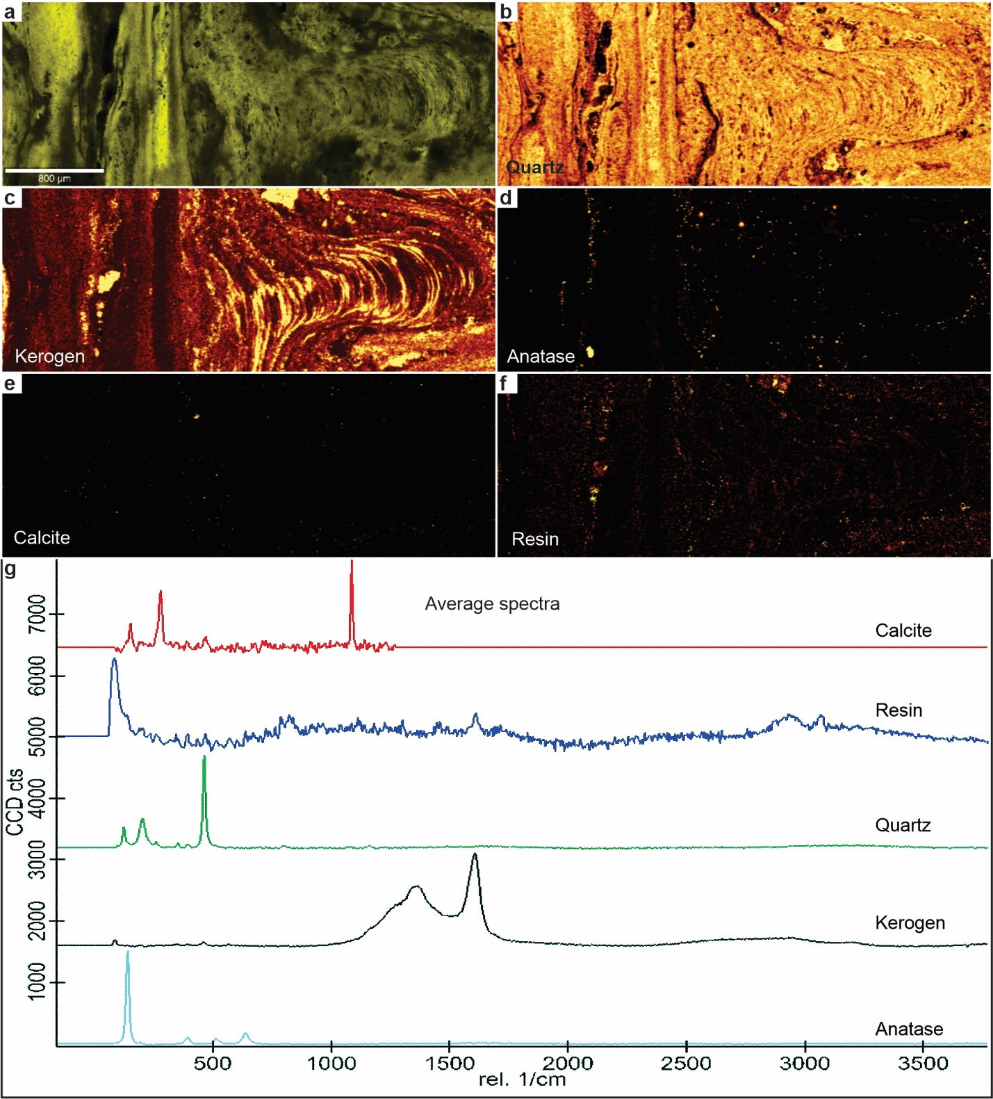
Supplementary Figure S1: Raman spectroscopy from Loma Alta sinter, Claudia, mid- to high-temperature facies.
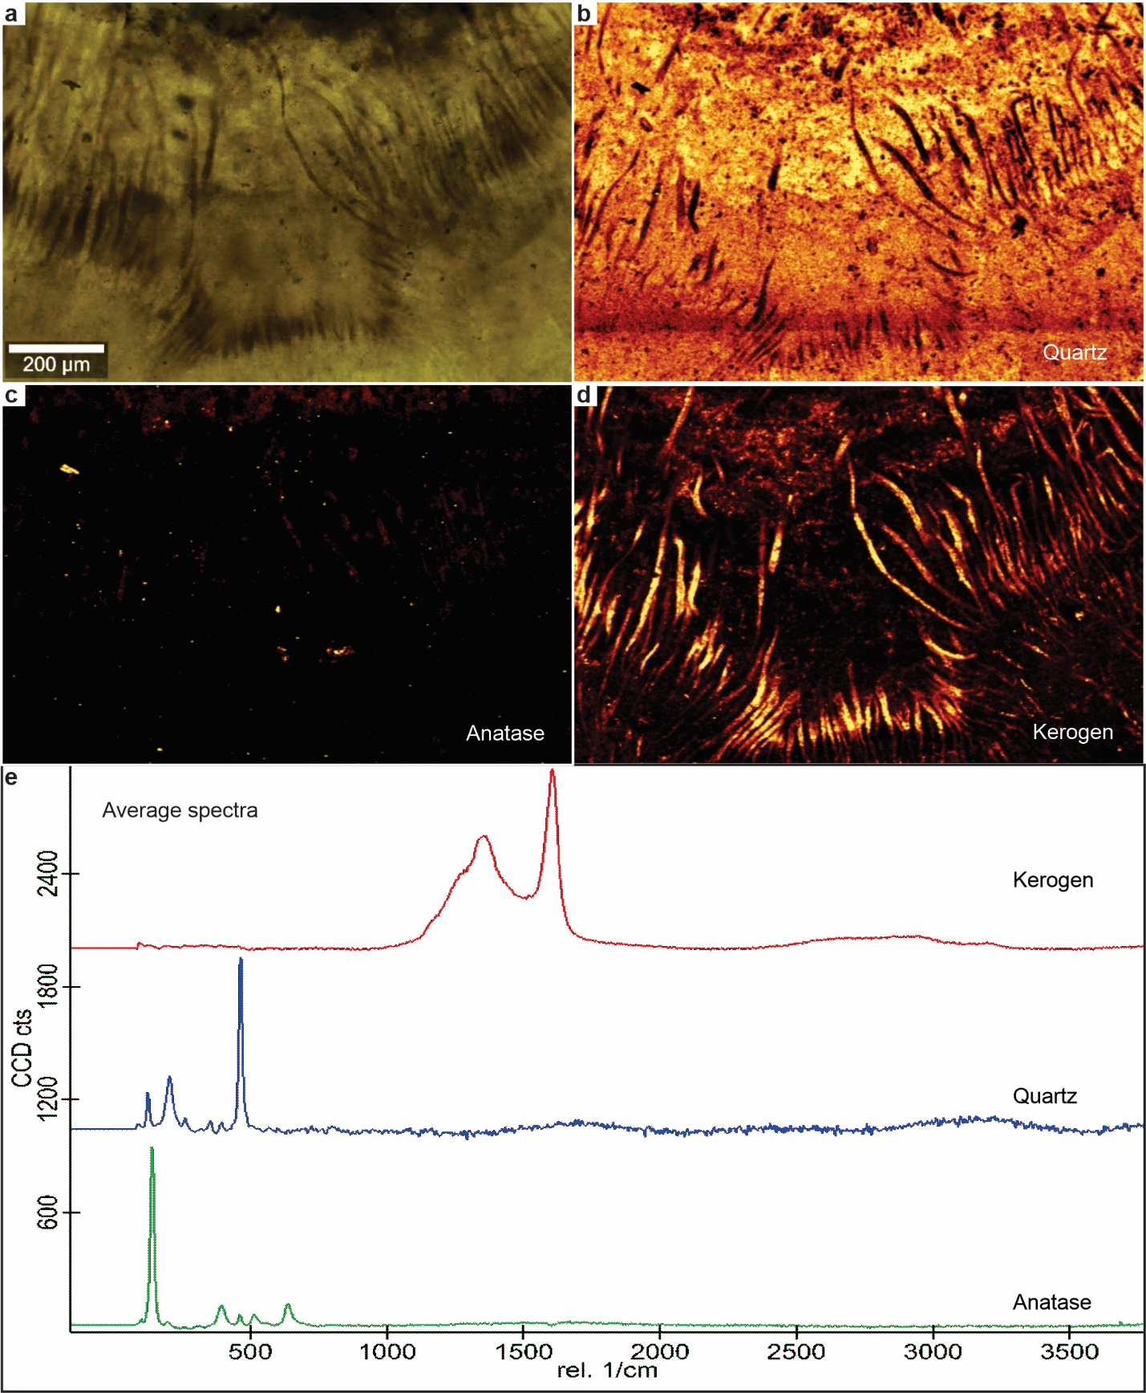
Supplementary Figure S2: Raman spectroscopy from Loma Alta sinter, Claudia, mid- to low-temperature facies.

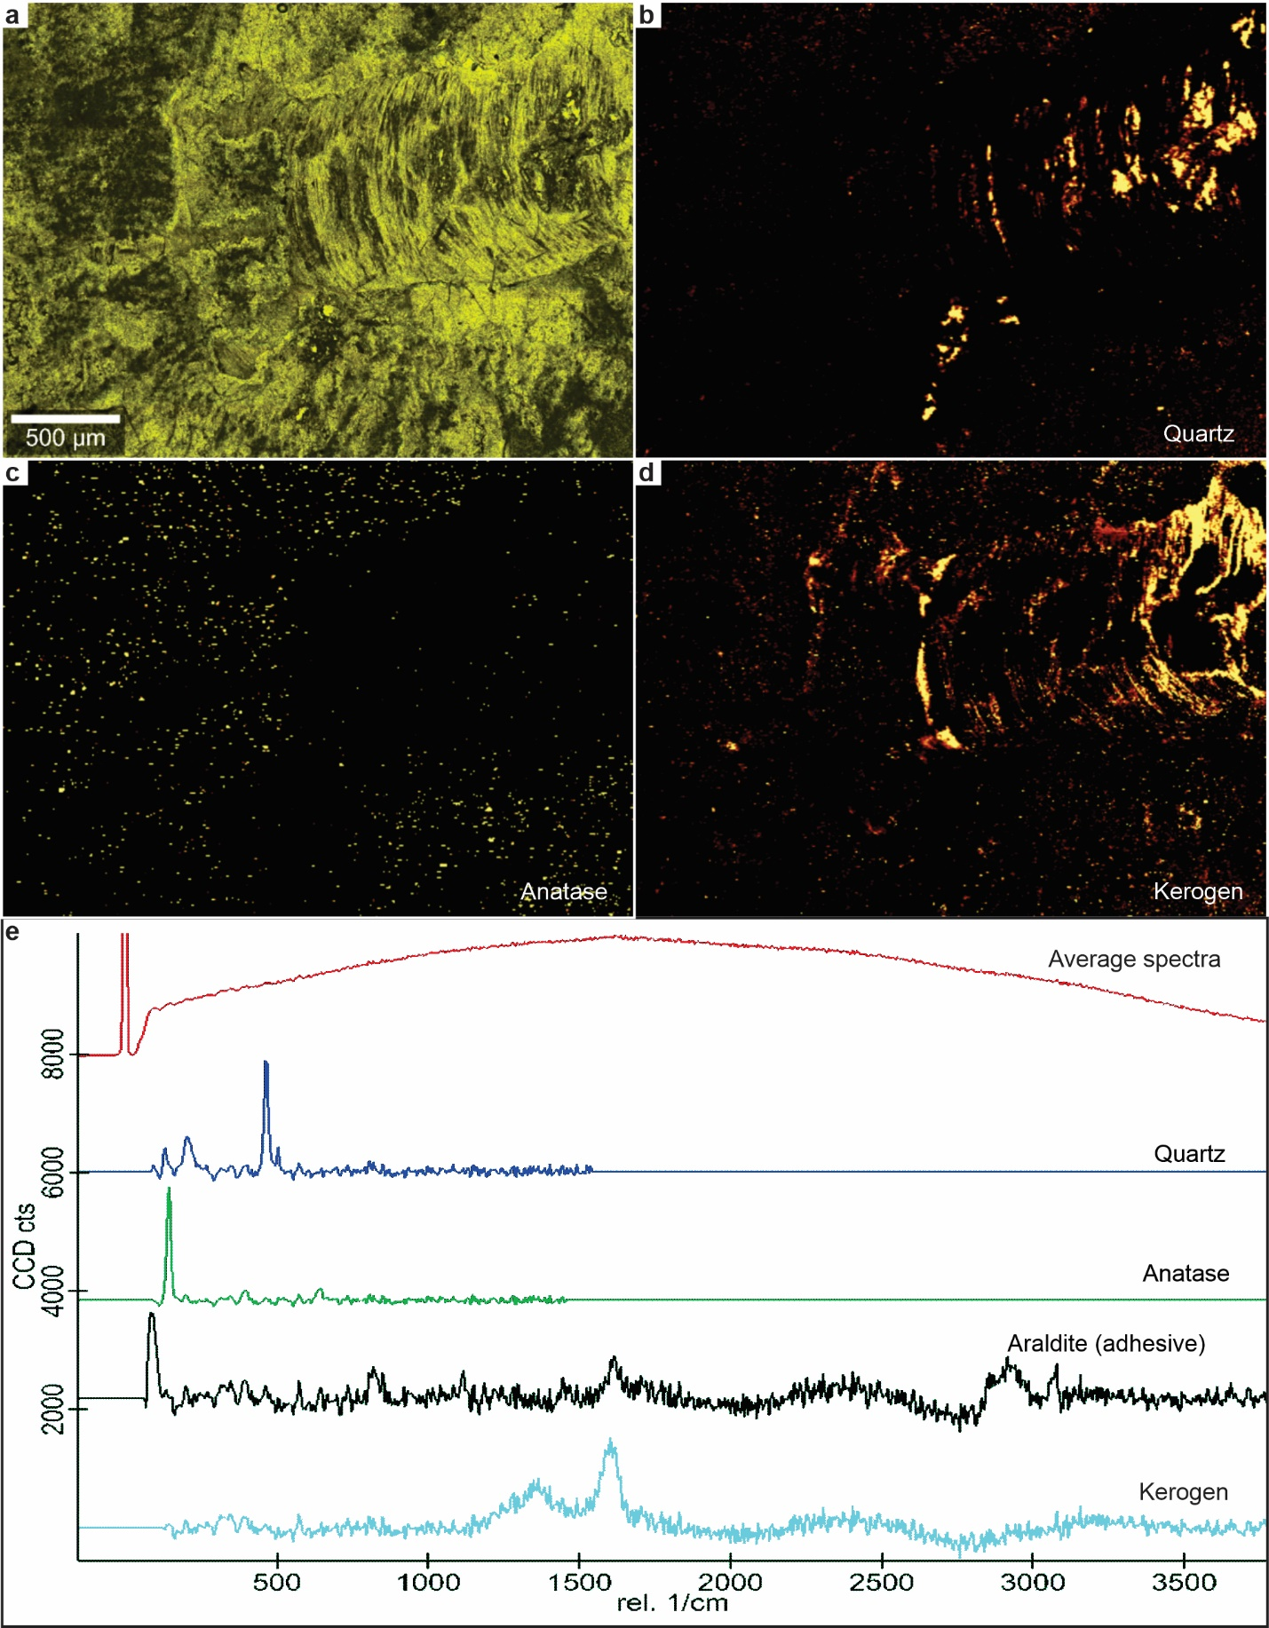
Supplementary Figure S3: Raman spectroscopy from Te Kopia sinter, high-temperature facies.

