Supplementary material
- Differential Diagnosis
- Phylogenetic analysis
- New and modified characters
- Character scorings, Yuornis
- Supplemental Figure
- Supplemental References
- Differential diagnosis
Differential diagnosis: L08-7-3 can be distinguished from other Late Cretaceous taxa by the unique condition of the humerus, having a long (more than one-third humeral length) and narrow deltopectoral crest, similar only to Martinavis cruzyensis, but differing from this taxon in the absence of a well developed flexor tubercle. Although similar to the Mongolian Gobipteryx in that the upper and lower jaws are both edentulous, L08-7-3 differs in the shape of the rostrum, the skull of Gobipteryx being taller than that of L08-7-3, as evidenced from the shape of the premaxillary corpus and external nares. The two taxa further differ in the shape of the maxilla; L08-7-3 has a well developed dorsal (nasal) process, which is absent in Gobipteryx. Nanantius valifanovi, a taxon very similar to Gobipteryx minuta, differs postcranially from L08-7-3 in the shape of the humerus, having a shorter deltopectoral crest as in most other Late Cretaceous enantiornithines.

- Phylogenetic Analysis
The systematic position of Yuornis was investigated through cladistic analysis. Yuornis was added to the matrix by Atterholt et al. (2018), which represents a modified version of the O’Connor and Zhou (2013) dataset, with the addition of seven tarsometatarsal characters and removal of Rahonavis, now widely reconsidered as a unenlagid dromaeosaurid (Turner et al., 2012), and several fragmentary taxa (e.g., Otogornis, Chaoyangia). We also included revised cranial scorings for Ichthyornis based on recently published data (Field et al., 2018). The final dataset, consisting of 37 taxa scored across 252 characters, was analysed using TNT (Goloboff et al., 2008a). Thirty-one characters were treated as ordered and all characters were equally weighted. We conducted a heuristic search retaining the single shortest tree from every 1000 trees followed by an additional round of tree bisection and reconnection (TBR) branch swapping. The first round of TBR returned 7 trees of 719 steps; the second round of TBR returned 36 trees of the same length. In the Nelson strict consensus tree (Fig. S1), Sapeornis, the Confuciusornithiformes, Jeholornis and Archaeopteryx form successive outgroups to Ornithothoraces, which is fairly resolved except for a small polytomy in both the Enantiornithes and the Ornithuromorpha. Yuornis + Gobipteryx are resolved together with Eoenantiornis as the out-group; this clade is part of a polytomy of derived enantiornithines. Since avian evolution is highly homoplastic (O’Connor et al., 2011; Xu, 2018), we explored the effects of implied weighting on the analysis (Goloboff et al., 2008b). The results stabilized when k values reached 12, which is the minimum suggested k value, producing a single well resolved tree (Fig. 1). As in the a priori weighted analysis Yuornis + Gobipteryx are still resolved together but now Shenqiornis forms the out-group, previously part of the polytomy of derived enantiornithines (Fig. S1). This clade forms a dichotomy with an Eoalulavis + Cathayornis and Eocathayornis clade. Eoenantiornis is resolved with Concornis, in a dichotomy with Neuquenornis + Halimornis and Enantiophoenix. These two clades form a dichotomy with Elsornis, the Pengornithidae, the Longipterygidae, and Protopteryx + Iberomesornis forming successive out groups.
The Yuornis + Gobipteryx clade is supported by three characters (4 – predentary teeth absent, 7 – maxillary teeth absent, 34 – dentary teeth absent), which together simply indicate an edentulous rostrum. Since it is clear from the fossil record that an edentulous rostrum has evolved many times during avian evolution, this relationship will most likely collapse with the addition of new material especially from the poorly sampled Late Cretaceous.

- New and modified characters:
Modified Character 233 (state 3 new)
Metatarsal II tubercle (associated with the insertion of the tendon of the m. tibialis cranialis in Aves): absent (0); present, on the medial dorsomedial margin of metatarsal II (1); located approximately the center of the proximodorsal surface of metatarsal II (2); developed on lateral surface of metatarsal II, at contact with metatarsal III or on lateral edge of metatarsal III (3). (ORDERED)

New Characters 246 – 252:
246. Metatarsals II and III, tubercle for muscle attachment (presumably the m. tibialis cranialis): one such tubercle (0); two tubercles present (1). (modified from O’Connor et al., 2014 – Evgenavis).

247. Position of the tubercle for the m. tibialis cranialis: proximally located (0); located approximately 1/3 from the proximal end (1); located near to or distal from the midpoint (2). (from O’Connor, 2009)

248. Tubercle for the m. tibialis cranialis hypertrophied: absent (0); present (1). (New)

249. Medial condyle of metatarsal III trochlea projecting strongly plantarly relative to the lateral condyle: absent (0); present (1); lateral condyle projects farther (2). (modified from Chiappe, 1993).

250. Medial trochlea of metatarsal III, protrudes farther distally than lateral trochlea: absent (0); present (1). (New)

251. Dorsal surface of metatarsal III strongly convex: absent (0); present (1). (from Chiappe, 1993)

252. Metatarsal IV trochlea: ginglymous (0); reduced to a single convex surface in caudal view (1); single condyle medially excavated (2). (modified from Chiappe, 1993).

- Character Scorings
Yuornis 0 21[12]31?12?0 011???111? 111011???0 ??01?100?0 ?0??11???? ?????????? ?????????? ?????????? ??111101?? ???????000 ?????????? ?????????? 001??10000 ??10?00011 1??1110??1 ???[012]?????? 0??0?01?0? ???????0?? 010??????? ?????1???0 101??????? ?????????? ?????????? ?????????? ?????????? ??

5. Supplementary figure

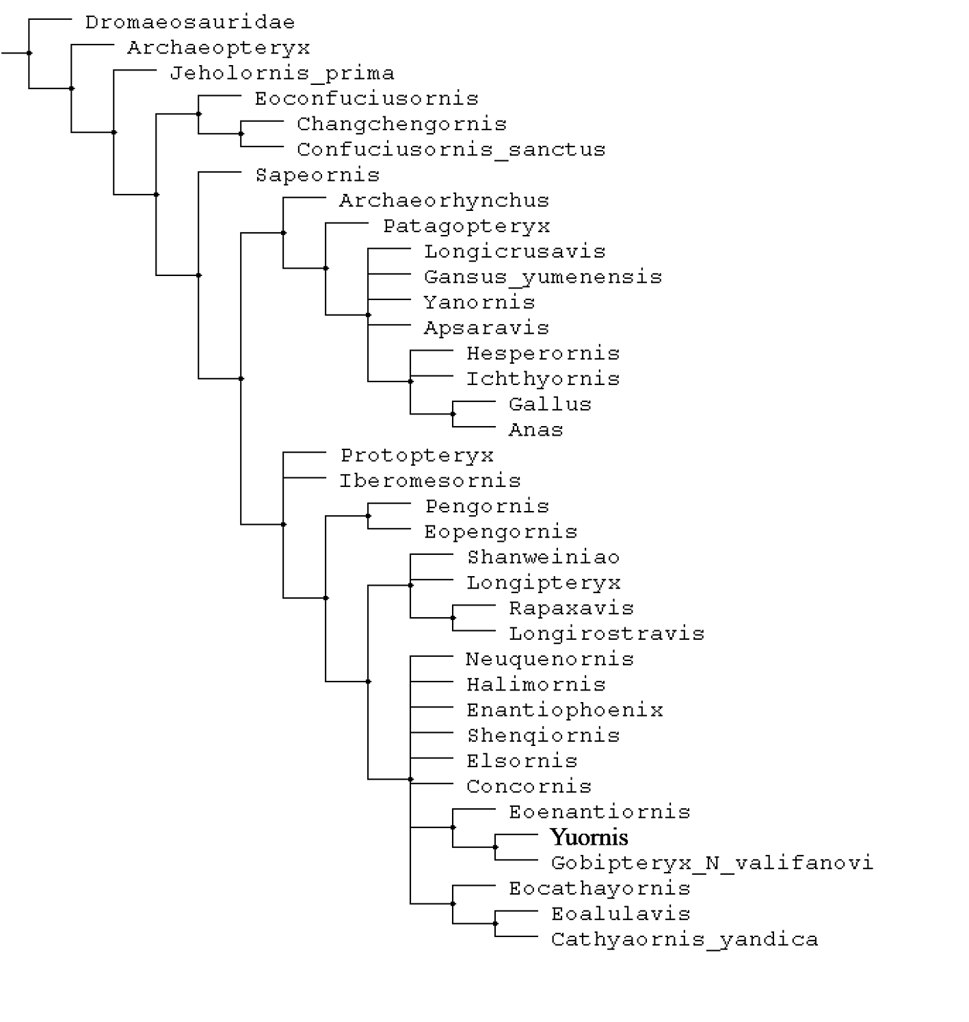

Figure S1. Nelsen Strict Consensus tree of 36 most parsimonious trees of 719 steps, produced after two rounds of tree-bisection reconnection without using implied weights.

- Supplemental References
Atterholt, J. A., J. H. Hutchison, and J. O’Connor. 2018. The most complete enantiornithine from North America and a phylogenetic analysis of the Avisauridae. PeerJ 6:e5910 DOI 10.7717/peerj.5910 .
Chiappe, L. M. 1993. Enantiornithine (Aves) tarsometatarsi from the Cretaceous Lecho Formation of northwestern Argentina. American Museum Novitates 3083:1-27.
Field, D. J., M. Hanson, D. A. Burnham, L. E. Wilson, K. Super, D. Ehret, J. A. Ebersole, and B.-A. Bhullar. 2018. Complete Ichthyornis skull illuminates mosaic assembly of the avian head. Nature 557:96.
Goloboff, P. A., J. S. Farris, and K. C. Nixon. 2008a. TNT, a free program for phylogenetic analysis. Cladistics 24:774-786.
Goloboff, P. A., J. M. Carpenter, J. S. Arias, and D. R. M. Esquivel. 2008b. Weighting against homoplasy improves phylogenetic analysis of morphological data sets. Cladistics 24:1-16.
O'Connor, J. K., and Z.-H. Zhou. 2013. A redescription of Chaoyangia beishanensis (Aves) and a comprehensive phylogeny of Mesozoic birds. Journal of Systematic Palaeontology 11:889-906.
O'Connor, J. K., L. M. Chiappe, and A. Bell. 2011. Pre-modern birds: avian divergences in the Mesozoic; pp. 39–114 in G. D. Dyke, and G. Kaiser (eds.), Living Dinosaurs: the Evolutionary History of Birds. J. Wiley & Sons, Hoboken, NJ.
O'Connor, J. K., X.-R. Wang, L. M. Chiappe, C.-H. Gao, Q.-J. Meng, X.-D. Cheng, and J.-Y. Liu. 2009. Phylogenetic support for a specialized clade of Cretaceous enantiornithine birds with information from a new species. Journal of Vertebrate Paleontology 29:188-204.
Turner, A. H., P. J. Makovicky, and M. A. Norell. 2012. A review of dromaeosaurid systematics and paravian phylogeny. Bulletin of the American Museum of Natural History 371:1-206.
Xu, X. 2018. Mosaic evolution in birds: Brain vs. feeding apparatus. Science Bulletin 63: 812-813.

