Geological Magazine

Morphological variation in the rangeomorph organism Fractofusus misrai from the Ediacaran of Newfoundland, Canada

Rod S. Taylor, Robert Nicholls, Jenna M. Neville and Duncan McIlroy

Supplementary Material

Supplementary figure 1. (a) Strongly ‘kinked’ specimen of Fractofusus misrai in Fig. 6 (a) (field photograph). (b) The same photograph retrodeformed according to the Mistaken Point tectonic deformation data (shortening of approximately 40% in the direction perpendicular to cleavage (58°/238°)) according to Seilacher 1999 and Wood et al. 2003. (c) Fractofusus andersoni from Location 5, Bonavista Peninsula, identified by Hofmann et al. (2008, fig. 20.1) as F. misrai (cast photograph) (scale bar: (a), 10 mm; (c), 10 mm).
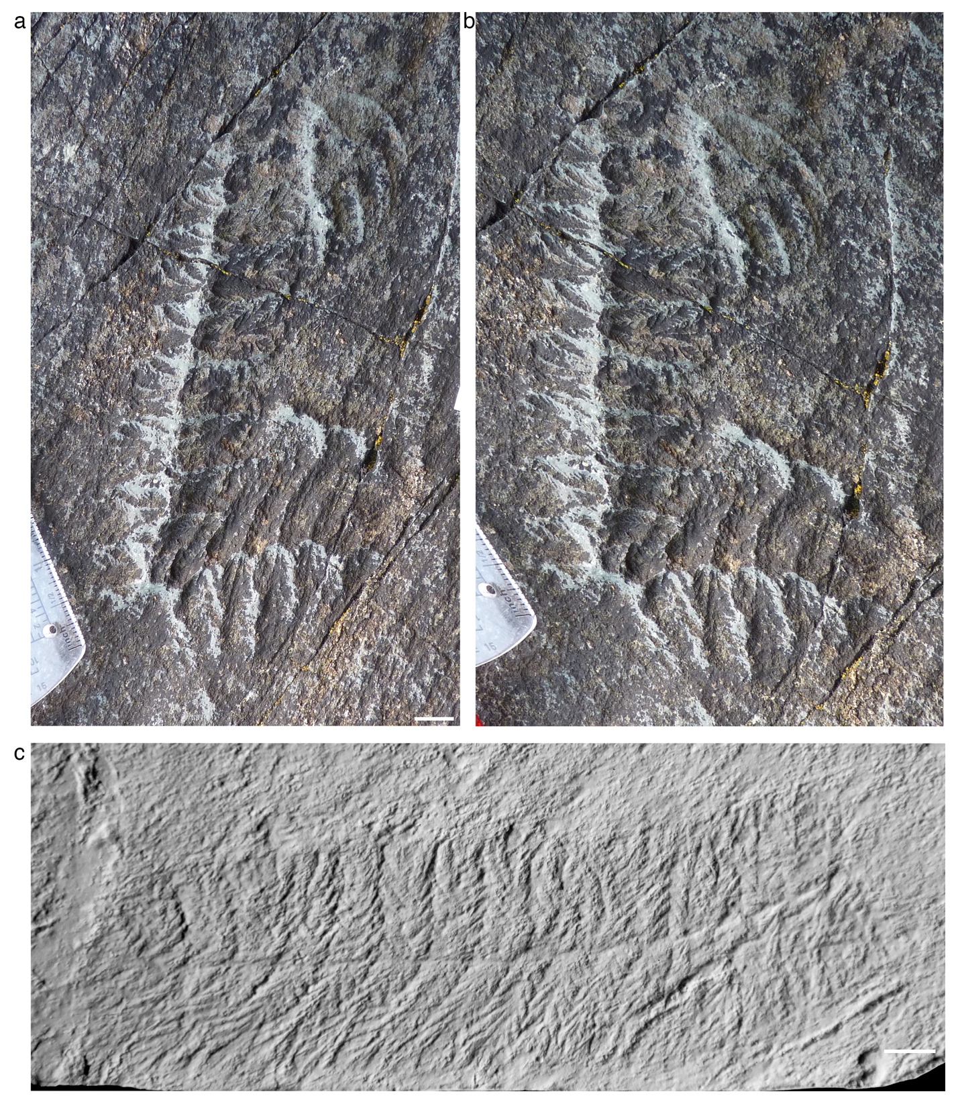

Supplementary figure 2. (a) Strongly ‘kinked’ specimen of Fractofusus misrai in Fig. 6 (b) (field photograph). (b) The same photograph retrodeformed according to the Mistaken Point tectonic deformation data (shortening of approximately 40% in the direction perpendicular to cleavage (58°/238°)) according to Seilacher 1999 and Wood et al. 2003 (scale bar: (a), 10 mm).
