**Geochemical constraints on the petrogenesis of mafic rocks (metadolerites) from the Proterozoic Shillong Basin, Northeast India: implications for growth of the Greater Indian Landmass**

Pallabi Basumatary1, Ashima Saikia2, Tribujjal Prakash1, Bibhuti Gogoi1,*

1Department of Geology, Cotton University, Guwahati, Assam 781001, India

2Department of Geology, University of Delhi, Delhi 110007, India

*bibhuti.gogoi.baruah@gmail.com

**Supplement 1**

**Figure S1**

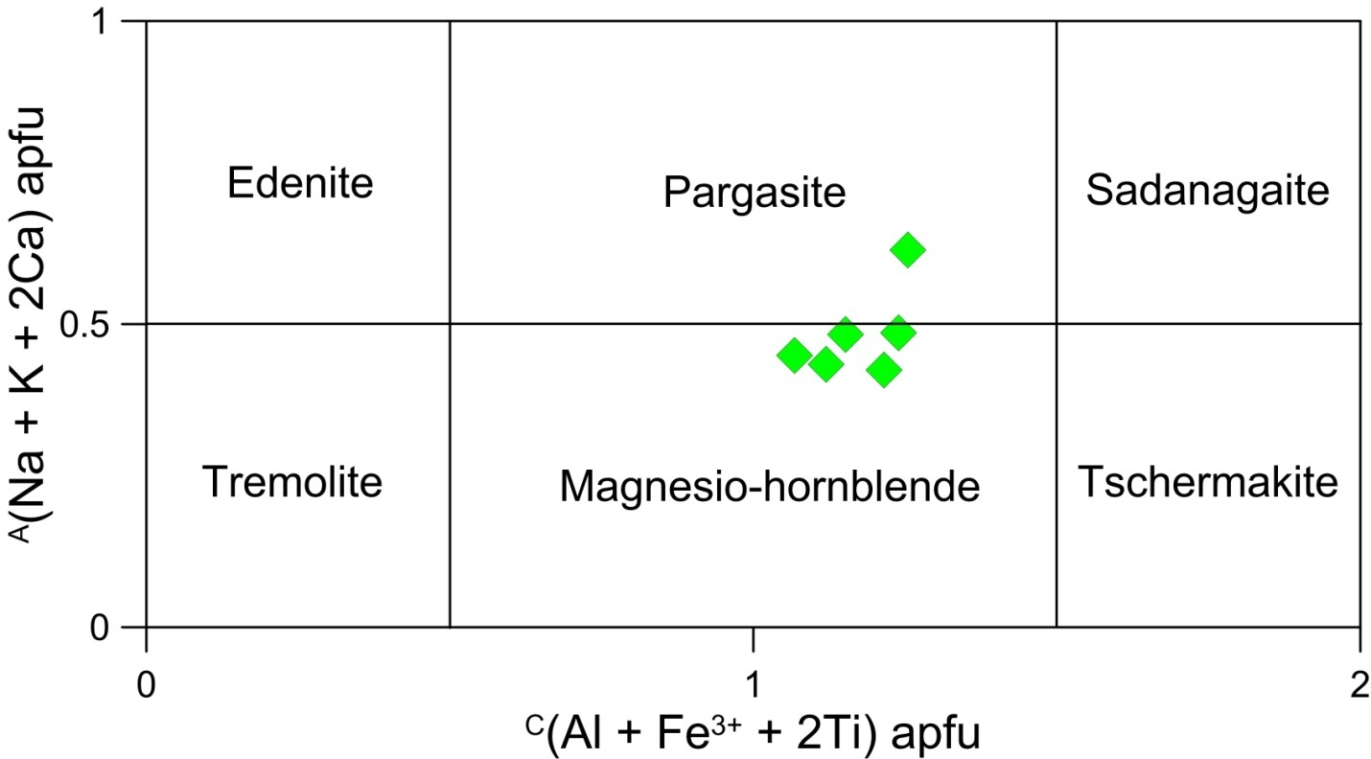

**Fig. S1.** Nomenclature of amphibole from the metadolerites of Borjuri (after Hawthorne *et al*. 2012).

**Figure S2**

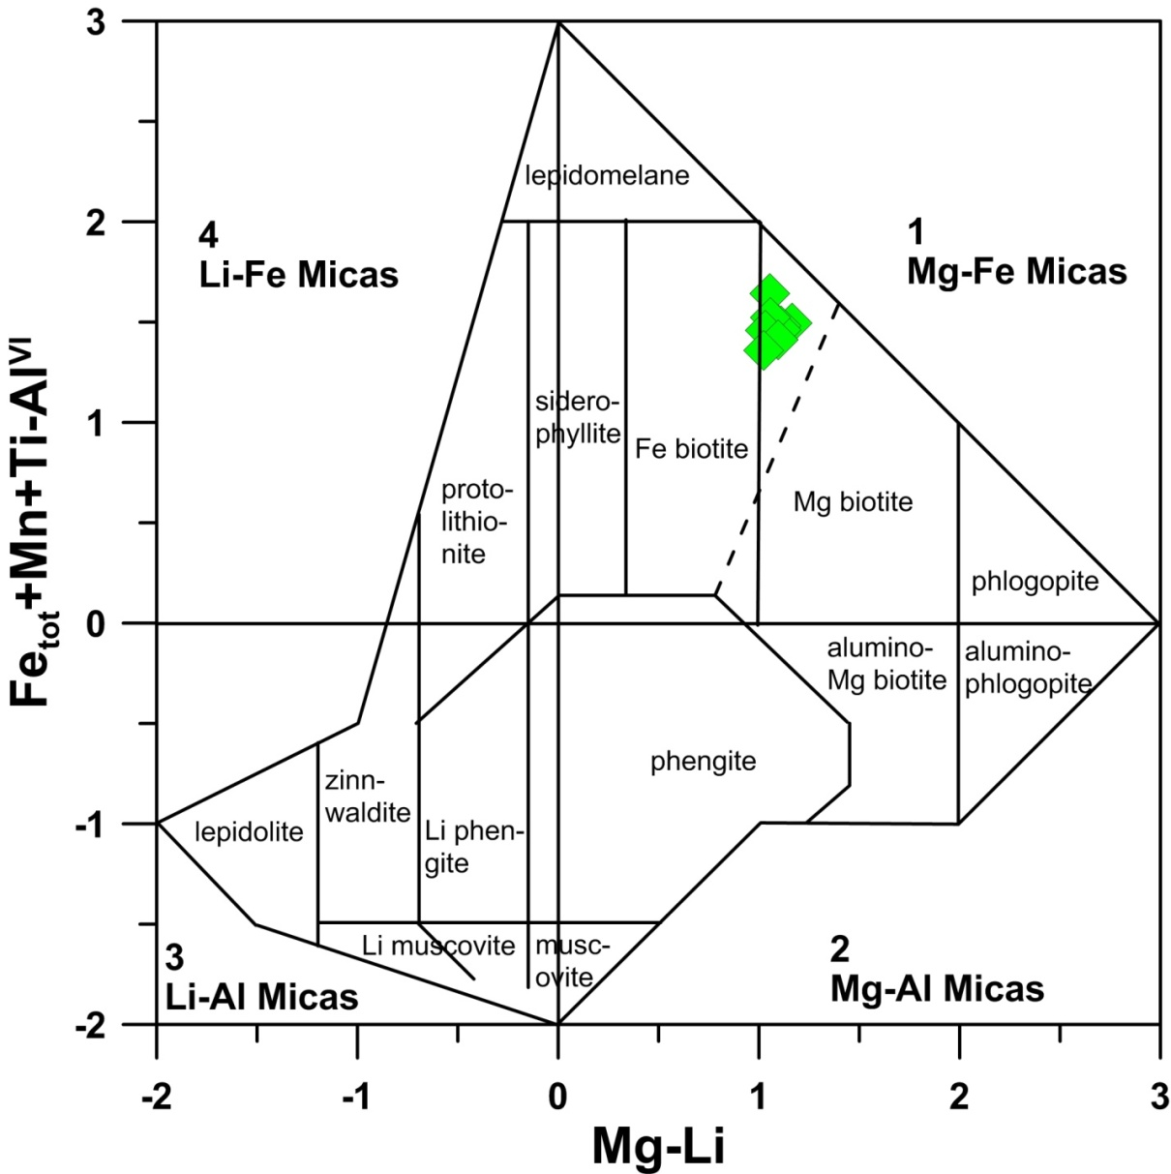

**Fig. S2.** Nomenclature and classification of biotite from the metadolerites of Borjuri (after Tischendorf *et al*. 1997).

**Figure S3**

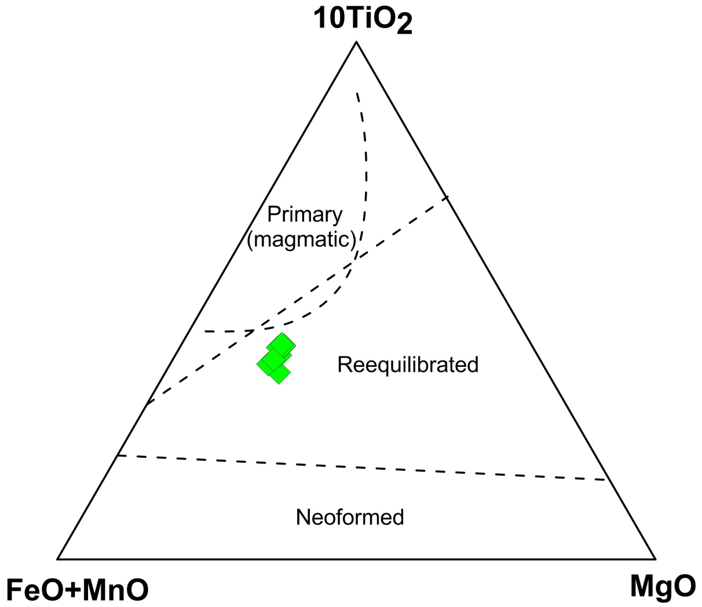

**Fig. S3.** FeO+MnO–10TiO2–MgO ternary plot showing that biotites from the metadolerites are classified as re-equilibrated biotites (after Nachit *et al.* 2005).

**Figure S4**

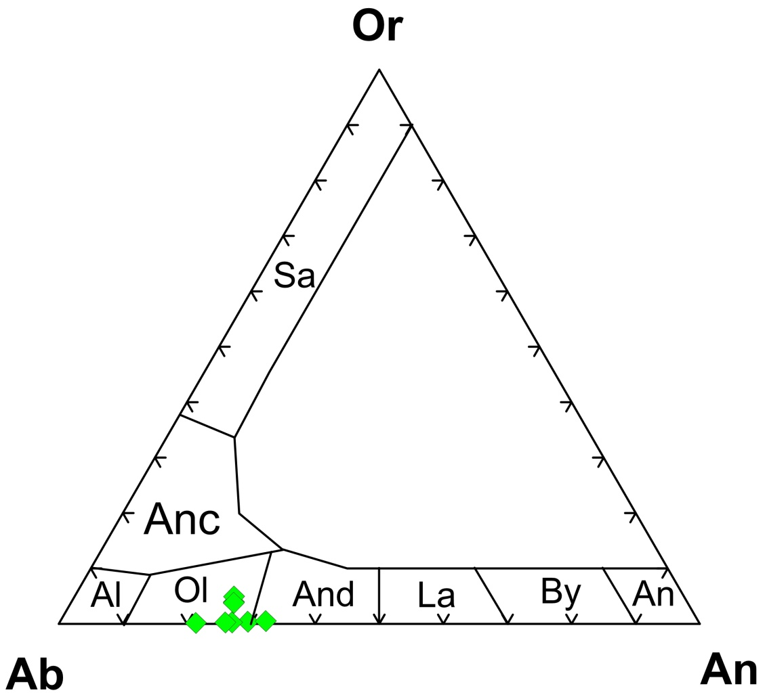

**Fig. S4.** Nomenclature of plagioclase occurring in the metadolerites of Borjuri.

**Figure S5**

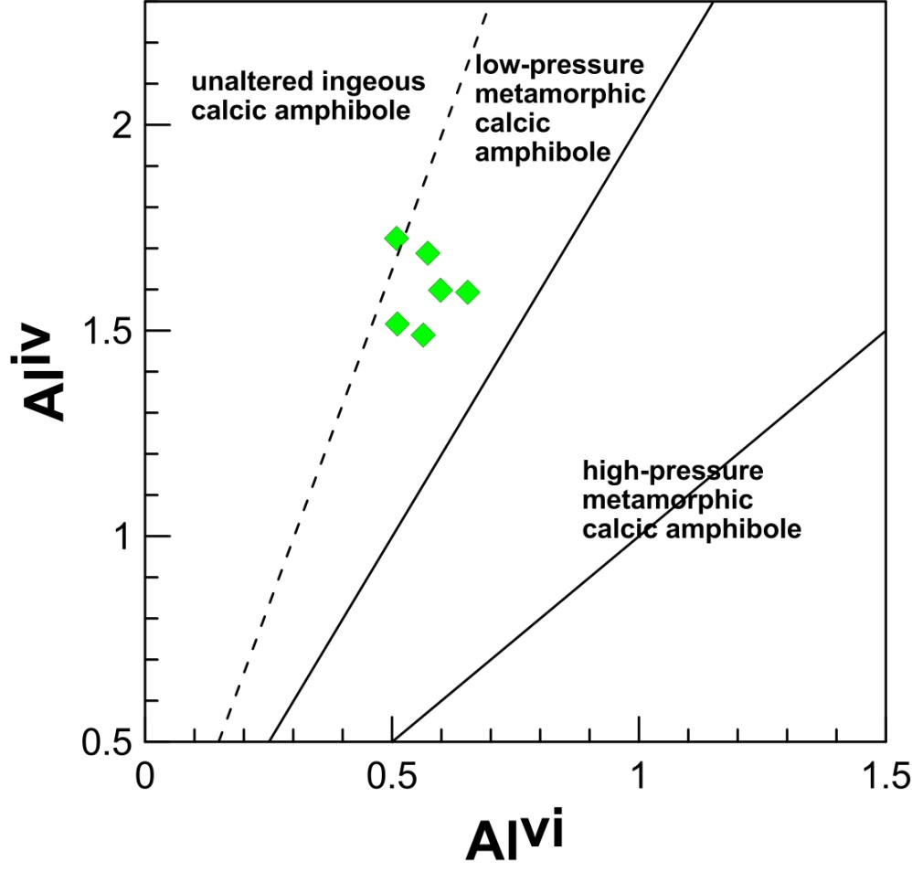

**Fig. S5.** Aliv versus Alvi calcic amphibole discrimination diagram displaying the fields of igneous and metamorphic amphiboles (after Fleet & Barnett, 1978).

**Figure S6**

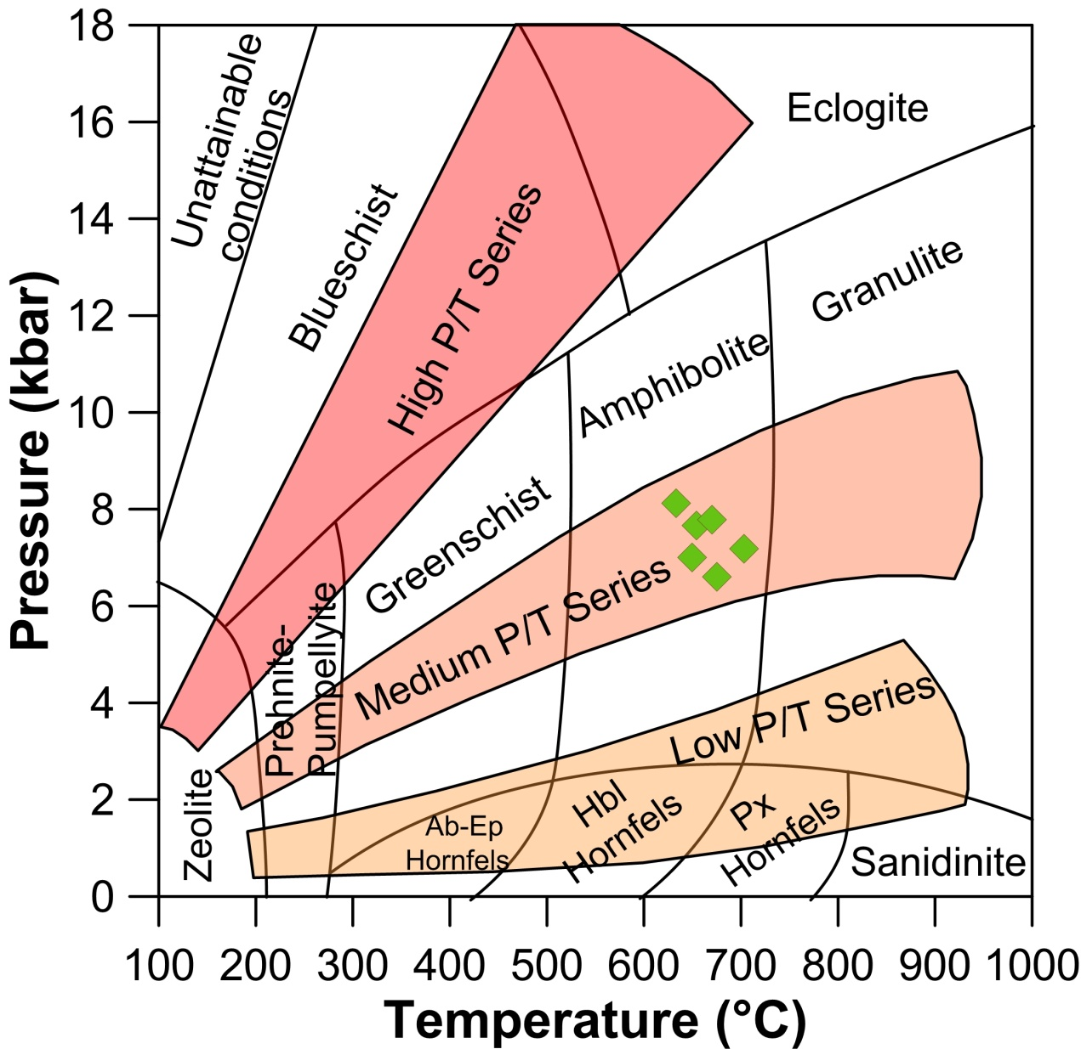

**Fig. S6.** Temperature-Pressure diagram from Winter (2010) showing the major metamorphic facies series proposed by Miyashiro (1973, 1994).

**Supplement 2**

**Table S1.** Representative EPMA analyses of amphibole from the metadolerites of Borjuri area (in wt % oxide)

|  |  |  |  |  |  |  |
| --- | --- | --- | --- | --- | --- | --- |
| SiO2 | 42.37 | 42.00 | 41.79 | 41.89 | 40.47 | 40.32 |
| TiO2 | 0.43 | 0.72 | 0.50 | 0.34 | 1.00 | 0.59 |
| Al2O3 | 11.33 | 11.14 | 12.44 | 12.20 | 12.22 | 12.25 |
| Cr2O3 | 0.01 | 0.03 | 0.02 | 0.01 | 0.00 | 0.01 |
| FeO | 21.31 | 21.58 | 22.01 | 21.71 | 22.19 | 21.49 |
| MnO | 0.31 | 0.32 | 0.36 | 0.33 | 0.30 | 0.37 |
| MgO | 7.12 | 6.99 | 6.36 | 6.94 | 7.48 | 6.55 |
| CaO | 11.83 | 11.65 | 11.69 | 11.74 | 9.48 | 11.51 |
| Na2O | 1.22 | 1.15 | 1.39 | 1.15 | 1.02 | 1.23 |
| K2O | 0.57 | 0.64 | 0.56 | 0.64 | 2.36 | 0.74 |
| Total | 96.49 | 96.22 | 97.13 | 96.95 | 96.52 | 95.06 |
| Calculation based on 23 O | | | | | | |
| Si | 6.51 | 6.48 | 6.41 | 6.40 | 6.28 | 6.31 |
| Aliv | 1.49 | 1.52 | 1.59 | 1.60 | 1.72 | 1.69 |
| Sum T | 8.00 | 8.00 | 8.00 | 8.00 | 8.00 | 8.00 |
| Alvi | 0.56 | 0.51 | 0.65 | 0.60 | 0.51 | 0.57 |
| Ti | 0.05 | 0.08 | 0.06 | 0.04 | 0.12 | 0.07 |
| Fe3+ | 0.41 | 0.44 | 0.38 | 0.54 | 0.51 | 0.53 |
| Cr | 0.00 | 0.01 | 0.00 | 0.00 | 0.00 | 0.00 |
| Mg | 1.63 | 1.61 | 1.45 | 1.58 | 1.73 | 1.53 |
| Fe2+ | 2.33 | 2.34 | 2.44 | 2.24 | 2.13 | 2.28 |
| Mn3+ | 0.01 | 0.01 | 0.01 | 0.01 | 0.00 | 0.02 |
| Sum C | 5.00 | 5.00 | 5.00 | 5.00 | 5.00 | 5.00 |
| Mg | 0.00 | 0.00 | 0.00 | 0.00 | 0.00 | 0.00 |
| Fe2+ | 0.00 | 0.00 | 0.00 | 0.00 | 0.23 | 0.00 |
| Mn2+ | 0.03 | 0.04 | 0.04 | 0.04 | 0.04 | 0.03 |
| Ca | 1.95 | 1.93 | 1.92 | 1.92 | 1.57 | 1.93 |
| Na | 0.03 | 0.04 | 0.04 | 0.04 | 0.15 | 0.04 |
| Sum B | 2.00 | 2.00 | 2.00 | 2.00 | 2.00 | 2.00 |
| Na | 0.34 | 0.31 | 0.37 | 0.30 | 0.16 | 0.34 |
| K | 0.11 | 0.13 | 0.11 | 0.13 | 0.47 | 0.15 |
| Sum A | 0.45 | 0.43 | 0.48 | 0.42 | 0.62 | 0.49 |
| Total | 15.45 | 15.43 | 15.48 | 15.42 | 15.62 | 15.49 |
| (Mg+Fe2++Mn2+) | 4.01 | 3.99 | 3.94 | 3.86 | 4.14 | 3.86 |
| Mg/Mg+Fe2+ | 0.41 | 0.41 | 0.37 | 0.41 | 0.42 | 0.40 |
| (Ca+Na)B | 1.97 | 1.96 | 1.96 | 1.96 | 1.73 | 1.97 |
| (Na+K+2Ca)A | 0.45 | 0.43 | 0.48 | 0.42 | 0.62 | 0.49 |
| (Al+Fe3++2Ti)C | 1.07 | 1.12 | 1.15 | 1.22 | 1.25 | 1.24 |

**Table S2.** Representative EPMA analyses of biotite from the metadolerites of Borjuri (in wt % oxide)

|  |  |  |  |  |  |  |  |  |
| --- | --- | --- | --- | --- | --- | --- | --- | --- |
| SiO2 | 33.39 | 33.46 | 33.99 | 35.30 | 34.66 | 35.03 | 35.26 | 36.35 |
| TiO2 | 1.86 | 2.01 | 2.09 | 2.28 | 2.21 | 1.99 | 2.23 | 2.18 |
| Al2O3 | 15.82 | 14.94 | 15.29 | 15.39 | 14.61 | 14.86 | 15.21 | 14.57 |
| FeO | 22.93 | 24.18 | 22.49 | 22.78 | 22.74 | 22.65 | 22.20 | 21.66 |
| MnO | 0.21 | 0.18 | 0.27 | 0.19 | 0.24 | 0.28 | 0.17 | 0.14 |
| MgO | 9.76 | 8.75 | 9.28 | 9.55 | 8.87 | 8.68 | 9.31 | 8.75 |
| CaO | 0.12 | 0.18 | 0.06 | 0.02 | 0.06 | 0.18 | 0.04 | 0.09 |
| Na2O | 0.04 | 0.24 | 0.21 | 0.11 | 0.31 | 0.42 | 0.04 | 0.20 |
| K2O | 8.67 | 8.79 | 8.91 | 9.12 | 8.79 | 8.53 | 8.90 | 9.07 |
| Cl | 0.06 | 0.06 | 0.05 | 0.05 | 0.07 | 0.05 | 0.07 | 0.05 |
| F | 0.00 | 0.04 | 0.00 | 0.05 | 0.19 | 0.10 | 0.00 | 0.26 |
| BaO | 0.44 | 0.28 | 0.37 | 0.12 | 0.26 | 0.13 | 0.37 | 0.20 |
| Total | 93.29 | 93.09 | 93.00 | 94.97 | 92.99 | 92.91 | 93.81 | 93.52 |
| Cation calculation based on 11 O | | | | | | | | |
| Si | 2.67 | 2.70 | 2.72 | 2.75 | 2.77 | 2.79 | 2.78 | 2.85 |
| Aliv | 1.33 | 1.30 | 1.28 | 1.25 | 1.23 | 1.21 | 1.22 | 1.15 |
| Sum T | 4.00 | 4.00 | 4.00 | 4.00 | 4.00 | 4.00 | 4.00 | 4.00 |
| Alvi | 0.17 | 0.13 | 0.17 | 0.17 | 0.14 | 0.19 | 0.20 | 0.20 |
| Ti | 0.11 | 0.12 | 0.13 | 0.13 | 0.13 | 0.12 | 0.13 | 0.13 |
| Fe | 1.53 | 1.63 | 1.51 | 1.49 | 1.52 | 1.51 | 1.47 | 1.42 |
| Mn | 0.01 | 0.01 | 0.02 | 0.01 | 0.02 | 0.02 | 0.01 | 0.01 |
| Mg | 1.16 | 1.05 | 1.11 | 1.11 | 1.06 | 1.03 | 1.10 | 1.02 |
| Sum Y | 2.99 | 2.95 | 2.93 | 2.92 | 2.87 | 2.87 | 2.90 | 2.79 |
| Ca | 0.01 | 0.02 | 0.01 | 0.00 | 0.00 | 0.02 | 0.00 | 0.01 |
| Na | 0.01 | 0.04 | 0.03 | 0.02 | 0.05 | 0.07 | 0.01 | 0.03 |
| K | 0.89 | 0.91 | 0.91 | 0.91 | 0.90 | 0.87 | 0.90 | 0.91 |
| Ba | 0.01 | 0.01 | 0.01 | 0.00 | 0.01 | 0.00 | 0.01 | 0.01 |
| Sum X | 0.92 | 0.97 | 0.96 | 0.93 | 0.96 | 0.95 | 0.92 | 0.95 |
| F | 0.00 | 0.01 | 0.00 | 0.01 | 0.05 | 0.03 | 0.00 | 0.07 |
| Cl | 0.01 | 0.01 | 0.01 | 0.01 | 0.01 | 0.01 | 0.01 | 0.01 |
| Fe+Mg | 2.70 | 2.69 | 2.62 | 2.60 | 2.58 | 2.54 | 2.56 | 2.45 |
| Fe/Fe+Mg | 0.57 | 0.61 | 0.58 | 0.57 | 0.59 | 0.59 | 0.57 | 0.58 |
| Fetot+Mn+Ti-Alvi | 1.50 | 1.64 | 1.48 | 1.46 | 1.52 | 1.46 | 1.41 | 1.36 |

**Table S3.** Representative EPMA analyses of plagioclase from the metadolerites of Borjuri (in wt % oxide). An = Anorthite; Al = Albite; Or = Orthoclase

|  |  |  |  |  |  |  |  |  |
| --- | --- | --- | --- | --- | --- | --- | --- | --- |
| SiO2 | 59.71 | 59.64 | 62.19 | 60.25 | 59.90 | 60.35 | 60.68 | 60.96 |
| TiO2 | 0.00 | 0.00 | 0.08 | 0.00 | 0.00 | 0.04 | 0.05 | 0.02 |
| Al2O3 | 23.53 | 24.26 | 22.59 | 23.05 | 23.74 | 23.30 | 23.33 | 23.81 |
| FeO | 0.42 | 0.93 | 0.22 | 0.26 | 0.19 | 0.06 | 0.33 | 0.26 |
| MnO | 0.06 | 0.02 | 0.01 | 0.00 | 0.05 | 0.00 | 0.00 | 0.00 |
| MgO | 0.00 | 0.07 | 0.00 | 0.00 | 0.00 | 0.00 | 0.00 | 0.00 |
| CaO | 6.23 | 6.86 | 4.60 | 5.27 | 5.81 | 5.21 | 5.39 | 5.71 |
| Na2O | 8.26 | 7.98 | 9.37 | 8.13 | 8.70 | 8.12 | 8.31 | 9.03 |
| K2O | 0.07 | 0.09 | 0.03 | 0.69 | 0.05 | 0.87 | 0.68 | 0.05 |
| BaO | 0.04 | 0.00 | 0.04 | 0.63 | 0.21 | 0.08 | 0.07 | 0.00 |
| Total | 98.30 | 99.87 | 99.12 | 98.28 | 98.65 | 98.02 | 98.82 | 99.84 |
| Cation calculation based on 8 O | | | | | | | | |
| Si | 2.71 | 2.68 | 2.78 | 2.74 | 2.71 | 2.74 | 2.74 | 2.72 |
| Ti | 0.00 | 0.00 | 0.00 | 0.00 | 0.00 | 0.00 | 0.00 | 0.00 |
| Al | 1.26 | 1.28 | 1.19 | 1.24 | 1.27 | 1.25 | 1.24 | 1.25 |
| Fe | 0.02 | 0.04 | 0.01 | 0.01 | 0.01 | 0.00 | 0.01 | 0.01 |
| Mn | 0.00 | 0.00 | 0.00 | 0.00 | 0.00 | 0.00 | 0.00 | 0.00 |
| Mg | 0.00 | 0.00 | 0.00 | 0.00 | 0.00 | 0.00 | 0.00 | 0.00 |
| Ca | 0.30 | 0.33 | 0.22 | 0.26 | 0.28 | 0.25 | 0.26 | 0.27 |
| Na | 0.73 | 0.69 | 0.81 | 0.72 | 0.76 | 0.72 | 0.73 | 0.78 |
| K | 0.00 | 0.01 | 0.00 | 0.04 | 0.00 | 0.05 | 0.04 | 0.00 |
| Cl | 0.00 | 0.00 | 0.00 | 0.00 | 0.00 | 0.00 | 0.00 | 0.00 |
| F | 0.00 | 0.00 | 0.00 | 0.00 | 0.00 | 0.00 | 0.00 | 0.00 |
| Ba | 0.00 | 0.00 | 0.00 | 0.01 | 0.00 | 0.00 | 0.00 | 0.00 |
| Total | 5.02 | 5.03 | 5.02 | 5.02 | 5.04 | 5.02 | 5.02 | 5.04 |
| An(%) | 29.30 | 32.05 | 21.30 | 25.35 | 26.89 | 24.88 | 25.41 | 25.85 |
| Ab(%) | 70.31 | 67.45 | 78.53 | 70.70 | 72.86 | 70.18 | 70.79 | 73.89 |
| Or(%) | 0.39 | 0.51 | 0.17 | 3.95 | 0.26 | 4.94 | 3.80 | 0.26 |

**Table S4.** Pressure and temperature estimates for the metadolerites using the Al-in-hornblende barometer of Anderson & Smith (1995) and the edenite-richterite thermometer of Holland & Blundy (1994)

|  |  |  |  |  |  |  |
| --- | --- | --- | --- | --- | --- | --- |
| Amphibole data | | | | | | |
| SiO2 | 42.37 | 42.00 | 41.79 | 41.89 | 40.47 | 40.32 |
| TiO2 | 0.43 | 0.72 | 0.50 | 0.34 | 1.00 | 0.59 |
| Al2O3 | 11.33 | 11.14 | 12.44 | 12.20 | 12.22 | 12.25 |
| FeO | 21.31 | 21.58 | 22.01 | 21.71 | 22.19 | 21.49 |
| MgO | 7.12 | 6.99 | 6.36 | 6.94 | 7.48 | 6.55 |
| MnO | 0.31 | 0.32 | 0.36 | 0.33 | 0.30 | 0.37 |
| CaO | 11.83 | 11.65 | 11.69 | 11.74 | 9.48 | 11.51 |
| Na2O | 1.22 | 1.15 | 1.39 | 1.15 | 1.02 | 1.23 |
| K2O | 0.57 | 0.64 | 0.56 | 0.64 | 2.36 | 0.74 |
| F | 0.06 | 0.06 | 0.00 | 0.13 | 0.64 | 0.00 |
| Cl | 0.04 | 0.04 | 0.05 | 0.04 | 0.04 | 0.04 |
| Sum | 96.58 | 96.28 | 97.16 | 97.11 | 97.21 | 95.09 |
| Plagioclase data | | | | | | |
| Ab | 70.31 | 67.45 | 78.53 | 70.70 | 70.18 | 70.79 |
| An | 29.30 | 32.05 | 21.30 | 25.35 | 24.88 | 25.41 |
| Results | | | | | | |
| T (ºC) | 650 | 675 | 633 | 654 | 703 | 670 |
| P (kbar) | 7 | 7 | 8 | 8 | 7 | 8 |