SUPPLEMENTARY MATERIALS
GEOLOGICAL MAGAZINE

The origin of the ultrahigh-pressure Tso Morari Complex, NW Himalaya: Implication for Early Paleozoic rifting
Takeshi Imayama¹*, Dripta Dutta^{1,2}, Keewook Yi³
¹ Research Institute of Frontier Science and Technology, Okayama University of Science, Okayama, 700–0005, Japan
² Department of Earth Sciences, Indian Institute of Technology Kanpur, Uttar Pradesh, 208016, India
³ Geochronology Team, Korea Basic Science Institute, Ochang, Republic of Korea
* Corresponding author
E-mail address: imayama@ifst.ous.ac.jp (T. Imayama)

Contents of this file
• Supplementary Text S1
• Supplementary Figures S1 to S3
• Supplementary Table S1 (two more Supplementary tables S2 and S3 are uploaded as excel sheets)

Supplementary Text S1

Zircon U–Pb ages
Eight gneisses and one amphibolite in the Tso Morari complex were crushed using Multi Beads Shocker MB3200. To avoid risk of cross-contamination, disposable container was replaced by each sample. The zircon grains were separated using the standard heavy liquid technique with Sodium polytungstate (a maximum specific weight of 3.1) and were then handpicked under a binocular microscope. Zircon grains and the FC1 zircon reference material (ca. 1099 Ma, Paces & Miller, 1993) were mounted in epoxy. Zircon mount was polished using a diamond suspension of up to 1-micron size. Cathodoluminescence and back-scattered electron images were obtained using the scanning electron microscope JEOL 6610LV with the accelerating voltage of 15 kV at the Korea Basic Science Institute (KBSI), Ochang, South Korea.
The zircon U–Pb ages from the nine samples were analyzed using the SHRIMP IIe ion microprobe at the KBSI. The analytical procedures for SHRIMP dating were mainly based on those followed by Williams (1998) and Ireland & Williams (2003). A 15–20 μm spot size was used for all analyses using a 1.5–2 nA negative ion oxygen beam (O₂⁻). The zircon reference material SL13 (Kinny et al., 1991) was used for the calibration of the U concentrations. Data reduction, age calculations, and common Pb corrections were conducted with the model of Stacey & Kramers (1975) using the Isoplot 4.15 (Ludwig, 2012). Common Pb for zircons was corrected using ²⁰⁴Pb. The ²⁰⁷Pb-corrected ²⁰⁶Pb/ ²³⁸U ages and ²⁰⁴Pb-corrected ²⁰⁷Pb/²⁰⁶Pb ages from each analytical spot are quoted at a 1σ confidence level. A weighted mean ²⁰⁶Pb/²³⁸U age is quoted at a 2σ confidence level. These SHRIMP data are listed in Supplementary Table S2 (uploaded separately as Microsoft Excel Sheet).

Whole-rock compositions
The whole-rock chemistry of ten metabasites from the Tso Morari complex has been analyzed to characterize the tectonic setting in which magmatism occurred. Each sample was roughly crushed using Multi Beads Shocker MB3200, and if necessary some coarse particles of the sample were pulverized into a fine powder using agate mortars. The powder was melted, and then the molten bead was digested in a weak nitric acid solution. Major elements (with a few trace elements) and trace elements were analyzed using inductively coupled plasma–atomic emission spectrometry (ICP–AES, Thermo Jarrel-Ash ENVIRO II) and ICP mass spectrometry (Perkin Elmer Optima 3000), respectively at Activation Laboratories, Canada. Details of the analytical conditions and methods used are given on the lithogeochemistry homepage (https://actlabs.com/geochemistry/lithogeochemistry-and-whole-rock-analysis/lithogeochemistry) provided by Activation Laboratories. Whole-rock data is listed in Supplementary Table S3 (uploaded separately as Microsoft Excel Sheet). For Fig. 3A-D, primitive mantle and chondrite values are obtained from Sun & McDonough (1989).

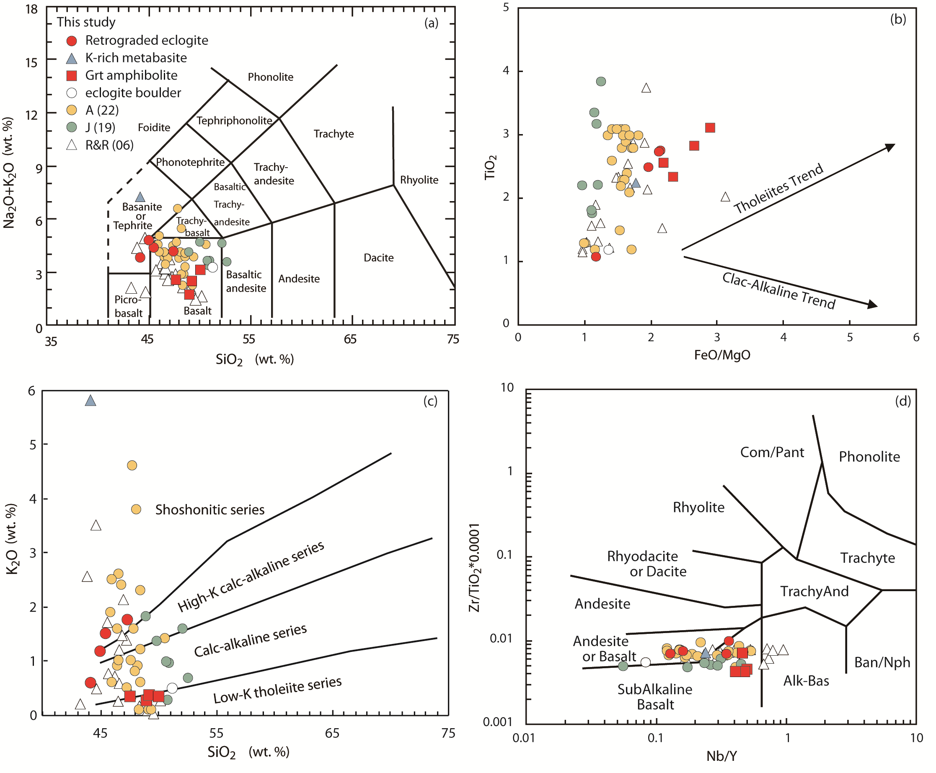
Supplementary Figures

Figure S1. Plots of (a) SiO₂ versus Na₂O+K₂O, (b) FeO/MgO versus TiO₂ (Miyashiro, 1974), (c) SiO₂ versus K₂O, and (d) Nb/Y versus Zr/TiO₂ × 0.0001 (Winchester & Floyd, 1976) for metabasites from Tso Morari area, NW India. A(22): Ahmad et al. (2022), J(19): Jonnalagadda et al. (2019), R&R(06): Rao & Rai (2006).

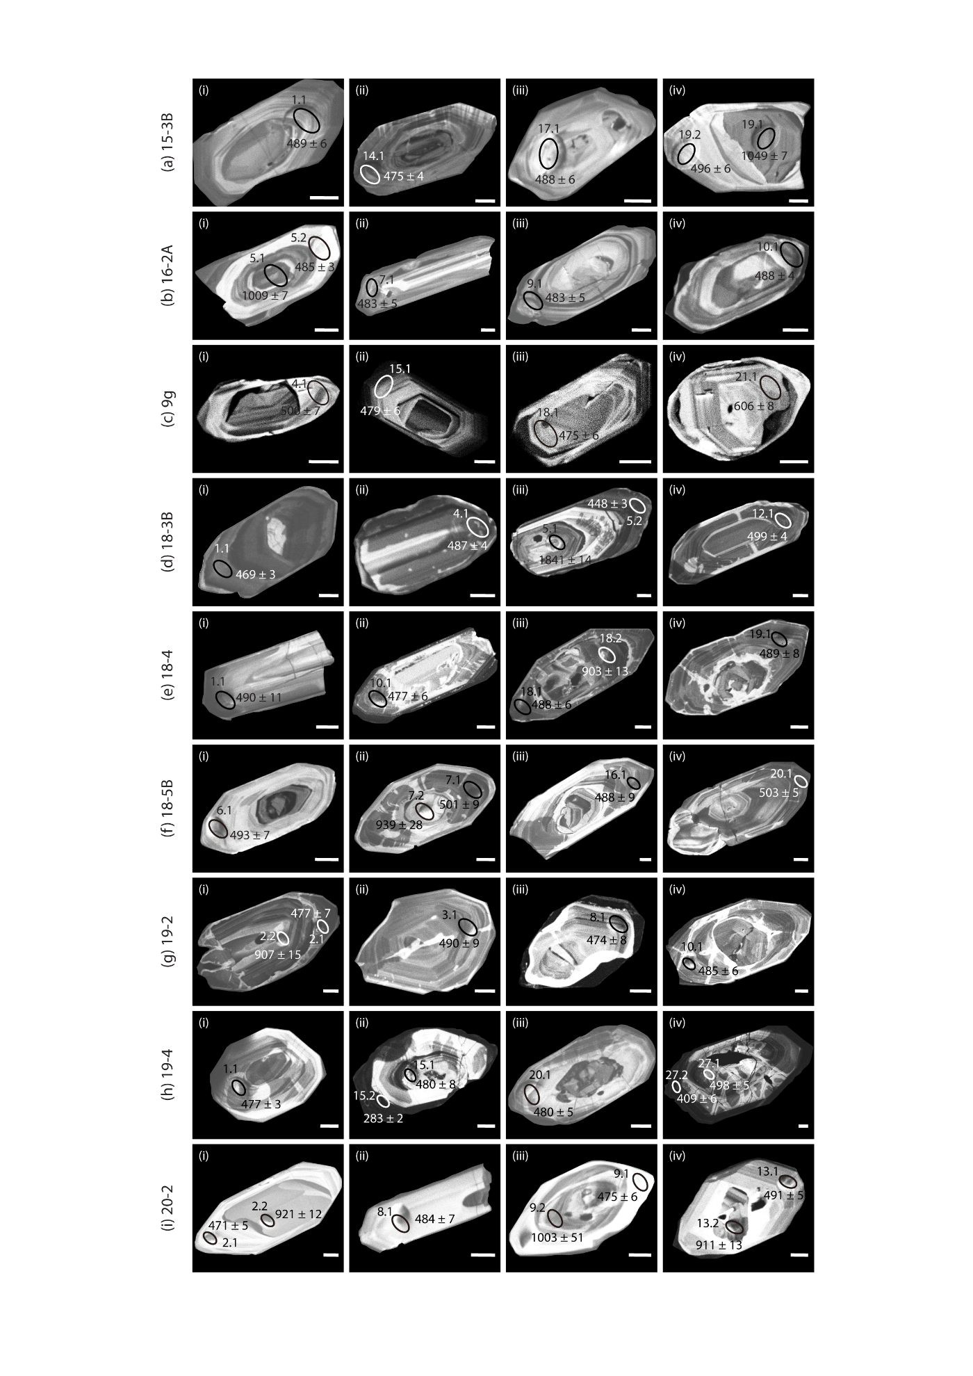
Figure S2. Representative cathodoluminescence images of dated zircon crystals in (a) Ph-Bt gneiss (15-3B), (b) Grt-Ph gneiss (16-2A), (c) Ph-Bt gneiss (9g), (d) Grt-Ph gneiss (18-3B), (e) Grt-Ph gneiss (18-4), (F) Ph-rich gneiss (18-5B), (g) Quartzofeldspathic gneiss (19-2), (h) Quartzofeldspathic gneiss (19-4), and (i) Grt amphibolite (20-2). The analysed spots are shown with the ²⁰⁶Pb/²³⁸U ages. The white bars below the zircons are 20 μm long.

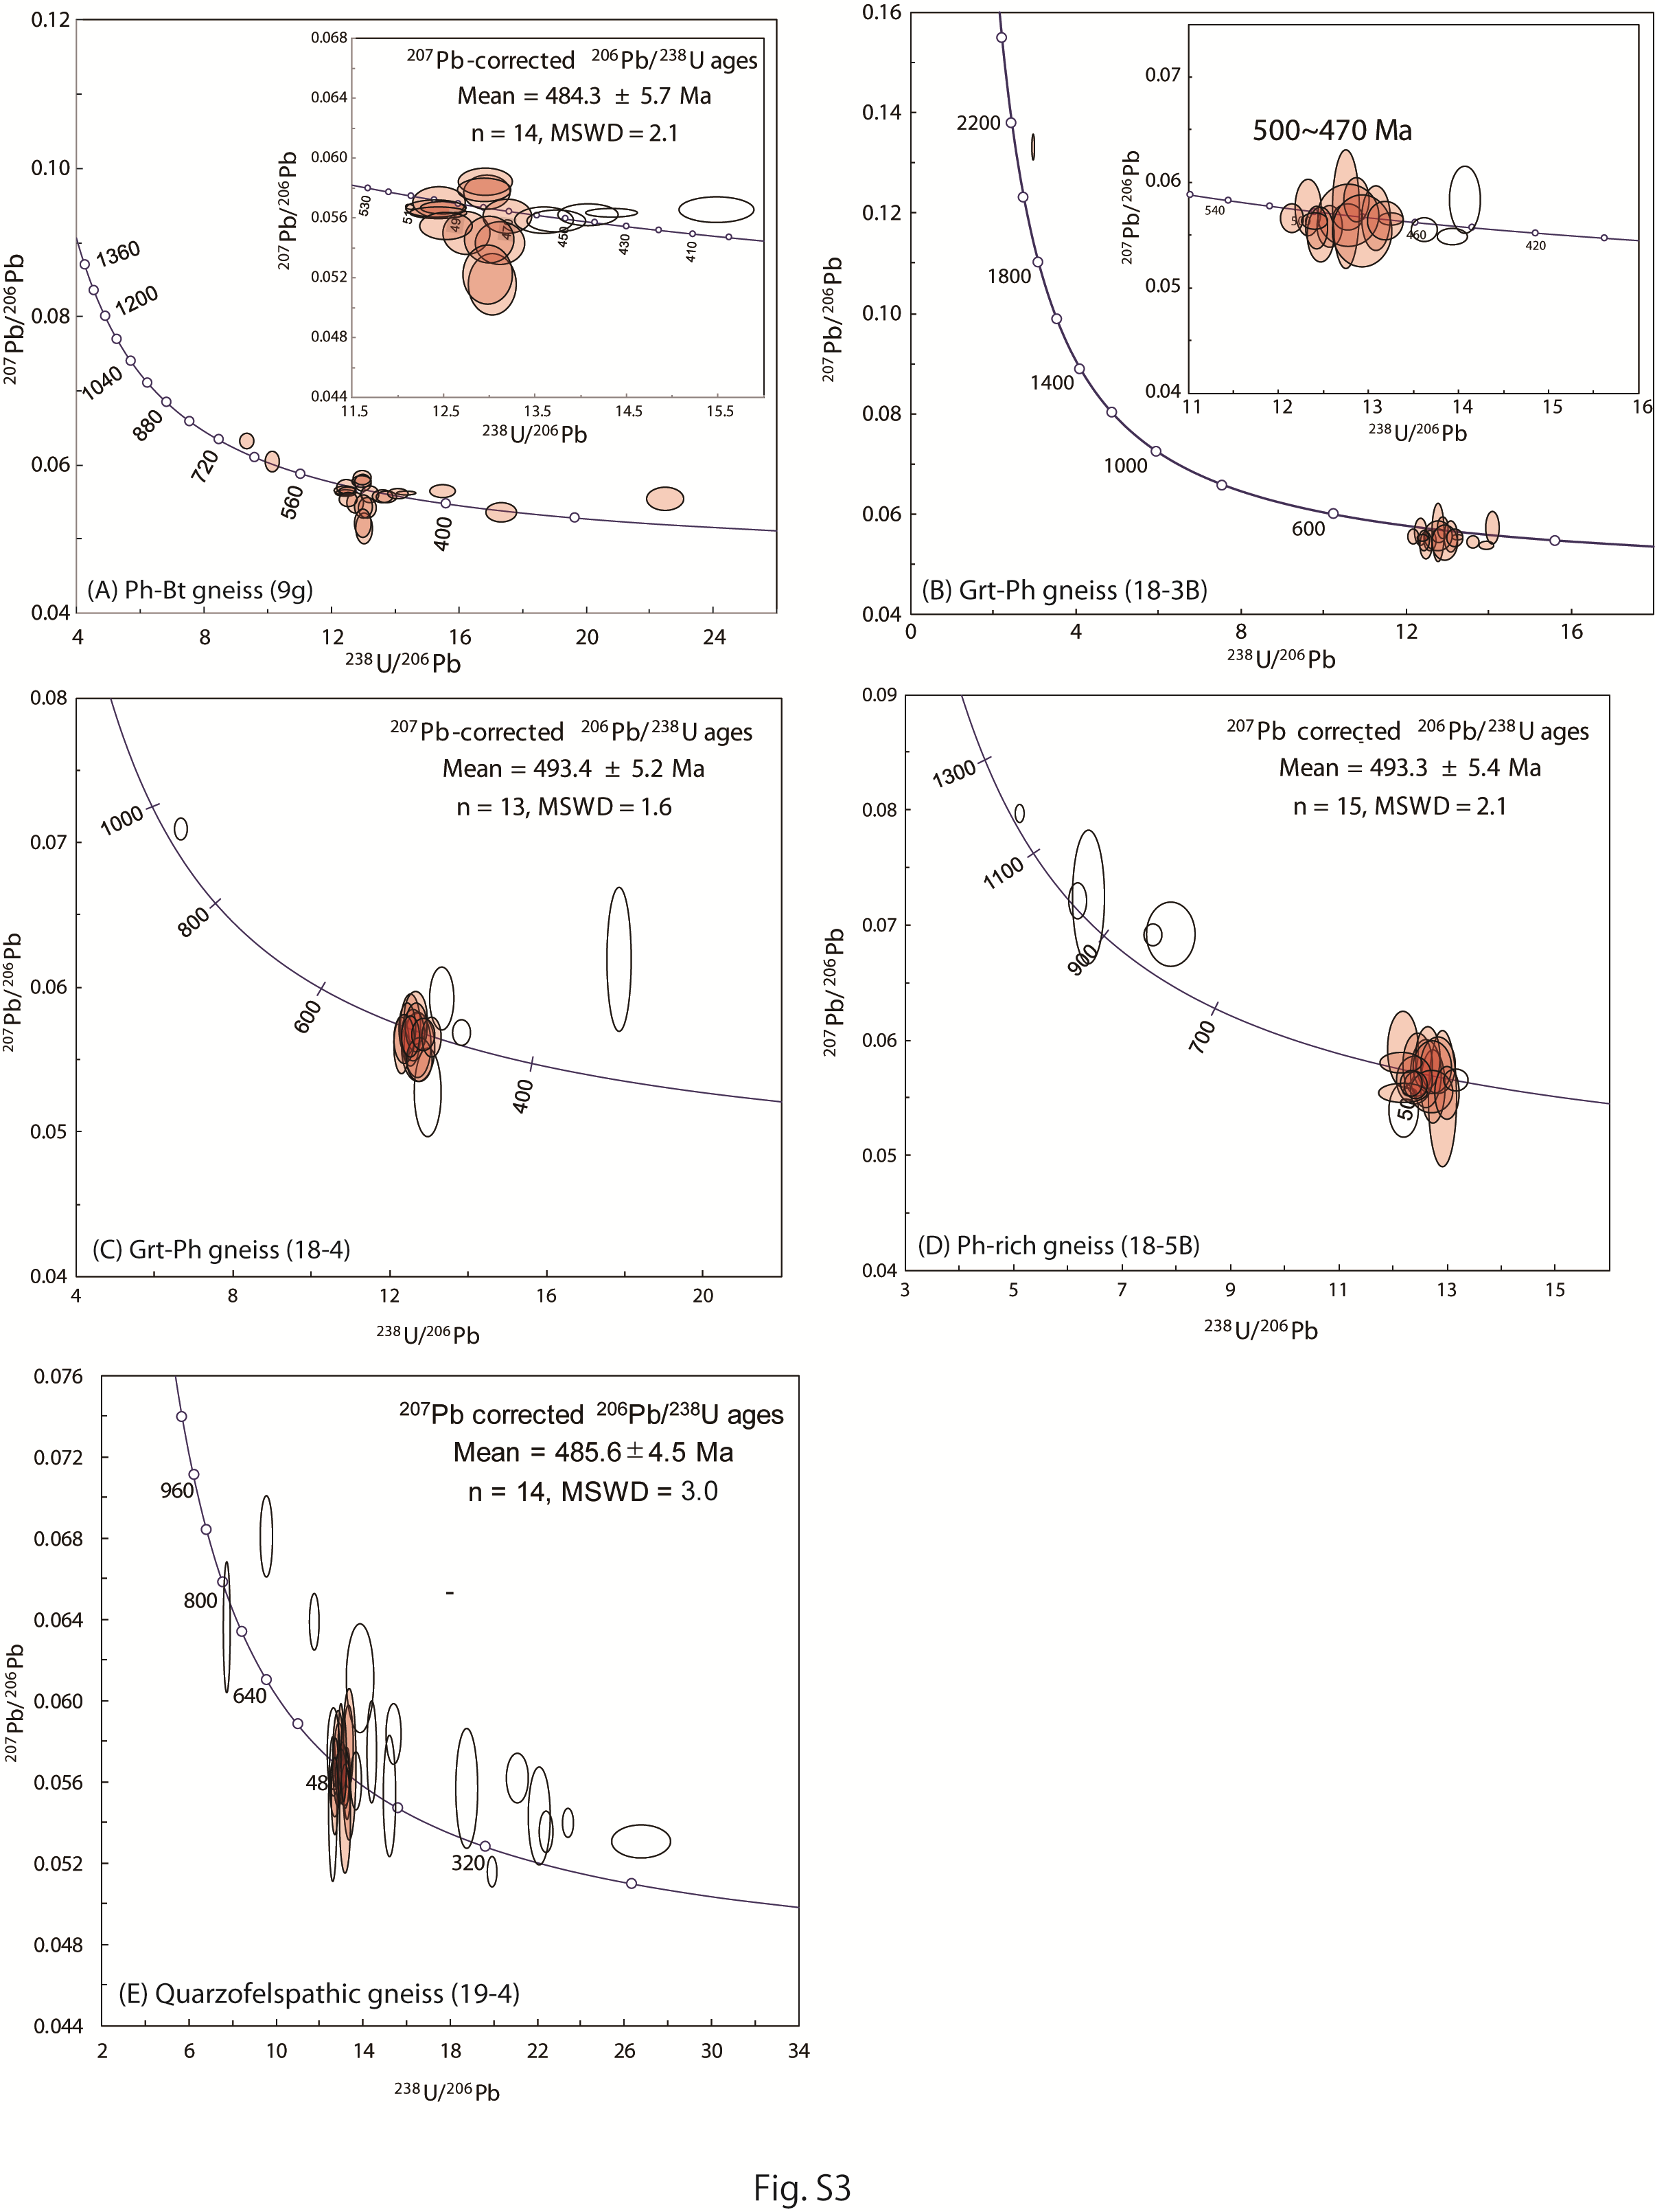

Figure S3. Concordia diagrams from the SHRIMP zircon U–Pb analyses of (a) Ph-Bt gneiss (9g), (b) Grt-Ph gneiss (18-3B), (c) Grt-Ph gneiss (18-4), (d) Ph-rich gneiss (18-5B), and (e) Quartzofeldspathic gneiss (19-4). All error ellipses and weighted mean ²⁰⁶Pb/²³⁸U ages are quoted at the 1σ and 2σ levels, respectively.

Supplementary Table
Table S1 Summary of the studied samples from the UHP Tso Morari complex
Sample | Rock type | Bulk | U-Pb | Location
Metabasites
15-1D | Retrograded eclogite | ○ |  | N33° 11' 00.6" / E78° 21' 44.0"
16-2B | Retrograded eclogite | ○ |  | N33° 04' 14.9" / E78° 16' 54.6"
17-6C | eclogite boulder | ○ |  | N33° 03' 28.6" / E78° 32' 82.3”
18-5A | K-rich metabasite | ○ |  | N33° 14' 43.4" / E78° 14' 70.5"
19-8B | Grt amphibolite | ○ |  | N33° 18' 47.6" / E77° 54' 71.1”
19-9A | Grt amphibolite | ○ |  | N33° 17' 29.7" / E77° 53' 69.0"
20-1B | Grt amphibolite | ○ |  | N33° 16' 97.5" / E77° 53' 12.3"
20-2 | Grt amphibolite | ○ | ○ | N33°16’31.9” / E77°52’29.8”
8-mafic | Retrograded eclogite | ○ |  | N33°14’93.5” / E78°35’78.0”
9-mafic | Retrograded eclogite | ○ |  | N33°11’86.2” / E78°33’54.0”
Gneisses
15-3B | Ph-Bt gneiss |  | ○ | N33° 08' 96.2" / E78° 21' 44.2"
16-2A | Grt-Ph gneiss |  | ○ | N33° 04' 14.9" / E78° 16' 54.6"
18-3B | Grt-Ph gneiss |  | ○ | N33°13’62.6” / E78°18’95.3”
18-4 | Grt-Ph gneiss |  | ○ | N33° 13' 61.8" / E78° 18' 31.2”
18-5B | Phe-rich gneiss |  | ○ | N33° 14' 43.4" / E78° 14' 70.5"
19-2 | Quartzofeldspathic gneiss |  | ○ | N33° 22' 34.5" / E78° 01' 09.4"
19-4 | Quartzofeldspathic gneiss |  | ○ | N33°23’10.3” / E77°56’44.2”
9g | Ph-Bt gneiss |  | ○ | N33°11’86.2” / E78°33’54.0”

References
Ahmad, T., Bhat, I.M., Tanaka, T., Bickle, M., Asahara, Y., Chapman, H. & Sachan, H.K. 2022. Tso Morari Eclogites, Eastern Ladakh: Isotopic and Elemental Constraints on Their Protolith, Genesis, and Tectonic Setting. The Journal of Geology 130(3), 231–252.
Ireland, T.R. & Williams, I.S. 2003. Considerations in Zircon Geochronology by SIMS. In Reviews in Mineralogy and Geochemistry (eds. J. M. Hanchar & P. W. O. Hoskin), pp. 215–241.
Jonnalagadda, M.K., Karmalkar, N.R. & Duraiswami, R.A. 2019. Geochemistry of eclogites of the Tso Morari complex, Ladakh, NW Himalayas: Insights into trace element behavior during subduction and exhumation. Geoscience Frontiers 10(3), 811–826.
Kinny, P.D., Compston, W. & Williams, I.S. 1991. A reconnaissance ion-probe study of hafnium isotopes in zircons. Geochimica et Cosmochimica Acta 55, 849–859.
Ludwig, K.R. 2012. Isoplot 3.75-4.15: A Geochronological Toolkit for Microsoft Excel. Berkeley Geochronology Center Special Publication, Berkeley, California.
Miyashiro, A. 1974. Volcanic rock series in island arcs and active continental margins. American Journal of Science 274(4), 321–355.
Paces, J.B. & Miller, J.D. 1993. Precise U-Pb ages of Duluth Complex and related mafic intrusions, northeastern Minnesota: Geochronological insights to physical, petrogenetic, paleomagnetic, and tectonomagmatic processes associated with the 1.1 Ga Midcontinent Rift System. Journal of Geophysical Research: Solid Earth 98(B8), 13997–14013.
Rao, D.R. & Rai, H. 2006. Signatures of rift environment in the production of garnet-amphibolites and eclogites from Tso-Morari region, Ladakh, India: A geochemical study. Gondwana Research 9(4), 512–523.
Stacey, J.S. & Kramers, J.D. 1975. Approximation of Terrestrial Lead Isotope Evolution by a Two-Stage Model. Earth and Planetary Science Letters 26, 207–221.
Sun, S. -s. & McDonough, W.F. 1989. Chemical and isotopic systematics of oceanic basalts: implications for mantle composition and processes. In Magmatism in the Ocean Basins. (eds. A. J. Saunder & M. J. Norry), pp. 313–345. Geological Society of London, Special Publications.
Williams, I.S. 1998. U-Th-Pb Geochronology by Ion Microprobe. In Applications of Microanalytical Techniques to Understanding Mineralizing Processes (eds. M. A. McKibben, W. C. Shanks III, & W. L. Ridley), pp. 1–36. Reviews in Economic Geology, Society of Economic Geologists.
Winchester, J.A. & Floyd, P.A. 1976. Geochemical magma type discrimination: application to altered and metamorphosed basic igneous rocks. Earth and Planetary Science Letters 28(3), 459–469.

