Jonas Tallberg, Thomas Sommerer, Theresa Squatrito and Christer Jönsson, ”Explaining the Transnational Design of International Organizations.” International Organization

Supplementary Online Appendix: Figures and Tables

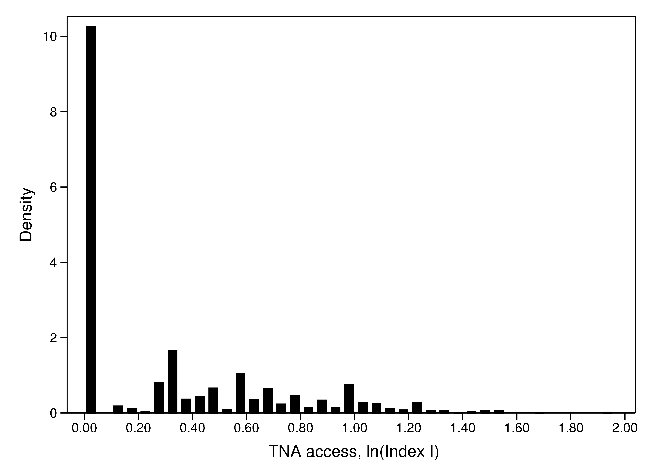

Figure A1. Distribution of TNA Access, (ln)Index

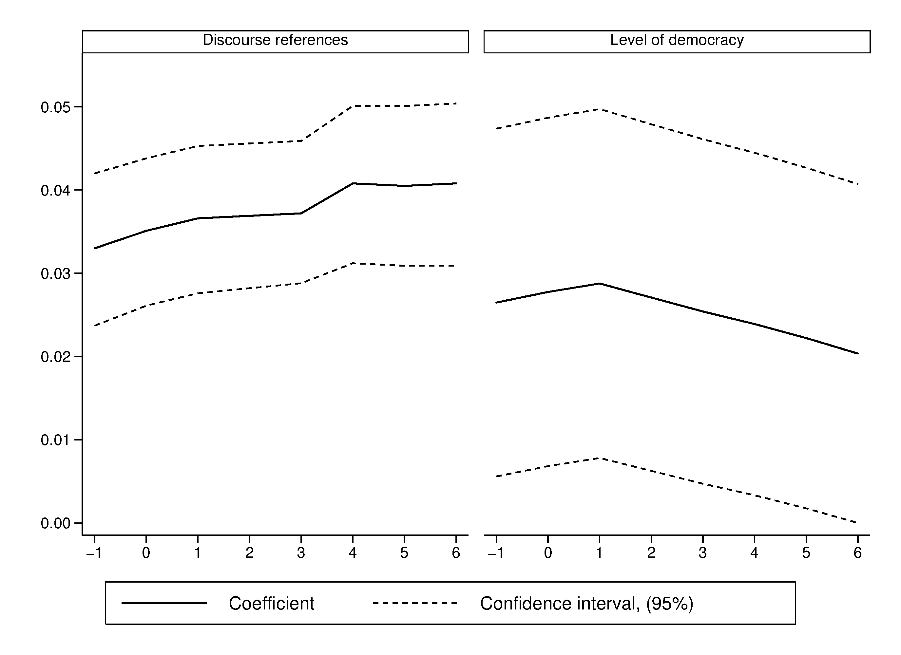

Figure A.2. Lag Effects on TNA Access (Index)

Table A.1. Descriptive Statistics
 | Observations | Mean | Std. Deviation | Minimum | Maximum
TNA Access, Index | 9007 | 0.4739 | 0.6966 | 0.0000 | 6.1000
Within IOs |  |  | 0.4712
Across IOs |  |  | 0.4352
TNA Access, Index (ln) | 9007 | 0.3046 | 0.3833 | 0.0000 | 1.9601
TNA Access, depth (ln) | 9007 | 0.2282 | 0.2833 | 0.0000 | 1.2238
TNA Access, range (ln) | 9007 | 0.2599 | 0.2926 | 0.0000 | 1.4816
TNA Access, Index (ln), >0 | 9007 | 0.3046 | 0.3833 | 0.0000 | 1.9601
Participatory discourse | 8411 | 1173.3010 | 1521.8070 | 0.0000 | 5010.0000
UN conferences | 8989 | 4.4610 | 4.5209 | 0.0000 | 15.3173
Protests against IO (ln) | 9007 | 0.7349 | 1.6180 | 0.0000 | 7.2731
Protests against similar IOs (ln) | 9007 | 3.8176 | 2.3060 | 0.0000 | 8.0240
Media coverage (ln) | 7871 | 2.9657 | 4.3863 | 0.0000 | 16.7362
Technical complexity | 9007 | 0.6726 | 0.8855 | 0.0000 | 2.0000
Local activity | 9007 | 0.2211 | 0.4964 | 0.0000 | 2.0000
Non-compliance incentives | 9007 | 0.1531 | 0.4782 | 0.0000 | 2.0000
Level of democracy | 8752 | 4.0994 | 4.8532 | -8.7500 | 10.0000
Decision-making | 9007 | 0.3658 | 0.4817 | 0.0000 | 1.0000
Security | 9007 | 0.0916 | 0.2885 | 0.0000 | 1.0000
IO budget | 8791 | 3.6263 | 2.5943 | -1.6094 | 8.8537
Affinity of member states | 8336 | -0.7439 | 0.1585 | -0.9887 | 0.0996
Democratic major power | 9007 | 0.3438 | 0.4750 | 0.0000 | 1.0000
TNA supply (ln) | 8894 | 6.2647 | 1.2964 | 2.1972 | 8.7587

Table A.2. Robustness Checks
 |  | 6 | 7 | 8 | 9 | 10 | 11 | 12 | 13
 |  | Logit, Openness ª |  |  | Count, Index ^{b} | OLS, Index ^{c} | Tobit, Index, IO-level^{d}
 |  | All | Before 1990 | After 1990 | All | All | All | Before 1990 | After 1990
Participatory discourse |  | 0.0002 | 0.0001 | 0.0002 | 0.0003 | 0.0001 | 0.0000 | 0.0003 | 0.0001
Participatory discourse |  | (2.50)* | (0.05) | (2.17)* | (4.44)** | (2.34)* | (1.57) | (0.55) | (2.15)*
UN conferences |  | 0.0044 | -0.0160 | 0.0033 | 0.0021 | -0.0022 | 0.0049 | 0.0008 | 0.0048
UN conferences |  | (0.31) | (0.30) | (0.30) | (0.29) | (0.51) | (1.65) | (0.16) | (1.57)
Protests against IO (ln) |  | 0.1028 | 0.8204 | 0.0468 | -0.0044 | 0.0127 | 0.0153 | 0.0939 | -0.0031
Protests against IO (ln) |  | (1.22) | (3.32)** | (0.57) | (0.08) | (1.01) | (0.85) | (1.86) | (0.17)
Protests against similar IOs (ln) |  | 0.0608 | 0.1911 | 0.0427 | 0.1335 | 0.0286 | 0.0193 | 0.0333 | 0.0297
Protests against similar IOs (ln) |  | (0.97) | (1.60) | (0.58) | (2.85)** | (2.85)** | (1.15) | (1.78) | (1.50)
Media coverage (ln) |  | -0.0181 | -0.0501 | -0.0029 | 0.0839 | 0.0100 | -0.0040 | -0.0117 | 0.0177
Media coverage (ln) |  | (0.46) | (0.99) | (0.07) | (2.11)* | (1.37) | (0.18) | (0.60) | (0.57)
Technical complexity |  | -0.0230 | -0.1002 | 0.0341 | -0.1463 | -0.0332 | -0.1409 | -0.1568 | -0.1163
Technical complexity |  | (0.13) | (0.41) | (0.19) | (0.94) | (1.20) | (1.56) | (1.56) | (1.14)
Local activity |  | 0.1382 | -0.9106 | 0.6128 | 0.4611 | 0.0704 | 0.0926 | -0.1882 | 0.2492
Local activity |  | (0.58) | (2.15)* | (2.28)* | (2.93)** | (1.83) | (0.57) | (1.08) | (1.46)
Non-compliance incentives |  | 0.5756 | 0.0799 | 0.8497 | 0.5201 | 0.1681 | 0.2703 | 0.3435 | 0.2901
Non-compliance incentives |  | (2.25)* | (0.21) | (2.82)** | (3.70)** | (3.62)** | (1.79) | (1.34) | (1.97)*
Level of democracy |  | 0.1020 | 0.1394 | 0.1000 | 0.1094 | 0.0165 | 0.0194 | 0.0165 | 0.0215
Level of democracy |  | (3.84)** | (3.39)** | (3.44)** | (4.31)** | (4.55)** | (2.85)** | (2.15)* | (2.95)**
Decision-making |  | -0.6004 | -1.3030 | -0.2294 | -0.5623 | -0.0990 | -0.5799 | -0.7645 | -0.2835
Decision-making |  | (1.66) | (2.48)* | (0.65) | (1.67) | (1.78) | (2.43)* | (3.10)** | (1.02)
Security |  | -2.1581 | -3.8866 | -1.8524 | -1.4724 | -0.3180 | -0.5013 | -0.4842 | -0.4845
Security |  | (3.40)** | (1.82) | (3.83)** | (2.55)* | (5.27)** | (3.32)** | (2.43)* | (3.20)**
IO budget |  | 0.1587 | -0.0002 | 0.1347 | 0.0449 | 0.0156 | 0.0118 | -0.0127 | 0.0058
IO budget |  | (2.23)* | (0.00) | (1.96)* | (0.90) | (1.51) | (0.57) | (0.60) | (0.24)
Affinity of member states |  | -0.7113 | -0.3727 | -1.0834 | -0.4737 | -0.1378 | 0.0041 | 0.0098 | -0.0412
Affinity of member states |  | (0.83) | (0.25) | (1.37) | (1.28) | (1.11) | (0.02) | (0.04) | (0.18)
Democratic major power |  | 0.2215 | 1.4230 | -0.2096 | 0.0963 | 0.0383 | -0.0216 | 0.0898 | -0.0753
Democratic major power |  | (0.74) | (2.90)** | (0.70) | (0.43) | (0.83) | (0.26) | (1.02) | (0.82)
TNA supply (ln) |  | 0.1382 | -0.2258 | 0.4102 | -0.2361 | -0.0286 | 0.0344 | 0.0272 | 0.0184
TNA supply (ln) |  | (0.80) | (0.94) | (2.11)* | (1.85) | (1.04) | (0.71) | (0.54) | (0.30)
Constant |  | -2.6902 | -0.1322 | -4.8565 | -2.1839 | 0.0549 | 0.0497 | 0.2852 | -0.1405
Constant |  | (2.40)* | (0.08) | (3.57)** | (2.83)** | (0.36) | (0.14) | (0.71) | (-0.32)
N |  | 6,786 | 2,316 | 4,470 | 6,780 | 6,786 | 1,425 | 546 | 879
Wald Chi2 |  | 88.47 | 67.82 | 97.38 | 250.99 |  | 111.82 | 82.36 | 121.49
Log pseudolikelihood |  | -3,893.15 | -1,178.26 | -2,511.25 | -3,677.97 |  | -400.93 | -103.60 | -219.08
R2 |  |  |  |  |  | 0.29
* p<0.05; ** p<0.01 ª Logistic regression of binary dependent variable (open/not open) ^{b} Negative binomial regression (nbreg) with count version of the index as dependent variable with a five-stage scale from 0 to 4. ^{c} OLS regression with year fixed-effects ^{d} Tobit regression (intreg, STATA 11) at IO level. Estimations clustered by panel identifier (IO body). Robust standard errors are used to compute Z statistics in all regressions.

Table A.3. Effects of World Regions and Policy Areas
 | 14 | 15
 | Tobit, Index | Tobit, Indexª
Africa | -0.3370 | -0.1138
 | (2.97)** | (0.81)
Americas | -0.0234 | 0.1045
 | (0.26) | (0.96)
Asia | -0.2481 | -0.1934
 | (2.32)* | (1.76)
Europe | 0.0134 | 0.0340
 | (0.15) | (0.33)
Commodities | -0.0198 | 0.0412
 | (0.15) | (0.29)
Social affairs | 0.0210 | 0.1572
 | (0.20) | (1.44)
Development | -0.1962 | -0.1760
 | (1.18) | (1.25)
Environment | -0.1186 | -0.0866
 | (0.98) | (0.78)
Finance | -0.6690 | -0.6313
 | (4.06)** | (4.38)**
Human rights | 0.6991 | 0.4055
 | (6.86)** | (3.04)**
Security | -0.6297 | -0.6745
 | (3.83)** | (3.98)**
Technology | -0.2189 | -0.0696
 | (1.67) | (0.56)
Trade | -0.0413 | -0.1381
 | (0.39) | (1.39)
Participatory discourse |  | 0.0001
 |  | (3.56)**
Local activity |  | 0.1275
 |  | (2.11)*
Non-compliance incentives |  | 0.1277
 |  | (2.14)*
Level of democracy |  | 0.0204
 |  | (2.21)*
IO budget |  | 0.0392
 |  | (2.36)*
Constant | 0.2344 | -0.2394
 | (2.77)** | (-0.69)
Wald Chi2 | 139.88 | 254.66
Log pseudolikelihood | -7,079.61 | -4,571.44
N | 9,007 | 6,786
* p<0.05; ** p<0.01 Tobit regression (intreg, STATA 11). Estimations clustered by panel identifier (IO body). Robust standard errors are used to compute Z statistics in all regressions. ª Only significant covariates from Model 1 shown.

