Supplementary material
Table S1. Primer sequence of quantitative real-time PCR.
Target taxon | Primer Sequences | Length (bp) |  | Reference
total bacteria | F: 5'-CGG CAA CGA GCG CAA CCC-3' |  | 130 | Denman and McSweeney, 2006
 | R: 3'-CCA TTG TAG CAC GTG TGT AGC C-5'
total methanogens | F: 5'-CCG GAGA TGG AAC CTG AGA C-3' |  | 160 | Zhou et al., 2009
 | R: 3'-CGG TCT TGC CCA GCT CTT ATT-5'
Methanobacteriales | F: 5'-CGW AGG GAA GCT GTT AAG T-3' |  | 343 | Yu et al., 2005
 | R: 3'-TAC CGT CGT CCA CTC CTT-5'
Methanomicrobiales | F: 5'-ATC GRT ACG GGT TGT GGG-3' |  | 506 | Yu et al., 2005
 | R: 3'-CAC CTA ACG CRC ATH GTT TA C-5'
Methanococcales | F: 5'-TAA GGG CTG GGC AAG T-3' |  | 337 | Yu et al., 2005
 | R: 3'-CAC CTA GTY CGC ARA GTT TA-5'
mcrA gene | F: 5'-TTC GGT GGA TCD CAR AGR GC-3' |  | 140 | Denman and McSweeney, 2006
 | R: 3'-GBA RGT CGW AWC CGT AGA ATC C-5'
¹ F, forward primer; R, reverse primer.
Fig S1. In vitro dry matter disappearance (IVDMD, a) and cumulative gas production (b) of a hay-rich feed incubated with rumen fluids at the present of nitroethane (NE), 2-nitroethanol (NEOH) and 2-nitro-1-propanol (NPOH). Effect of nitrocompounds on IVDMD was not significant at P = 0.210, but the effect of nitrocompounds on gas production was significant at P < 0.001.

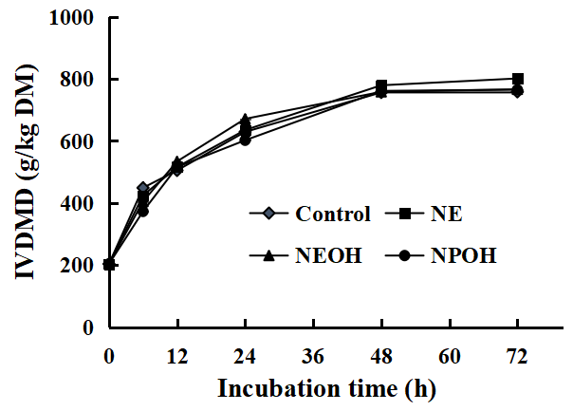 | 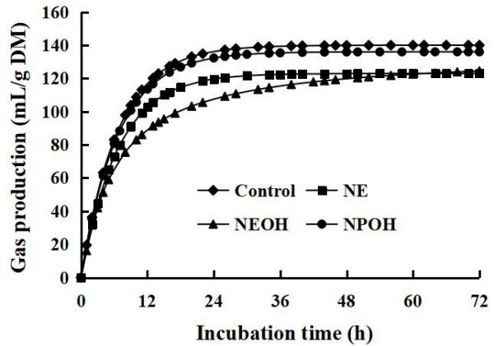
(a) | (b)

Fig S2. The concentrations of acetate (a), propionate (b), butyrate (c), and branched chain VFA (d) of a hay-rich feed incubated with rumen fluids at the present of nitroethane (NE), 2-nitroethanol (NEOH) and 2-nitro-1-propanol (NPOH). Effect of nitrocompounds was significant at P <0.001.
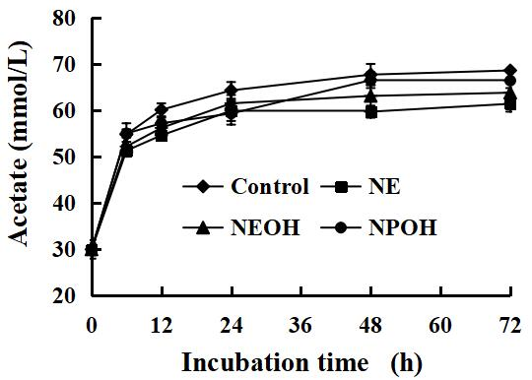 | 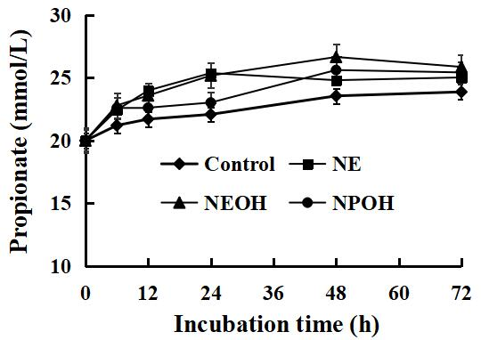
(a) | (b)
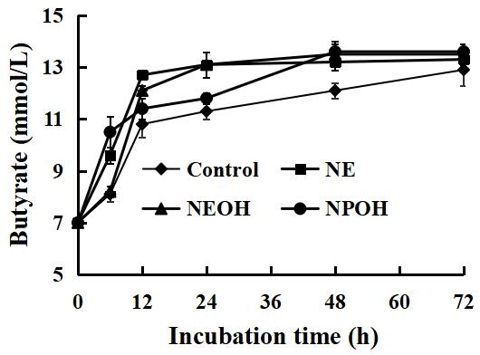 | 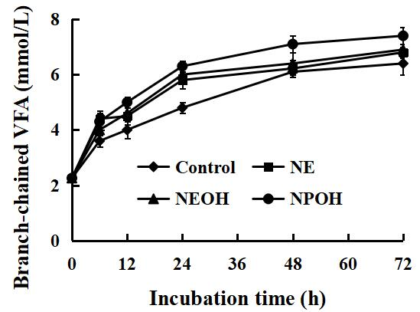
(c) | (d)

