Supplemental Materials
Dynamics of Red Blood Cells in Oscillating Shear Flow
Daniel Cordasco and Prosenjit Bagchi

- Influence of domain size

The influence of domain size is tested by doubling the domain size in all three directions. The following figures S1(a)—(d) present four cases selected from different regimes of the cell dynamics as described in the text. In these figures, the solid lines denote the original domain, and the dashed lines the increased domain. For the regular periodic dynamics as shown in (a)—(c), there is nice agreement in the results of the two domains. For the chaotic dynamics shown in (d), both the original and increased domains show similar chaotic behavior. (Note in the chaotic dynamics, the trajectories in the two domains would not coincide).

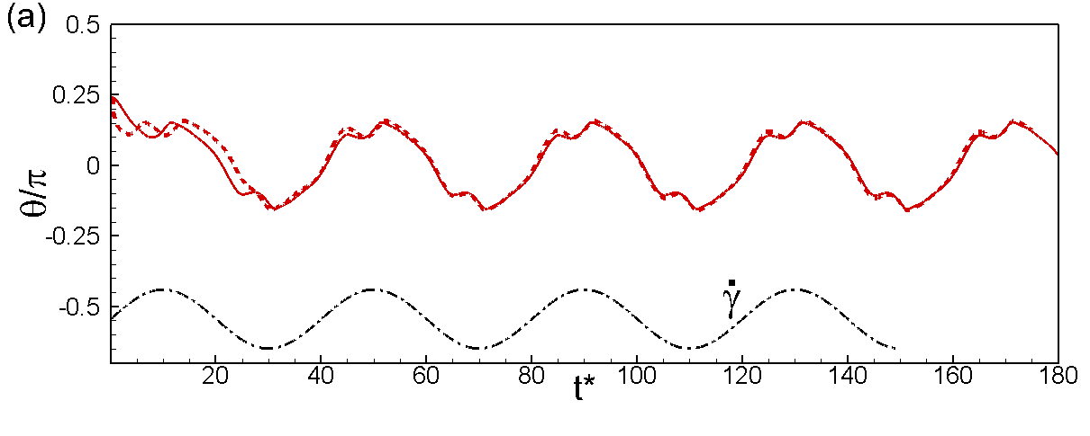
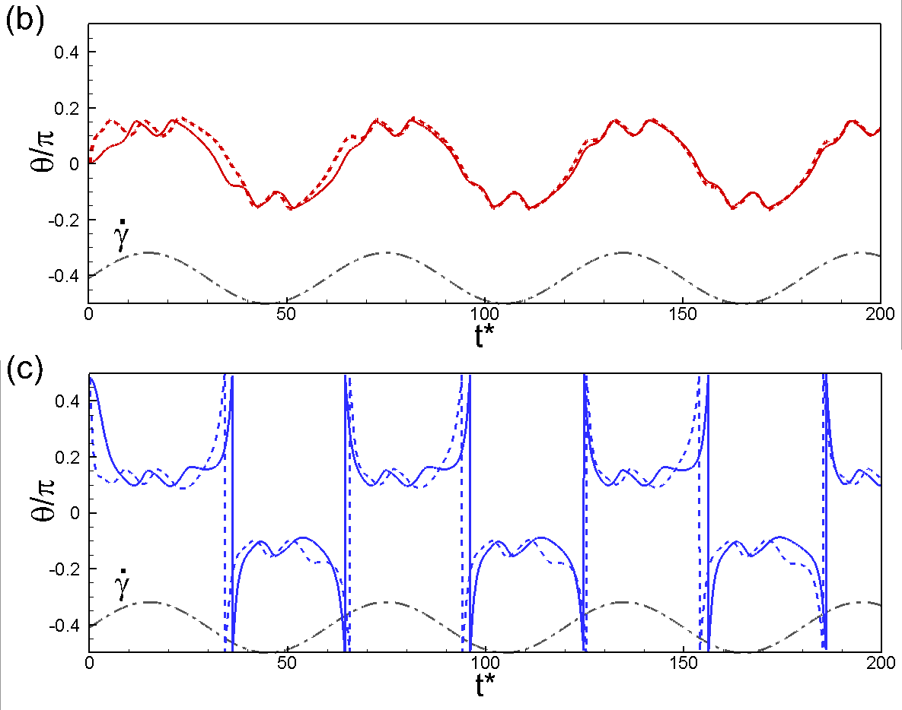
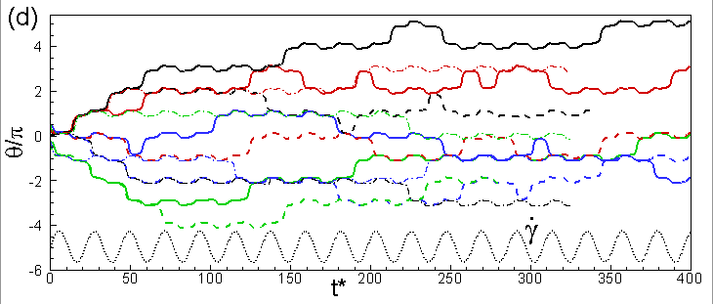

Figure S1. Influence of domain size. Solid lines for original domain of $(2πa)^{3}$ and the dashed lines are for an increased domain of $(4πa)^{3}$. (a) H-entrainment $1/ν=\text{40}$, (b,c) HR and VR at $1/ν=\text{60}$, (d) chaotic dynamics $1/ν=\text{22}$.

- Oblate and Spherical Capsule Dynamics
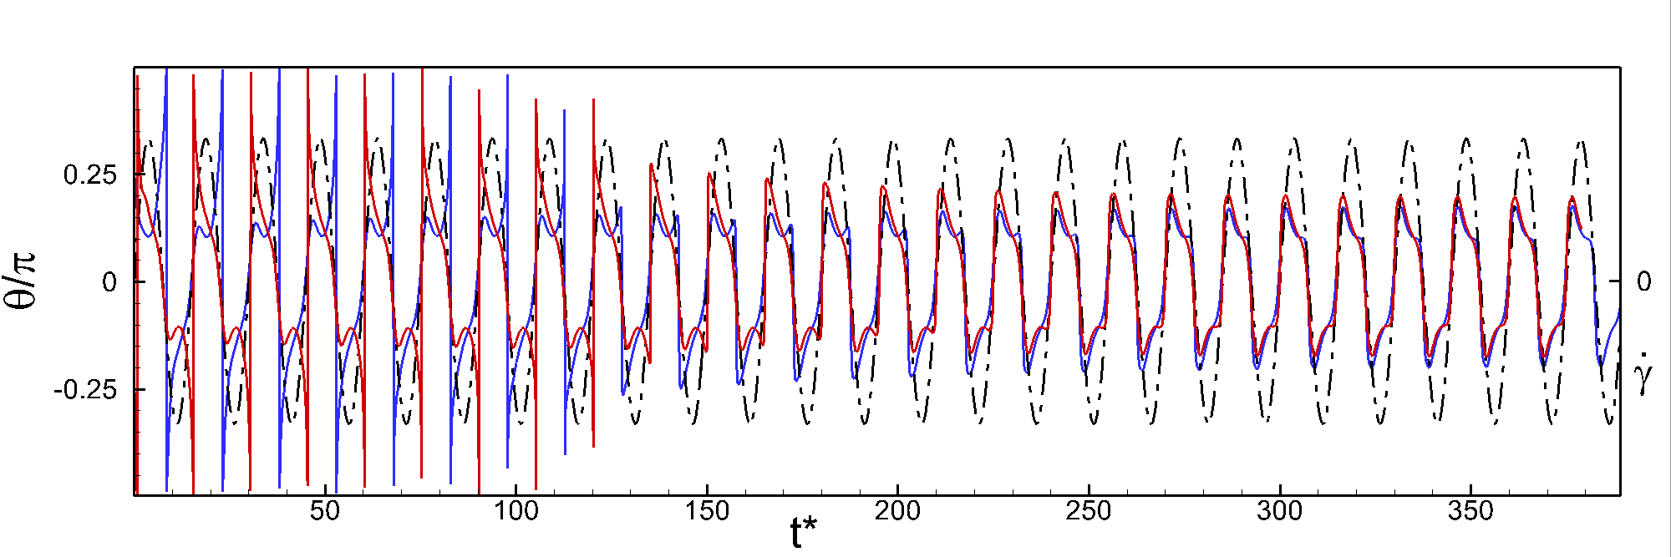

Figure S2. Horizontal entrainment of oblate capsule. $V_{0}=0\text{.}\text{872}$, $λ=0\text{.}1$, Ca=0.2, $1/ν=\text{15}$, $θ_{o}=π/4$(red), $θ_{o}={−π}/4$(blue). Black dash-dot is the shear rate.
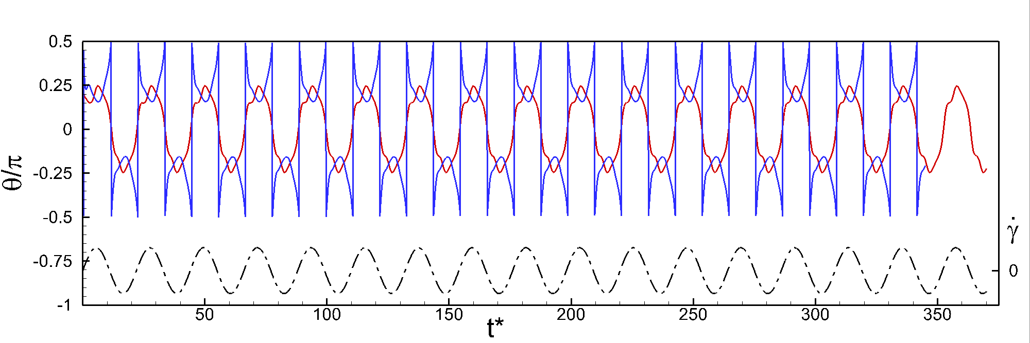

Figure S3. Stable horizontal and vertical reversals. $V_{0}=0\text{.}\text{965}$, $λ=0\text{.}1$, Ca=0.2, $1/ν=\text{22}$, $θ_{o}=π/4$(red), $θ_{o}={−π}/4$(blue).
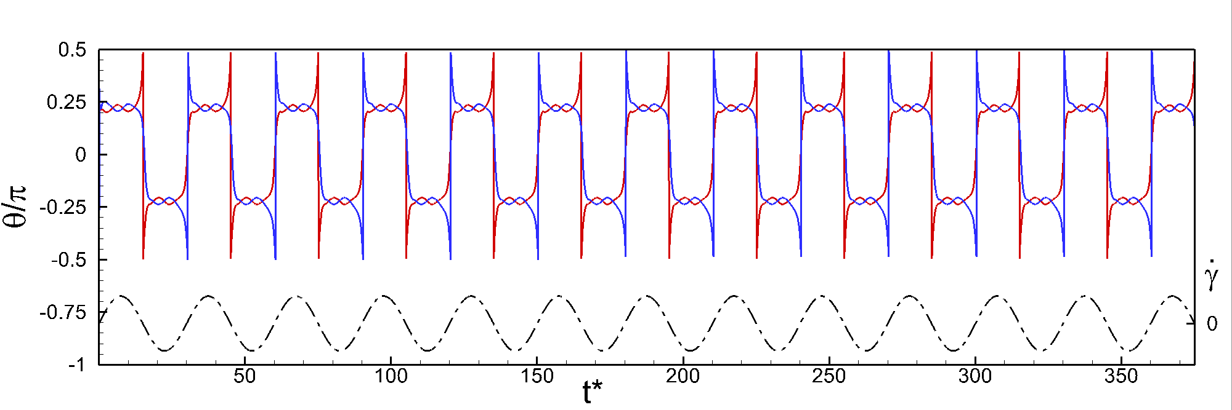

Figure S4. Stable horizontal and vertical reversals. $V_{0}=0\text{.}\text{997}$, $λ=0\text{.}1$, Ca=0.2, $1/ν=\text{30}$, $θ_{o}=π/4$(red), $θ_{o}={−π}/4$(blue).
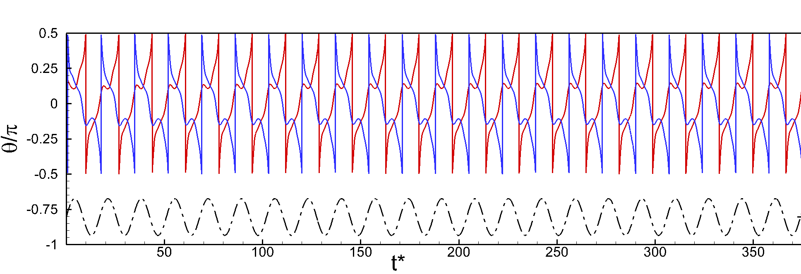

Figure S5. Unidirectional, continuous tumbling. $V_{0}=0\text{.}\text{872}$, $λ=0\text{.}1$, Ca=0.2, $1/ν=\text{17}$, $θ_{o}=π/4$(red), $θ_{o}={−π}/4$(blue).

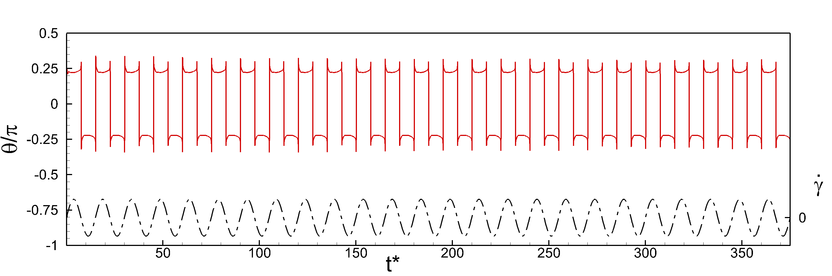
Figure S6. Stable vertical reversals for spherical capsules. $V_{0}=1$, $λ=0\text{.}1$, Ca=0.2, $1/ν=\text{15}$, $θ_{o}=π/4$(red).

3. Effect of Stress-free Configuration

We have also extended our study to a red blood cell in which the resting biconcave shape (BCSF; reduced volume ~ 0.644) is stress-free. We observe all the same types of dynamics independent of RBC stress-free configuration, namely, regular HR and VR, entrainment, and chaotic dynamics as shown in Figures S7—S9 below.
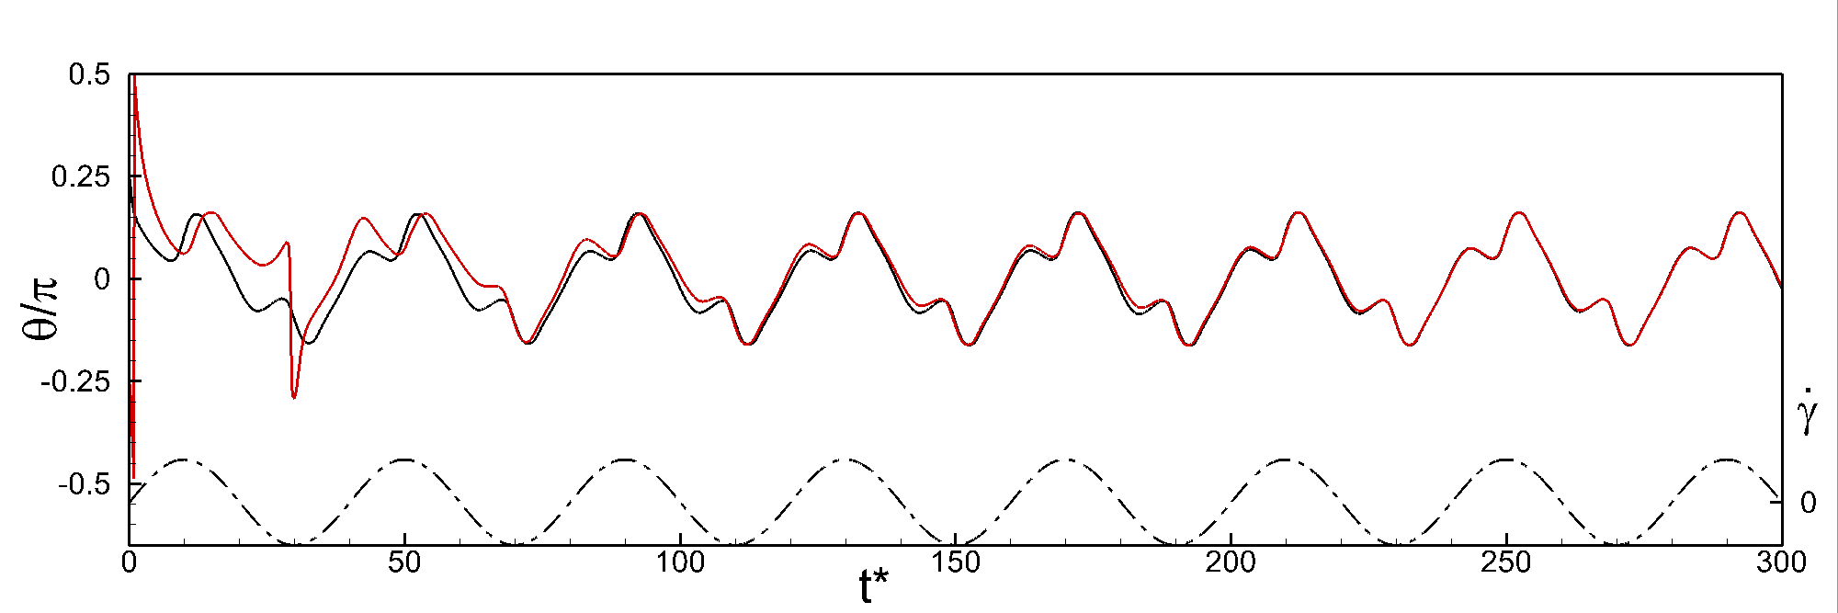
Figure S7. Horizontal entrainment for a BCSF RBC. $λ=0\text{.}1$, Ca=0.2, $1/ν=\text{40}$, $θ_{o}=π/4$(black), $θ_{o}={−π}/4$(red).
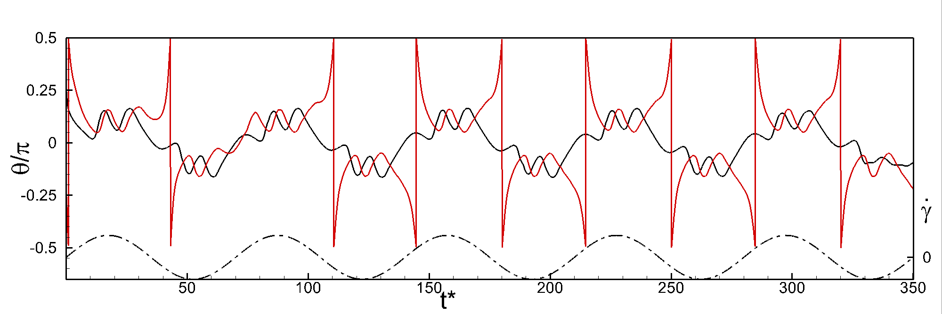
Figure S8. Horizontal and vertical reversals for a BCSF RBC. $λ=0\text{.}1$, Ca=0.2, $1/ν=\text{70}$, $θ_{o}=π/4$(black), $θ_{o}={−π}/4$(red).
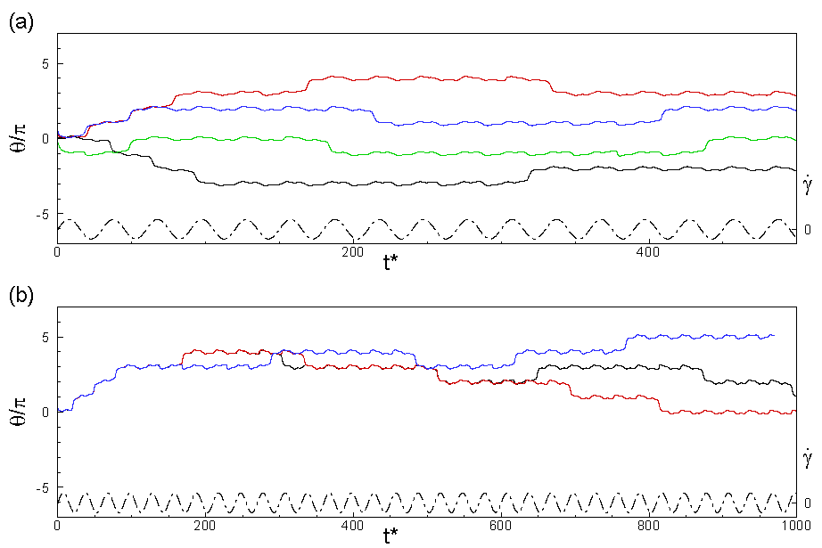
Figure S9. Chaotic trajectories for BCSF RBC. (a) $θ_{o}=0$ (black), $θ_{o}=π/4$ (red), $θ_{o}=π/2$(green) $θ_{o}={−π}/4$ (blue); (c) shows the slow divergence of RBCs started from very close initial orientations $θ_{o}=\text{44}π/{\text{180}}$ (black), $θ_{o}=\text{45}π/{\text{180}}$ (red), $θ_{o}=\text{46}π/{\text{180}}$(blue); $λ=0\text{.}1$, Ca=0.2, $1/ν=\text{30}$.

4. Deformation Contour Plot

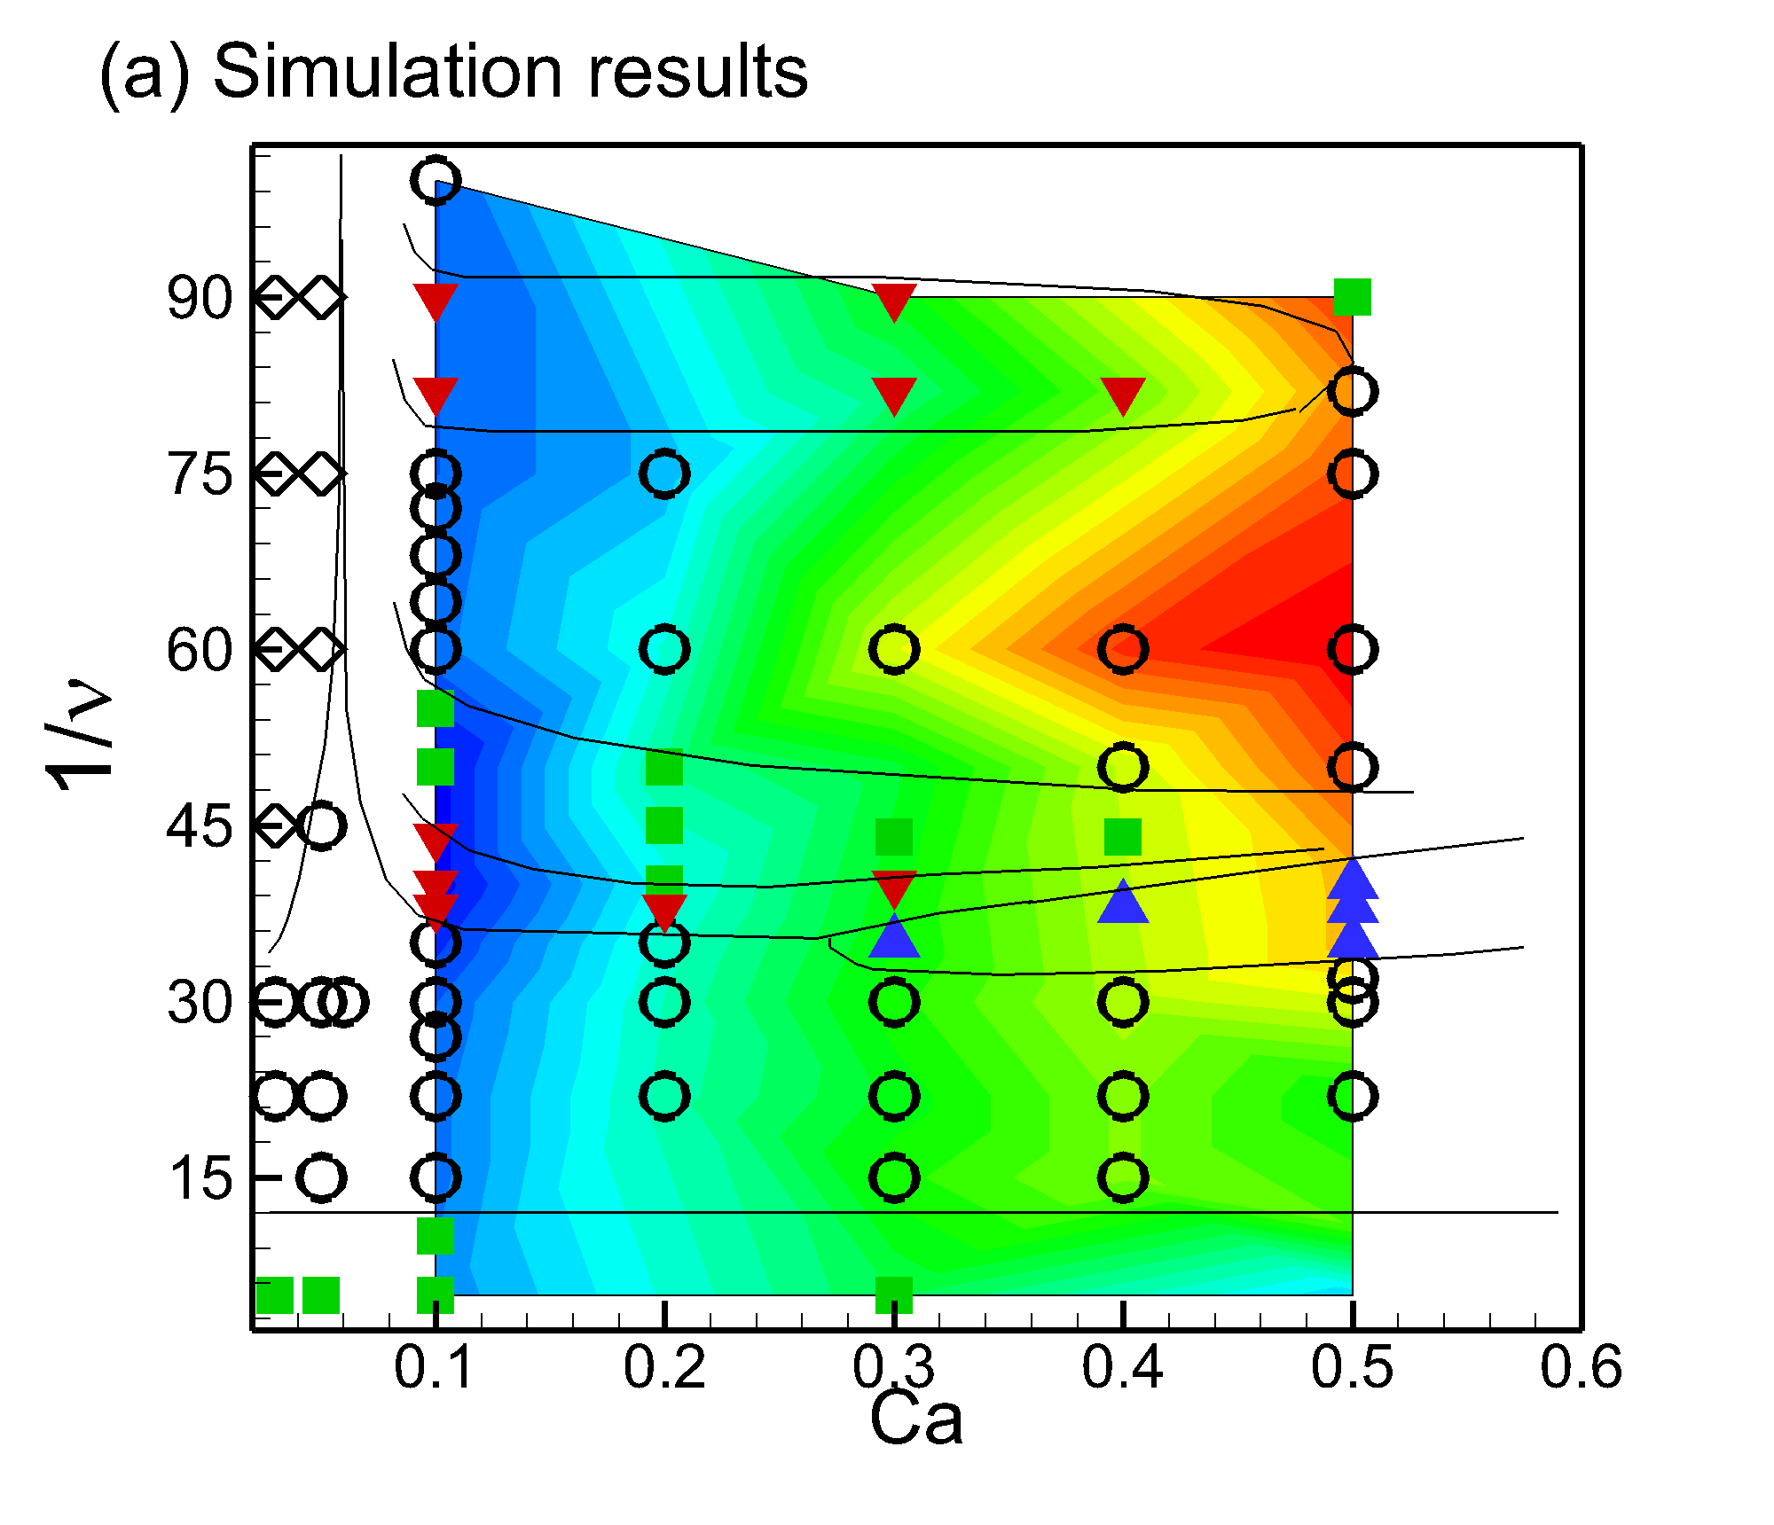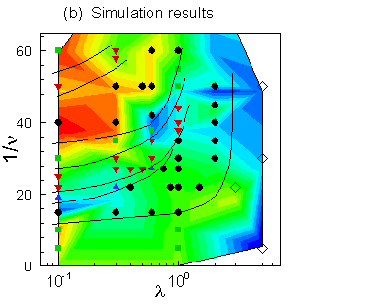
Figure S10. Average deformation $D_{\text{13}}>$ plotted as a 2D contour for H reversals on top of figures 14 and 16 in the main text. (a) Ca—ν space. The contour range is 0.005 (blue)—0.045 (red). (b) λ—ν space. The contour range is 0 (blue)—0.016 (red). The nonmonotonic trend in $D_{\text{13}}>$ with increasing Ca at high frequency as shown in Figure 21 of the manuscript is not as prominently displayed in the contour plot. It does appear that there is a significant decrease in $D_{\text{13}}>$ for RBCs undergoing chaotic H reversals at low frequency compared to regular H entrainment reversals (compare Ca=0.3 at $1/υ=\text{60}$with $1/υ=\text{90}$). This is due to the lower $D_{\text{13}}^{\text{min}}$undershoot which occurs during chaotic reversals when compared with H entrainment.

5. Simulations over extended time

Figure S11 shows several simulations over extended time (t* > 800) for the chaotic cases. It is evident that chaos is preserved over long time. For Ca=0.1, and $λ=0\text{.}1$, a simulation time of t*=800 implies a real time of 800 seconds, which is quite long when compared to the experimental data of DAV. This confirms that chaos persists in our simulations for a long time.

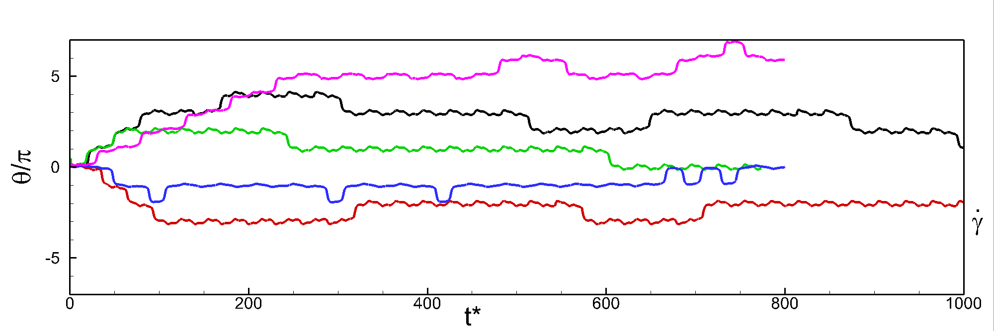

Figure S11. Simulations over extended time: chaotic simulations. BCSF $λ=0\text{.}1$, Ca=0.2, $1/ν=\text{30}$$θ_{o}=\text{44}π/{\text{180}}$(black), BCSF $λ=0\text{.}1$, Ca=0.2, $1/ν=\text{30}$(red), BCSF $λ=0\text{.}1$, Ca=0.2, $1/ν=\text{30}$ (green), SSF $λ=0\text{.}1$, Ca=0.1, (magenta), SSF , Ca=0.1, (blue).

Figure S12 shows long time simulations for periodic dynamics. Here also we simulate up to t*> 800 and see that the periodic behavior is stable over such a long time. Together, figures S11 and S12 confirm that the dynamical regimes observed in our simulations do not change over long time.
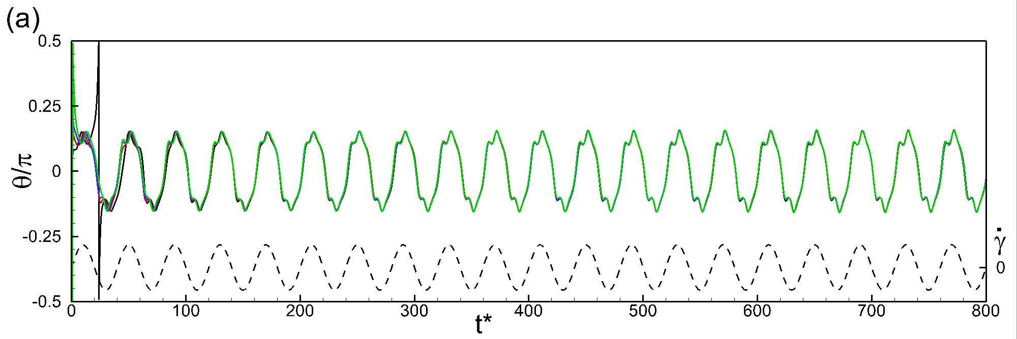
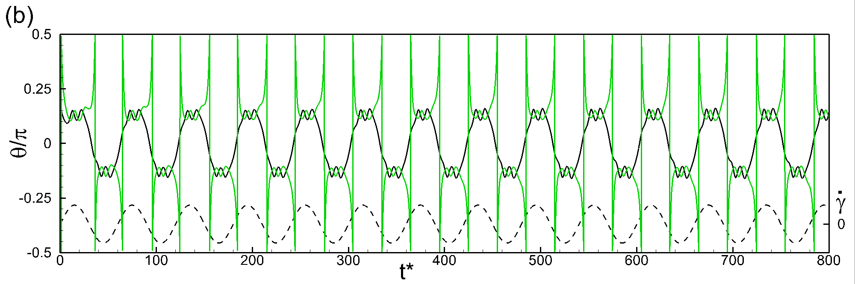

Figure S12. Longer duration simulations of periodic dynamics. (a) horizontal entrainment case $λ=0\text{.}1$, Ca=0.1, $1/ν=\text{40}$. The RBCs stay fully entrained for the duration of the simulation and do not show any indication of irregular or chaotic behavior. (b) horizontal and vertical reversals $λ=0\text{.}1$, Ca=0.1, $1/ν=\text{60}$. $θ_{o}=0$ (black), $θ_{o}=π/4$ (red), $θ_{o}=π/2$(blue) $θ_{o}={−π}/4$ (green) for all.

6. Additional analysis with oblate capsules

As noted before in section 3, simulations are performed with initially oblate capsules with reduced volume 0.997, 0.987, 0.965, 0.931, 0.872, 0.788, 0.766 and 0.644, the last one being that of an RBC but the shape is an oblate. The table below (TABLE 1) presents the amount of membrane rotation Δφ during one half cycle. For all cases, Ca = 0.2, λ=0.1 and 1/ν=25.
The results suggest for larger reduced volume, the amount of membrane rotation is much larger than π, and as the reduced volume approaches that of the RBC, the amount of membrane rotation approaches π.

Reduced volume | Δφ (in degree)
0.997 | 212.6º
0.987 | 204º
0.965 | 198.2º
0.931 | 192.4º
0.872 | 189.2º
0.788 | 185.7º

TABLE 1. Membrane rotation Δφ in one half-period as a function of oblate’s reduced volume. Ca = 0.2, λ=0.1, 1/ν = 25.

As noted in section 3, chaotic dynamics is no observed for oblate capsules for reduced volumes as low as 0.766. Specifically, for reduced volumes 0.997 to 0.965, only periodic dynamics is observed. For reduced volumes 0.872 to 0.766, a unidirectional flipping motion is also observed in addition to periodic dynamics (depending on the initial condition). These results were shown previously in figures S2—S6.

The figure S13 below shows the dynamics for an oblate capsule for the reduced volume of 0.644, which is the same reduced volume as that of an RBC. Now we see that the dynamics is characterized by irregular swinging, and tumbling, which is the hallmark of the chaos. As the excess area of the oblate approaches that of the RBC, chaos appears.
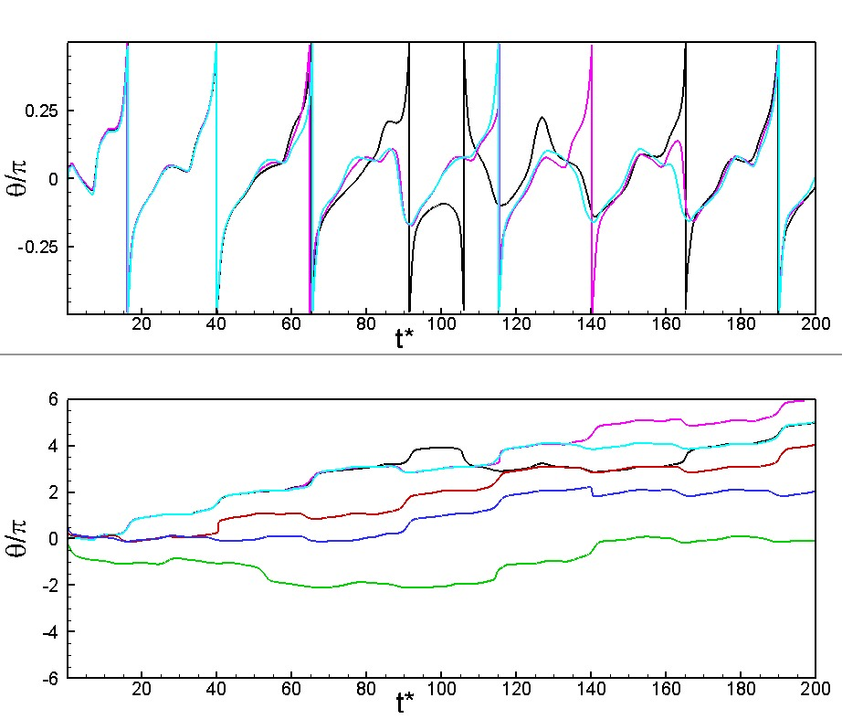
Figure S13. Chaotic dynamics of oblate capsules at reduced volume 0.644 (same as RBC). Ca=0.2, λ=0.1, 1/ν=25. Colors indicate different initial orientation θ₀ = 0º (black), 1º (magenta), -1º (cyan), 45º (red), 90º (blue), -45º (green).

Also note that as the reduced volume of an oblate approaches that of the RBC, the shape no longer remains an oblate. Instead, the shape naturally transitions to biconcave shape due to the presence of the membrane bending. This is shown in figure S14 below. Thus at these reduced volumes, it is sufficient just to consider the RBC rather than the oblate. Hence the results presented in the paper for RBCs would be valid for oblates at small reduced volumes (or, large excess area).

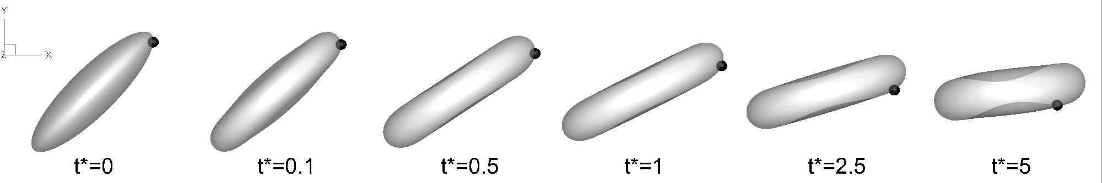
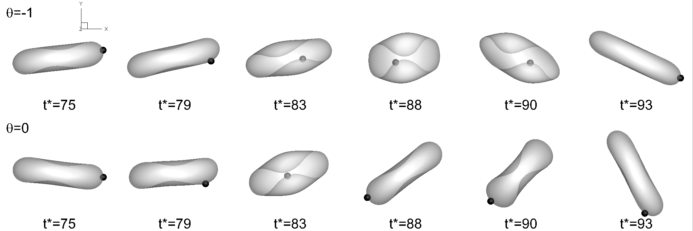
Figure S14. Top row shows the natural transition of an oblate of reduced volume 0.644 to a biconcave shape. Bottom two rows show the dynamics of such oblates in oscillating shear flow. Here Ca=0.2, λ=0.1, 1/ν=25.

It should be noted that a membrane rotation of nπ is not a sufficient condition for chaos to occur. A$Δφ≈nπ$ is possible for any reduced volume, but the forcing frequency needs to be adjusted. As noted in the paper, the capsule must be swinging and must not deform significantly; further, the swinging must occur at the time of flow reversals. All these conditions must be satisfied for chaos to occur. Consider, e.g., an initially nearly spherical capsule. One may be able to find a flow frequency such that the membrane rotation is nπ, but since such a capsule does not exhibit a large swinging motion, one would not find chaos. Likewise, capsule deformation would prevent large swinging motion, and chaos is not possible even if membrane rotation is nπ.

