**Supplementary materials:**

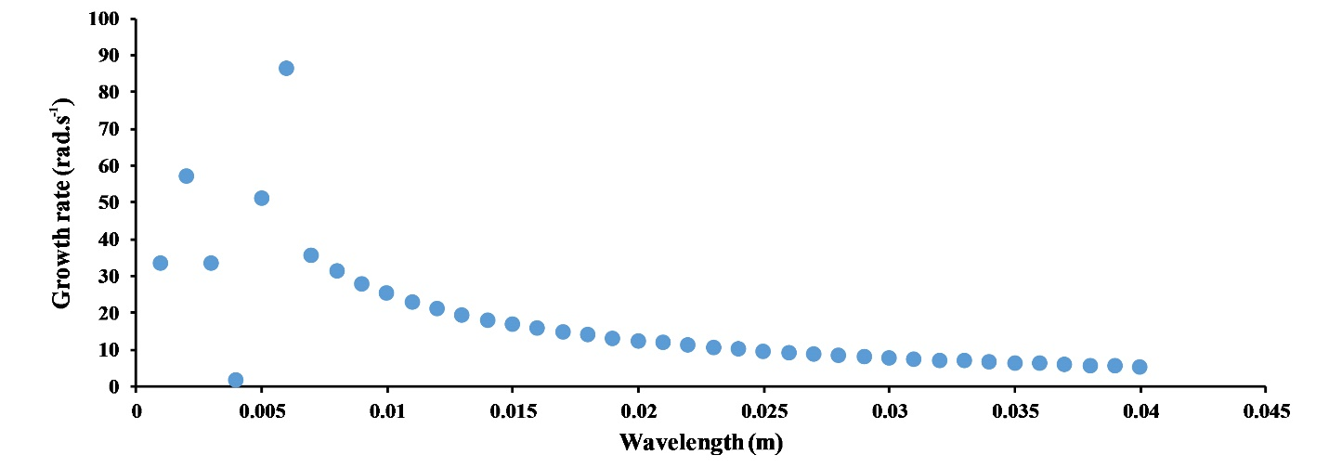

Figure S1: Growth rate as a function of the wavelength calculated by linear stability analysis using a tanh density profile and the mean observed horizontal velocity profile of the trailing face of the bolus in figure 8a. (Details of this method can be found in Gímez-Giraldo et al., 2008, Smyth et al., 2011, Bouffard et al., 2012)

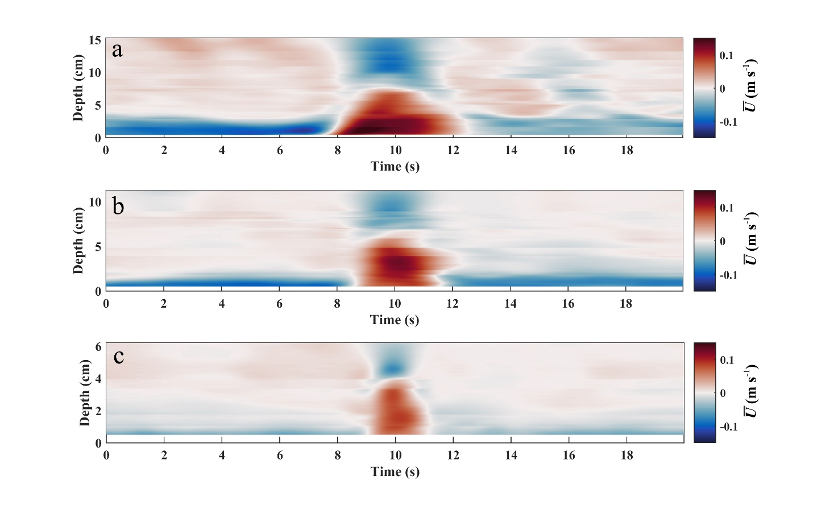

Figure S2: Time series of mean velocity profiles for a bolus in horizental direction ( $\overline{U}$ component) captured by a) the first ADVp, b) the second ADVp and c) the third ADVp for the Run 8.

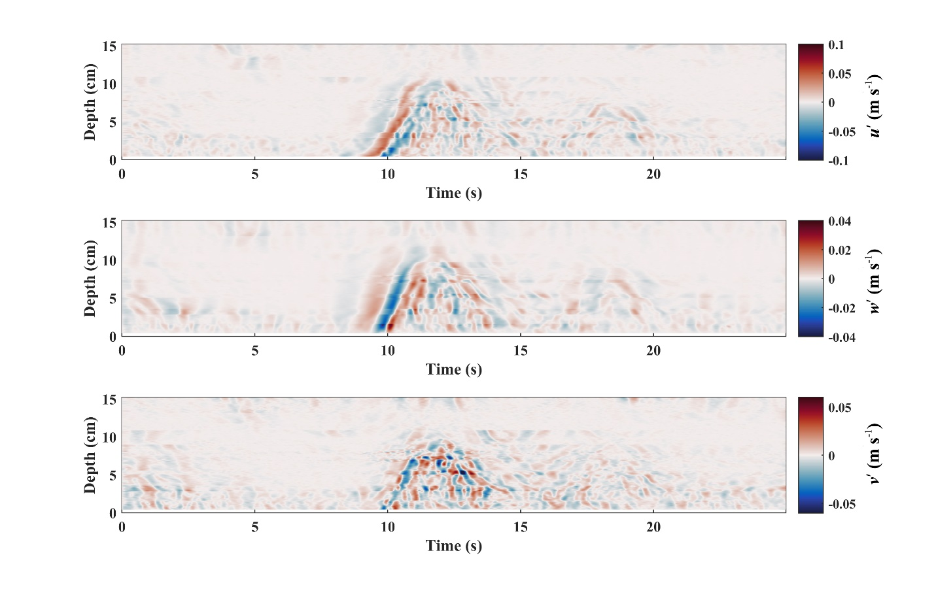

Figure S3: Time series of fluctuating velocity profiles for a bolus in a) horizontal direction (u’ component), b) vertical direction (w’ component) and c) spanwise direction (v’ component) for run 8 (Table 2) captured by the first ADVp. Measured data within 5 mm of the bed have been removed because of the poor signal-to-noise ratio and correlation.

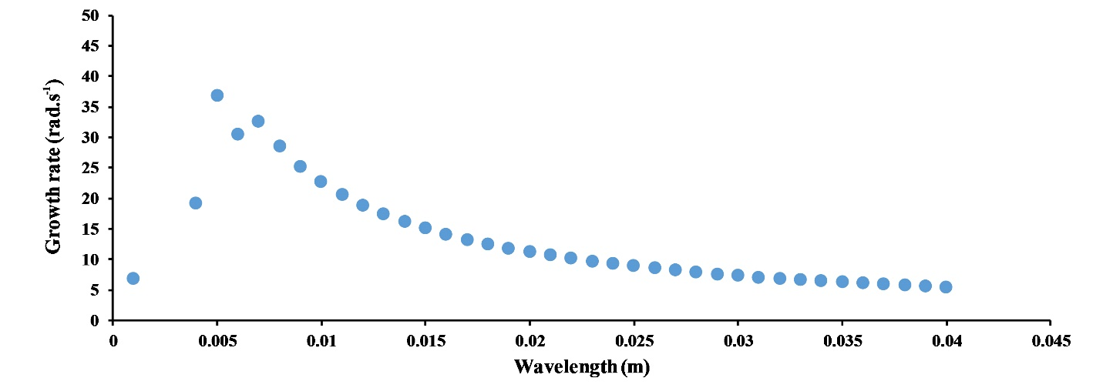

Figure S4: Growth rate as a function of the wavelength calculated by linear stability analysis using a tanh density profile and the mean observed horizontal velocity profile of the trailing face of the bolus in figure 10. (Details of this method can be found in Gímez-Giraldo et al., 2008, Smyth et al., 2011, Bouffard et al., 2012)

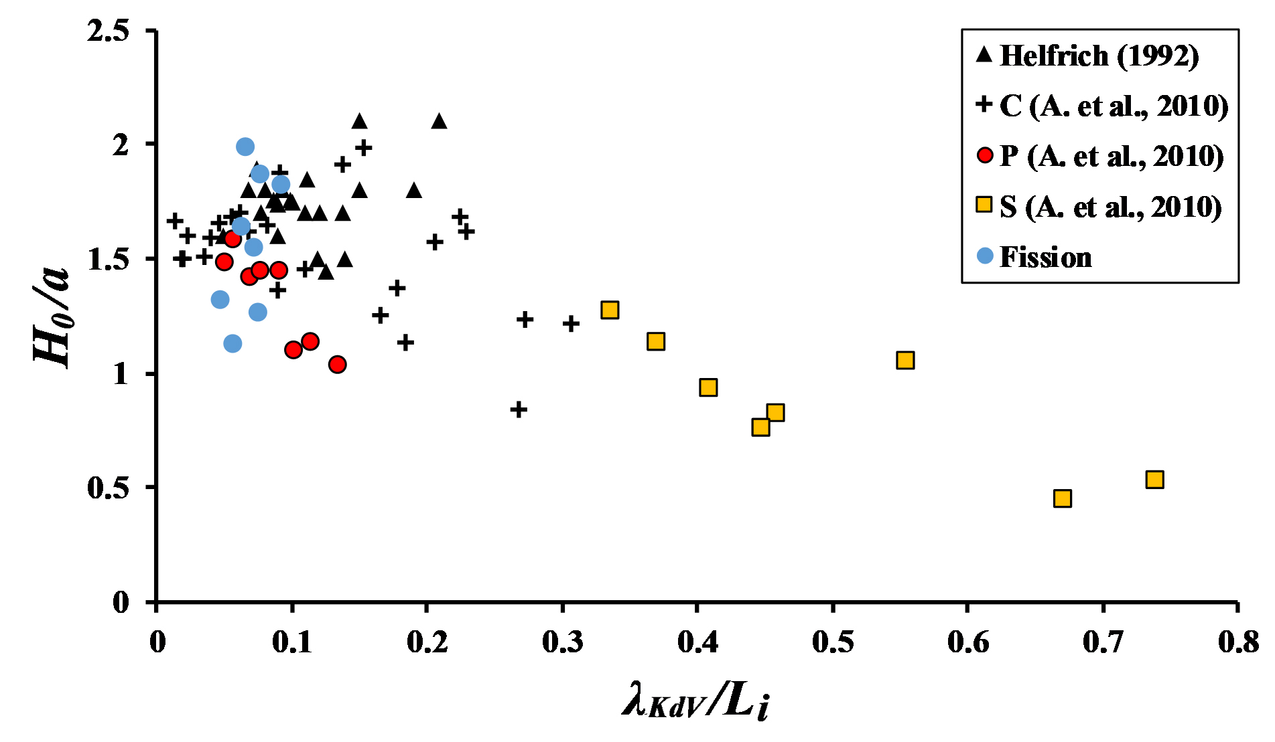

Figure S5: Initial height of the bolus normalized by wave amplitude versus λKdV/Li. The letters represent the shoaling type: C for collapsing, S for surging and P for plunging. Aghsaee et al. (2010) refers to as (A. et al., 2010).