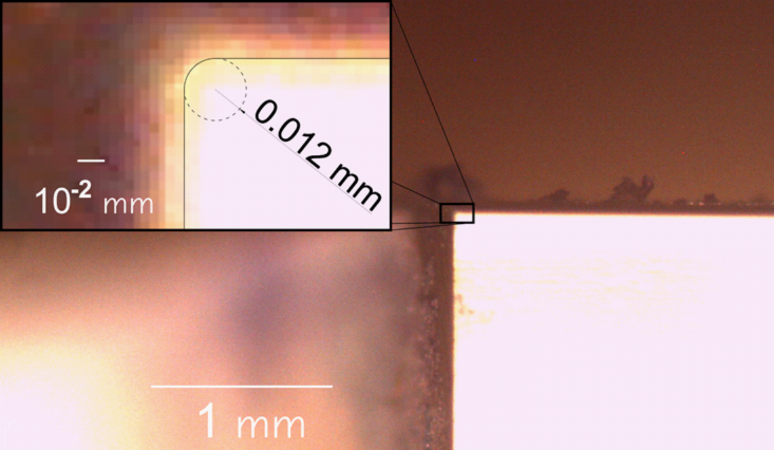

**Figure 1** :

The figure shows a magnified picture of the acrylic wedge previously carved by means of a CNC mill (Proxxon ff500 CNC).

The picture is obtained by means of a stereo-microscope (Nikon SMZ800) equipped with Leica camera.