**SUPPLEMENTAL MATERIALS TO:**

**Antarctic iceberg distribution revealed through three decades of systematic ship-based observations** **in the SCAR International Iceberg Database**

**Olav Orheim¹, Barry Giles², Geir Moholdt³, T.H. (Jo) Jacka⁴ and Are Bjørdal³**

¹Formerly Norsk Polarinstitutt, Tromsø, Norway.

²Formerly Antarctic Climate and Ecosystems Cooperative Research Centre (ACE CRC), now Institute for Marine and Antarctic Studies (IMAS), University of Tasmania, Private Bag 80, Hobart, Tasmania 7001, Australia

³Norsk Polarinstitutt, 9296 Tromsø, Norway

⁴Formerly Antarctic Climate Program, Australian Antarctic Division, 203 Channel Highway, Kingston, Tasmania 7050, Australia

**The front page of the blue form.**

**ICEBERG OBSERVING PROGRAMME**

**Name of Ship:**

**Season and Country:**

**Elevation of Observing Platform:**

The 1981 meeting of the SCAR Working Group on Glaciology endorsed an effort by the Norwegian Polar Institute to organize the collection of iceberg data through international collaboration. This form should be used on all ships traversing the oceans around Antarctica.

*An iceberg is defined as: a large mass of floating or stranded ice of greatly varying shape, more than five metres above sea level, which has broken away from a glacier or ice shelf.*

Please record the icebergs every six hours at the times of standard meteorological observations. More frequent observations may be made if convenient. Observations can be stopped when the ship is at the same location for longer periods.

Please start recordings on the first day after port departure, or after crossing 40 degrees S, even though no icebergs may be observed. Such zero observations are also of high value.

Record all icebergs irrespective of size, but make more detailed observations of the larger ones.

A rough estimate of numbers is adequate when many icebergs of the smallest group are present.

Note if possible also exceptional icebergs, or concentrations, observed between the regular recordings.

Page two of cover contains a guide to facilitate size determination.

Under “Comments”, include for example additional data on the larger icebergs, such as shape, and degree of tilt, or note the proportion of overturned icebergs. Please note if icebergs contain rock sediment. Please include information on visibility when limited.

Two examples of how the form can be completed are found at the bottom of the last page.

Please return the form, with additional comments, to your national organizer, or to the address below:

**Norwegian Polar Institute**

**Polar Environmental Centre**

**9296 Tromsø**

**Norway**

**Page 2 of the Blue Form**

This was a guide to help the observer to quickly place the observed iceberg in the correct size class, based on horizontal dimension measured by sextant angle, and distance by radar.

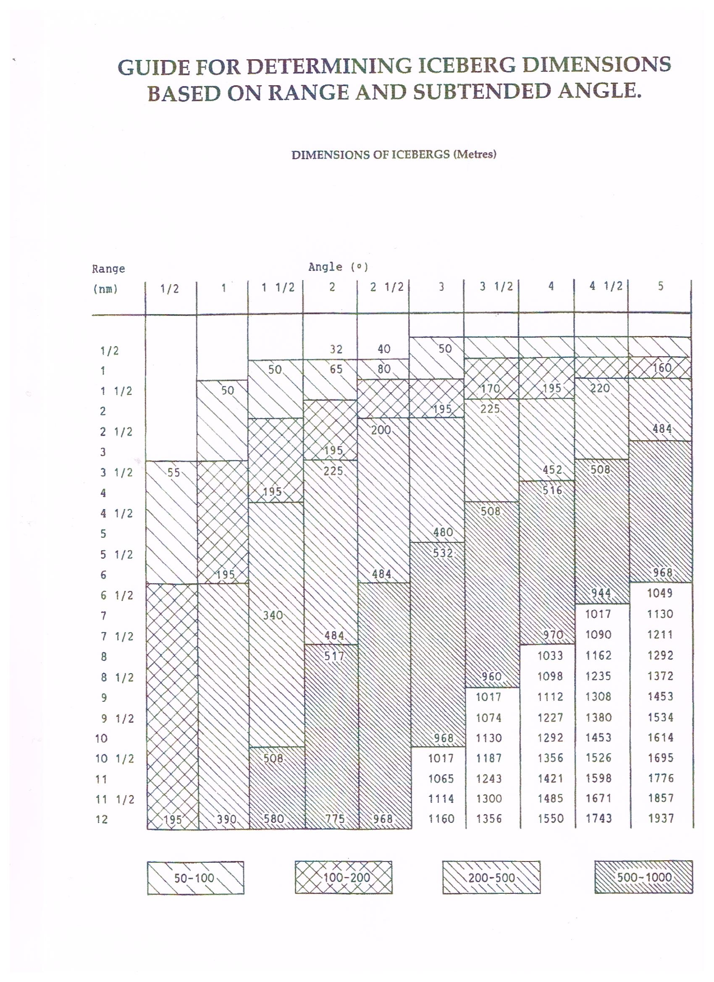

**Fig. S1.** The Blue Form.

**Table S2 – THE SCAR DATABASE CSV FILE FORMAT STRUCTURE USED FOR THE NPI RECORDS**

|  |  |  |  |
| --- | --- | --- | --- |
| Field name | Data type | Field size | Range |
| ID | number | double | 1, 2, 3, …. |
| Cruise–ID | text |  | See description below (1) |
| Vessel | text |  | Vessel name |
| Obs. Date ISO | date/time |  | yyyy–mm–ddThh:nnZ (2) |
| Obs. Date Excel | date/time |  | Excel time and date format  dd\mm\yyyy hh:nn (3) |
| Obs. latitude | number | float | +/– 0–90o |
| Obs. longitude | number | float | +/– 0–180o |
| Ice conc. | number | byte | 0–10 (4) |
| RV | text |  | R, V, RV or VR (5) |
| Total icebergs | number | integer |  |
| No. 10–50 m | number | integer |  |
| No. 50–200 m | number | integer |  |
| No. 200–500 m | number | integer |  |
| No. 500–1000 m | number | integer |  |
| > 1000 m | number | integer |  |
| Freeboard m | number | integer |  |
| Length m | number | long integer |  |
| Width m | number | long integer |  |
| Dim as average | text | 10 chars. | Y, N see description below (6) |
| View radius | number | byte | See description below (7) |
| Comments | text | 255 chars. |  |

1. ‘Cruise**–**ID’ is in the format 9596xx where the first 4 digits give the season and xx is a running number. For example, 959601 is cruise no. 1 in season 95/96. Note that this field must be treated as text and not as a number.
2. ‘Obs. Date ISO’ gives the observation time and date in standard ISO date format.
3. ‘Obs. Date Excel’ gives the observation time and date in a more human-readable format.
4. Ice conc. gives the sea ice concentration in the range from 0 to 10 where 10 is complete sea ice cover.
5. RV indicates whether the observation was made visually or by radar (or both).
6. ‘Dim as average’ defines whether the dimensions recorded for icebergs larger than 1000 m should be used as average in calculations. This is only relevant in cases when more than 1 iceberg is recorded in the > 1000 column.

If ‘N’ is given, a conservative estimate will be given for the latter icebergs.

1. The view radius is given in nautical miles and is derived from radar range, visibility estimate or from the altitude of the viewing platform.

The CSV file format structure used for the ANARE database:

1. The ice concentration and RV columns in the ANARE database file do not contain any information but are deliberately introduced dummy spacer columns so that both data files follow the same column order layout.
2. The NPI columns for Freeboard, Length, Width, Dim–as–average, View–radius and Comments do not exist in the ANARE database. The data for these parameters, and the two dummy columns at (1), were often recorded by Australian observers but were never formally typed up within the growing Australian database though many of these records still exist in some form. Note that the pre–size–change (1984/1985 season) Australian data that was sent to Norway on the standard ‘Blue Forms’ were typed up there in the normal way and thus these data can in fact potentially exist within the NPI database in the appropriate locations.
3. The ANARE database includes all the Australian observations which means that the data collected before 1984/1985 are found in both the NPI and ANARE databases. Some 970 early ANARE observations are contained within the NPI archive representing 3.6 % of its total observations. These same observations represent 10.7 % of the total ANARE archive.
4. All entries in the ANARE database actually show 7-size class columns but a final flag column indicates whether the data line is for 5 or 7-size classes with the 6th and 7th columns being set to zero for a 5–class entry.

**Table S3 – OVERVIEW OF THE ICEBERG DATA COLLECTED DURING THE PROGRAM**

|  |  |  |  |  |  |  |  |  |  |
| --- | --- | --- | --- | --- | --- | --- | --- | --- | --- |
| Season | No.  obs. | Total  icebergs | Bergs/  obs. | Classified  icebergs | 10–50 | 50–200 | Size m  200–500 | 500-1000 | >1000 |
| 09/10 | 176 | 628 | 3.6 | 540  % | 209  38.7 | 316  58.5 | 13  2.4 | 1  0.2 | 1  0.2 |
| 07/08 | 198 | 1642 | 8.3 | 1552  % | 1243  80.1 | 217  14.0 | 72  4.6 | 15  1.0 | 5  0.3 |
| 06/07 | 757 | 14 538 | 19.2 | 13 712  % | 6814  49.7 | 4354  31.8 | 1867  13.6 | 565  4.1 | 112  0.8 |
| 05/06 | 405 | 8017 | 19.8 | 8007  % | 5323  66.5 | 1822  22.8 | 692  8.6 | 127  1.6 | 43  0.5 |
| 04/05 | 454 | 4053 | 8.9 | 2289  % | 748  32.7 | 696  30.4 | 442  19.3 | 338  14.8 | 65  2.8 |
| 03/04 | 893 | 5576 | 6.2 | 5228  % | 3047  58.3 | 1536  29.4 | 365  7.0 | 187  3.6 | 93  1.8 |
| 02/03 | 828 | 10 659 | 12.9 | 9700  % | 4769  49.2 | 3360  34.6 | 1223  12.6 | 293  3.0 | 55  0.6 |
| 01/02 | 688 | 7676 | 11.2 | 3206  % | 677  21.1 | 1480  46.2 | 547  17.1 | 315  9.8 | 187  5.8 |
| 00/01 | 956 | 15 241 | 15.9 | 13 004  % | 5627  43.3 | 3808  29.3 | 2363  18.2 | 938  7.2 | 268  2.1 |
| 99/00 | 860 | 6437 | 7.5 | 3993  % | 1705  42.7 | 1304  32.7 | 625  15.7 | 291  7.3 | 68  1.7 |
| 98/99 | 1143 | 9606 | 8.4 | 8308  % | 2756  33.2 | 2862  34.4 | 1549  18.6 | 739  8.9 | 402  4.8 |
| 97/98 | 1631 | 19 027 | 11.7 | 16 594  % | 6788  40.9 | 5376  32.4 | 2651  16.0 | 1146  6.9 | 633  3.8 |
| 96/97 | 370 | 4892 | 13.2 | 3165  % | 1402  44.3 | 892  28.2 | 421  13.3 | 322  10.2 | 128  4.0 |
| 95/96 | 504 | 10 791 | 21.4 | 10 071  % | 5626  52.2 | 3144  31.2 | 1160  11.5 | 411  4.1 | 94  0.9 |
| 94/95 | 916 | 10 340 | 11.3 | 8926  % | 2320  26.0 | 2889  32.4 | 2173  24.3 | 1154  12.9 | 390  4.4 |
| 93/94 | 654 | 10 398 | 15.9 | 4969  % | 1765  35.5 | 1705  34.3 | 994  20.0 | 399  8.0 | 106  2.1 |
| 92/93 | 846 | 9184 | 10.9 | 6561  % | 1903  29.0 | 2453  37.4 | 1629  24.8 | 444  6.8 | 132  2.0 |
| 91/92 | 771 | 8110 | 10.5 | 7448  % | 2443  32.8 | 2642  35.5 | 1537  20.6 | 662  8.9 | 164  2.2 |
| 90/91 | 992 | 8431 | 8.5 | 7744  % | 2392  30.9 | 2760  35.6 | 1612  20.8 | 686  8.9 | 294  3.8 |
| 89/90 | 781 | 9961 | 12.8 | 9385  % | 3540  37.7 | 3455  36.8 | 1613  17.2 | 583  6.2 | 194  2.1 |
| 88/89 | 1212 | 15 225 | 12.6 | 10 953  % | 2761  25.2 | 4107  37.5 | 2879  26.3 | 920  8.4 | 286  2.6 |
| 87/88 | 1782 | 24 332 | 13.7 | 19 374  % | 7582  39.1 | 6612  34.1 | 3395  17.5 | 1434  7.4 | 351  1.8 |
| 86/87 | 1391 | 24 161 | 17.4 | 22 451  % | 8642  38.5 | 7596  33.8 | 4062  18.1 | 1646  7.3 | 505  2.2 |
| 85/86 | 1197 | 13 533 | 11.3 | 11 349  % | 4424  39.0 | 3657  32.2 | 2157  19.0 | 813  7.2 | 298  2.6 |
| 84/85 | 1569 | 12 313 | 7.8 | 9925  % | 3871  39.0 | 3393  34.2 | 1879  18.9 | 635  6.4 | 147  1.5 |
| 83/84 | 2345 | 31 740 | 13.5 | 24 831  % | 8554  34.4 | 7603  30.6 | 5154  20.8 | 2627  10.6 | 893  3.6 |
| 82/83 | 1001 | 13 780 | 13.8 | 10 735  % | 2824  26.3 | 3683  34.3 | 2802  26.1 | 1025  9.5 | 401  3.7 |
| 81/82 | 548 | 4377 | 8.0 | 3374  % | 1232  36.5 | 1252  37.1 | 698  20.7 | 147  4.4 | 45  1.3 |
| 80/81 | 129 | 494 | 3.8 | 99  % | 12  12.1 | 23  23.2 | 21  21.2 | 4  4.0 | 39  39.4 |
| 79/80 | 93 | 359 | 3.9 | 52  % | 22  42.3 | 6  11.5 | 1  1.9 | 4  7.7 | 19  36.5 |
| 78/79 | 352 | 3100 | 8.8 | 1934  % | 983  50.8 | 641  33.1 | 194  10.0 | 98  5.1 | 18  0.9 |
| 76/77 | 159 | 1873 | 11.8 | 0  % | 0  **–** | 0  **–** | 0  **–** | 0  **–** | 0  **–** |
| Total | 26 601 | 320 494 | 12.0 | 259 479  % | 101 640  39.2 | 85 644  33.0 | 46 790  18.0 | 18 969  7.3 | 6436  2.5 |

Example of how to read the above: During the 2009/2010 season, a total of 628 icebergs were seen but only 540 of these were classified by size. In the lowest class there were 209 bergs representing 38.7% of the classified total that season. The observations are mainly from the summer months, December–March. Nearly all years also contain April data. In some years there is also considerable number of winter observations (see Supplementary Material).

**Table S4. List of all 68 contributing ships, altogether 233 ship records.**

|  |  |  |
| --- | --- | --- |
| Season | No | Names of ship providing the iceberg data |
| 2009/10 | 1 | Ernest Shackleton |
| 2007/08 | 1 | Ernest Shackleton |
| 2006/07 | 1 | Polarstern |
| 2005/06 | 2 | Polarstern, Ernest Shackleton |
| 2004/05 | 2 | Polarstern, Agulhas |
| 2003/04 | 4 | Polarstern, Agulhas, Ernest Shackleton, Italica |
| 2002/03 | 5 | Polarstern, Agulhas, Ernest Shackleton, OGS Explora, Ary Rongel |
| 2001/02 | 5 | Polarstern, Agulhas, Ernest Shackleton, Italica, Ary Rongel |
| 2000/01 | 7 | Polarstern, Agulhas, Almirante Irizar, Italica, Ary Rongel, Hesperides, unnamed |
| 1999/00 | 8 | Polarstern, JCR, Shackleton, Shirase, Italica, Rongel, Gurruchaga, Deseado |
| 1998/99 | 7 | Polarstern, JCR, Almirante Irizar, Italica, Rongel, N B Palmer |
| 1997/98 | 11 | Polarstern, JCR, Irizar, Italica, Rongel, Palmer, Deseado, Bransfield, Endurance, Inach, Polo |
| 1996/97 | 5 | Polarstern, JCR, Italica, Bransfield, OGS Explora |
| 1995/96 | 7 | JCR, Irizar, Italica, Bransfield, Castillo, Puerto Deseado, Umitaka Maru |
| 1994/95 | 6 | JCR, Almirante Irizar, Italica, Bransfield, OGS Explora, Mikhail Somov |
| 1993/94 | 7 | Polarstern, Agulhas, Irizar, Italica, Hesperides, Africana, Barao de Teffe |
| 1992/93 | 7 | Polarstern, Agulhas, Irizar, Bransfield, Barao de Teffe, Gurruchaga, Polarbjørn |
| 1991/92 | 7 | Agulhas, Irizar, Bransfield, Barao de Teffe, JCR, Italica, Gondwana |
| 1990/91 | 11 | Polarstern, Irizar, Bransfield, de Teffe, Italica, Gondwana, Explora, Las Palmas, Aviso Irigoyen, Gurruchaga, Cariboo |
| 1989/90 | 10 | Irizar, Bransfield, Agulhas, Gurruchaga, Cariboo, Thuleland, Andenes, VIII Brazil Ant. Exp., Columbialand, Biscoe |
| 1988/89 | 12 | Irizar, Bransfield, Agulhas, Somov, de Teffe, Shirase, Arctica, Viese, Zubov, Barken, Biscoe, Alvaro Alberto |
| 1987/88 | 15 | Polarstern, Irizar, Bransfield, Agulhas, Somov, de Teffe, Shirase, Viese, Zubov, Paraiso, Finnpolaris, Camara, Bernard, Kaiyo, Polar Queen |
| 1986/87 | 10 | Polarstern, Irizar, Bransfield, Agulhas, Somov, de T, Viese, Paraiso, Glacier, Aurora |
| 1985/86 | 10 | Polarstern, Irizar, Bransfield, Agulhas, Zubov, Paraiso, Glacier, Endurance, Polar Star, Biscoe |
| 1984/85 | 14 | Irizar, Bransfield, Agulhas, Paraiso, Endurance, Disc, Myshevskij, Andenes, Rulegi, Sibex 2, Halley, Jantar, Kaiyo, unnamed |
| 1983/84 | 17 | Polarstern, Irizar, Bransfield, Agulhas, Endurance, Myshevskij, Shirase, Nella Dan, Somov, Viese, Paraiso, de T, P Sea, Nanok S, Kaiyo, H Maru, unnamed |
| 1982/83 | 14 | Bransfield, Agulhas, Nella Dan, Somov, Viese, Zubov, Nanok S, Franklin, P Pardo, Alcazar, Polar Circle, Polarbjørn, Hero, Biscoe |
| 1981/82 | 9 | Bransfield, Agulhas, Paraiso, Irizar, Fuji, Polar Queen, Polar Circle, Nella Dan, Nanok S |
| 1980/81 | 4 | John Biscoe, Nanok S, Nella Dan, Thala Dan |
| 1979/80 | 3 | Bransfield, Nella Dan, Thala Dan |
| 1978/79 | 7 | Bransfield, Agulhas, Polarsirkel, Yelco, Nella Dan, Thala Dan, unnamed |
| 1976/77 | 1 | Polarsirkel |

Key to abbreviated names:

|  |  |  |  |  |  |
| --- | --- | --- | --- | --- | --- |
| Alcazar = | Capitan Alcazar | Franklin = | Lady Franklin | Polo = | Marco Polo |
| Bernard = | Prof W. Bernard | Halley = | Depot Halley | P Pardo = | Piloto Pardo |
| Biscoe = | John Biscoe | H Maru = | Hakuho Maru | P Sea = | Polar Sea |
| Camara = | Almirante Camara | Irizar = | Almirante Irizar | Rongel = | Ary Rongel |
| Castillo = | Aviso Subof Castillo | JCR = | James Clark Ross | Rulegi = | Kaiyo Rulegi |
| Deseado = | Puerto Deseado | Kaiyo = | Kaiyo Maru | Somov = | Mikhail Somov |
| de T = | Barao de Teffe | Myshevskij = | Kapt. Myshevskij | Viese = | Professor Viese |
| Disc = | Discovery | Paraiso = | Bahia Paraiso | Zubov = | Professor Zubov |

In three cases forms were sent in without information on the name of the ship.

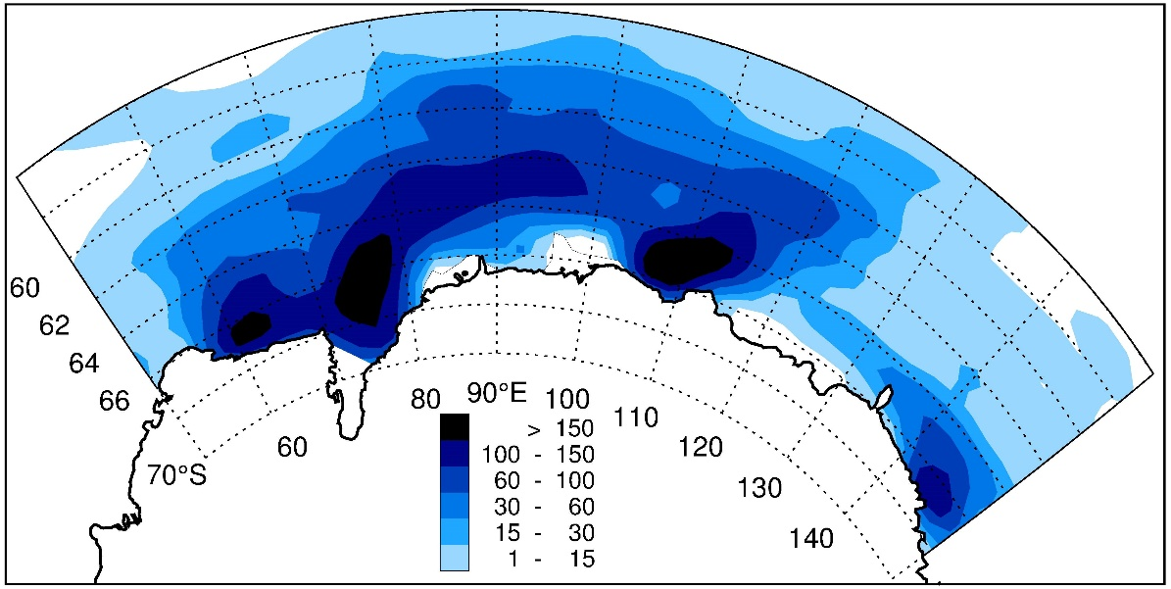

Distribution of all the ANARE observations from 1978/1979 to 2010/2011. The data are smoothed by the same routine as in the main paper. However, as this map covers few regions of low density of observations, no boxes have been over–plotted with uniform colour.

**Fig. S5.** The Australian contribution to the SCAR database

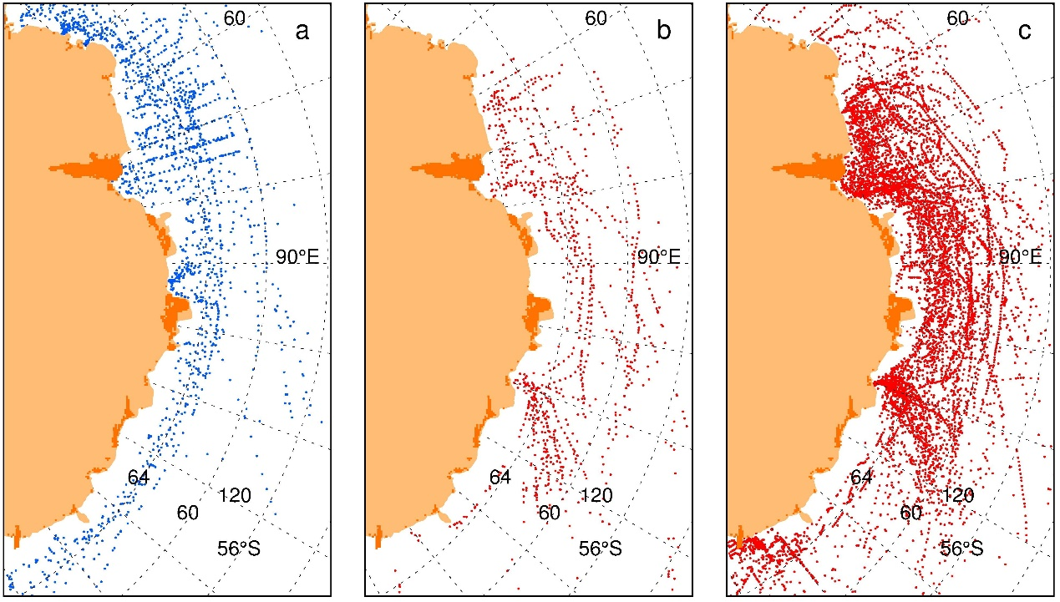

The distribution of iceberg observations in East Antarctica. Panel a shows the NPI 5–class observations without any 5–class ANARE contribution. These 5–class ANARE pre–1984/1985 data are shown in panel b. The 7–class ANARE 1984/1985 and onwards observations are shown in panel c.

Comparing the ANARE data with the NPI data show that the 7–class ANARE observations provide the major dataset. However, the non–ANARE data are important for geographic coverage outside the main travel routes to the Australian stations, Mawson (67° 36′ S, 62° 52′ E), Davis (68° 34′ S, 77° 58′ E) and Casey (66° 16′ S, 110° 31′ E).

**Fig. S6.** Comparison of ANARE and NPI datasets for the East Antarctic region.

**Table S7. Area of grid boxes measuring 1° in latitude by 5° in longitude.**

|  |  |  |  |  |  |  |  |
| --- | --- | --- | --- | --- | --- | --- | --- |
| Latitude Range °S | Area  km2 | Latitude  range °S | Area  km2 | Latitude  range °S | Area  km2 | Latitude  range °S | Area  km2 |
| 40–41 | 46 949 | 50–51 | 39 273 | 60–61 | 30 403 | 70–71 | 20 610 |
| 41–42 | 46 242 | 51–52 | 38 435 | 61–62 | 29 461 | 71–72 | 19 591 |
| 42–43 | 45 521 | 52–53 | 37 586 | 62–63 | 28 509 | 72–73 | 18 566 |
| 43–44 | 44 786 | 53–54 | 36 726 | 63–64 | 27 549 | 73–74 | 17 535 |
| 44–45 | 44 038 | 54–55 | 35 854 | 64–65 | 26 581 | 74–75 | 16 500 |
| 45–46 | 43 276 | 55–56 | 34 971 | 65–66 | 25 604 | 75–76 | 15 459 |
| 46–47 | 42 501 | 56–57 | 34 078 | 66–67 | 24 619 | 76–77 | 14 413 |
| 47–48 | 41 712 | 57–58 | 33 174 | 67–68 | 23 628 | 77–78 | 13 363 |
| 48–49 | 40 912 | 58–59 | 32 260 | 68–69 | 22 628 | 78–79 | 12 309 |
| 49–50 | 40 098 | 59–60 | 31 336 | 69–70 | 21 622 | 79–80 | 11 251 |

The areas of the grid boxes are calculated as 5/360 of circular annulus ring computed from the differences in ‘cap’ area of a sphere from each latitude. The Earth radius is taken as 6367 km or half the polar plus equatorial radius.

**Table S8.** Known Antarctic gigantic icebergs since 1962, that exceed 5000 km², and associated discussion of any effect of calving of very large icebergs on the annual variation in the ship records.

|  |  |  |  |  |  |
| --- | --- | --- | --- | --- | --- |
| Iceberg  name | Surface  area km2 | Length  km | Width  km | Time of  calving | Location and  reference |
| Amery | 10 000 | – | – | Dec 63/Jan 64 | Amery Ice Shelf1 |
| Trolltunga | 5000 | 100 | 50 | July 1967 | Fimbulisen2 |
| A20 | 7284 | – | – | January 1986 | Larsen Ice Shelf |
| A22 | 5212 | – | – | August 1986 | Filchner–Ronne Ice Shelf |
| A23 | 5883 | – | – | August 1986 | Filchner–Ronne Ice Shelf |
| A24 | 6863 | – | – | August 1986 | Filchner–Ronne Ice Shelf |
| B09 | 5096 | 154 | 35 | October 1987 | Ross Ice Shelf |
| B10 | 5689 | – | – | January 1992 | Thwaites Glacier |
| A38 | 5603 | 144 | 48 | October 1998 | Filchner–Ronne Ice Shelf |
| B15 | 11 000 | 295 | 37 | March 2000 | Ross Ice Shelf |
| A43 | 5000 | 167 | 32 | May 2002 | Filchner–Ronne Ice Shelf |
| C19 | 6368 | 200 | 32 | May 2002 | Ross Ice Shelf |
| B15 | 5800 | 200 | – | July 2017 | Larsen C Ice Shelf |

The two earliest events in the Table above are described by Fricker and others (2002)¹ and Vinje (1977)² and Swithinbank and others (1977)². Icebergs listed from A20 onwards are from the National Ice Center and Brigham Young University satellite iceberg databases (Budge and Long, 2018). Icebergs A22, A23 and A24 formed when a ~210 km x ~90 km section of the eastern Filchner–Ronne Ice Shelf north of the Grand Chasm broke off. The section had already split into three icebergs when detected by satellite. Viewed as a single calving it is by far the largest. Taking the thickness of the giant icebergs in Table S8 to be 250–300 m means that these icebergs have masses ranging from 1000 to 2000 Gt, which is comparable with the reported annual discharge. Table S8 shows that such giant icebergs form only occasionally, yet in those years when these extreme events occur the Antarctic iceberg production must far exceed both the annual accumulation and the discharge across the grounding line. By chance, none of these giant icebergs were recorded in their initial stages by observation in this database, but ships in this program subsequently encountered and identified four of the giants (A20, A22, A24, A38). Examination of the records show that these encounters did not cause a significant increase in the iceberg/observation ratio for the relevant season.

A further question concerns whether other giant calvings caused the year–to–year variations. Recording of all giant Antarctic icebergs with long axis >18.5 km was started by the US National Ice Center (NIC) in 1976 (Ballantyne and Long, 2002), initially from visual and infrared sensors. The giant icebergs were designated A–D for the “sector of birth”, with numbers given consecutively in time. From 1979, icebergs of ~ >10 km length were registered in the Brigham Young University (BYU) satellite database (Budge and Long, 2018). Altogether 292 icebergs >18.5 km broke off from the continent between 1979 and 2020 and on average, seven such giants were formed annually, but there was also large year–to–year variations. BYU additionally listed icebergs of size 10–18 km for which origins were not known.

A part of the variation in annual iceberg frequencies in Table S3 is possibly tied to the intermittent calvings of icebergs in the range 500–5000 km². On the other hand, the dissolution of giant icebergs can take many years or even decades, and therefore difficult to relate to annual observations. For example, a remnant of iceberg B15 was still tracked by NIC, 20 years after the initial calving. It is clear that the most of the year–to–year variations in observed icebergs are explained by year-to-year differences in the regions traversed by the ships.

**Table S9. The years with more than 10 000 observed icebergs, with information on seasons covered.**

|  |  |  |  |  |  |  |  |  |  |  |
| --- | --- | --- | --- | --- | --- | --- | --- | --- | --- | --- |
| Season | No.  obs. | No.  bergs | Bergs  / obs. | Classed  bergs | 10–50 | 50–200 | Size  200–500 | m  500–1000 | >  1000 | Comment |
| 2006/2007 | 757 | 14 538 | 19.2 | 13 712 | 49.7 | 31.8 | 13.6 | 4.1 | 0.8 | year, April–March |
| 2002/2003 | 828 | 10 659 | 12.9 | 9700 | 49.2 | 34.6 | 12.6 | 3.0 | 0.6 | summer + June & July |
| 2000/2001 | 956 | 15 241 | 15.9 | 13 004 | 43.3 | 29.3 | 18.2 | 7.2 | 2.1 | summer + May |
| 1997/1998 | 1631 | 19 027 | 11.7 | 16 594 | 40.9 | 32.4 | 16.0 | 6.9 | 3.8 | summer + May-July |
| 1995/1996 | 504 | 10 791 | 21.4 | 10 071 | 52.2 | 31.2 | 11.5 | 4.1 | 0.9 | Summer |
| 1994/1995 | 916 | 10 340 | 11.3 | 8926 | 26.0 | 32.4 | 24.3 | 12.9 | 4.4 | summer + May |
| 1993/1994 | 654 | 10 398 | 15.9 | 4969 | 35.5 | 34.3 | 20.0 | 8.0 | 2.1 | Summer |
| 1988/1989 | 1212 | 15 225 | 12.6 | 10 953 | 25.2 | 37.5 | 26.3 | 8.4 | 2.6 | summer + Oct & May |
| 1987/1988 | 1782 | 24 332 | 13.7 | 19 374 | 39.1 | 34.1 | 17.5 | 7.4 | 1.8 | summer |
| 1986/1987 | 1391 | 24 161 | 17.4 | 22 451 | 38.5 | 33.8 | 18.1 | 7.3 | 2.2 | summer |
| 1985/1986 | 1197 | 13 533 | 11.3 | 11 349 | 39.0 | 32.2 | 19.0 | 7.2 | 2.6 | summer |
| 1984/1985 | 1569 | 12 313 | 7.8 | 9925 | 39.0 | 34.2 | 18.9 | 6.4 | 1.5 | summer + some Oct |
| 1983/1984 | 2345 | 31 740 | 13.5 | 24 831 | 34.4 | 30.6 | 20.8 | 10.6 | 3.6 | summer |
| 1982/1983 | 1001 | 13 780 | 13.8 | 10 735 | 26.3 | 34.3 | 26.1 | 9.5 | 3.7 | summer + some Oct |

**Table S10. Summary of iceberg data sorted by month and by season.**

|  |  |  |  |  |  |  |  |  |  |  |
| --- | --- | --- | --- | --- | --- | --- | --- | --- | --- | --- |
| Time  period | Number obs. | | Total  icebergs | Bergs/  obs. | Classified icebergs | 10–50 | 50–200 | Size m  200–500 | 500–1000 | >1000 |
| January | | 6982 | 97 912 | 14.0 | 86 159  % | 35 189  40.8 | 29 030  33.7 | 14 437  16.8 | 5482  6.4 | 2021  2.3 |
| February | | 5925 | 80 010 | 13.5 | 62 224  % | 25 131  40.4 | 19 461  31.3 | 10 816  17.4 | 5008  8.0 | 1808  2.9 |
| March | | 3955 | 54 821 | 13.9 | 39 848  % | 16 132  40.5 | 13 018  32.7 | 7385  18.4 | 2670  6.7 | 693  1.7 |
| April | | 1843 | 16 228 | 8.8 | 11 764  % | 3923  33.3 | 4163  35.4 | 2476  21.0 | 884  7.5 | 318  2.7 |
| May | | 400 | 3162 | 7.9 | 2770  % | 905  32.7 | 964  34.8 | 633  22.9 | 194  7.0 | 74  2.7 |
| June | | 156 | 818 | 5.2 | 751  % | 239  31.8 | 444  59.1 | 63  8.4 | 3  0.4 | 2  0.3 |
| July | | 182 | 427 | 2.3 | 420  % | 245  58.3 | 156  37.1 | 17  4.0 | 1  0.2 | 1  0.2 |
| August | | 92 | 103 | 1.1 | 102  % | 38  37.3 | 61  59.9 | 3  2.8 | 0  0.0 | 0  0.0 |
| September | | 139 | 429 | 3.1 | 260  % | 72  27.7 | 71  27.3 | 105  40.4 | 7  2.7 | 5  1.9 |
| October | | 327 | 3311 | 10.1 | 2848  % | 1320  46.3 | 639  22.4 | 544  19.1 | 245  8.6 | 100  3.5 |
| November | | 1533 | 11 571 | 7.5 | 8735  % | 3538  40.5 | 2804  32.1 | 1550  17.7 | 610  7.0 | 233  2.7 |
| December | | 5100 | 54 728 | 10.7 | 46 126  % | 16 511  35.8 | 15 623  33.9 | 8907  19.3 | 3888  8.4 | 1197  2.6 |
| Total | | 26 634 | 323 520 | 12.1 | 262 057  % | 103 243  39.4 | 86 434  33.0 | 46 936  17.9 | 18 992  7.2 | 6452  2.5 |
| Summer | | 21 962 | 287 471 | 13.1 | 234 407  % | 92 963  39.7 | 77 132  32.9 | 41 545  17.7 | 17 048  7.3 | 5719  2.4 |
| Winter | | 969 | 4939 | 5.1 | 4303  % | 1499  34.8 | 1696  39.4 | 821  19.1 | 205  4.8 | 82  1.9 |

The last five columns show the number of classified icebergs together withpercentages. The lower two lines compare summer (December to March) and winter (June to September) data. The iceberg densities are much higher for the summer period, but it is important to bear in mind the significant differences in location of winter and summer observations; the winter data are mostly collected much further north in the Southern Ocean. In mid–winter (June–August) the densities of icebergs in the largest ice classes are particularly low, but the few data and the location aspects suggest this conclusion should be viewed with caution. For analyses of seasonal variations in iceberg densities and sizes it is necessary to compare individual grid boxes for different periods.

**Table S11. Iceberg distribution in longitude sectors spanning 45° intervals, showing large variations in iceberg density around the continent.**

|  |  |  |  |  |  |  |  |  |  |
| --- | --- | --- | --- | --- | --- | --- | --- | --- | --- |
| Longitude  sector | Number obs. | Total icebergs | Bergs /  obs. | Classified  icebergs | 10–50 | 50–200 | Size m  200–500 | 500–1000 | >1000 |
| 0–45 ⁰W | 9784 | 116 036 | 11.9 | 97 618  % | 39 196  40.2 | 32 442  33.2 | 16 664  17.1 | 6877  7.0 | 2439  2.5 |
| 45–90 ⁰W | 7301 | 114 142 | 115.6 | 95 412  % | 43 889  46.0 | 29 321  30.7 | 15 049  15.8 | 5557  5.8 | 1569  1.7 |
| 90–135 ⁰W | 471 | 8397 | 17.8 | 5587  % | 1503  26.9 | 2157  38.6 | 1294  23.2 | 469  8.4 | 164  2.9 |
| 135–180 ⁰W | 870 | 10 017 | 11.5 | 7958  % | 2341  29.4 | 3134  39.4 | 1564  19.7 | 655  8.2 | 264  3.3 |
| 180–135 ⁰E | 1534 | 9227 | 6.0 | 7698  % | 2416  31.4 | 2275  29.6 | 1606  20.9 | 929  12.1 | 472  6.1 |
| 135–90 ⁰E | 1130 | 20 184 | 17.9 | 13 887  % | 2985  21.5 | 4692  33.8 | 3575  25.7 | 1892  13.6 | 743  5.4 |
| 90–45 ⁰E | 1762 | 24 377 | 13.8 | 16 578  % | 4178  25.2 | 5793  34.9 | 4422  26.7 | 1646  9.9 | 539  3.3 |
| 45–0 ⁰E | 3749 | 18 114 | 4.8 | 14 741  % | 5132  34.8 | 5830  39.5 | 2616  17.7 | 944  6.4 | 219  1.5 |
| Total | 26 601 | 320 494 | 12.0 | 259 479  % | 101 640  39.4 | 85 644  33.0 | 46 790  17.9 | 18 969  7.2 | 6436  2.5 |

**References:**

Fricker HA, Young NW, Allison I and Coleman R (2002) Iceberg calving from the Amery Ice Shelf, East Antarctica. Ann. Glaciol. 34 241–246, <https://doi.org/10.3189/172756402781817581>

Swithinbank C, McClain P and Little P (1977) Drift tracks of Antarctic icebergs. Polar Rec. 18 495– 501, https://doi.org/10.1017/S0032247400000991

Vinje TE (1977) Drift av Trolltunga i Weddellhavet. Norsk Polarinstitutt Årbok, 1975. 251, http://hdl.handle.net/11250/172803