***Journal of Helminthology***

**Influence of an extreme climatic event on bilateral asymmetry and occurrence of eye flukes in perch (*Perca fluviatilis*) and roach (*Rutilus rutilus*) from a lake in southeast England**

**Neil J. Morley & John W. Lewis**

**Supplementary Material**

**i. Roach**

Supplementary Figure S1. Relationship between the number of eye flukes in the left and right eye of (i.) Roach and (ii.) Perch in 1993. Line indicates the 1:1 expectation of equal parasite numbers in each eye. (a.) *Tylodelphys* sp*.* (b.) *Diplostomum* sp.

**a. *Tylodelphys* sp.**

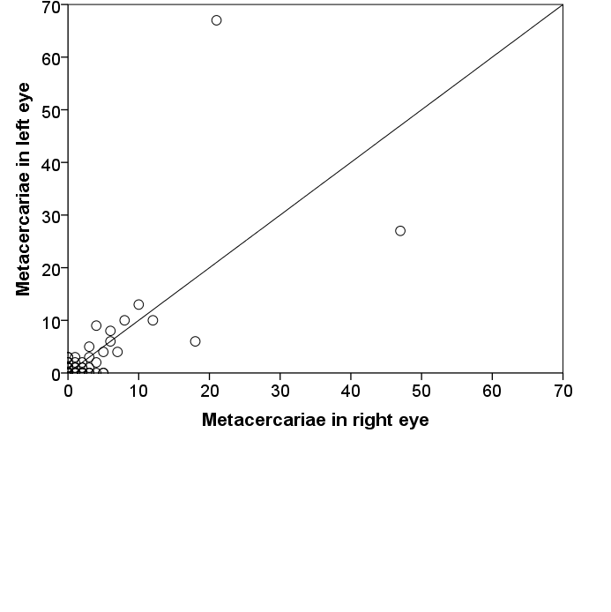

**b. *Diplostomum* sp.**

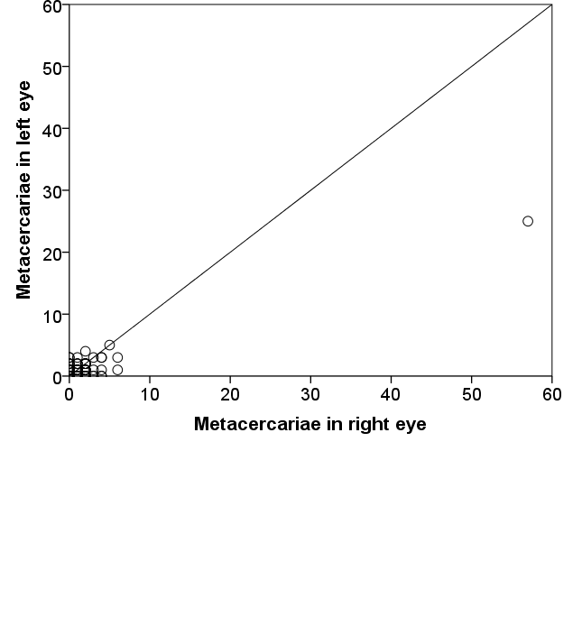

**ii. Perch**

**a. *Tylodelphys* sp.**

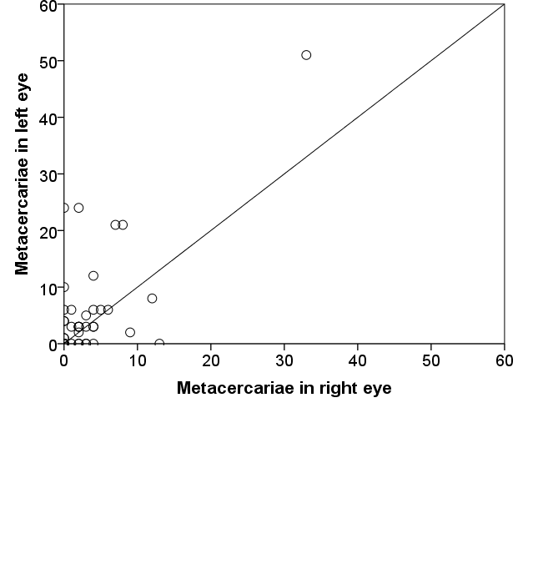

**b. *Diplostomum* sp.**

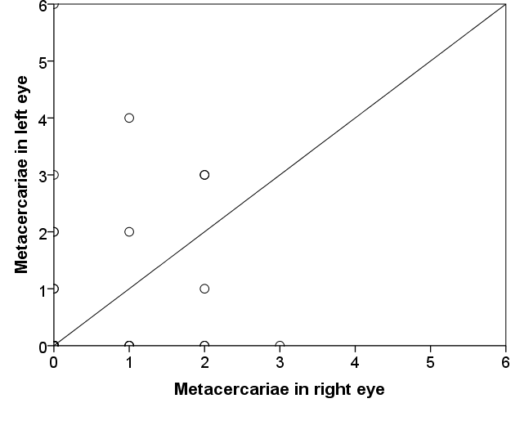

**i. Roach**

Supplementary Figure S2. Relationship between the number of eye flukes in the left and right eye of (i.) Roach and (ii.) Perch in 1994. Line indicates the 1:1 expectation of equal parasite numbers in each eye. (a.) *Tylodelphys* sp*.* (b.) *Diplostomum* sp.

**a. *Tylodelphys* sp.**

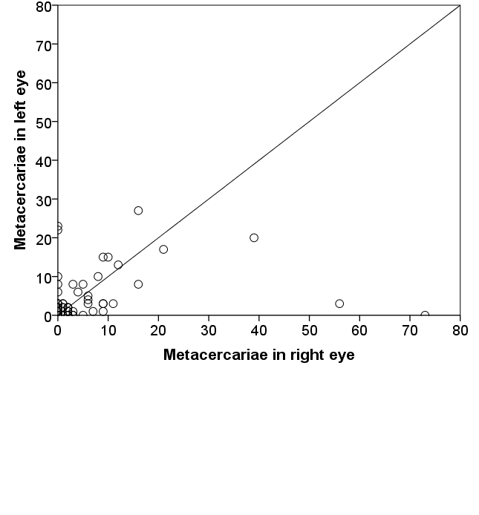

**b. *Diplostomum* sp.**

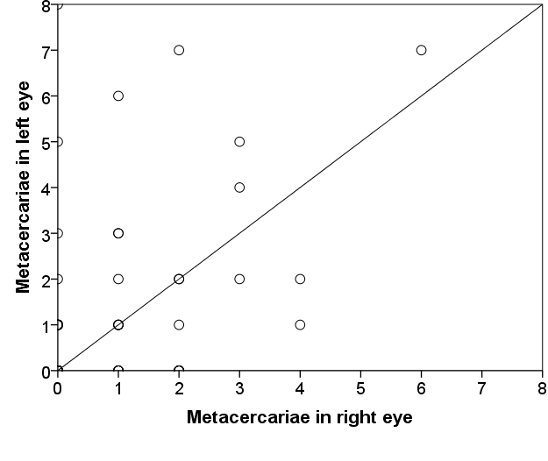

**ii. Perch**

**a. *Tylodelphys* sp.**

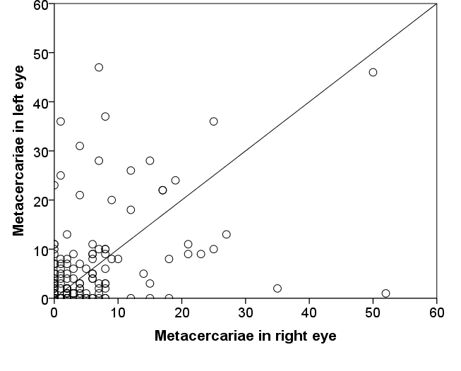

**b. *Diplostomum* sp.**

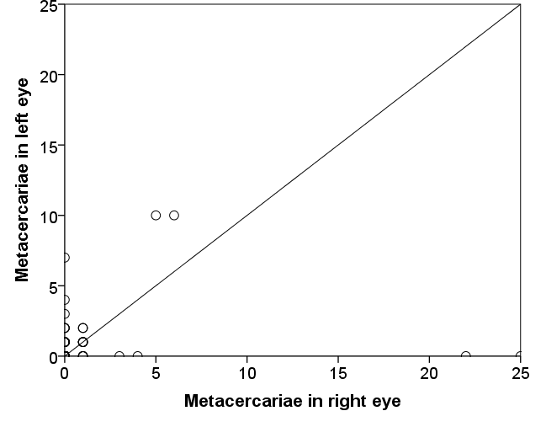

**i. Roach**

Supplementary Figure S3. Relationship between the number of eye flukes in the left and right eye of (i.) Roach and (ii.) Perch in 1995. Line indicates the 1:1 expectation of equal parasite numbers in each eye. (a.) *Tylodelphys* sp*.* (b.) *Diplostomum* sp.

**a. *Tylodelphys* sp.**

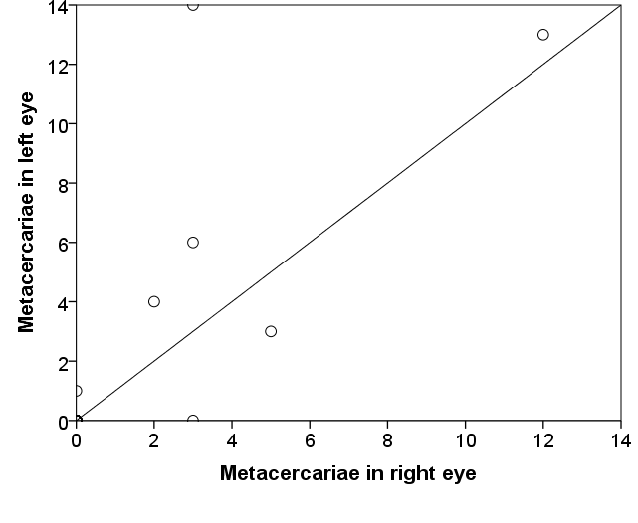

**b. *Diplostomum* sp.**

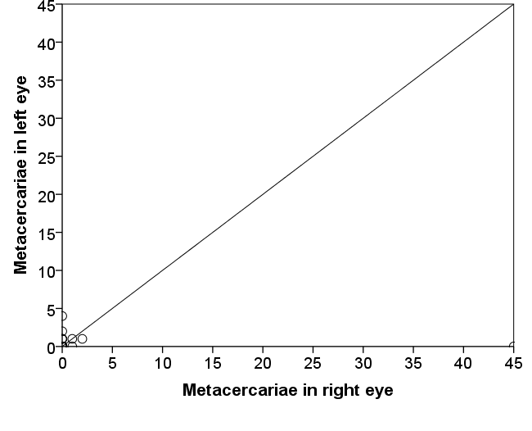

**ii. Perch**

**a. *Tylodelphys* sp.**

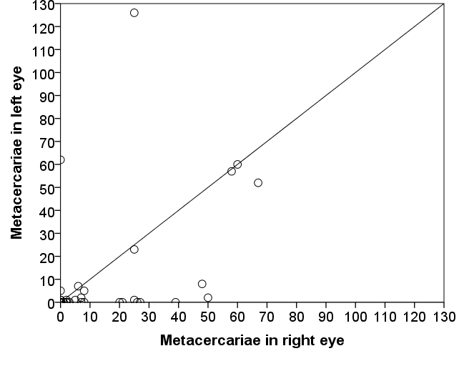

**b. *Diplostomum* sp.**

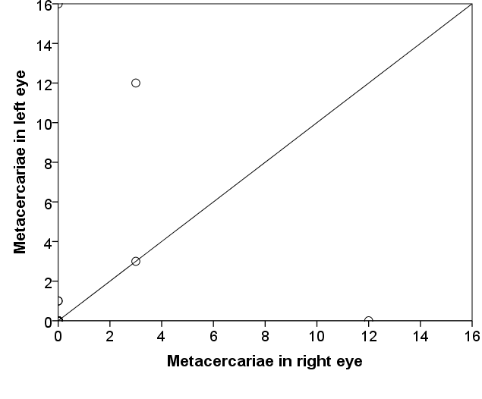

**i. Roach**

Supplementary Figure S4. Relationship between the number of eye flukes in the left and right eye of (i.) Roach and (ii.) Perch in 1996. Line indicates the 1:1 expectation of equal parasite numbers in each eye. (a.) *Tylodelphys* sp*.* (b.) *Diplostomum* sp.

**a. *Tylodelphys* sp.**

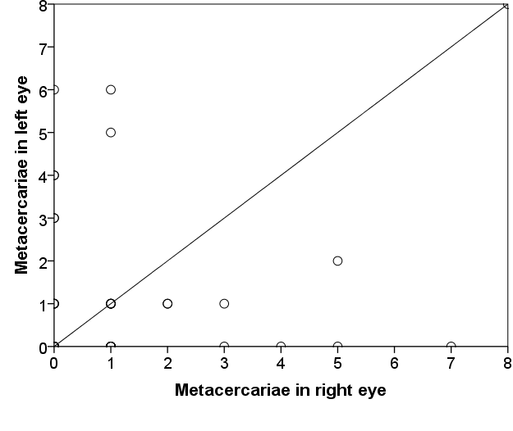

**b. *Diplostomum* sp.**

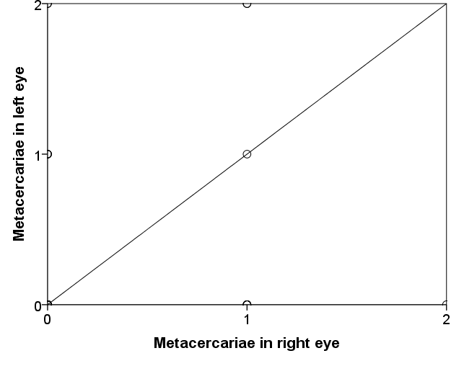

**ii. Perch**

**a. *Tylodelphys* sp.**

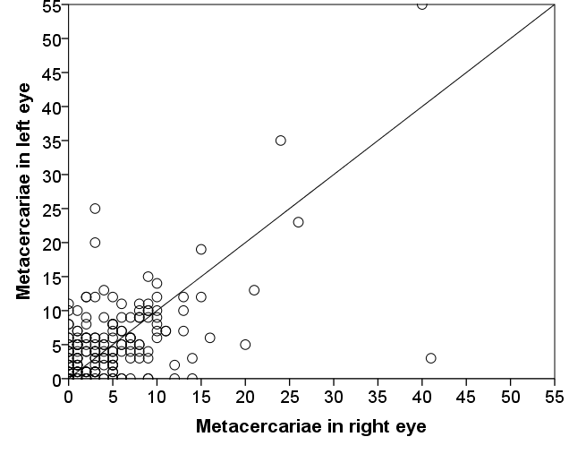

**b. *Diplostomum* sp.**

