Journal of Helminthology
High parasite diversity in a neglected host: Larval trematodes of Bithynia tentaculata in Central Europe
Jessica Schwelm, Olena Kudlai, Nico Smit, Christian Selbach, Bernd Sures
Supplementary Figure S1.
Phylogenetic tree for the Psilostomidae based on the partial sequences of the 28S rRNA gene. Numbers above branches indicate nodal support as posterior probabilities from the Bayesian inference (BI) followed by bootstrap values from the maximum likelihood (ML) analysis. Support values lower than 0.90 (BI) and 70 (ML) are not shown. The scale bar indicates the expected number of substitutions per site. The newly generated sequences are highlighted in bold.
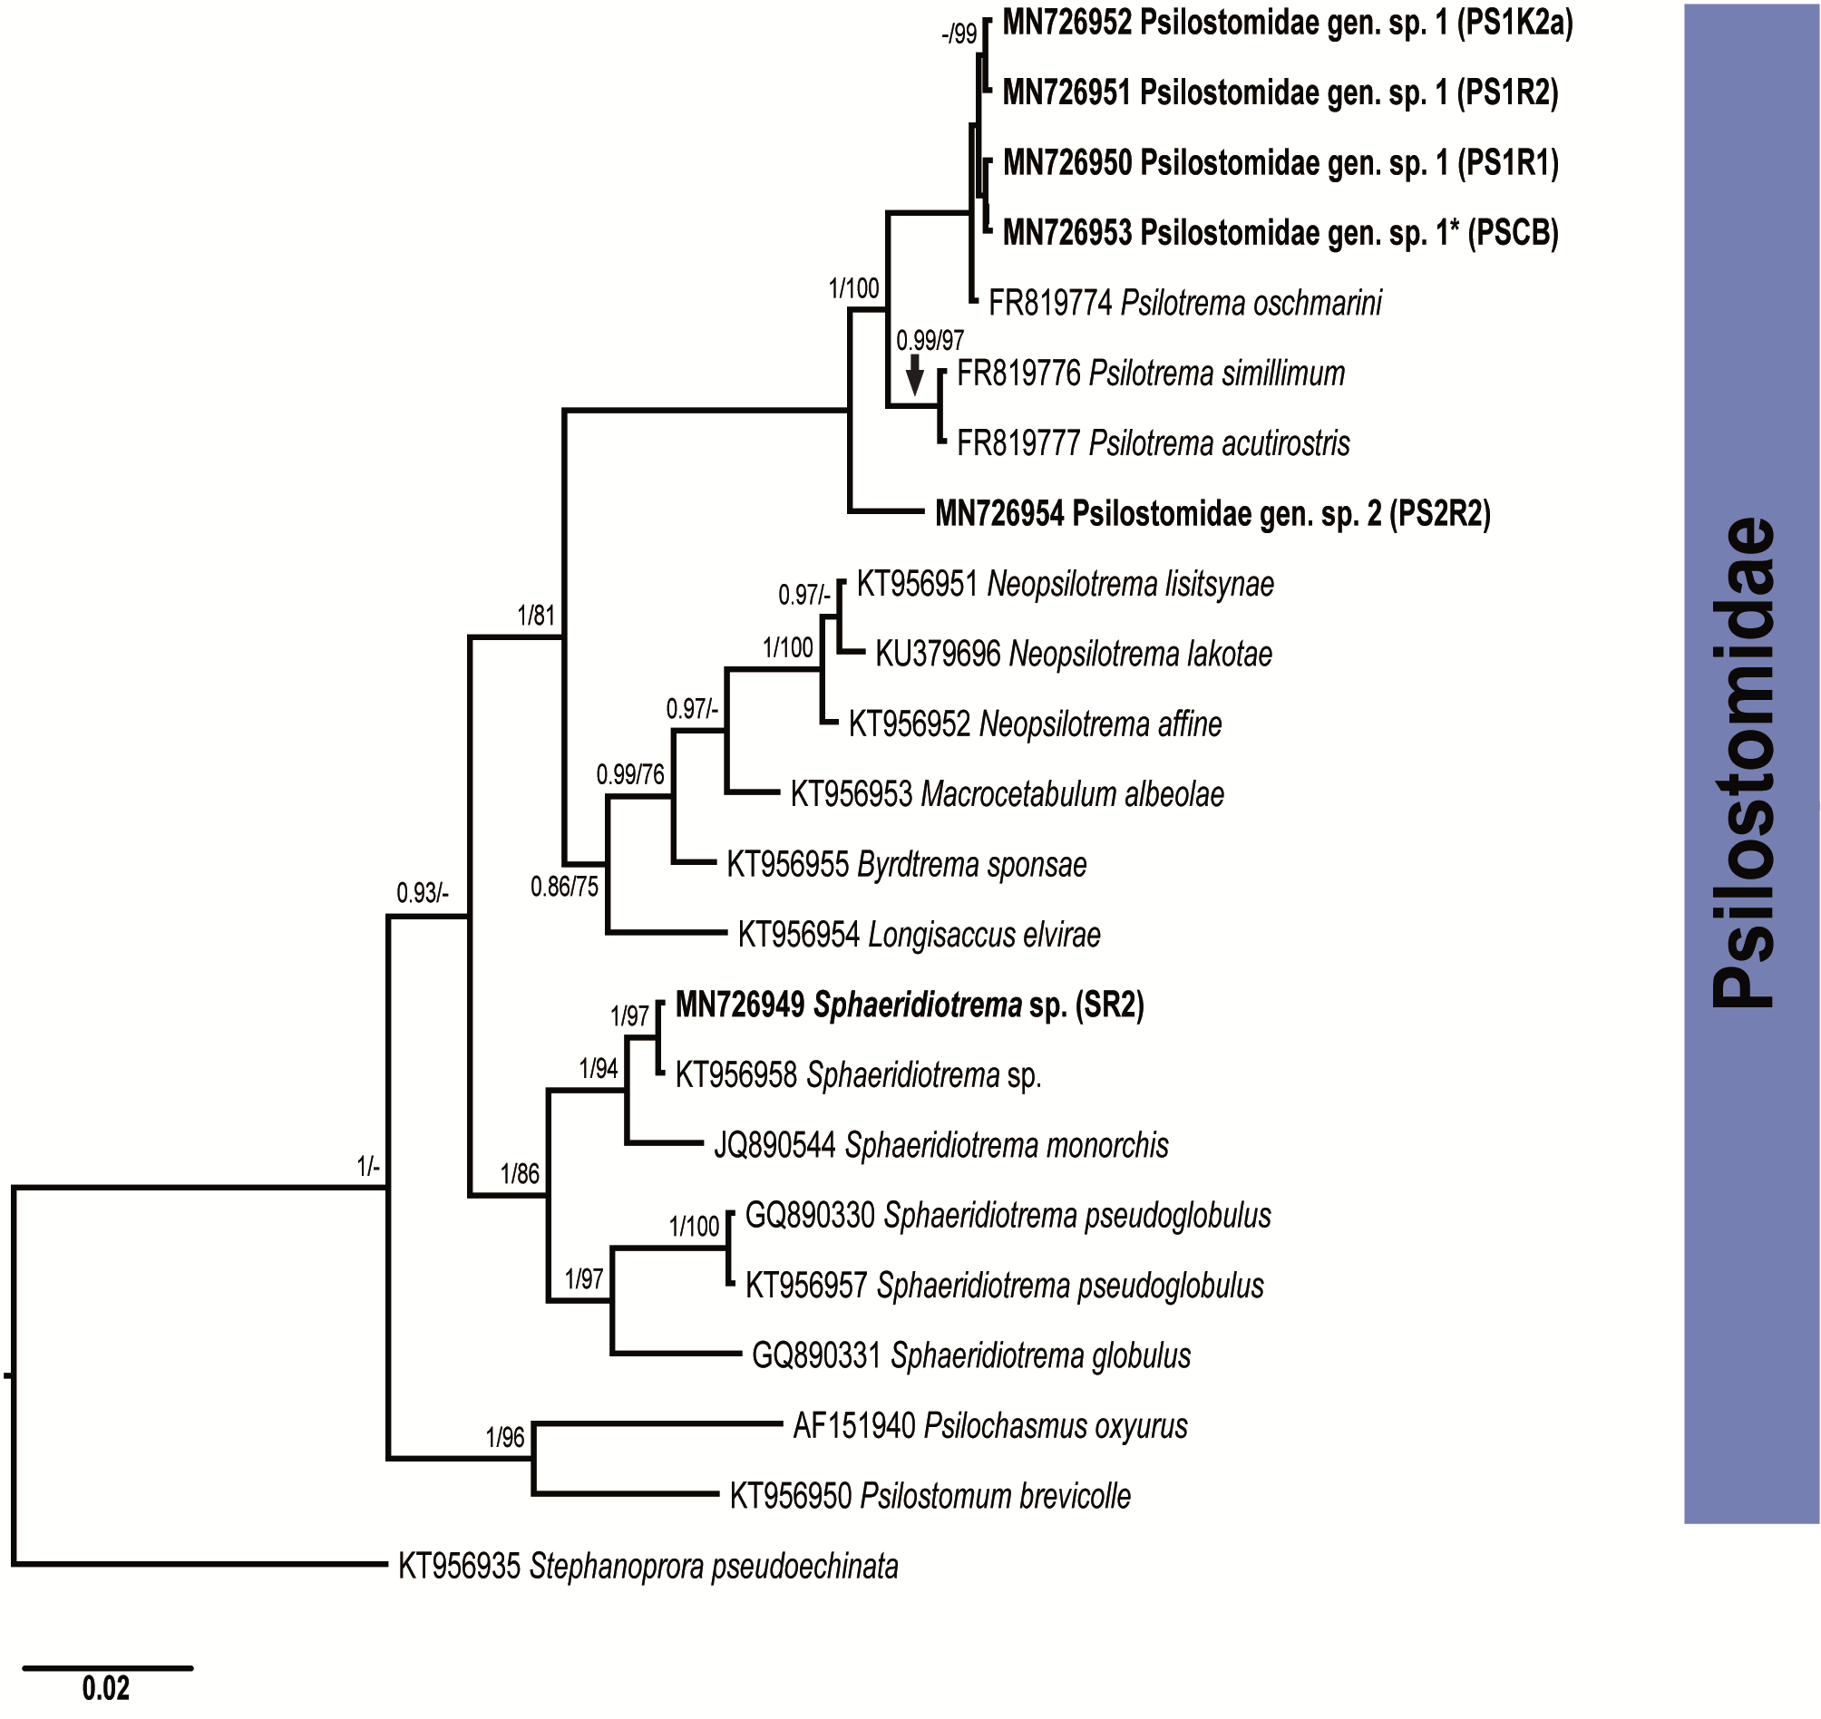

Supplementary Table S1. Summary data for the taxa included in molecular analyses
Taxon | Life-cycle stageª | Host | Country | GenBank No. 28S | GenBank No. ITS2 | Source
Cyathocotylidae Mühling, 1898
Cyathocotyle prussica | M | Gasterosteus aculeatus | Germany | MH521249 | − | Locke et al. (2018)
Mesostephanus microbursa | A | Sula nebouxii | Mexico | MF398326 | − | Hernández-Mena et al. (2017)
Cyathocotylidae sp. | C | Clypeomorus batillariaeformis | Australia | MH257776 | − | Huston et al. (2018)
Echinochasmidae Odhner, 1910
Echinochasmus beleocephalus | A | Ardea alba | Ukraine | KT956929 | − | Tkach et al. (2016)
Echinochasmus bursicola | A | Ardea alba | Ukraine | KT956938 | − | Tkach et al. (2016)
Echinochasmus coaxatus | A | Podiceps nigricollis | Ukraine | KT956928 | − | Tkach et al. (2016)
Echinochasmus donaldsoni | A | Podilymbus podiceps | USA | KT956930 | − | Tkach et al. (2016)
Echinochasmus japonicus | A | Gallus gallus | Vietnam | JQ890579 | − | Besprozvannykh et al. (2013)
Echinochasmus milvi | − | not specified | Russia | KT873319 | − | Besprozvannykh et al. (2017)
Echinochasmus mordax | A | Podiceps nigricollis | Ukraine | KT956931 | − | Tkach et al. (2016)
Echinochasmus sp. | R | Lithoglyphus naticoides | Lithuania | JQ088098 | − | Stanevičiūtė et al. (2015)
Echinochasmus sp. | A | Anhinga anhinga | USA | KT956932 | − | Tkach et al. (2016)
Microparyphium facetum | A | Anhinga anhinga | USA | KT956933 | − | Tkach et al. (2016)
Stephanoprora chasanensis | A | Gallus gallus domesticus | Russia | KT873320 | − | Besprozvannykh et al. (2017)
Stephanoprora pseudoechinata | A | Chroicocephalus genei | Ukraine | KT956935 | − | Tkach et al. (2016)
Stephanoprora pseudoechinata | A | Larus fuscus | USA | KT956934 | − | Tkach et al. (2016)
Stephanoprora sp. 1 | A | Gavia immer | USA | KT956936 | − | Tkach et al. (2016)
Stephanoprora sp. 2 | A | Aechmophorus occidentalis | USA | KT956937 | − | Tkach et al. (2016)
Opisthorchiidae Looss, 1899
Amphimerus ovalis | A | Trionyx muticus | USA | AY116876 | − | Olson et al. (2003)
Clonorchis sinensis | A | Homo sapiens | Vietnam | JF823989 | − | Thaenkham et al. (unpublished)
Metorchis ussuriensis | A | “duck” | Russia | KY075777 | − | Besprozvannykh et al. (2019)
Opisthorchis felineus | A | “cat” | Russia | MF099790 | − | Dao et al. (2017)
Opisthorchis noverca | A | Sus scrofa domestica | India | KC295443 | − | Tandon et al. (unpublished)
Opisthorchis viverrini | A | Puntius brevis | Thailand | HM004188 | − | Thaenkham et al. (unpublished)
Opisthorchis sp. | A | “duck” | Vietnam | MF110001 | − | Dao et al. (2017)
Notoctylidae Lühe, 1909
Catatropis indicus | A | Cairina moschata | Australia | AY222220 | − | Olson et al. (2003)
Catotropis vietnamensis | A | “duck” | Vietnam | MH750019 |  | Izrailskaia et al. (2019)
Ogmogaster antarctica | A | Balaenoptera borealis | Argentina | KM258675 | − | Fraija-Fernández et al. (2015)
Notocotylus atlanticus | A | Anas plathyrhynchos | Russia | MH818008 |  | Gonchar et al. (2019)
Notocotylus attenuatus | A | Aythya ferina | Ukraine | AF184259 | − | Tkach et al. (2001)
Notocotylus intestinalis | A | Gallus gallus | Vietnam | JQ890559 | − | Besprozvannykh et al. (2013)
Notocotylus magniovatus |  | “chicken” | Russia | MH750016 |  | Izrailskaia et al. (2019)
Taxon | Life-cycle stageª | Host | Country | GenBank No. 28S | GenBank No. ITS2 | Source
Notocotylus malhamensis | A | Myodes glareolus; Myodes agrestis | United Kingdom | JQ766939 | − | Boyce et al. (2012)
Notocotylus sp. | S | Lymnaea palustris | United Kingdom | AY222219 | − | Olson et al. (2003)
Notocotylus sp. | C | Radix balthica | Norway | KY513158 | − | Soldánová et al. (2010)
Notocotylus sp. | C | Physa gyrina | USA | EU712725 | − | Hanelt (2009)
Paramonostomum anatis | A | Tringa erythropus | Ukraine | AF184258 | − | Tkach et al. (2001)
Pseudocatatropis dvoryadkini | A | “duck” | Russia | MH750022 |  | Izrailskaia et al. (2019)
Quinqueserialis quinqueserialis | A | Ondatra zibethicus | USA | JQ670848 | − | Detwiler et al. (2012)
Notocotylidae gen. sp. 1 NZ | C | Austrolittorina antipodum | New Zealand | KJ868210 | − | O'Dwyer et al. (2014)
Notocotylidae gen. sp. 2 NZ | C | Austrolittorina antipodum | New Zealand | KJ868214 | − | O'Dwyer et al. (2014)
Pleurogenidae Looss, 1899
Brandesia turgida | A | Rana lessonae | Ukraine | AY220622 | − | Tkach et al. (2003)
Candidotrema loossi | A | Rana ridibunda | Ukraine | AY220621 | − | Tkach et al. (2003)
Cortrema magnicaudata | A | Hirundo rustica | Czech Republic | KJ700420 | − | Kanarek et al. (2014)
Gyrabascus amphoraeformis | A | Pipistrellus kuhli | Ukraine | AF151924 | − | Tkach et al. (2000)
Leyogonimus polyoon | A | Fulica atra | Poland | KY752116 | − | Kanarek et al. (2017)
Macyella massanae | A | Erithacus rubecula | Czech Republic | KP682451 | − | Kanarek et al. (2015)
Macyella postgonoporus | A | Dendrocopus major | Czech Republic | KY752115 | − | Kanarek et al. (2017)
Parabascus duboisi | A | Myotis daubentoni | Ukraine | AY220618 | − | Tkach et al. (2003)
Parabascus joannae | A | Myotis daubentoni | Ukraine | AY220619 | − | Tkach et al. (2003)
Parabascus semisquamosus | A | Pipistrellus kuhli | Ukraine | AF151923 | − | Tkach et al. (2003)
Pleurogenes claviger | A | Rana temporaria | Ukraine | AF151925 | − | Tkach et al. (2000)
Pleurogenes sp. | − | Limnonectes bannaensis | China | MK342571 | − | Li & Fan et al. (unpublished)
Pleurogenoides medians | A | Rana lessonae | Ukraine | AF433670 | − | Tkach et al. (2001)
Prosotocus confusus | A | Rana lessonae | Ukraine | AY220623 | − | Tkach et al. (2003)
Prosthogonimidae Lühe, 1909
Prosthogonimus cuneatus | A | Sturnus vulgaris | Ukraine | AY220634 | − | Tkach et al. (2003)
Prosthogonimus cuneatus | A | Anas platyrhynchos | Vietnam | − | MG910996 | Huynh et al. (unpublished)
Prosthogonimus cuneatus | A | Anas platyrhynchos | Czech Republic | − | KP192725 | Heneberg et al. (2015)
Prosthogonimus ovatus | A | Pica pica | Ukraine | AF151928 | − | Tkach et al. (2000)
Prosthogonimus pellucidus | A | Anas platyrhynchos | Czech Republic | − | KP192732 | Heneberg et al. (2015)
Prosthogonimus ovatus | A | Aythya ferina | Czech Republic | − | KP192722 | Heneberg et al. (2015)
Schistogonimus rarus | A | Anas clypeata | Czech Republic | − | KP192724 | Heneberg et al. (2015)
Schistogonimus rarus | A | Anas querquedula | Ukraine | AY116869 | − | Olson et al. (2003)
Psilostomidae Looss, 1900
Byrdtrema sponasae | A | Aix sponsa | USA | KT956955 | − | Tkach et al. (2016)
Longisaccus elvirae | A | Aix sponsa | USA | KT956954 | − | Tkach et al. (2016)
Macroacetabulum albeolae | A | Bucephala albeola | USA | KT956953 | − | Tkach et al. (2016)
Taxon | Life-cycle stageª | Host | Country | GenBank No. 28S | GenBank No. ITS2 | Source
Neopsilotrema affine | A | Aythya affinis | USA | KT956952 | − | Tkach et al. (2016)
Neopsilotrema lakotae | A | Aythya americana | USA | KU379696 | − | Kudlai et al. (2016)
Neopsilotrema lisitsynae | A | Anas crecca | Ukraine | KT956951 | − | Tkach et al. (2016)
Psilochasmus oxyurus | A | Anas platyrhynchos | Ukraine | AF151940 | − | Tkach et al. (2000)
Psilostomum brevicolle | A | Haematopus ostralegus | Ukraine | KT956950 | − | Tkach et al. (2016)
Psilotrema acutirostris | A | “chikens” | Russia | FR819777 | − | Atopkin (2011)
Psilotrema oschmarini | A | “chikens” | Russia | FR819774 | − | Atopkin (2011)
Psilotrema simillimum | A | “chikens” | Russia | FR819776 | − | Atopkin (2011)
Sphaeridiotrema globulus | A | “duck” | USA | GQ890331 | − | Bergmame et al. (2011)
Sphaeridiotrema monorchis | A | Gallus gallus | Vietnam | JQ890544 | − | Besprozvannykh et al. (2013)
Sphaeridiotrema pseudoglobulus | A | Anas platyrhynchos domesticus | Canada | GQ890330 | − | Bergmame et al. (2011)
Sphaeridiotrema pseudoglobulus | A | Aythya affinis | USA | KT956957 | − | Tkach et al. (2016)
Sphaeridiotrema sp. | C | Bithynia tentaculata | Lithuania | KT956958 | − | Tkach et al. (2016)
Outgroup
Acanthoparyphium spinulosum | A | Pluvialis squatarola | Ukraine | KT956939 | − | Tkach et al. (2016)
Apophallus_zalophi | A | Callorhinus ursinus | USA | MG806918 | − | Kuzmina et al. (2018)
Himasthla limnodromi | A | Limnodromus griseus | USA | KT956943 | − | Tkach et al. (2016)
Labicola cf. elongata | A | Dugong dugong | Australia | AY222221 | − | Olson et al. (2003)
Levinseniella sp. | A | Somateria mollissima v-nigrum | Russia | MG783585 | MG783580 | Galaktionov & Blasco-Costa (2018)
Microphallus minutus | C | Posticobia brazieri | Australia | − | KT355829 | Kudlai et al. (2015)
Microphallus similis | M | Carcinus maenas | Northen Ireland | AY220625 | − | Tkach et al. (2003)
Opisthotrema dujonis | A | Dugong dugong | Australia | AY222223 | − | Olson et al. (2003)
Posthodiplostomum brevicaudatum | M | Perca fluviatilis | Czech Republic | KX931426 | − | Stoyanov et al. (2017)
Taprobanella bicaudata | A | Dugong dugong | Australia | AY222217 | − | Olson et al. (2003)
ª Life-cycle stages: A, adult; C, cercaria; M, Metacercariae; R, redia; S, sporocyst, −: not specified

References

Atopkin, D.M. (2011) Genetic characterization of the Psilotrema (Digenea: Psilostomatidae) genus by partial 28S ribosomal DNA sequences. Parasitology International, 60, 541–543.
Bergmame, L., Huffman, J., Cole, R., Dayanandan, S., Tkach, V. & McLaughlin, J.D. (2011) Sphaeridiotrema globulus and Sphaeridiotrema pseudoglobulus (Digenea): Species Differentiation Based On mtDNA (Barcode) and Partial LSU–rDNA Sequences. Journal of Parasitology, 97, 1132–1136.
Besprozvannykh V., Ngo, H., Ha, N., Hung, N., Rozhkovan, K. & Ermolenko, A. (2013) Descriptions of digenean parasites from three snail species, Bithynia fuchsiana (More Fraija-Fernandez let), Parafossarulus striatulus Benson and Melanoides tuberculata Müller, in North Vietnam. Helminthologia, 50 190–204.
Besprozvannykh, V. V., Rozhkovan, K. V. & Ermolenko, A. V. (2017) Stephanoprora chasanensis n. sp. (Digenea: Echinochasmidae): Morphology, life cycle, and molecular data. Parasitology International, 66, 863–870.
Besprozvannykh, V. V., Tatonova, Y. V. & Shumenko, P.G. (2019) Life cycle, morphology of developmental stages of Metorchis ussuriensis sp. nov. (Trematoda: Opisthorchiidae), and phylogenetic relationships with other opisthorchiids. Journal of Zoological Systematics and Evolutionary Research, 57, 24–40.
Boyce, K., Hide, G., Craig, P.S., Harris, P.D., Reynolds, C., Pickles, A. & Rogan, M.T. (2012) Identification of a new species of digenean Notocotylus malhamensis n. sp. (Digenea: Notocotylidae) from the bank vole (Myodes glareolus) and the field vole (Microtus agrestis). Parasitology, 139, 1630–1639.
Dao, T.T.H., Nguyen, T.T.G., Gabriël, S., Bui, K.L., Dorny, P. & Le, T.H. (2017) Updated molecular phylogenetic data for Opisthorchis spp. (Trematoda: Opisthorchioidea) from ducks in Vietnam. Parasites and Vectors, 10, 1–10.
Detwiler, J.T., Zajac, A.M., Minchella, D.J. & Belden, L.K. (2013) Revealing cryptic parasite diversity in a definitive host: Echinostomes in muskrats. Journal of Parasitology, 98, 1148–1155.
Fraija-Fernández, N., Olson, P.D., Crespo, E.A., Raga, J.A., Aznar, F.J. & Fernández, M. (2015) Independent host switching events by digenean parasites of cetaceans inferred from ribosomal DNA. International Journal for Parasitology, 45, 167–173.
Galaktionov, K. V. & Blasco-Costa, I. (2018) Microphallus ochotensis sp. nov. (Digenea, Microphallidae) and relative merits of two-host microphallid life cycles. Parasitology Research, 117, 1051–1068.
Gonchar, A., Jouet, D., Skírnisson, K., Krupenko, D. & Galaktionov, K. V. (2019) Transatlantic discovery of Notocotylus atlanticus (Digenea : Notocotylidae) based on life cycle data. Parasitology Research, 118, 1445–1456.
Hanelt, B. (2009) Hyperparasitism by Paragordius varius (Nematomorpha: Gordiida) Larva of monostome redia (Trematoda : Digenea ) The Journal of parasitology, 95, 242–243.
Heneberg, P., Sitko, J. & Bizos, J. (2015) Integrative taxonomy of central European parasitic flatworms of the family Prosthogonimidae Lühe, 1909 (Trematoda: Plagiorchiida). Parasitology International, 64, 264–273.
Hernández-Mena, D.I., García-Varela, M. & Pérez-Ponce de León, G. (2017) Filling the gaps in the classification of the Digenea Carus, 1863: systematic position of the Proterodiplostomidae Dubois, 1936 within the superfamily Diplostomoidea Poirier, 1886, inferred from nuclear and mitochondrial DNA sequences. Systematic Parasitology, 94, 833–848.
Izrailskaia, A. V, Besprozvannykh, V. V, Tatonova, Y. V, Manh Nguyen, H. & Duy Ngo, H. (2019) Developmental stages of Notocotylus magniovatus Yamaguti , 1934, Catatropis vietnamensis n . sp., Pseudocatatropis dvoryadkini n. sp., and phylogenetic relationships of Notocotylidae Lühe, 1909. Parasitology Research, 118, 469–481.
Kanarek, G., Zaleśny, G., Sitko, J. & Tkach, V. V. (2014) Phylogenetic relationships and systematic position of the families Cortrematidae and Phaneropsolidae (Platyhelminthes: Digenea). Folia Parasitologica, 61, 523–528.
Kanarek, G., Zaleśny, G., Czujkowska, A., Sitko, J. & Harris, P.D. (2015) On the systematic position of Collyricloides massanae Vaucher, 1969 (Platyhelminthes: Digenea) with notes on distribution of this trematode species. Parasitology Research, 114, 1495–1501.
Kanarek, G., Zaleśny, G., Sitko, J. & Tkach, V. V. (2017) The systematic position and structure of the genus Leyogonimus Ginetsinskaya, 1948 (Platyhelminthes: Digenea) with comments on the taxonomy of the superfamily Microphalloidea Ward, 1901. Acta Parasitologica, 62, 617–624.
Kudlai, O., Cutmore, S.C. & Cribb, T.H. (2015) Morphological and molecular data for three species of the Microphallidae (Trematoda: Digenea) in Australia, including the first descriptions of the cercariae of Maritrema brevisacciferum Shimazu et Pearson, 1991 and Microphallus minutus Johnston, 1948. Folia Parasitologica, 62.
Kudlai, O., Pulis, E.E., Kostadinova, A. & Tkach, V. V. (2016) Neopsilotrema n. g. (Digenea: Psilostomidae) and three new species from ducks (Anseriformes: Anatidae) in North America and Europe. Systematic Parasitology, 93, 307–319.
Kuzmina, T.A., Tkach, V. V., Spraker, T.R., Lyons, E.T. & Kudlai, O. (2018) Digeneans of northern fur seals Callorhinus ursinus (Pinnipedia: Otariidae) from five subpopulations on St. Paul Island, Alaska. Parasitology Research, 117, 1079–1086.
Locke, S.A., Van Dam, A., Caffara, M., Pinto, H.A., López-Hernández, D. & Blanar, C.A. (2018) Validity of the Diplostomoidea and Diplostomida (Digenea, Platyhelminthes) upheld in phylogenomic analysis. International Journal for Parasitology, 48, 1043–1059.
O’Dwyer, K., Blasco-Costa, I., Poulin, R. & Faltýnková, A. (2014) Four marine digenean parasites of Austrolittorina spp. (Gastropoda: Littorinidae) in New Zealand: morphological and molecular data. Systematic Parasitology, 89, 133–152.
Olson, P.D., Cribb, T.H., Tkach, V. V., Bray, R.A. & Littlewood, D.T.J. (2003) Phylogeny and classification of the Digenea (Platyhelminthes: Trematoda). International Journal for Parasitology, 33, 733–755.
Staneviciute, G., Stunženas, V. & Petkeviciute, R. (2015) Phylogenetic relationships of some species of the family Echinostomatidae Odner, 1910 (Trematoda), inferred from nuclear rDNA sequences and karyological analysis. Comparative Cytogenetics, 9, 257–270.
Soldánová, M., Selbach, C., Sures, B., Kostadinova, A. & Pérez-Del-Olmo, A. (2010) Larval trematode communities in Radix auricularia and Lymnaea stagnalis in a reservoir system of the Ruhr River. Parasites & vectors, 3, 56.
Stoyanov, B., Georgieva, S., Pankov, P., Kudlai, O., Kostadinova, A. & Georgiev, B.B. (2017) Morphology and molecules reveal the alien Posthodiplostomum centrarchi Hoffman, 1958 as the third species of Posthodiplostomum Dubois, 1936 (Digenea: Diplostomidae) in Europe. Systematic Parasitology, 94, 1–20.
Tkach, V., Pawlowski, J. & Mariaux, J. (2000) Phylogenetic analysis of the suborder Plagiorchiata (Platyhelminthes, Digenea) based on partial lsrDNA sequences. International Journal for Parasitology, 30, 83–93.
Tkach, V.V., Snyder, S.D. & Świderski, Z. (2001) On the phylogenetic relationships of some members of Macroderoididae and Ochetosomatidae (Digenea, Plagiorchioidea). Acta Parasitologica, 46, 267–75.
Tkach, V. V., Littlewood, D.T.J., Olson, P.D., Kinsella, J.M. & Swiderski, Z. (2003) Molecular phylogenetic analysis of the Microphalloidea Ward, 1901 (Trematoda: Digenea). Systematic Parasitology, 56, 1–15.
Tkach, V. V., Kudlai, O. & Kostadinova, A. (2016) Molecular phylogeny and systematics of the Echinostomatoidea Looss, 1899 (Platyhelminthes: Digenea). International Journal for Parasitology, 46, 171–185.

