Journal of Helminthology
Short Communication: Mitochondrial genome of Rhabdosynochus viridisi (Monogenea: Diplectanidae), a parasite of Pacific white snook Centropomus viridis
Víctor Caña-Bozada, Raúl Llera-Herrera, Emma J. Fajer-Ávila, F. Neptalí Morales-Serna

Supplementary Table S1. Monogenean species and outgroups (*) used for comparative mitogenomic and phylogenetic analyses.
ID | Organism | Order | Family
MW565922 | Rhabdosynochus viridisi | Monopisthocotylea | Diplectanidae
MH328204.1 | Lamellodiscus spari | Monopisthocotylea | Diplectanidae
NC_039617.1 | Lepidotrema longipenis | Monopisthocotylea | Diplectanidae
JQ038231.1 | Pseudorhabdosynochus yangjiangensis | Monopisthocotylea | Diplectanidae
NC_014591.1 | Benedenia hoshinai | Monopisthocotylea | Capsalidae
NC_014291.1 | Benedenia seriolae | Monopisthocotylea | Capsalidae
NC_047185.1 | Capsala pricei | Monopisthocotylea | Capsalidae
MN746369.1 | Capsaloides cristatus | Monopisthocotylea | Capsalidae
JQ038228.1 | Neobenedenia melleni | Monopisthocotylea | Capsalidae
MN095192.1 | Ancyrocephalus mogurndae | Monopisthocotylea | Dactylogyridae
MG970255.1 | Cichlidogyrus halli | Monopisthocotylea | Dactylogyridae
MG970257.1 | Cichlidogyrus mbirizei | Monopisthocotylea | Dactylogyridae
JQ038226.1 | Cichlidogyrus sclerosus | Monopisthocotylea | Dactylogyridae
KR871673.1 | Dactylogyrus lamellatus | Monopisthocotylea | Dactylogyridae
NC_048529.1 | Enterogyrus malmbergi | Monopisthocotylea | Dactylogyridae
MT447060.1 | Scutogyrus longicornis | Monopisthocotylea | Dactylogyridae
NC_018031.1 | Tetrancistrum nebulosi | Monopisthocotylea | Dactylogyridae
KU679421.1 | Aglaiogyrodactylus forficulatus | Monopisthocotylea | Gyrodactylidae
NC_031337.1 | Gyrodactylus brachymystacis | Monopisthocotylea | Gyrodactylidae
NC_010976.1 | Gyrodactylus derjavinoides | Monopisthocotylea | Gyrodactylidae
KU659806.1 | Gyrodactylus gurleyi | Monopisthocotylea | Gyrodactylidae
NC_030050.1 | Gyrodactylus kobayashii | Monopisthocotylea | Gyrodactylidae
MG970256.1 | Gyrodactylus nyanzae | Monopisthocotylea | Gyrodactylidae
NC_031438.1 | Gyrodactylus parvae | Monopisthocotylea | Gyrodactylidae
NC_008815.1 | Gyrodactylus salaris | Monopisthocotylea | Gyrodactylidae
NC_009682.1 | Gyrodactylus thymalli | Monopisthocotylea | Gyrodactylidae
MG970258.1 | Macrogyrodactylus karibae | Monopisthocotylea | Gyrodactylidae
NC_024754.1 | Paragyrodactylus variegatus | Monopisthocotylea | Gyrodactylidae
NC_046757.1 | Tetraonchus monenteron | Monopisthocotylea | Tetraonchidae
NC_036305.1 | Paratetraonchoides inermis | Monopisthocotylea | Tetraonchoididae
NC_016950.1 | Pseudochauhanea macrorchis | Polyopisthocotylea | Chauhaneidae
MG458327.1 | Paradiplozoon opsariichthydis | Polyopisthocotylea | Diplozoidae
MG458326.1 | Sindiplozoon sp. | Polyopisthocotylea | Diplozoidae
JQ038229.1 | Neomazocraes dorosomatis | Polyopisthocotylea | Mazocraeidae
NC_009055.1 | Microcotyle sebastis | Polyopisthocotylea | Microcotylidae
NC_016057.1 | Polylabris halichoeres | Polyopisthocotylea | Microcotylidae
JQ038227.1 | Diplorchis hangzhouensis | Polyopisthocotylea | Polystomatidae
NC_026978.1 | Obama sp. * | Seriata | Geoplanidae
KP208776.1 | Crenobia alpina * | Seriata | Planariidae

Supplementary Table S2. The best partitioning scheme selected by PartitionFinder for phylogenetic analyses of maximum likelihood using the PCGs and rRNA genes of monogeneans.
Subset | Best model | # sites | Partition names
1 | GTR+I+G | 276 | atp6_mafft_codon1
2 | GTR+I+G | 580 | cox3_mafft_codon2, atp6_mafft_codon2
3 | GTR+G | 376 | atp6_mafft_codon3, nad4L_mafft_codon3
4 | GTR+I+G | 643 | cox1_mafft_codon1
5 | GTR+I+G | 643 | cox1_mafft_codon2
6 | GTR+I+G | 1055 | cytb_mafft_codon3, cox1_mafft_codon3
7 | GTR+I+G | 280 | cox2_mafft_codon1
8 | GTR+I+G | 280 | cox2_mafft_codon2
9 | GTR+I+G | 280 | cox2_mafft_codon3
10 | GTR+I+G | 304 | cox3_mafft_codon1
11 | GTR+I+G | 756 | cox3_mafft_codon3, nad3_mafft_codon3, nad1_mafft_codon3
12 | GTR+I+G | 412 | cytb_mafft_codon1
13 | GTR+G | 412 | cytb_mafft_codon2
14 | GTR+I+G | 323 | nad1_mafft_codon1
15 | GTR+G | 323 | nad1_mafft_codon2
16 | GTR+I+G | 414 | nad2_mafft_codon1
17 | GTR+I+G | 414 | nad2_mafft_codon2
18 | GTR+I+G | 414 | nad2_mafft_codon3
19 | GTR+I+G | 1246 | nad5_mafft_codon1, nad3_mafft_codon1, nad4_mafft_codon1
20 | GTR+I+G | 1433 | nad3_mafft_codon2, nad5_mafft_codon2, nad6_mafft_codon2, nad4_mafft_codon2
21 | GTR+I+G | 287 | nad4L_mafft_codon1, nad6_mafft_codon1
22 | GTR+G | 100 | nad4L_mafft_codon2
23 | GTR+I+G | 1304 | nad6_mafft_codon3, nad4_mafft_codon3, nad5_mafft_codon3
24 | GTR+I+G | 2066 | rrnL_mafft, rrnS_mafft

Supplementary Table S3. The best partitioning scheme selected by PartitionFinder for phylogenetic analyses of Bayesian inference using the PCGs and rRNA genes of monogeneans.
Subset | Best Model | # sites | Partition names
1 | GTR+I+G | 1183 | nad1_mafft_codon1, cox2_mafft_codon1, cox3_mafft_codon1, atp6_mafft_codon1
2 | GTR+I+G | 1595 | cytb_mafft_codon2, cox3_mafft_codon2, cox2_mafft_codon2, nad1_mafft_codon2, atp6_mafft_codon2
3 | GTR+I+G | 2094 | nad2_mafft_codon3, nad6_mafft_codon3, nad5_mafft_codon3, nad4_mafft_codon3, nad4L_mafft_codon3, atp6_mafft_codon3
4 | GTR+I+G | 1055 | cytb_mafft_codon1, cox1_mafft_codon1
5 | GTR+I+G | 643 | cox1_mafft_codon2
6 | GTR+I+G | 2091 | cox1_mafft_codon3, nad1_mafft_codon3, cytb_mafft_codon3, nad3_mafft_codon3, cox2_mafft_codon3, cox3_mafft_codon3
7 | GTR+I+G | 1947 | nad2_mafft_codon1, nad4L_mafft_codon1, nad5_mafft_codon1, nad3_mafft_codon1, nad6_mafft_codon1, nad4_mafft_codon1
8 | GTR+I+G | 1947 | nad2_mafft_codon2, nad4L_mafft_codon2, nad5_mafft_codon2, nad6_mafft_codon2, nad3_mafft_codon2, nad4_mafft_codon2
9 | GTR+I+G | 2066 | rrnL_mafft, rrnS_mafft

Supplementary Table S4. Nucleotide composition and skewness comparison of different elements of the mitochondrial genome of Rhabdosynochus viridisi.
Regions | Size (bp) | T(U) | C | A | G | AT(%) | GC(%) | AT skew | GC skew
PCGs | 9972 | 49.2 | 7.5 | 27.3 | 16.1 | 76.5 | 23.6 | -0.287 | 0.367
1st codon position | 3324 | 42 | 8.4 | 29.5 | 20.1 | 71.5 | 28.5 | -0.174 | 0.413
2nd codon position | 3324 | 49.5 | 11.9 | 21.1 | 17.6 | 70.6 | 29.5 | -0.403 | 0.194
3rd codon position | 3324 | 56 | 2.2 | 31.2 | 10.6 | 87.2 | 12.8 | -0.285 | 0.662
atp6 | 510 | 48.6 | 8.6 | 27.1 | 15.7 | 75.7 | 24.3 | -0.285 | 0.29
cox1 | 1557 | 46.4 | 9.5 | 25.1 | 19 | 71.5 | 28.5 | -0.297 | 0.333
cox2 | 573 | 41.9 | 8 | 28.6 | 21.5 | 70.5 | 29.5 | -0.188 | 0.456
cox3 | 649 | 51.8 | 8 | 26.3 | 13.8 | 78.1 | 21.8 | -0.326 | 0.265
cytb | 1089 | 46.5 | 9.5 | 26.2 | 17.9 | 72.7 | 27.4 | -0.279 | 0.309
nad1 | 903 | 48.6 | 6.8 | 25.4 | 19.3 | 74 | 26.1 | -0.314 | 0.481
nad2 | 873 | 53.3 | 5 | 29.9 | 11.8 | 83.2 | 16.8 | -0.281 | 0.401
nad3 | 354 | 50.3 | 3.4 | 28.2 | 18.1 | 78.5 | 21.5 | -0.281 | 0.684
nad4 | 1203 | 50.8 | 8.1 | 27.9 | 13.2 | 78.7 | 21.3 | -0.29 | 0.242
nad4L | 246 | 53.7 | 4.9 | 29.7 | 11.8 | 83.4 | 16.7 | -0.288 | 0.415
nad5 | 1542 | 50 | 6 | 29.3 | 14.7 | 79.3 | 20.7 | -0.261 | 0.423
nad6 | 450 | 54 | 6.9 | 24.9 | 14.2 | 78.9 | 21.1 | -0.369 | 0.347
16S rRNA | 934 | 39.5 | 8.1 | 37 | 15.3 | 76.5 | 23.4 | -0.032 | 0.306
12S rRNA | 737 | 41.2 | 8.3 | 35.7 | 14.8 | 76.9 | 23.1 | -0.072 | 0.282
rRNAs | 1671 | 40.3 | 8.2 | 36.4 | 15.1 | 76.7 | 23.3 | -0.05 | 0.296
tRNAs | 1421 | 40.3 | 7.6 | 37 | 15.1 | 77.3 | 22.7 | -0.042 | 0.331
Full genome | 13863 | 46.9 | 7.6 | 30 | 15.5 | 76.9 | 23.1 | -0.219 | 0.341

Supplementary Figure S1. Coverage of the mitochondrial genome of Rhabdosynochus viridisi (13,863 bp; NCBI accession MW565922).

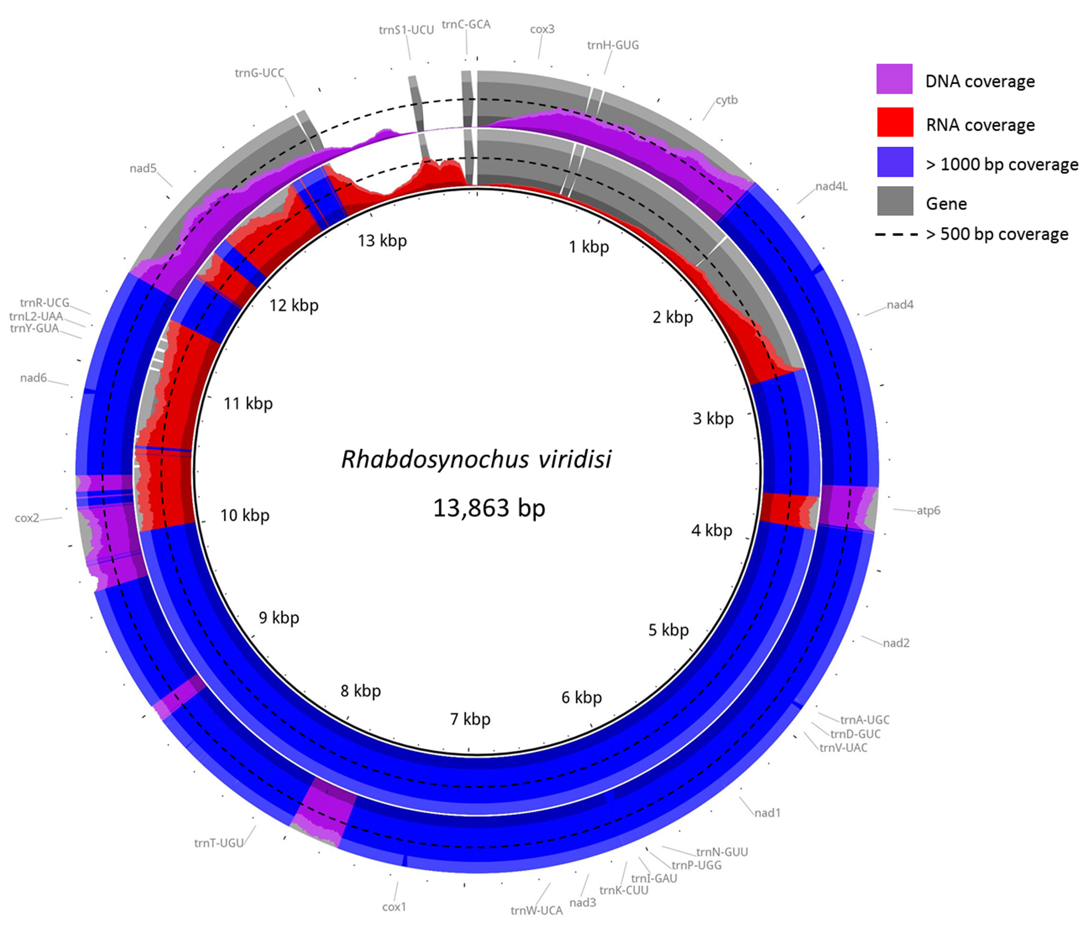

Supplementary Figure S2. Bases in the mitogenome of R. viridisi in which at least 20% of the nucleotide coverage differed from the assembly. Non-conflicting bases are shown in gray.
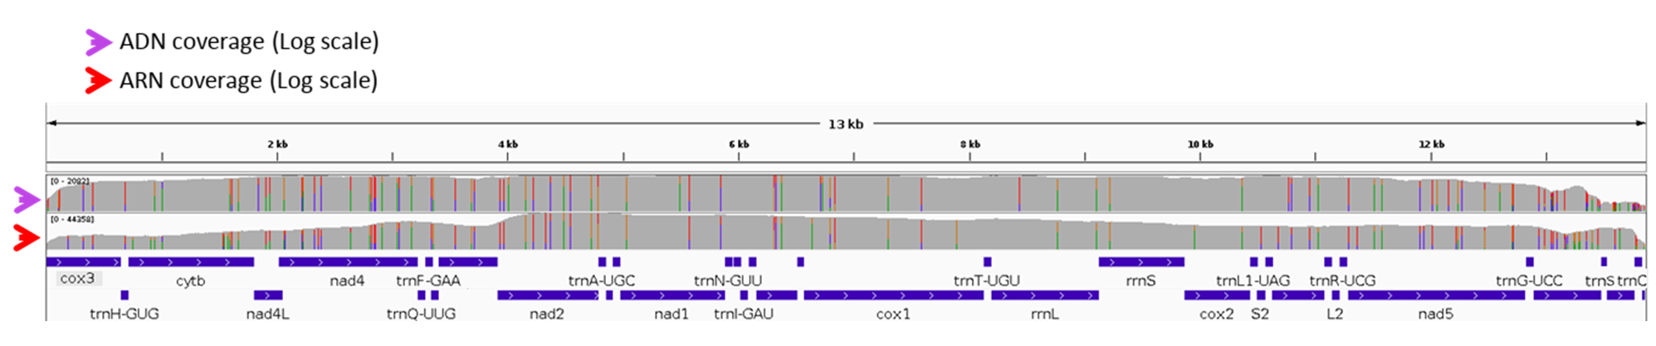

Supplementary Figure S3. Circular representation of the mitochondrial genome of Rhabdosynochus viridisi.
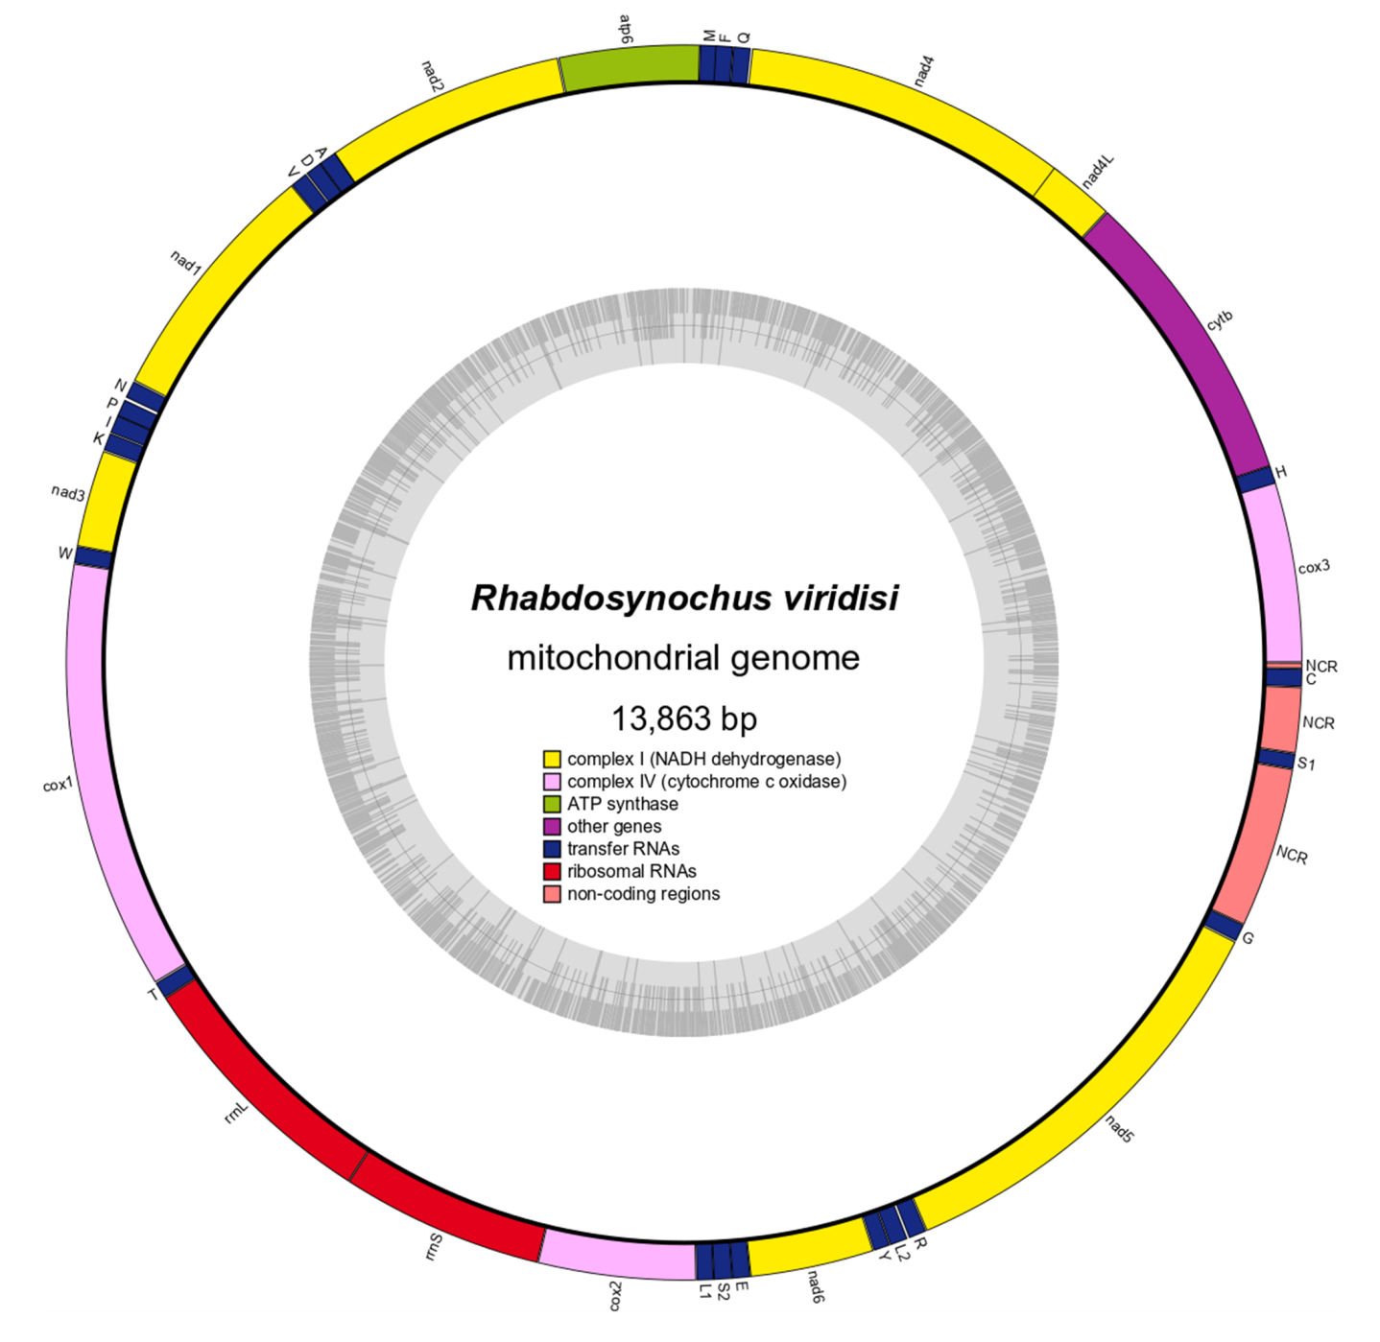

Supplementary Figure S4. Gene order representation for members of the Diplectanidae family showing the most probable scenario of transposition.

