<JLO 19516; supplementary material>

**Table 1.** Number of data zones by number of cases of vestibular schwannomas

|  |  |
| --- | --- |
| Cases of vestibular schwannoma (*n*) | Data zones (*n*) |
| 1 | 398 |
| 2 | 54 |
| 3 | 3 |

**Table 2.** Council areas by cases of vestibular schwannomas

|  |  |
| --- | --- |
| Council area | Vestibular schwannoma (*n*) |
| Clackmannanshire | 2 |
| East Ayrshire | 30 |
| East Dunbartonshire | 28 |
| East Renfrewshire | 34 |
| Falkirk | 5 |
| Glasgow city | 96 |
| Inverclyde | 31 |
| North Lanarkshire | 36 |
| Perth and Kinross | 2 |
| Renfrewshire | 60 |
| South Lanarkshire | 54 |
| Stirling | 7 |
| West Dunbartonshire | 12 |
| Highland | 20 |
| Moray | 2 |
| Na h-Eileanan an Iar | 7 |
| Argyll and Bute | 24 |
| North Ayrshire | 24 |
| Dumfries and Galloway | 10 |
| South Ayrshire | 27 |

**Fig. 1.** Distribution of Scottish Index of Multiple Deprivation ranks across vestibular schwannoma cases in Scotland. Note that Scottish Index of Multiple Deprivation ranks of each vestibular schwannoma case were assigned by postcode. SIMD = Scottish Index of Multiple Deprivation; VS = vestibular schwannoma

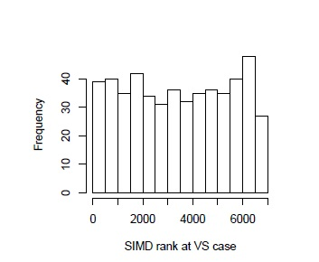

– Please change y-axis label to ‘Vestibular schwannoma cases (*n*)’

**Fig. 2.** Observed empirical cumulative distribution functions of vestibular schwannoma Scottish Index of Multiple Deprivation ranks with simulation envelope. ECDF = empirical cumulative distribution functions

SIMD = Scottish Index of Multiple Deprivation; VS = vestibular schwannoma

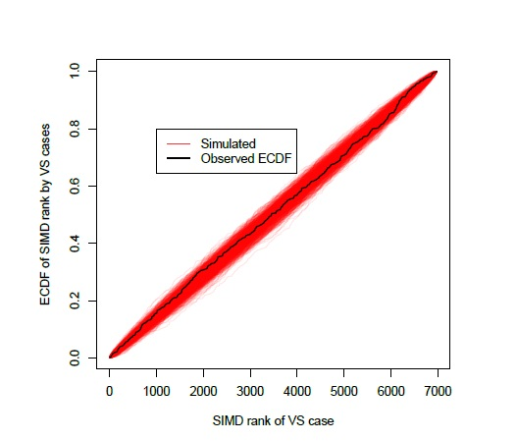

– Please move the key to below the x-axis.