Figure 2: Altars to La Santa Muerte and the colonias’ prison population in the Federal District, April 2008
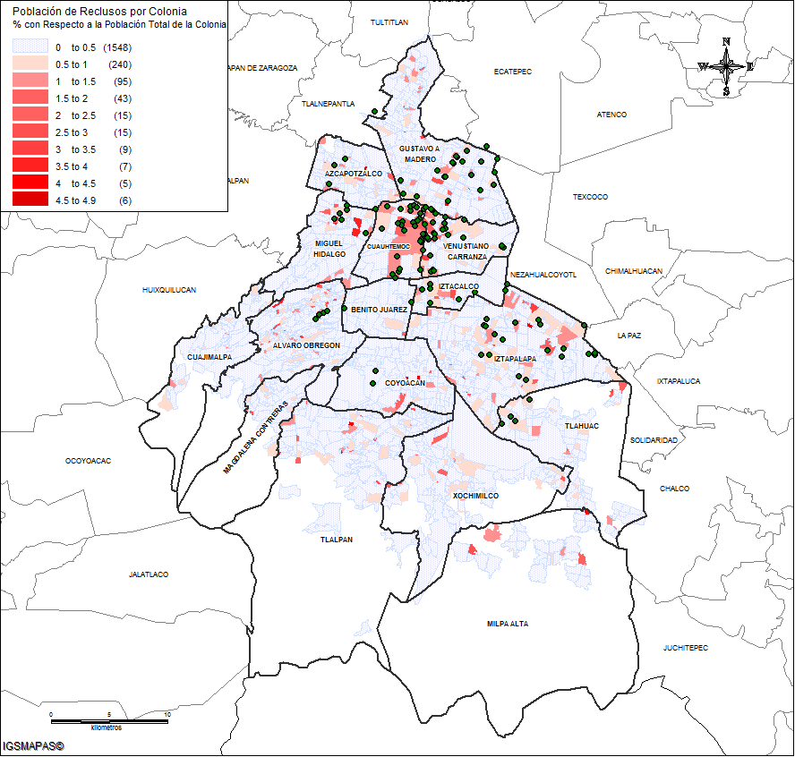
Note on source: Author’s projection, derived from the Federal District government’s statistics on prison population. The government of the Federal District provided the author with a list of each colonia’s total number of people serving time in one of the Federal District’s prisons. This list does not include people from the Federal District who are serving time in a federal jail. This number is small due to the much smaller capacities of the five federal high-security prisons in Mexico, which receive inmates from all over the Mexican Republic

