Supporting Information:
Table S1. The composition of liquid medium.
Figure S1. The single colony of QD1.
Figure S2. The growth curve of Renibacterium sp. QD1.
Figure S3. Effects of cultivation time and temperature on chitosanase production. The effect of cultivation time and temperature on enzyme activity was determined at different temperatures at different time points under standard assay conditions as described before.

Table S1. The composition of liquid medium.
Chemicals | Concentration ( m/v )
Chitosan | 0.50%
KH₂SO₄ | 0.10%
K₂HPO₄ | 0.20%
MgSO₄ | 0.07%
NaCl | 0.05%
CaCl₂ | 0.01%
yeast extract | 0.05%

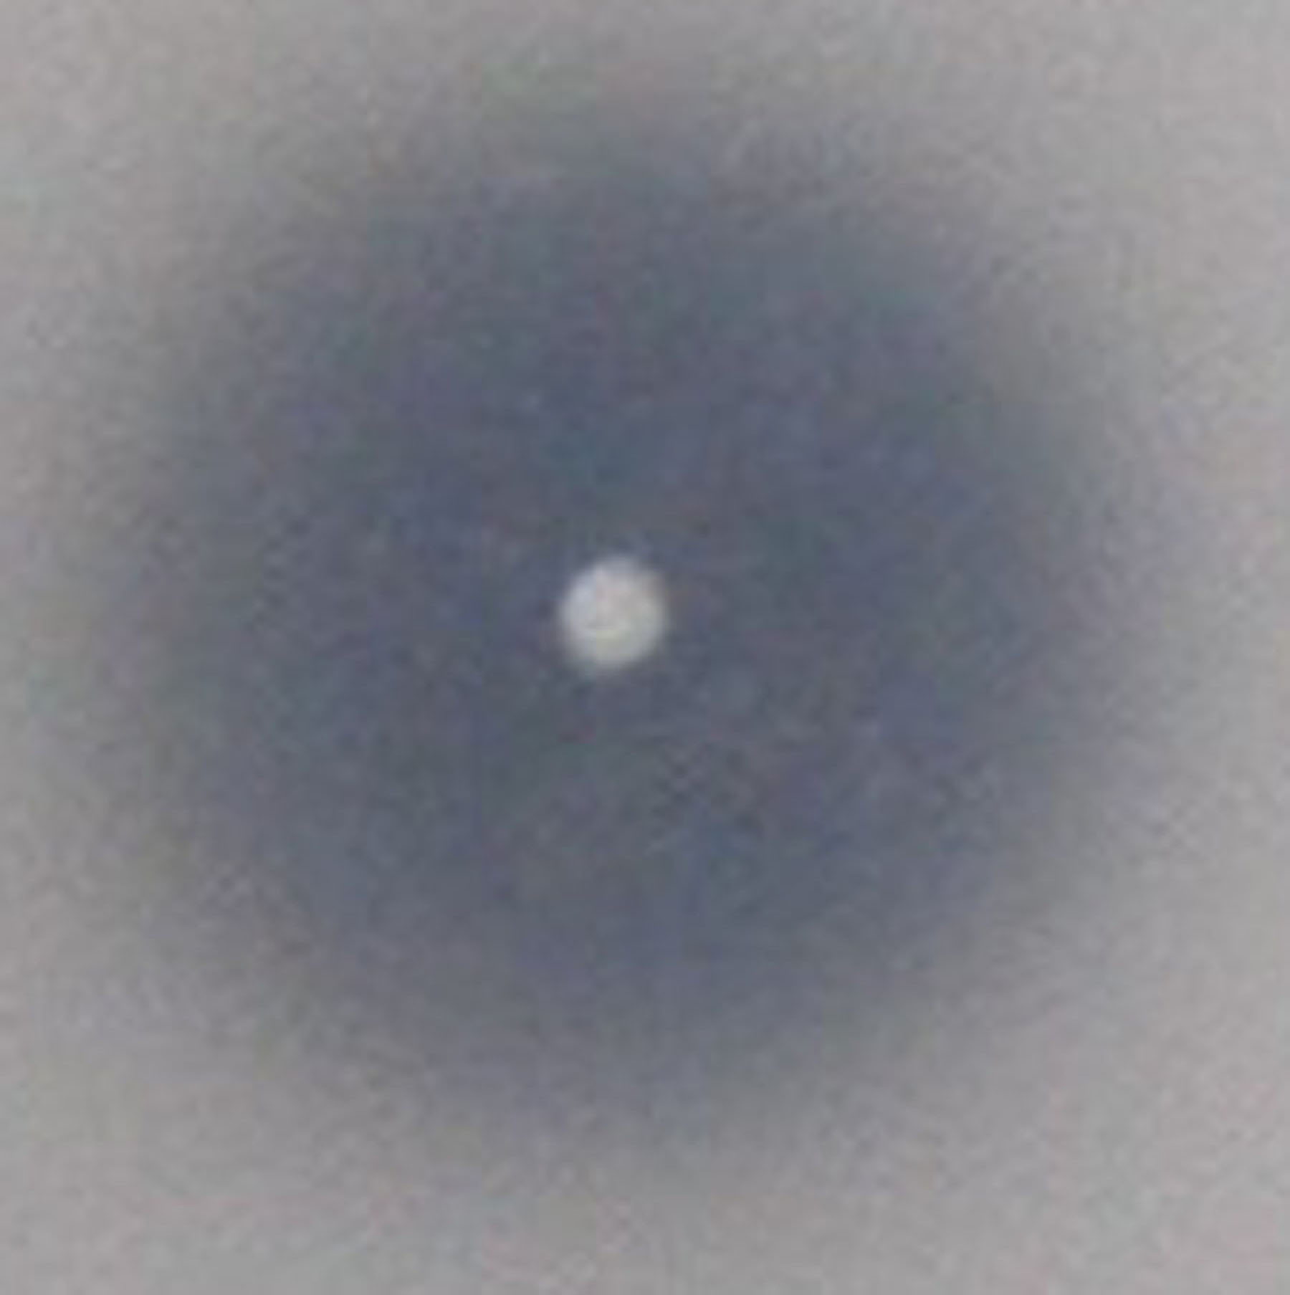
Figure S1. The single colony of QD1.

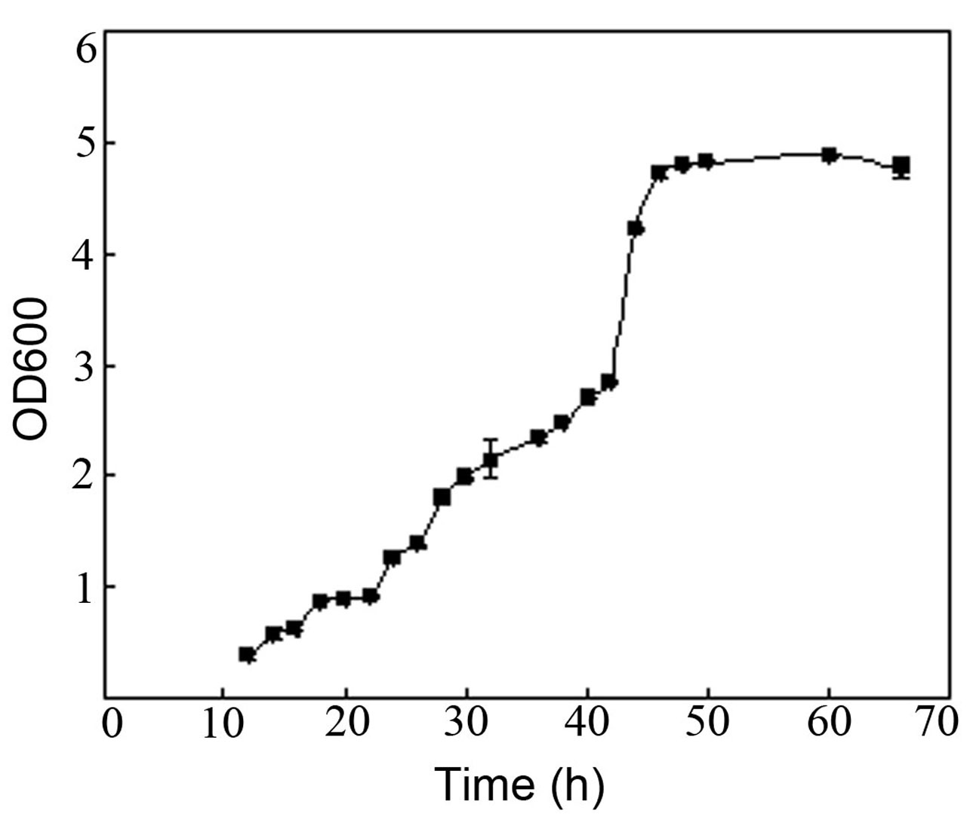
Figure S2. The growth curve of Renibacterium sp. QD1.

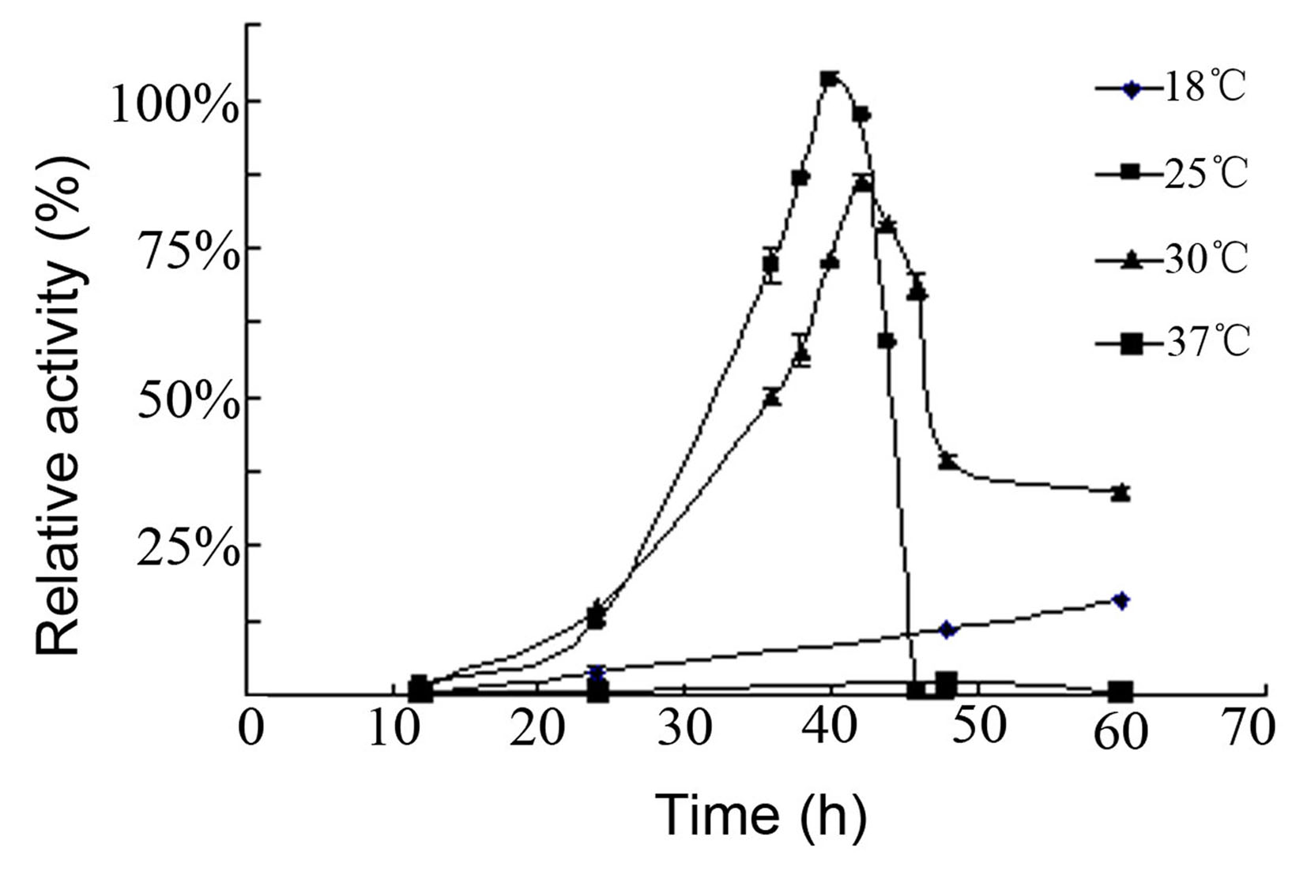
Figure S3. Effects of cultivation time and temperature on chitosanase production.

