Supplementary Material
SM1. Phylogenetic reconstruction of each dataset…………………………………...1
Maximum Parsimony………………………………………...……………….…1
Maximum Likelihood…………………………………………………...............4
Bayesian Inference………………………………………………………............7
SM2. Model Selection of the concatenated dataset………………………………….13
SM1. Phylogenetic reconstruction of each dataset
The phylogenetic reconstruction of each dataset (12S rRNA, 16S rRNA, 28S rRNA and H3) was carried out with both model-based, maximum likelihood (ML) and Bayesian inference (BI), and Maximum parsimony (MP) methods and are detailed below.
Maximum Parsimony
Maximum Parsimony analyzes were carried out using TNT (Goloboff et al. 2008). We used the traditional search, including a tree bisection–reconnection (TBR) as swapping algorithm and 10 trees saved by replication. We obtained 28 equally parsimonious trees with 575 steps for the 12S rRNA, four trees and 525 steps for the 16S rRNA, one tree and 353 steps for the 28S rRNA and 97 trees and 75 steps for the H3. Then, a strict consensus tree for each dataset was calculated. Branch support was evaluated through bootstrapping (500 replications).

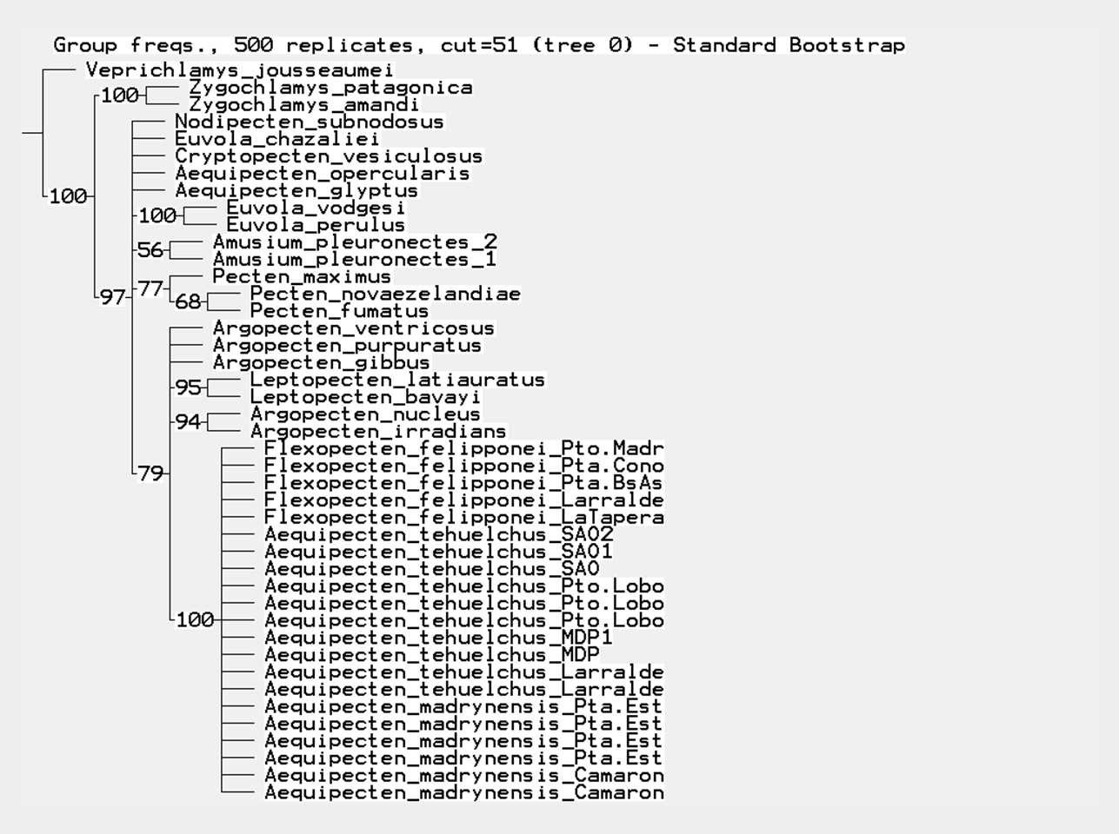
Figure 1. Maximum parsimony bootstrap consensus tree of the 12s rRNA dataset.

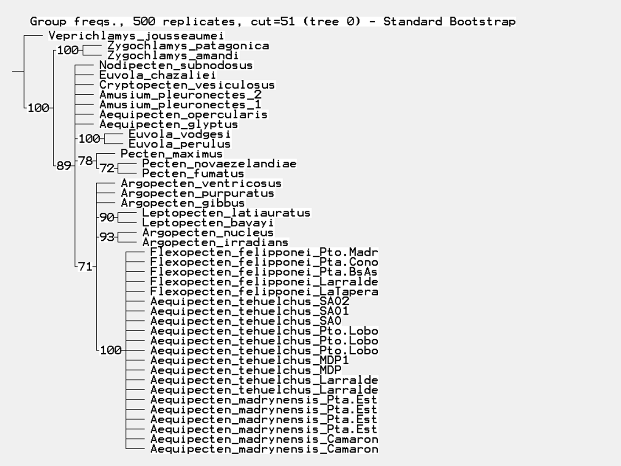
Figure 2. Maximum parsimony bootstrap consensus tree of the 16s rRNA dataset.

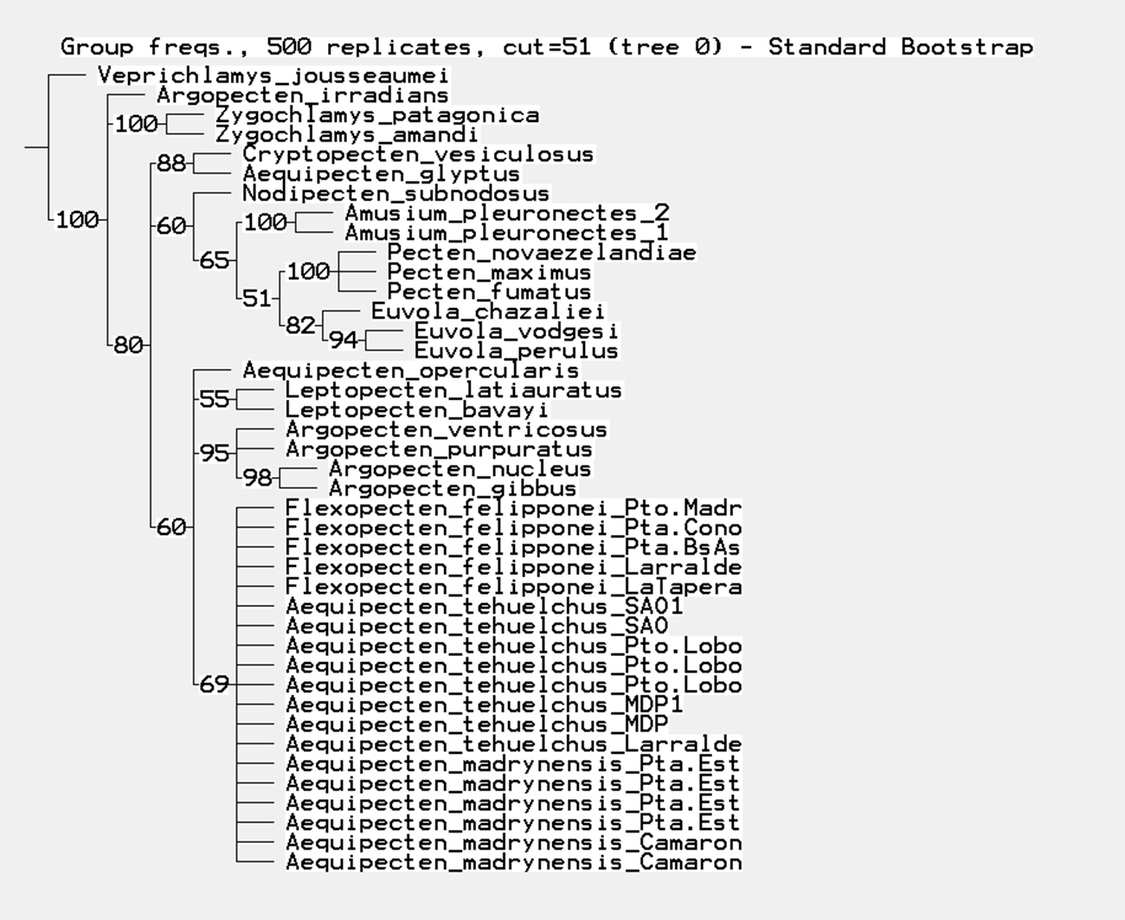
Figure 3. Maximum parsimony bootstrap consensus tree of the 28S rRNA dataset.

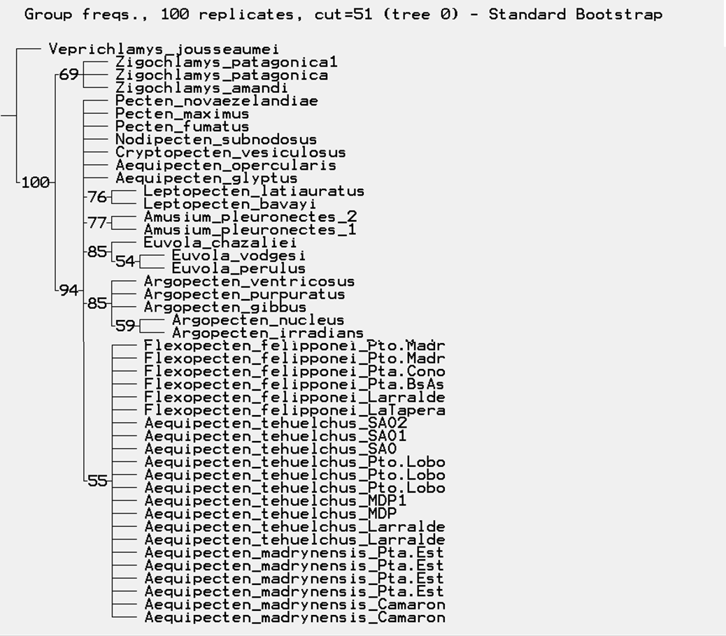
Figure 4. Maximum parsimony bootstrap consensus tree of the H3 dataset.
Maximum Likelihood
The Akaike Information Criterion (AIC), implemented in jModelTest v 2.1.10 (Darriba et al. 2012), was applied to find the models of evolution that best fit the data. The selected models (Table 1) were used in ML analyses of the four datasets (12S rRNA, 16S rRNA, 28S rRNA and H3), conducted with RAxML 7.4.2 (Stamatakis 2006), implemented in raxmlGUI 1.3 (Silvestro and Michalak 2012); a rapid bootstrapping analysis with 500 replicates was conducted.

Table 1. Selected substitution models for the mitochondrial and nuclear datasets.
 | 12S rRNA | 16S rRNA | 28S rRNA | H3
Model | GTR+I+G | GTR+I+G | GTR+I+G | GTR+I+G
Weight | 0.896 | 0.233 | 0.590 | 0.095

For the 12S rRNA dataset, the model with the lowest AIC in the rank was the GTR+I+G with a weight of 0.896.Comparing the first two models of substitutions in the rank generated by jModeltest (GTR+I+G and GTR+G) with the decision table of Kass and Raftery (1995), we obtained decisive evidence against GTR+G (ΔAIC = 7.22). For the 16S rRNA dataset, the model with the lowest AIC in the rank was the GTR+G+I with a weight of 0.233. Comparing the first two models of substitutions in the rank (GTR+I+G and TIM1+I+G) we obtained a ΔAIC of 0.401, implying no evidence against TIM1+I+G however, we choose the first model because TIM1+I+G was not available in raxmlGUI. For the 28S rRNA dataset, the model with the lowest AIC in the rank was the GTR+I+G with a weight of 0.59. Comparing the first two models of substitutions in the rank generated by jModeltest (GTR+I+G and TVM+I+G) with the decision table of Kass and Raftery (1995), we obtained substantial evidence against TVM+I+G (ΔAIC = 0.749). For the H3 dataset, the model with the lowest AIC in the rank was the TIM2+I with a weight of 0.28 but since this model was not available in raxmlGUI the second model (GTR+I+G, weight=0.095) was chosen.

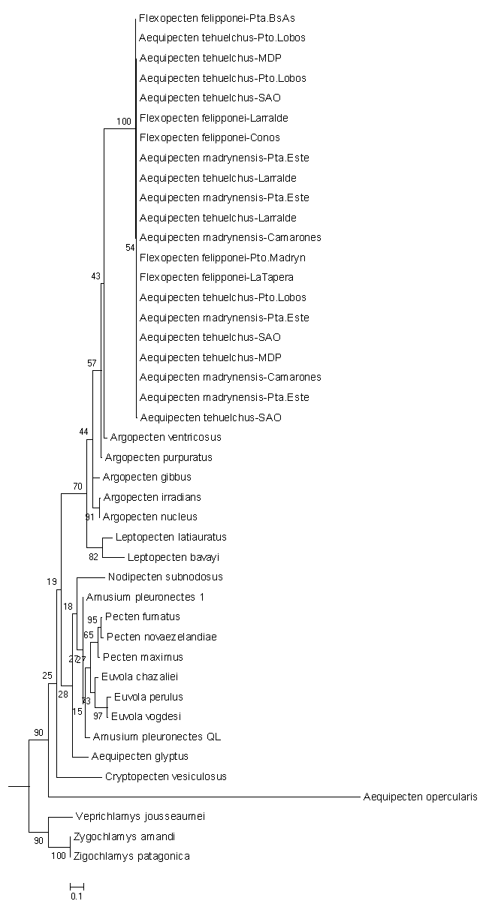
Figure 5. Maximum likelihood tree of the 12s rRNA dataset.
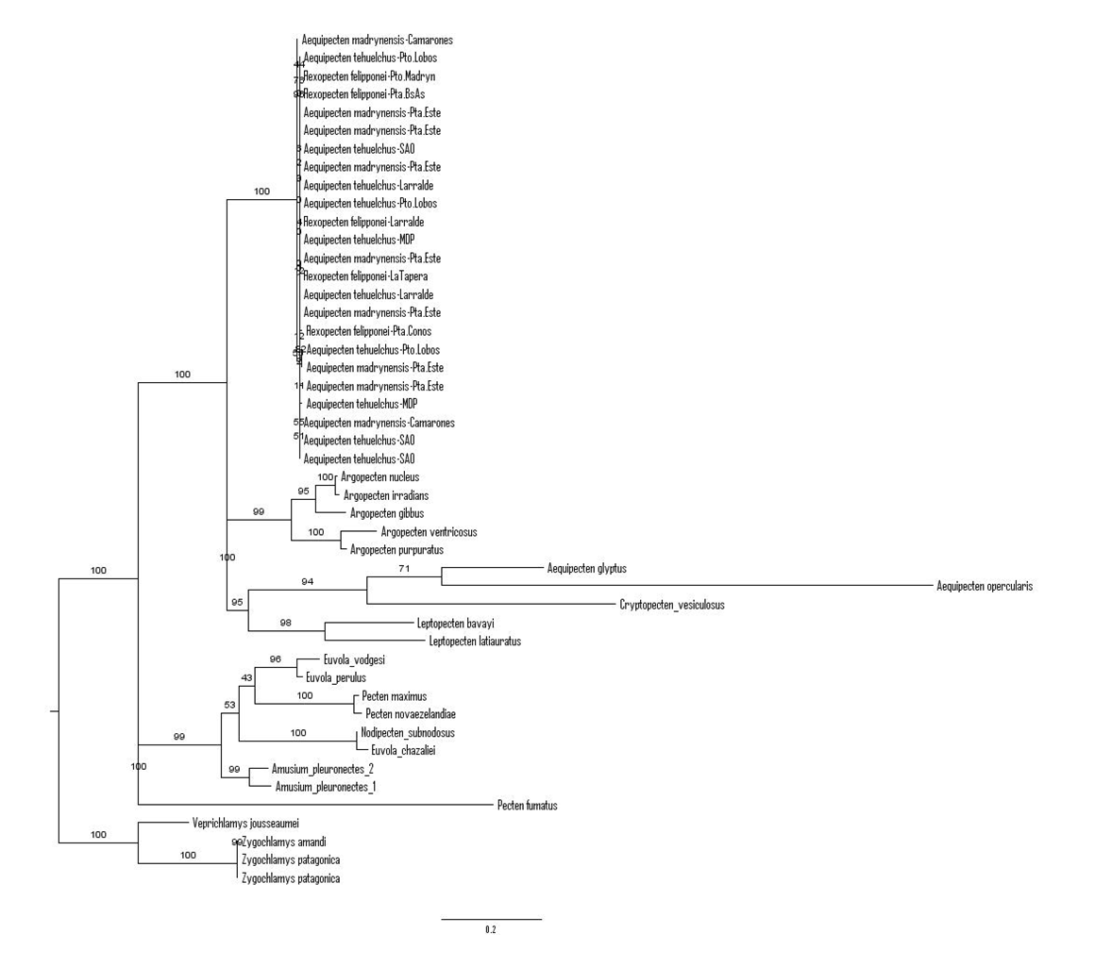
Figure 6. Maximum likelihood tree of the 16s rRNA dataset.
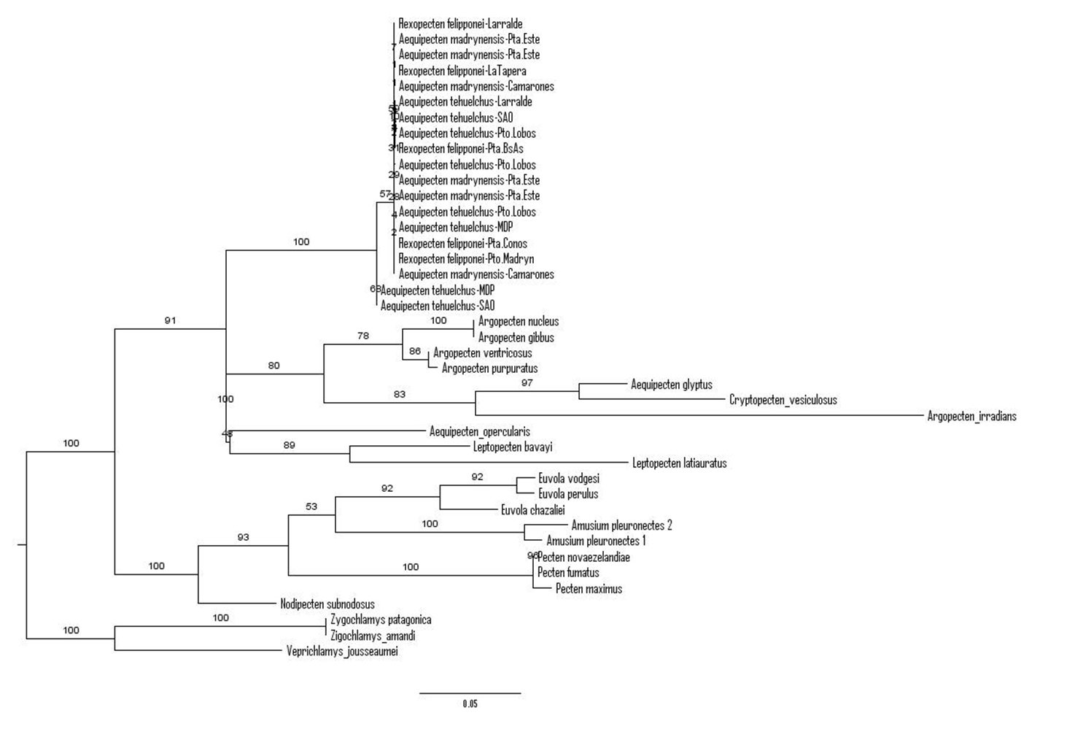
Figure 7. Maximum likelihood tree of the 28S rRNA dataset.
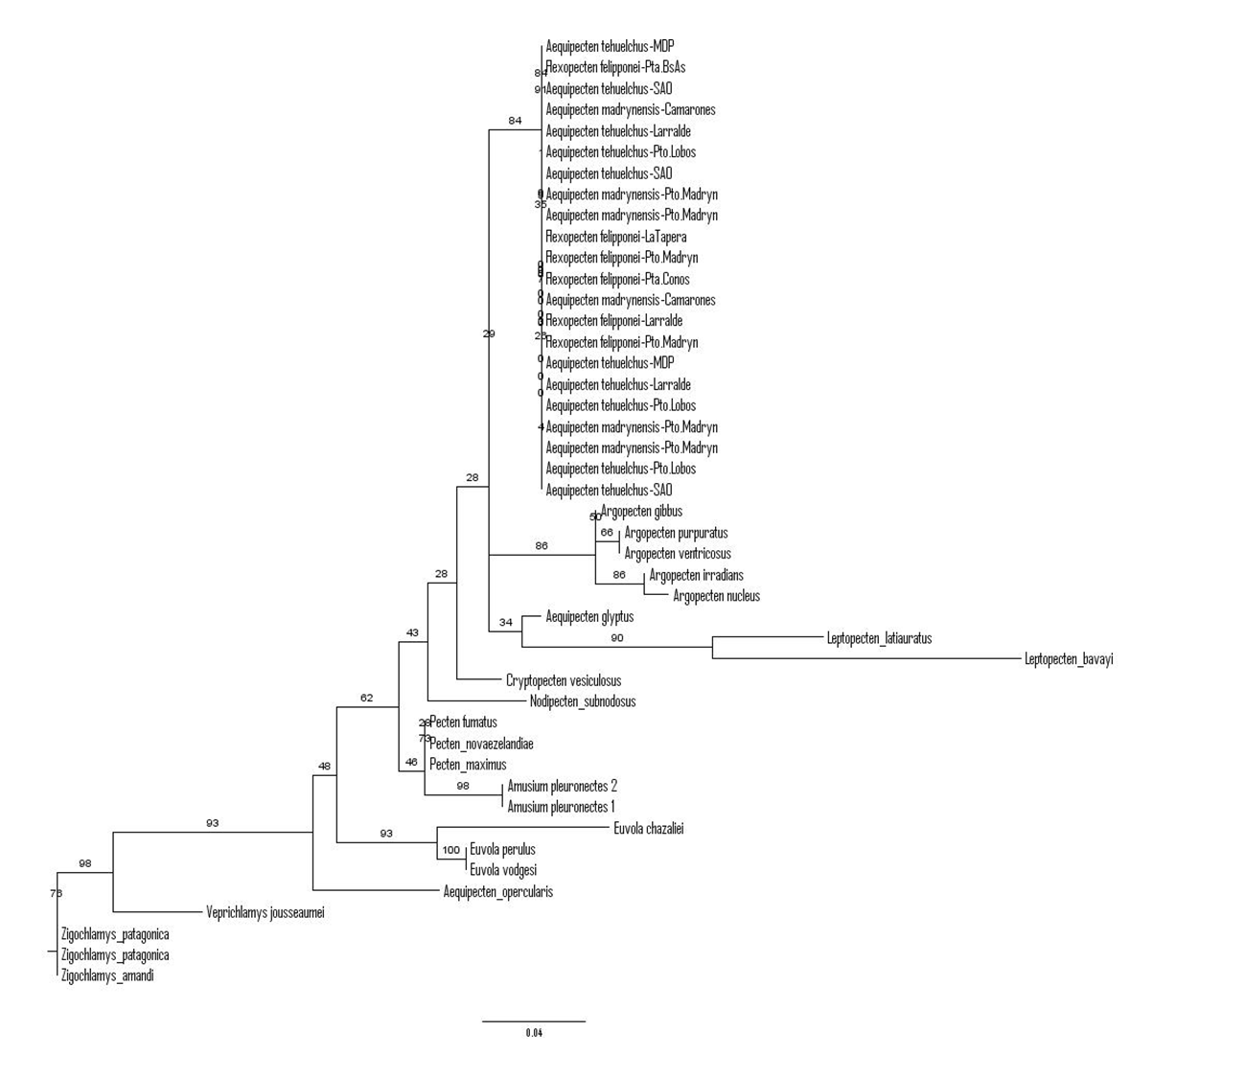
Figure 8. Maximum likelihood tree of the H3 dataset.
Bayesian Inference
Phylogenies reconstructed with BI were estimated with different substitution (HKY+G+I, Hasegawa et al. 1985, and GTR+G+I, Tavaré 1985) and clock (strict and relaxed) models. The marginal-likelihood scores of the posterior distributions were compared using Bayes Factors (BFs, Kass and Raftery 1995), defined as
Log₁₀ [Pr (D | H1)] – Log₁₀ [Pr (D | Ho)].
Two different methods were applied: harmonic mean estimation (HME, Newton and Raftery 1994) and a posterior simulation-based analog of the Akaike information criterion through Markov chain Monte Carlo analysis (AICM, Raftery et al. 2007) implemented in Tracer v1.6 (Rambaut et al. 2014). Bayesian reconstructions were conducted under a Yule process as a tree prior using BEAST v. 1.8.3 (Drummond et al. 2012) with a Markov Chain Monte Carlo (MCMC) simulation for 100 million of generations, sampling trees every 10000 generations with a burn-in of 10%. Convergence diagnostics were conducted in Tracer and reliable ESS values (>200) were ensured. Then, the maximum credibility tree was generated from the combined trees in TreeAnnotator v 1.6.1 (Drummond et al. 2012).
The substitution and clock models favored by BFs were the GTR+I+G and strict clock models for the four genes, whether the HME (Table 2) or AICM (Table 3) method was followed. The same pattern was obtained for the concatenated dataset (Tables 4, 5).

Table 2. Bayes Factor (BF) calculations based on HME for different combination of models; and for the three genes (12S rRNA, 16S rRNA, 28S rRNA and H3). Values from 0 to 0.5 indicate that there is not evidence against Ho; 0.5 to 1, substantial evidence against Ho; 1 to 2, strong evidence against Ho and higher than 2 indicate decisive evidence against Ho. Also, a higher probability value indicates better model fit (indicated in bold).

 | Substitution Model
Clock Model | H₁: GTR+G+I | Ho: HKY+G+I | BF
12S rRNA  H₁: Relaxed clock | -3118.508 | -3128.215 | 9.707
Ho: Strict clock | -2793.282 | -2802.898 | 9.616
BF | 325.226 | 325.317
16S rRNA  H₁: Relaxed clock | -4782.733 | -4739.688 | 43.045
Ho: Strict clock | -4351.191 | -4366.719 | 15.528
BF | 431.542 | 372.969
28S rRNA  H₁: Relaxed clock | -3265.553 | -3282.616 | 17.063
Ho: Strict clock | -2922.704 | -2944.982 | 22.278
BF | 342.849 | 337.796
H3  H₁: Relaxed clock | -1280.664 | -1280.845 | 0.181
Ho: Strict clock | -892.993 | -899.071 | 6.078
F | 387.671 | 381.774
Table 3. Comparison of substitution and clock models following the AICM approach, mitochondrial and nuclear datasets. A lower AIC value (in boldface in the table) indicates better model fit.
 | Substitution Model
Clock Model | GTR+G+I | HKY+G+I
12S rRNA  Relaxed clock | 6282.769 | 6296.445
Strict clock | 5625.944 | 5638.98
16S rRNA  Relaxed clock | 9501.178 | 9529.344
Strict clock | 8729.595 | 8765.025
28S rRNA  Relaxed clock | 6567.659 | 6602.943
Strict clock | 5877.071 | 5914.856
H3  Relaxed clock | 2589.723 | 2597.045
Strict clock | 1811.98 | 1816.565

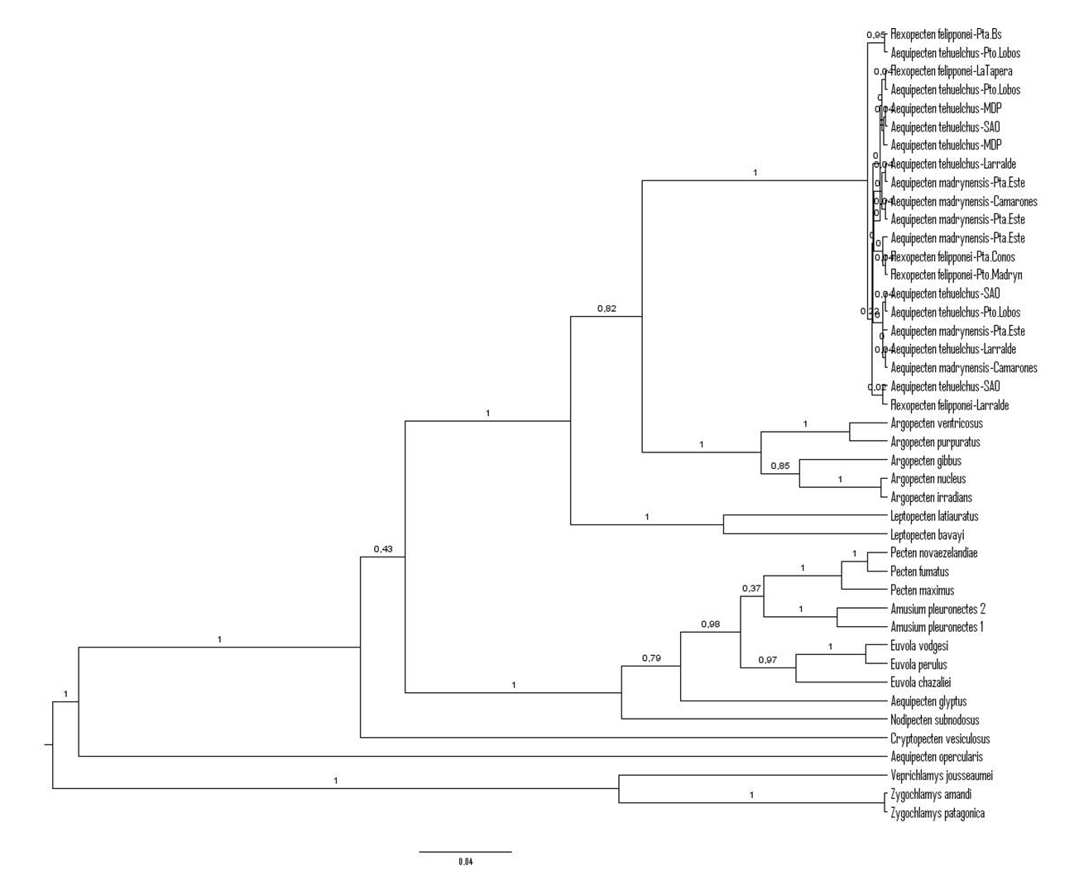
Figure 9. Bayesian tree of the 12s rRNA dataset.
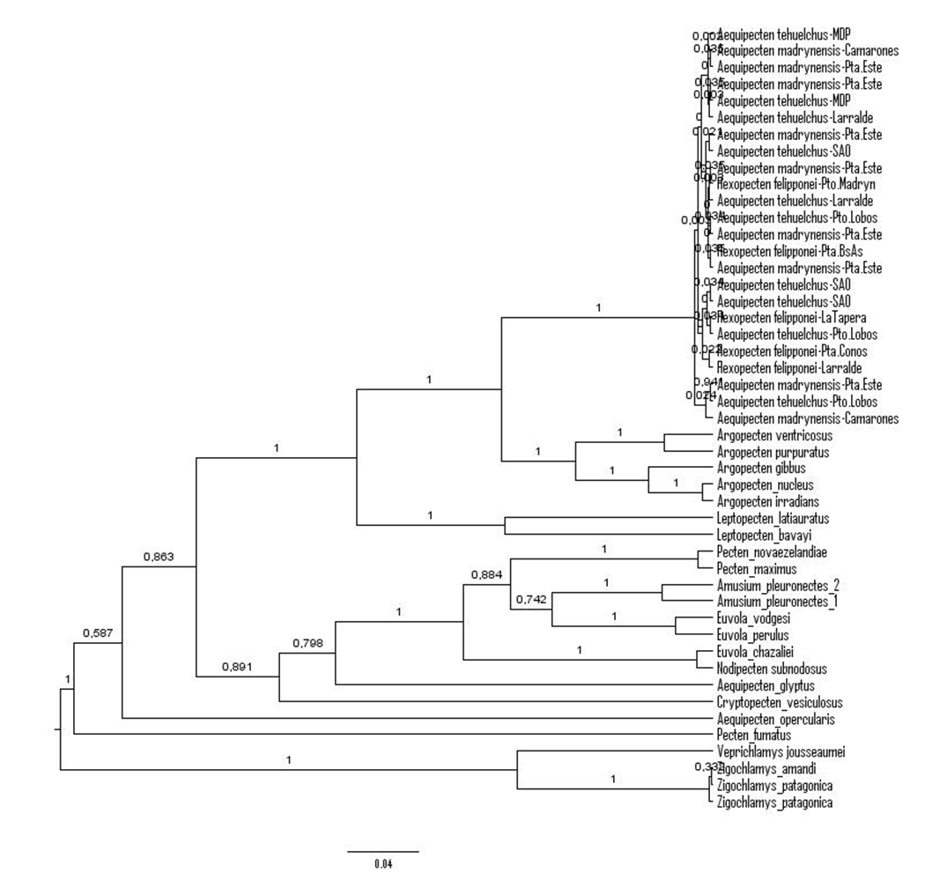
Figure 10. Bayesian tree of the 16s rRNA dataset.

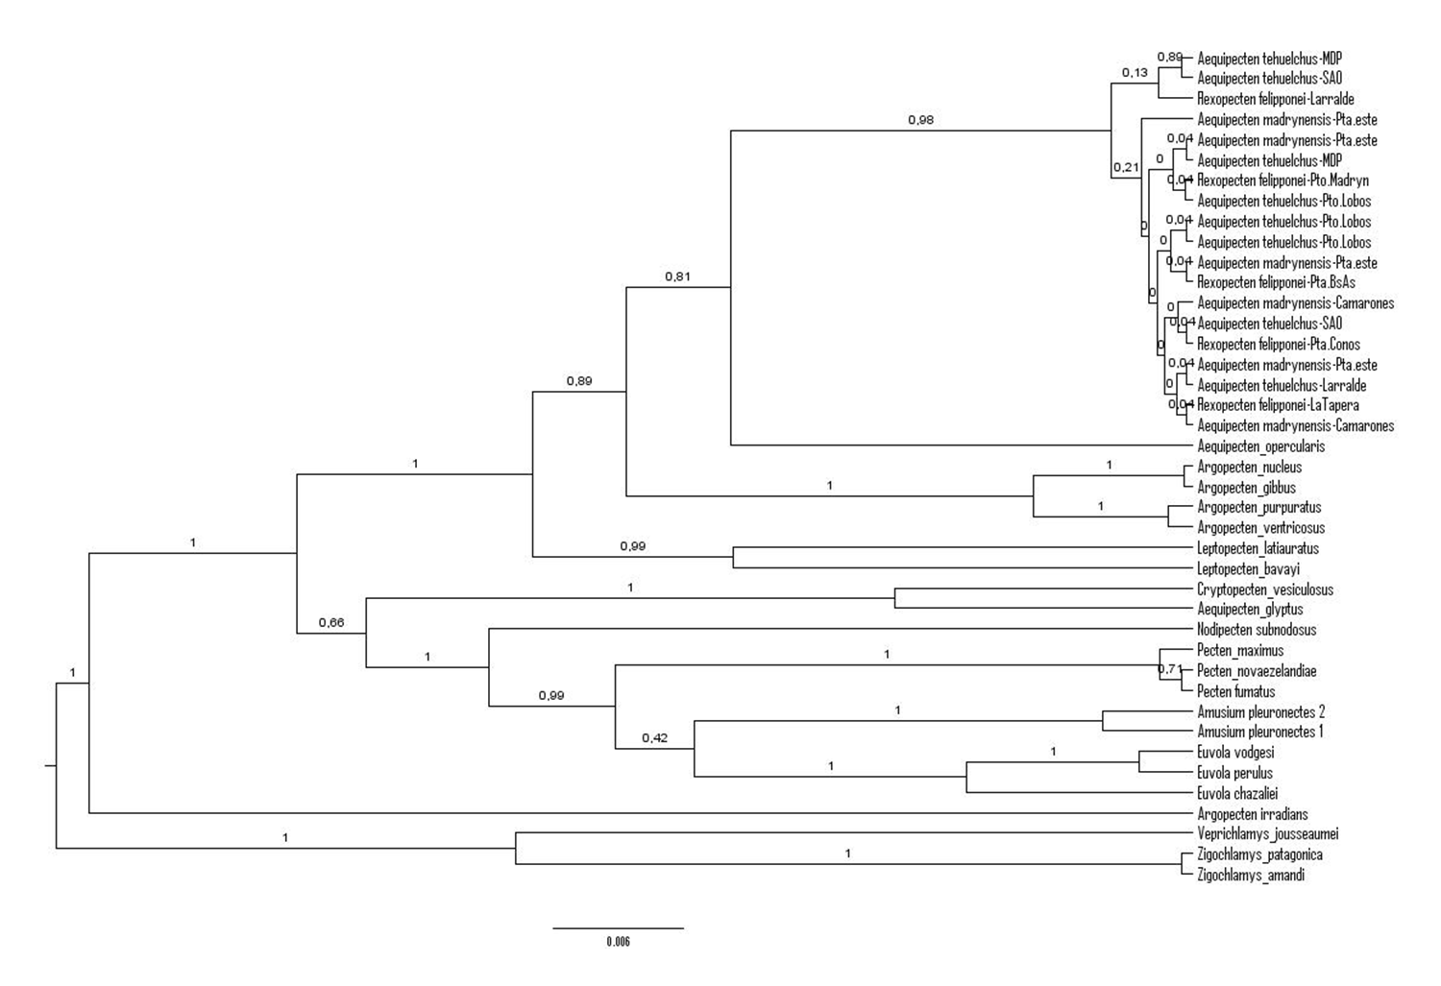
Figure 11. Bayesian tree of the 28S rRNA dataset.
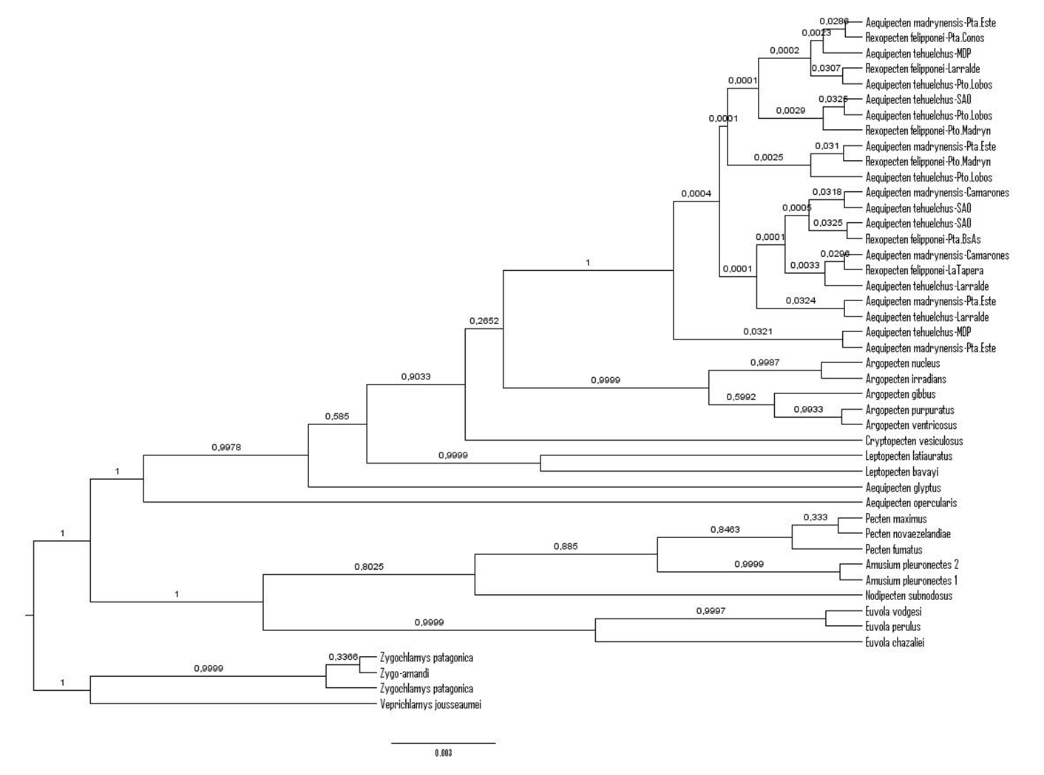
Figure 12. Bayesian tree of the H3 dataset.
SM2. Model Selection of the concatenated dataset
Table 4. Bayes Factor (BF) calculations based on HME for the different combinations of models. Values from 0 to 0.5 indicate that there is not evidence against Ho; 0.5 to 1, substantial evidence against Ho; 1 to 2, strong evidence against Ho and higher than 2 indicate decisive evidence against Ho. Also, a higher probability value indicates better model fit (indicated in bold).

12S+16S+28S+H3 | Substitution Model
Clock Model | H₁: GTR+G+I | Ho: HKY+G+I | BF
H₁: Relaxed clock | -11883.685 | -11969.801 | 86.116
Ho: Strict clock | -11552.182 | -11631.271 | -79.089
BF | 331.503 | 338.53

Table 5. Comparison of substitution and clock models following the AICM approach, mitochondrial and nuclear datasets. A lower AIC value (in boldface in the table) indicates better model fit.
12S+16S+28S+H3 | Substitution Model
Clock Model | GTR+G+I | HKY+G+I
H₁: Relaxed clock | 23825.504 | 23988.639
Ho: Strict clock | 23137.186 | 23296.399

References
Kass, R.E., and Raftery, A.E. (1995). Bayes Factors. Journal of the American Statistical Association 90, 773-795.
Newton, M.A., and Raftery, A.E. (1994). Approximate Bayesian inference by the weighted likelihood bootstrap. Journal of The Royal Statistical Society Series B-Methodological 56, 3-48.
Raftery, A.E., Newton, M.A., Satagopan, J.M., and Krivitsky, P.N. (2007). Estimating the integrated likelihood via posterior simulation using the harmonic mean identity. In 'Bayesian statistics.' (Eds. Bernardo J.M., Bayarri M.J., JO Berger, Dawid A.P., Heckerman D., Smith A.F.M. and West M.) pp. 1–45. (Oxford University Press: Oxford).
Tavaré, S. (1985). Some probabilistic and statistical problems in the analysis of DNA Sequences. Lectures on Mathematics in the Life Sciences 17, 57-86.

