**Online Appendix 1**

1. **ABGD test results** (the initial partitions with prior maximal distance are the divergence values of intraspecific divergence mentioned in the results section of the manuscript).

Kimura 80 two OTUs

Initial Partition with prior maximal distance P=3.79e-02   
Distance K80 Kimura MinSlope=1.500000

**Group[ 1 ] n: 3 ;**id: Hap_78_C FJ528642.1_C HT_C  
**Group[ 2 ] n: 157 ;**id: Hap_125_A Hap_67_A Hap_112_A Hap_120_A Hap_24_A Hap_127_A Hap_96_A Hap_130_A Hap_97_A Hap_131_A Hap_132_A Hap_2_A Hap_129_A Hap_16_A Hap_116_A Hap_117_A Hap_119_A Hap_137_A Hap_135_A Hap_136_A Hap_107_A Hap_111_A Hap_5_A Hap_86_A Hap_60_A Hap_62_A Hap_59_A Hap_46_A Hap_148_A Hap_61_A Hap_26_A Hap_64_A Hap_66_A Hap_65_A Hap_34_A Hap_37_A Hap_36_A Hap_33_A Hap_41_A Hap_84_A Hap_87_A Hap_95_A Hap_98_A Hap_92_A Hap_128_A Hap_71_A Hap_85_A Hap_91_A Hap_81_A Hap_42_A Hap_82_A Hap_54_A Hap_145_A Hap_43_A Hap_147_A Hap_146_A Hap_140_A Hap_55_A Hap_35_A Hap_56_A Hap_49_A Hap_141_A Hap_143_A Hap_139_A Hap_50_A Hap_4_A Hap_138_A Hap_57_A Hap_39_A Hap_30_A Hap_38_A Hap_40_A Hap_142_A Hap_3_A Hap_10_A Hap_58_A Hap_1_A Hap_63_A Hap_22_A Hap_29_A Hap_32_A Hap_23_A Hap_99_A Hap_9_A Hap_73_A Hap_105_A Hap_83_A Hap_134_A Hap_72_A Hap_93_A Hap_133_A Hap_28_A Hap_94_A Hap_14_A Hap_18_A Hap_123_A Hap_27_A Hap_118_A Hap_114_A Hap_126_A Hap_115_A Hap_121_A Hap_25_A Hap_113_A Hap_144_A Hap_13_A Hap_15_A Hap_19_A Hap_12_A Hap_21_A Hap_17_A Hap_124_A Hap_108_A Hap_20_A Hap_11_A Hap_8_A Hap_110_A Hap_109_A Hap_122_A Hap_101_D AY116601.1_D Hap_103_D Hap_31_D Hap_77_HL_D Hap_100_D Hap_102_D HU_B HN_E Hap_104_E Hap_79_E Hap_74_E Hap_76_E Hap_106_E Hap_7_E Hap_75_E Hap_80_E Hap_88_E Hap_89_E Hap_90_E Hap_70_E Hap_68_E Hap_51_E Gr03_12_E Hap_53_E Hap_52_E Hap_69_E Gr23_E Gr13_E Hap_44_E Hap_45_E Hap_48_E Hap_47_E JN248360.1 Botryllus schlosseri haplotype Bs19 JN248361.1 Botryllus schlosseri haplotype Bs20 JN248362.1 Botryllus schlosseri haplotype Bs21 JN248373.1 Botryllus schlosseri haplotype Bs32 JN248374.1 Botryllus schlosseri haplotype Bs33

-------------------

Kimura 80 one OTU

Initial Partition with prior maximal distance P=4.83e-02  
Distance K80 Kimura MinSlope=1.500000

**Group[ 1 ] n: 160 ;**id: Hap_78_C FJ528642.1_C HT_C Hap_125_A Hap_67_A Hap_112_A Hap_120_A Hap_24_A Hap_127_A Hap_96_A Hap_130_A Hap_97_A Hap_131_A Hap_132_A Hap_2_A Hap_129_A Hap_16_A Hap_116_A Hap_117_A Hap_119_A Hap_137_A Hap_135_A Hap_136_A Hap_107_A Hap_111_A Hap_5_A Hap_86_A Hap_60_A Hap_62_A Hap_59_A Hap_46_A Hap_148_A Hap_61_A Hap_26_A Hap_64_A Hap_66_A Hap_65_A Hap_34_A Hap_37_A Hap_36_A Hap_33_A Hap_41_A Hap_84_A Hap_87_A Hap_95_A Hap_98_A Hap_92_A Hap_128_A Hap_71_A Hap_85_A Hap_91_A Hap_81_A Hap_42_A Hap_82_A Hap_54_A Hap_145_A Hap_43_A Hap_147_A Hap_146_A Hap_140_A Hap_55_A Hap_35_A Hap_56_A Hap_49_A Hap_141_A Hap_143_A Hap_139_A Hap_50_A Hap_4_A Hap_138_A Hap_57_A Hap_39_A Hap_30_A Hap_38_A Hap_40_A Hap_142_A Hap_3_A Hap_10_A Hap_58_A Hap_1_A Hap_63_A Hap_22_A Hap_29_A Hap_32_A Hap_23_A Hap_99_A Hap_9_A Hap_73_A Hap_105_A Hap_83_A Hap_134_A Hap_72_A Hap_93_A Hap_133_A Hap_28_A Hap_94_A Hap_14_A Hap_18_A Hap_123_A Hap_27_A Hap_118_A Hap_114_A Hap_126_A Hap_115_A Hap_121_A Hap_25_A Hap_113_A Hap_144_A Hap_13_A Hap_15_A Hap_19_A Hap_12_A Hap_21_A Hap_17_A Hap_124_A Hap_108_A Hap_20_A Hap_11_A Hap_8_A Hap_110_A Hap_109_A Hap_122_A Hap_101_D AY116601.1_D Hap_103_D Hap_31_D Hap_77_HL_D Hap_100_D Hap_102_D HU_B HN_E Hap_104_E Hap_79_E Hap_74_E Hap_76_E Hap_106_E Hap_7_E Hap_75_E Hap_80_E Hap_88_E Hap_89_E Hap_90_E Hap_70_E Hap_68_E Hap_51_E Gr03_12_E Hap_53_E Hap_52_E Hap_69_E Gr23_E Gr13_E Hap_44_E Hap_45_E Hap_48_E Hap_47_E JN248360.1 Botryllus schlosseri haplotype Bs19 JN248361.1 Botryllus schlosseri haplotype Bs20 JN248362.1 Botryllus schlosseri haplotype Bs21 JN248373.1 Botryllus schlosseri haplotype Bs32 JN248374.1 Botryllus schlosseri haplotype Bs33

Above is Based on TS/TV =3.79 as computed by MEGA.

--------------------

Jukes Cantor 69 two OTUs

Initial Partition with prior maximal distance P=8.86e-03  
Distance JC69 Jukes-Cantor MinSlope=1.200000

**Group[ 1 ] n: 3 ;**id: Hap_78_C FJ528642.1_C HT_C  
**Group[ 2 ] n: 157 ;**id: Hap_125_A Hap_67_A Hap_112_A Hap_120_A Hap_24_A Hap_127_A Hap_96_A Hap_130_A Hap_97_A Hap_131_A Hap_132_A Hap_2_A Hap_129_A Hap_16_A Hap_116_A Hap_117_A Hap_119_A Hap_137_A Hap_135_A Hap_136_A Hap_107_A Hap_111_A Hap_5_A Hap_86_A Hap_60_A Hap_62_A Hap_59_A Hap_46_A Hap_148_A Hap_61_A Hap_26_A Hap_64_A Hap_66_A Hap_65_A Hap_34_A Hap_37_A Hap_36_A Hap_33_A Hap_41_A Hap_84_A Hap_87_A Hap_95_A Hap_98_A Hap_92_A Hap_128_A Hap_71_A Hap_85_A Hap_91_A Hap_81_A Hap_42_A Hap_82_A Hap_54_A Hap_145_A Hap_43_A Hap_147_A Hap_146_A Hap_140_A Hap_55_A Hap_35_A Hap_56_A Hap_49_A Hap_141_A Hap_143_A Hap_139_A Hap_50_A Hap_4_A Hap_138_A Hap_57_A Hap_39_A Hap_30_A Hap_38_A Hap_40_A Hap_142_A Hap_3_A Hap_10_A Hap_58_A Hap_1_A Hap_63_A Hap_22_A Hap_29_A Hap_32_A Hap_23_A Hap_99_A Hap_9_A Hap_73_A Hap_105_A Hap_83_A Hap_134_A Hap_72_A Hap_93_A Hap_133_A Hap_28_A Hap_94_A Hap_14_A Hap_18_A Hap_123_A Hap_27_A Hap_118_A Hap_114_A Hap_126_A Hap_115_A Hap_121_A Hap_25_A Hap_113_A Hap_144_A Hap_13_A Hap_15_A Hap_19_A Hap_12_A Hap_21_A Hap_17_A Hap_124_A Hap_108_A Hap_20_A Hap_11_A Hap_8_A Hap_110_A Hap_109_A Hap_122_A Hap_101_D AY116601.1_D Hap_103_D Hap_31_D Hap_77_HL_D Hap_100_D Hap_102_D HU_B HN_E Hap_104_E Hap_79_E Hap_74_E Hap_76_E Hap_106_E Hap_7_E Hap_75_E Hap_80_E Hap_88_E Hap_89_E Hap_90_E Hap_70_E Hap_68_E Hap_51_E Gr03_12_E Hap_53_E Hap_52_E Hap_69_E Gr23_E Gr13_E Hap_44_E Hap_45_E Hap_48_E Hap_47_E JN248360.1 Botryllus schlosseri haplotype Bs19 JN248361.1 Botryllus schlosseri haplotype Bs20 JN248362.1 Botryllus schlosseri haplotype Bs21 JN248373.1 Botryllus schlosseri haplotype Bs32 JN248374.1 Botryllus schlosseri haplotype Bs33

--------------------

Jukes Cantor 69 one OTU

Initial Partition with prior maximal distance P=1.13e-02  
Distance JC69 Jukes-Cantor MinSlope=1.200000

**Group[ 1 ] n: 160 ;**id: Hap_78_C FJ528642.1_C HT_C Hap_125_A Hap_67_A Hap_112_A Hap_120_A Hap_24_A Hap_127_A Hap_96_A Hap_130_A Hap_97_A Hap_131_A Hap_132_A Hap_2_A Hap_129_A Hap_16_A Hap_116_A Hap_117_A Hap_119_A Hap_137_A Hap_135_A Hap_136_A Hap_107_A Hap_111_A Hap_5_A Hap_86_A Hap_60_A Hap_62_A Hap_59_A Hap_46_A Hap_148_A Hap_61_A Hap_26_A Hap_64_A Hap_66_A Hap_65_A Hap_34_A Hap_37_A Hap_36_A Hap_33_A Hap_41_A Hap_84_A Hap_87_A Hap_95_A Hap_98_A Hap_92_A Hap_128_A Hap_71_A Hap_85_A Hap_91_A Hap_81_A Hap_42_A Hap_82_A Hap_54_A Hap_145_A Hap_43_A Hap_147_A Hap_146_A Hap_140_A Hap_55_A Hap_35_A Hap_56_A Hap_49_A Hap_141_A Hap_143_A Hap_139_A Hap_50_A Hap_4_A Hap_138_A Hap_57_A Hap_39_A Hap_30_A Hap_38_A Hap_40_A Hap_142_A Hap_3_A Hap_10_A Hap_58_A Hap_1_A Hap_63_A Hap_22_A Hap_29_A Hap_32_A Hap_23_A Hap_99_A Hap_9_A Hap_73_A Hap_105_A Hap_83_A Hap_134_A Hap_72_A Hap_93_A Hap_133_A Hap_28_A Hap_94_A Hap_14_A Hap_18_A Hap_123_A Hap_27_A Hap_118_A Hap_114_A Hap_126_A Hap_115_A Hap_121_A Hap_25_A Hap_113_A Hap_144_A Hap_13_A Hap_15_A Hap_19_A Hap_12_A Hap_21_A Hap_17_A Hap_124_A Hap_108_A Hap_20_A Hap_11_A Hap_8_A Hap_110_A Hap_109_A Hap_122_A Hap_101_D AY116601.1_D Hap_103_D Hap_31_D Hap_77_HL_D Hap_100_D Hap_102_D HU_B HN_E Hap_104_E Hap_79_E Hap_74_E Hap_76_E Hap_106_E Hap_7_E Hap_75_E Hap_80_E Hap_88_E Hap_89_E Hap_90_E Hap_70_E Hap_68_E Hap_51_E Gr03_12_E Hap_53_E Hap_52_E Hap_69_E Gr23_E Gr13_E Hap_44_E Hap_45_E Hap_48_E Hap_47_E JN248360.1 Botryllus schlosseri haplotype Bs19 JN248361.1 Botryllus schlosseri haplotype Bs20 JN248362.1 Botryllus schlosseri haplotype Bs21 JN248373.1 Botryllus schlosseri haplotype Bs32 JN248374.1 Botryllus schlosseri haplotype Bs33

--------------------

Simple partition two OTUs

Initial Partition with prior maximal distance P=2.98e-02  
Distance Simple Dist MinSlope=1.200000

**Group[ 1 ] n: 3 ;**id: Hap_78_C FJ528642.1_C HT_C  
**Group[ 2 ] n: 157 ;**id: Hap_125_A Hap_67_A Hap_112_A Hap_120_A Hap_24_A Hap_127_A Hap_96_A Hap_130_A Hap_97_A Hap_131_A Hap_132_A Hap_2_A Hap_129_A Hap_16_A Hap_116_A Hap_117_A Hap_119_A Hap_137_A Hap_135_A Hap_136_A Hap_107_A Hap_111_A Hap_5_A Hap_86_A Hap_60_A Hap_62_A Hap_59_A Hap_46_A Hap_148_A Hap_61_A Hap_26_A Hap_64_A Hap_66_A Hap_65_A Hap_34_A Hap_37_A Hap_36_A Hap_33_A Hap_41_A Hap_84_A Hap_87_A Hap_95_A Hap_98_A Hap_92_A Hap_128_A Hap_71_A Hap_85_A Hap_91_A Hap_81_A Hap_42_A Hap_82_A Hap_54_A Hap_145_A Hap_43_A Hap_147_A Hap_146_A Hap_140_A Hap_55_A Hap_35_A Hap_56_A Hap_49_A Hap_141_A Hap_143_A Hap_139_A Hap_50_A Hap_4_A Hap_138_A Hap_57_A Hap_39_A Hap_30_A Hap_38_A Hap_40_A Hap_142_A Hap_3_A Hap_10_A Hap_58_A Hap_1_A Hap_63_A Hap_22_A Hap_29_A Hap_32_A Hap_23_A Hap_99_A Hap_9_A Hap_73_A Hap_105_A Hap_83_A Hap_134_A Hap_72_A Hap_93_A Hap_133_A Hap_28_A Hap_94_A Hap_14_A Hap_18_A Hap_123_A Hap_27_A Hap_118_A Hap_114_A Hap_126_A Hap_115_A Hap_121_A Hap_25_A Hap_113_A Hap_144_A Hap_13_A Hap_15_A Hap_19_A Hap_12_A Hap_21_A Hap_17_A Hap_124_A Hap_108_A Hap_20_A Hap_11_A Hap_8_A Hap_110_A Hap_109_A Hap_122_A Hap_101_D AY116601.1_D Hap_103_D Hap_31_D Hap_77_HL_D Hap_100_D Hap_102_D HU_B HN_E Hap_104_E Hap_79_E Hap_74_E Hap_76_E Hap_106_E Hap_7_E Hap_75_E Hap_80_E Hap_88_E Hap_89_E Hap_90_E Hap_70_E Hap_68_E Hap_51_E Gr03_12_E Hap_53_E Hap_52_E Hap_69_E Gr23_E Gr13_E Hap_44_E Hap_45_E Hap_48_E Hap_47_E JN248360.1 Botryllus schlosseri haplotype Bs19 JN248361.1 Botryllus schlosseri haplotype Bs20 JN248362.1 Botryllus schlosseri haplotype Bs21 JN248373.1 Botryllus schlosseri haplotype Bs32 JN248374.1 Botryllus schlosseri haplotype Bs33

--------------------

Simple partition one OTU

Initial Partition with prior maximal distance P=3.79e-02  
Distance Simple Dist MinSlope=1.200000

**Group[ 1 ] n: 160 ;**id: Hap_78_C FJ528642.1_C HT_C Hap_125_A Hap_67_A Hap_112_A Hap_120_A Hap_24_A Hap_127_A Hap_96_A Hap_130_A Hap_97_A Hap_131_A Hap_132_A Hap_2_A Hap_129_A Hap_16_A Hap_116_A Hap_117_A Hap_119_A Hap_137_A Hap_135_A Hap_136_A Hap_107_A Hap_111_A Hap_5_A Hap_86_A Hap_60_A Hap_62_A Hap_59_A Hap_46_A Hap_148_A Hap_61_A Hap_26_A Hap_64_A Hap_66_A Hap_65_A Hap_34_A Hap_37_A Hap_36_A Hap_33_A Hap_41_A Hap_84_A Hap_87_A Hap_95_A Hap_98_A Hap_92_A Hap_128_A Hap_71_A Hap_85_A Hap_91_A Hap_81_A Hap_42_A Hap_82_A Hap_54_A Hap_145_A Hap_43_A Hap_147_A Hap_146_A Hap_140_A Hap_55_A Hap_35_A Hap_56_A Hap_49_A Hap_141_A Hap_143_A Hap_139_A Hap_50_A Hap_4_A Hap_138_A Hap_57_A Hap_39_A Hap_30_A Hap_38_A Hap_40_A Hap_142_A Hap_3_A Hap_10_A Hap_58_A Hap_1_A Hap_63_A Hap_22_A Hap_29_A Hap_32_A Hap_23_A Hap_99_A Hap_9_A Hap_73_A Hap_105_A Hap_83_A Hap_134_A Hap_72_A Hap_93_A Hap_133_A Hap_28_A Hap_94_A Hap_14_A Hap_18_A Hap_123_A Hap_27_A Hap_118_A Hap_114_A Hap_126_A Hap_115_A Hap_121_A Hap_25_A Hap_113_A Hap_144_A Hap_13_A Hap_15_A Hap_19_A Hap_12_A Hap_21_A Hap_17_A Hap_124_A Hap_108_A Hap_20_A Hap_11_A Hap_8_A Hap_110_A Hap_109_A Hap_122_A Hap_101_D AY116601.1_D Hap_103_D Hap_31_D Hap_77_HL_D Hap_100_D Hap_102_D HU_B HN_E Hap_104_E Hap_79_E Hap_74_E Hap_76_E Hap_106_E Hap_7_E Hap_75_E Hap_80_E Hap_88_E Hap_89_E Hap_90_E Hap_70_E Hap_68_E Hap_51_E Gr03_12_E Hap_53_E Hap_52_E Hap_69_E Gr23_E Gr13_E Hap_44_E Hap_45_E Hap_48_E Hap_47_E JN248360.1 Botryllus schlosseri haplotype Bs19 JN248361.1 Botryllus schlosseri haplotype Bs20 JN248362.1 Botryllus schlosseri haplotype Bs21 JN248373.1 Botryllus schlosseri haplotype Bs32 JN248374.1 Botryllus schlosseri haplotype Bs33

1. **ASAP test results**

Jukes Cantor(JC69)model

Proba: 4.191617e-01

nb groups:3 (2)

------------------------------------------------------------

Group[ 1 ] n: 3 ;id: Hap_78_C FJ528642.1_C HT_C

Group[ 2 ] n: 127 ;id: Hap_125_A Hap_67_A Hap_24_A Hap_127_A Hap_96_A Hap_97_A Hap_2_A Hap_130_A Hap_129_A Hap_120_A Hap_112_A Hap_116_A Hap_117_A Hap_119_A Hap_137_A Hap_136_A Hap_107_A Hap_111_A Hap_5_A Hap_86_A Hap_59_A Hap_46_A Hap_148_A Hap_135_A Hap_60_A Hap_62_A Hap_61_A Hap_26_A Hap_64_A Hap_66_A Hap_65_A Hap_34_A Hap_36_A Hap_33_A Hap_41_A Hap_37_A Hap_131_A Hap_132_A Hap_16_A Hap_110_A Hap_109_A Hap_145_A Hap_43_A Hap_4_A Hap_146_A Hap_35_A Hap_56_A Hap_49_A Hap_141_A Hap_143_A Hap_50_A Hap_138_A Hap_57_A Hap_39_A Hap_30_A Hap_38_A Hap_40_A Hap_142_A Hap_3_A Hap_10_A Hap_1_A Hap_63_A Hap_22_A Hap_28_A Hap_14_A Hap_25_A Hap_20_A Hap_32_A Hap_23_A Hap_94_A Hap_123_A Hap_27_A Hap_118_A Hap_114_A Hap_126_A Hap_115_A Hap_113_A Hap_13_A Hap_15_A Hap_12_A Hap_21_A Hap_108_A Hap_147_A Hap_55_A Hap_139_A Hap_99_A Hap_9_A Hap_73_A Hap_105_A Hap_83_A Hap_72_A Hap_134_A Hap_133_A Hap_93_A Hap_18_A Hap_17_A Hap_58_A Hap_121_A Hap_144_A Hap_19_A Hap_29_A Hap_124_A Hap_140_A Hap_122_A Hap_84_A Hap_87_A Hap_92_A Hap_95_A Hap_98_A Hap_128_A Hap_71_A Hap_91_A Hap_81_A Hap_42_A Hap_85_A Hap_82_A Hap_54_A Hap_11_A Hap_8_A Hap_101_D Hap_103_D Hap_31_D AY116601.1_D Hap_100_D Hap_102_D Hap_77_HL_D HU_B

Group[ 3 ] n: 30 ;id: HN_E Hap_104_E Hap_74_E Hap_106_E Hap_76_E Hap_79_E JN248374.1 Botryllus schlosseri haplotype Bs33 Hap_75_E Hap_80_E Hap_88_E Hap_89_E JN248360.1 Botryllus schlosseri haplotype Bs19 JN248361.1 Botryllus schlosseri haplotype Bs20 JN248373.1 Botryllus schlosseri haplotype Bs32 Hap_90_E Hap_7_E JN248362.1 Botryllus schlosseri haplotype Bs21 Hap_51_E Gr03_12_E Hap_53_E Hap_52_E Hap_69_E Gr23_E Gr13_E Hap_44_E Hap_45_E Hap_48_E Hap_70_E Hap_68_E Hap_47_E

_______________________________________________________________________

Kimura (K80) model

Proba: 4.031936e-01

nb groups:3 (2)

------------------------------------------------------------

Group[ 1 ] n: 3 ;id: Hap_78_C FJ528642.1_C HT_C

Group[ 2 ] n: 127 ;id: Hap_125_A Hap_67_A Hap_24_A Hap_127_A Hap_96_A Hap_97_A Hap_2_A Hap_130_A Hap_129_A Hap_120_A Hap_112_A Hap_116_A Hap_117_A Hap_119_A Hap_137_A Hap_136_A Hap_107_A Hap_111_A Hap_5_A Hap_86_A Hap_59_A Hap_46_A Hap_148_A Hap_62_A Hap_135_A Hap_60_A Hap_61_A Hap_26_A Hap_64_A Hap_66_A Hap_65_A Hap_34_A Hap_36_A Hap_33_A Hap_41_A Hap_37_A Hap_110_A Hap_109_A Hap_145_A Hap_43_A Hap_146_A Hap_4_A Hap_56_A Hap_49_A Hap_141_A Hap_30_A Hap_38_A Hap_142_A Hap_3_A Hap_10_A Hap_1_A Hap_63_A Hap_22_A Hap_28_A Hap_14_A Hap_25_A Hap_20_A Hap_32_A Hap_23_A Hap_94_A Hap_123_A Hap_27_A Hap_114_A Hap_126_A Hap_115_A Hap_113_A Hap_15_A Hap_12_A Hap_21_A Hap_108_A Hap_35_A Hap_143_A Hap_50_A Hap_138_A Hap_57_A Hap_39_A Hap_40_A Hap_118_A Hap_13_A Hap_99_A Hap_9_A Hap_73_A Hap_83_A Hap_72_A Hap_134_A Hap_133_A Hap_105_A Hap_93_A Hap_18_A Hap_17_A Hap_147_A Hap_55_A Hap_139_A Hap_58_A Hap_19_A Hap_121_A Hap_144_A Hap_124_A Hap_29_A Hap_122_A Hap_131_A Hap_132_A Hap_16_A Hap_140_A Hap_84_A Hap_87_A Hap_92_A Hap_95_A Hap_98_A Hap_128_A Hap_71_A Hap_81_A Hap_42_A Hap_91_A Hap_85_A Hap_82_A Hap_11_A Hap_54_A Hap_8_A Hap_101_D Hap_103_D Hap_31_D AY116601.1_D Hap_100_D Hap_102_D Hap_77_HL_D HU_B

Group[ 3 ] n: 30 ;id: HN_E Hap_104_E Hap_74_E Hap_106_E Hap_76_E Hap_79_E JN248374.1 Botryllus schlosseri haplotype Bs33 Hap_75_E Hap_80_E Hap_88_E Hap_89_E JN248360.1 Botryllus schlosseri haplotype Bs19 JN248361.1 Botryllus schlosseri haplotype Bs20 JN248373.1 Botryllus schlosseri haplotype Bs32 Hap_90_E Hap_7_E JN248362.1 Botryllus schlosseri haplotype Bs21 Hap_51_E Gr03_12_E Hap_53_E Hap_52_E Hap_69_E Gr23_E Gr13_E Hap_44_E Hap_45_E Hap_48_E Hap_70_E Hap_68_E Hap_47_E

Above is Based on TS/TV =3.79 as computed by MEGA

______________________________________________________________________

Simple distance model

Proba: 5.009980e-01

nb groups:3 (2)

------------------------------------------------------------

Group[ 1 ] n: 3 ;id: Hap_78_C FJ528642.1_C HT_C

Group[ 2 ] n: 127 ;id: Hap_125_A Hap_67_A Hap_24_A Hap_127_A Hap_96_A Hap_97_A Hap_2_A Hap_130_A Hap_129_A Hap_120_A Hap_112_A Hap_116_A Hap_117_A Hap_119_A Hap_137_A Hap_136_A Hap_107_A Hap_111_A Hap_5_A Hap_86_A Hap_59_A Hap_46_A Hap_148_A Hap_135_A Hap_60_A Hap_62_A Hap_61_A Hap_26_A Hap_64_A Hap_66_A Hap_65_A Hap_34_A Hap_36_A Hap_33_A Hap_41_A Hap_37_A Hap_131_A Hap_132_A Hap_16_A Hap_110_A Hap_109_A Hap_145_A Hap_43_A Hap_4_A Hap_146_A Hap_35_A Hap_56_A Hap_49_A Hap_141_A Hap_143_A Hap_50_A Hap_138_A Hap_57_A Hap_39_A Hap_30_A Hap_38_A Hap_40_A Hap_142_A Hap_3_A Hap_10_A Hap_1_A Hap_63_A Hap_22_A Hap_28_A Hap_14_A Hap_25_A Hap_20_A Hap_32_A Hap_23_A Hap_94_A Hap_123_A Hap_27_A Hap_118_A Hap_114_A Hap_126_A Hap_115_A Hap_113_A Hap_13_A Hap_15_A Hap_12_A Hap_21_A Hap_108_A Hap_147_A Hap_55_A Hap_139_A Hap_99_A Hap_9_A Hap_73_A Hap_105_A Hap_83_A Hap_72_A Hap_134_A Hap_133_A Hap_93_A Hap_18_A Hap_17_A Hap_58_A Hap_121_A Hap_144_A Hap_19_A Hap_29_A Hap_124_A Hap_140_A Hap_122_A Hap_84_A Hap_87_A Hap_92_A Hap_95_A Hap_98_A Hap_128_A Hap_71_A Hap_91_A Hap_81_A Hap_42_A Hap_85_A Hap_82_A Hap_54_A Hap_11_A Hap_8_A Hap_101_D Hap_103_D Hap_31_D AY116601.1_D Hap_100_D Hap_102_D Hap_77_HL_D HU_B

Group[ 3 ] n: 30 ;id: HN_E Hap_104_E Hap_74_E Hap_106_E Hap_76_E Hap_79_E JN248374.1 Botryllus schlosseri haplotype Bs33 Hap_75_E Hap_80_E Hap_88_E Hap_89_E JN248360.1 Botryllus schlosseri haplotype Bs19 JN248361.1 Botryllus schlosseri haplotype Bs20 JN248373.1 Botryllus schlosseri haplotype Bs32 Hap_90_E Hap_7_E JN248362.1 Botryllus schlosseri haplotype Bs21 Hap_51_E Gr03_12_E Hap_53_E Hap_52_E Hap_69_E Gr23_E Gr13_E Hap_44_E Hap_45_E Hap_48_E Hap_70_E Hap_68_E Hap_47_E

________________________________________________________________________

**3.Tables**

**Table ST1.** Worldwide distribution of clades and sampling sites.

|  |  |  |
| --- | --- | --- |
| **Clade A** | | |
| A | Argentina | Mar Del Plata |
| A | Atlantic Canada | Digby, Nova Scotia |
| A | Atlantic Canada | Ingomar, Nova Scotia |
| A | Atlantic Canada | Little Narrows, Nova Scotia |
| A | Atlantic Canada | Louisbourg, Nova Scotia |
| A | Atlantic Canada | Mahone Bay, Nova Scotia |
| A | Atlantic Canada | Point Tupper Port Hawksbury and Mulgrave, Nova Scotia |
| A | Atlantic Canada | Port La Tour, Nova Scotia |
| A | Atlantic Canada | Shelburne, Nova Scotia |
| A | Atlantic Canada | Saint Peters Bay, Prince Edward Island |
| A | Atlantic Canada | Sydney, Nova Scotia |
| A | Atlantic Canada | Yarmouth, Nova Scotia |
| A | Atlantic Canada | St Margaret’s Bay Nova Scotia |
| A | Atlantic Canada | Lunenburg Yacht Club Nova Scotia |
| A | Atlantic Canada | Oak Island Marina Nova Scotia |
| A | Atlantic Canada | South Shore Marine Nova Scotia |
| A | Atlantic Canada | Chester Yacht Club & Ripe loft restaurant Nova Scotia |
| A | Atlantic Canada | Hubbards Yacht Club Nova Scotia |
| A | Atlantic Canada | Shining Waters Nova Scotia |
| A | Atlantic Canada | Ballantyn’s Cove Nova Scotia |
| A | Atlantic Canada | Cribbon’s Point Nova Scotia |
| A | Atlantic Canada | Guysborough Marina Nova Scotia |
| A | Atlantic Canada | Canso Marina Nova Scotia |
| A | Atlantic Canada | Petit de Grat Marina Nova Scotia |
| A | Atlantic Canada | Isle Madame Yacht Club Nova Scotia |
| A | Atlantic Canada | Lennox Passage Boat Club Nova Scotia |
| A | Atlantic Canada | Barra Strait Marina Nova Scotia |
| A | Atlantic Canada | Baddek Marine & Bras d’Or Yacht Club Nova Scotia |
| A | Atlantic Canada | Cape Breton Boat Yard & Iverary Resort Nova Scotia |
| A | Atlantic Canada | Whycocomagh Harbour Nova Scotia |
| A | Atlantic Canada | Ross Ferry Marina Nova Scotia |
| A | Atlantic Europe | Barbate, Spain |
| A | Atlantic Europe | Helgoland Germany |
| A | Atlantic Europe | Faro, Portugal |
| A | Atlantic Europe | Burela, Spain |
| A | Atlantic Europe | La Rochelle, France |
| A | Atlantic Europe | Llastres, Spain |
| A | Atlantic Europe | Mutriku, Spain |
| A | Atlantic Europe | Sada, Spain |
| A | Atlantic Europe | San Sebastian, Spain |
| A | Atlantic Europe | Sesmibra, Portugal |
| A | Atlantic Europe | Port of Breskens, Netherlands |
| A | Atlantic Europe | Ares, Spain |
| A | Atlantic/Mediterranean | Gibraltar |
| A | Atlantic USA | Atlantic City New Jersy |
| A | Atlantic USA | Bagaduce River Penobscot Bay, Maine |
| A | Atlantic USA | Carlisle Island Damariscotta River, Maine |
| A | Atlantic USA | Falmouth, Massachusetts |
| A | Atlantic USA | Glidden Ledge Damariscotta River, Maine |
| A | Atlantic USA | Mt Hope Bay, Rhode island |
| A | Atlantic USA | Muscongas Bay Maine |
| A | Atlantic USA | Nahant, Massachusetts |
| A | Atlantic USA | New Haven Harbor, Connecticut |
| A | Atlantic USA | Ocean Point, Maine |
| A | Atlantic USA | Prentice Point Damariscotta River, Maine |
| A | Atlantic USA | Quissett, Massachusetts |
| A | Atlantic USA | Salem, Massachusetts |
| A | Atlantic USA | Milford Connecticut |
| A | Atlantic USA | Sandwich, Maine |
| A | Atlantic USA | Wood Island Saco Bay, Maine |
| A | Atlantic USA | Woods Hole, Massachusetts USA |
| A | Australia | Port Lincoln |
| A | Chile | Algarrobo |
| A | Chile | Antofagesta |
| A | Chile | Puerto Montt |
| A | England | Auchenmalg, England |
| A | England | Hamble Point, England |
| A | England | Lossiemouth, Scotland |
| A | Japan | Motobu |
| A | Japan | Noheji |
| A | Japan | Shimoda Bay |
| A | Mediterranean | Alicante, Spain |
| A | Mediterranean | Ancona, Italy |
| A | Mediterranean | Barcelona, Spain |
| A | Mediterranean | Canet, France |
| A | Mediterranean | Cubelles, Spain |
| A | Mediterranean | Estaque, France |
| A | Mediterranean | Estartit, Spain |
| A | Mediterranean | L’Escala, Spain |
| A | Mediterranean | Marsaxlokk, Malta |
| A | Mediterranean | Motril, Spain |
| A | Mediterranean | Naples, Italy |
| A | Mediterranean | Palavas, France |
| A | Mediterranean | Palermo, Sicily |
| A | Mediterranean | Rovinj, Croatia |
| A | Mediterranean | Tossa, Spain |
| A | Mediterranean | Venice, Italy |
| A | New Zealand | Nelson |
| A | New Zealand | Auckland |
| A | Pacific Canada | Deep Bay, British Columbia |
| A | Pacific Canada | French Creek, British Columbia |
| A | Pacific Canada | Ladysmith, British Columbia |
| A | Pacific USA | Halfmoon Bay, California |
| A | Pacific USA | Monterey, California |
| A | Pacific USA | Moss Landing, California |
| A | Pacific USA | San Francisco Bay, California |
| A | Pacific USA | Santa Barbara, California |
| A | Pacific USA | Seattle, Washington |
| A | Pacific USA | Sequim, Washington |
| A | Pacific USA | Shilshole Bay, Washington |
| A | Pacific USA | Bodega Bay California |
| A | Pacific USA | Brinnon , Washington |
| A | Pacific USA | Des Moines Washington |
| A | Scandinavia | Ålesund, Norway |
| A | Scandinavia | Florø, Norway |
| A | Scandinavia | Risør |
| A | Scandinavia | Öckerö , Sweden |
| A | South Africa | Hout Bay |
| **Clade E** | | |
| E | Atlantic Europe | Granville, France |
| E | England | Torquay |
| E | Ireland | Cobh |
| **Clades A, C** | | |
| A,C | Atlantic Europe | Ferrol, Spain |
| **Clades A, D and A, E** | | |
| A,D | Mediterranean | Michmoret, Israel |
| A,E | Mediterranean | Carrara, Italy |
| A,E | Mediterranean | Arenys de Mar, Spain |
| A,E | Mediterranean | Blanes Spain |
| A,E | Mediterranean | Cadaques, Spain |
| A,E | Mediterranean | Roses, Spain |
| A,E | Mediterranean | Sete, France |
| A,D,E | England | Plymouth |
| A,E | Atlantic Europe | Brest, France |
| A,E | England | Falmouth Harbor |
| A,E | Atlantic Europe | Gijon, Spain |
| A,E | England | Gosport |
| A,E | Atlantic Europe | Grana, Spain |
| A,E | England | Parkstone Bay |
| A,E | Atlantic Europe | Perros Guirec, France |
| A,E | England | Poole |
| A,E | Atlantic Europe | Santander, Spain |
| A,E | England | Brixham |
| A,E | England | Port Pendennis |
| A,E | Atlantic | Concarneau, France |
| A,E | Mediterranean | Glyfada, Greece |
| **Clades D, E** | | |
| D,E | Atlantic Europe | Roscoff, France |
| **Clades A, B, C** | | |
| A,B,C | Mediterranean | Vilanova, Spain |
| **Clades C, D, E** | | |
| C,D,E | Atlantic Europe | Fornelos, Spain |

**Literature sources for this Table:**

Stach & Turbeville 2002.   
 López Legentil et al., 2006, 2015.  
 Pérez-Portela et al. 2009.  
 Lejeusne *et al*., 2011.  
 Bock *et al*.,2012.  
 Lacoursiere-Roussel  *et al*.,2012.  
 Yund *et a*l., 2015.  
 Nydam *et* *al*., 2017.  
 Reem *et al*., 2017.  
 This study.  
*The detailed sources, appear in the literature list of the study*

**Table ST2.** List of all COI haplotypes with accession numbers. In bold: the current study’s new haplotypes.

|  |  |  |
| --- | --- | --- |
| **Ser.no.** | **Clade** | **Acc. No.** |
| Hap_1 | A | GQ365698 |
| Hap_2 | A | GQ365700 |
| Hap_3 | A | GQ365704 |
| Hap_4 | A | DQ340205 |
| Hap_5 | A | DQ340211 |
| Hap_6 | E | DQ223768 |
| Hap_7 | A | DQ340212 |
| Hap_8 | A | DQ223766 |
| Hap_9 | A | DQ340217 |
| Hap_10 | A | KX500708 |
| **Hap_11** | **A** | **MK575752** |
| **Hap_12** | **A** | **MK575754** |
| **Hap_13** | **A** | **MK575762** |
| **Hap_14** | **A** | **MK575772** |
| **Hap_15** | **A** | **MK575776** |
| **Hap_16** | **A** | **MK575777** |
| **Hap_17** | **A** | **MK575778** |
| **Hap_18** | **A** | **MK575779** |
| **Hap_19** | **A** | **MK575781** |
| **Hap_20** | **A** | **MK575782** |
| **Hap_21** | **A** | **MK575783** |
| **Hap_22** | **A** | **MK575784** |
| Hap_23 | A | GQ365697 |
| Hap_24 | A | JN248377 |
| **Hap_25** | **A** | **MK575785** |
| Hap_26 | A | JN083287 |
| **Hap_27** | **A** | **MK575786** |
| **Hap_28** | **A** | **MK575787** |
| Hap_29 | A | KX500709 |
| **Hap_30** | **D** | **MK575788** |
|  |  |  |
| **Hap_31** | **A** | **MK575789** |
| **Hap_32** | **A** | **MK575790** |
| **Hap_33** | **A** | **MK575791** |
| **Hap_34** | **A** | **MK575792** |
| **Hap_35** | **A** | **MK575793** |
| **Hap_36** | **A** | **MK575794** |
| **Hap_37** | **A** | **MK575795** |
| **Hap_38** | **A** | **MK575796** |
| **Hap_39** | **A** | **MK575797** |
| **Hap_40** | **A** | **MK575798** |
| **Hap_41** | **A** | **MK575799** |
| **Hap_42** | **A** | **MK575800** |
| **Hap_43** | **E** | **MK575801** |
| **Hap_44** | **E** | **MK575802** |
| Hap_45 | A | KX500769 |
| **Hap_46** | **E** | **MK575803** |
| **Hap_47** | **E** | **MK575804** |
| **Hap_48** | **A** | **MK575805** |
| **Hap_49** | **A** | **MK575806** |
| **Hap_50** | **E** | **MK575807** |
| **Hap_51** | **E** | **MK575808** |
| **Hap_52** | **E** | **MK575809** |
| **Hap_53** | **A** | **MK575810** |
| **Hap_54** | **A** | **MK575811** |
| **Hap_55** | **A** | **MK575812** |
| **Hap_56** | **A** | **MK575813** |
| **Hap_57** | **A** | **MK575814** |
| **Hap_58** | **A** | **MK575815** |
| **Hap_59** | **A** | **MK575816** |
| **Hap_60** | **A** | **MK575817** |
| **Hap_61** | **A** | **MK575818** |
| Hap_62 | A | KM587663 |
| **Hap_63** | **A** | **MK575819** |
| **Hap_64** | **A** | **MK575820** |
| **Hap_65** | **A** | **MK575821** |
| Hap_66 | A | KJ680130 |
| Hap_67 | E | DQ340206 |
| Hap_68 | E | DQ340207 |
| Hap_69 | E | GQ365706 |
| Hap_70 | A | DQ340216 |
| Hap_71 | A | KX500686 |
| Hap_72 | A | KX500687 |
| Hap_73 | E | KX500895 |
| Hap_74 | E | JN248375 |
| Hap_75 | E | KJ680129 |
| Hap_76 | D | DQ340213 |
| Hap_77 | C | DQ340214 |
| Hap_78 | E | KX500876 |
| Hap_79 | E | KX500847 |
| Hap_80 | A | KX500751 |
| Hap_81 | A | KX500755 |
| Hap_82 | A | KX500772 |
| Hap_83 | A | KX500779 |
| Hap_84 | A | KX500782 |
| Hap_85 | A | KX500781 |
| Hap_86 | A | KX500787 |
| Hap_87 | E | KX500834 |
| Hap_88 | E | KX500850 |
| Hap_89 | E | KX500836 |
| **Hap_90** | **A** | **MK575822** |
| **Hap_91** | **A** | **MK575823** |
| **Hap_92** | **A** | **MK575824** |
| **Hap_93** | **A** | **MK575825** |
| **Hap_94** | **A** | **MK575826** |
| **Hap_95** | **A** | **MK575827** |
| **Hap_96** | **A** | **MK575828** |
| **Hap_97** | **A** | **MK575829** |
| **Hap_98** | **A** | **MK575830** |
| **Hap_99** | **D** | **MK575739** |
| Hap_100 | D | JN248372 |
| **Hap_101** | **D** | **MK575740** |
| **Hap_102** | **D** | **MK575741** |
| Hap_103 | E | KX500919 |
| Hap_104 | A | KX500815 |
| Hap_105 | E | KX500875 |
| Hap_106 | A | GQ365696 |
| Hap_107 | A | JN083275 |
| **Hap_108** | **A** | **MK575742** |
| **Hap_109** | **A** | **MK575743** |
| **Hap_110** | **A** | **MK575744** |
| **Hap_111** | **A** | **MK575745** |
| **Hap_112** | **A** | **MK575746** |
| **Hap_113** | **A** | **MK575747** |
| Hap_114 | A | JN083301 |
| **Hap_115** | **A** | **MK575748** |
| **Hap_116** | **A** | **MK575749** |
| **Hap_117** | **A** | **MK575750** |
| **Hap_118** | **A** | **MK575751** |
| **Hap_119** | **A** | **MK575753** |
| Hap_120 | A | JN083274 |
| Hap_121 | A | JN083272 |
| Hap_122 | A | JN083280 |
| Hap_123 | A | JN083273 |
| Hap_124 | A | JN083241 |
| Hap_125 | A | JN083277 |
| Hap_126 | A | JN561070 |
| Hap_127 | A | JN083238 |
| Hap_128 | A | JN561071 |
| Hap_129 | A | GQ365699 |
| Hap_130 | A | GQ365701 |
| Hap_131 | A | GQ365702 |
| **Hap_132** | **A** | **MK575755** |
| **Hap_133** | **A** | **MK575756** |
| **Hap_134** | **A** | **MK575757** |
| **Hap_135** | **A** | **MK575758** |
| **Hap_136** | **A** | **MK575759** |
| **Hap_137** | **A** | **MK575760** |
| **Hap_138** | **A** | **MK575761** |
| **Hap_139** | **A** | **MK575763** |
| **Hap_140** | **A** | **MK575764** |
| **Hap_141** | **A** | **MK575765** |
| **Hap_142** | **A** | **MK575766** |
| **Hap_143** | **A** | **MK575767** |
| **Hap_144** | **A** | **MK575768** |
| **Hap_145** | **A** | **MK575769** |
| **Hap_146** | **A** | **MK575770** |
| **Hap_147** | **A** | **MK575771** |
| Hap_148 | C | FJ528643 |
| Hap_149 | C | DQ340218 |
| Hap_150 | D | AY116601 |
| Hap_151 | B | DQ340219 |
| Hap_152 | E | DQ340215 |
| **Hap_153** | **E** | **MK575773** |
| **Hap_154** | **E** | **MK575774** |
| **Hap_155** | **E** | **MK575775** |
| Hap_156 | E | JN248360 |
| Hap_157 | E | JN248361 |
| Hap_158 | E | JN248362 |
| Hap_159 | E | JN248373 |
| Hap_160 | E | JN248374 |

**Table ST3**. Number of OTUs that were computed by ABGD program for the different models. All models gave the same results. For the Kimura 80 model a TS/TV =3.79 ratio computed by MEGA was applied.

|  |  |  |  |
| --- | --- | --- | --- |
| Nucleotide evolution Model | Clades | Prior maximal distances | No. of groups (OTUs) |
| JC69 | ABCDE | 1.3%  0.86% | 1 [ABCDE)  2 [ABDE] [C] |
| Kimura 80 | ABCDE | 4.8%  3.8% | 1 [ABCDE)  2 [ABDE] [C] |
| Simple | ABCDE | 3.8%  2.9% | 1 [ABCDE)  2 [ABDE] [C] |

**Table ST4.** The output of the NetStruct software revealing the number of communities in accordance with different threshold values.

|  |  |  |  |
| --- | --- | --- | --- |
| **Threshold** | **# Communities** | **Network size** | **Sig P-value** |
| 0.08 | 2 | 160 | 0.001 |
| 0.09 | 3 | 160 | 0.001 |
| 0.10 | 4 | 160 | 0.001 |
| 0.11 | 5 | 160 | 0.001 |

**Table ST5.** (a) Percentage of pairwise relatedness within and between *B. schlosseri* clades A, B, C, D and E. (b) Number of positive values of relatedness results between and within *B. schlosseri* clades. In Bold the within clades percentages and positive pairwise numbers.

|  |  |  |  |  |  |
| --- | --- | --- | --- | --- | --- |
| **a** | | | | | |
| clade | A | B | C | D | E |
| A | **91** | 5 | 0 | 2 | 0 |
| B |  | **-** | 100 | 86 | 100 |
| C |  |  | **100** | 86 | 94 |
| D |  |  |  | **100** | 73 |
| E |  |  |  |  | **100** |
| **b** | | | | | |
|  |
| clade | A | B | C | D | E |  |
| A | **6420/7021** | 6/119 | 0/354 | 19/833 | 0/3451 |  |
| B |  | **-** | 3/3 | 6/7 | 30/30 |  |
| C |  |  | **3/3** | 18/21 | 85/90 |  |
| D |  |  |  | **21/21** | 151/208 |  |
| E |  |  |  |  | **29/29** |  |

**Table ST6.** List of sequences from colonies collected in Roscoff (nos. 11-38), their progeny (nos.1-10) and their GeneBank accession numbers.

|  |  |  |  |  |  |  |
| --- | --- | --- | --- | --- | --- | --- |
| NO. | Colony code | COI clade | COI Acc. No. | H3 Acc. No. | 18S Acc. No. | 28S Acc. No. |
| 1 | Col F1 | A | OL629689  OL629689 | OL657355 | OL630482 |  |
| 2 | Col F2 | A | OL629690 | OL657356 | OL630483 |  |
| 3 | Col F 3 | A | OL629691 | OL657357 | OL630484 |  |
| 4 | Col F4 | A | OL629692 | OL657358 | OL630485 |  |
| 5 | Col F5 | A | OL629693 |  |  |  |
| 6 | Col F6 | A | OL629694 |  |  |  |
| 7 | Col F7 | A | OL629695 |  |  |  |
| 8 | Col F8 | A | OL629696 |  |  |  |
| 9 | Col F9 | A | OL629697 |  |  |  |
| 10 | Col F10 | A | OL629698 | OL657359 |  |  |
| 11 | Col 68 | A | OL629699 | OL657347 | L630475 |  |
| 12 | Col 70 | A | OL629700 | OL657348 | OL630476 |  |
| 13 | Col 71 | A | OL629701 | OL657349 | OL630477 | OL690542 |
| 14 | Col 74 | A | OL629702 | OL657350 | OL630478 |  |
| 15 | Col 75 | A | OL629703 |  |  |  |
| 16 | Col 79 | A | OL629704 | OL657351 | OL630479 |  |
| 17 | Col 80 | A | OL629705 | OL657352 | OL630480 |  |
| 18 | CoI 5 | D | OL629706 | OL657334 | OL630462 | OL690538 |
| 19 | Col 8 | D | OL629707 | OL657335 | OL630463 | OL690541 |
| 20 | Col 10 | D | OL629718 | OL657336 | OL630464 | OL690531 |
| 21 | Col 11 | D | OL629708 | OL657337 | OL630465 | OL690532 |
| 22 | Col 12 | D | OL629709 | OL657338 | OL630466 | OL690533 |
| 23 | Col 40 | D | OL629710 |  |  |  |
| 24 | Col 43 | D | OL629711 | OL657343 | OL630472 |  |
| 25 | Col 44 | D | OL629712 | OL657344 | OL630471 |  |
| 26 | Col 45 | D | OL629713 | OL657345 | OL630473 |  |
| 27 | Col 46 | D | OL629714 |  |  |  |
| 28 | Col 47 | D | OL629715 | OL657346 | OL630474 |  |
| 29 | Col 2 | E | OL629716 | OL657332 | OL630460 | OL690536 |
| 30 | Col 4 | E | OL629717 | OL657333 | OL630461 | OL690537 |
| 31 | Col 14 | E | OL629719 | OL657339 | OL630467 | OL690534 |
| 32 | Col 15 | E | OL629720 | OL657340 | OL630468 | OL690535 |
| 33 | Col 31 | E | OL629721 | OL657341 | OL630469 |  |
| 34 | Col 33 | E | OL629722 | OL657342 | OL630470 |  |
| 35 | Col 35 | E | OL629723 |  |  |  |
| 36 | Col 38 | E | OL629724 |  |  |  |
| 37 | Col 81 | E | OL629725 | OL657353 |  | OL690539 |
| 38 | Col 82 | E | OL629726 | OL657354 | OL630481 | OL690540 |

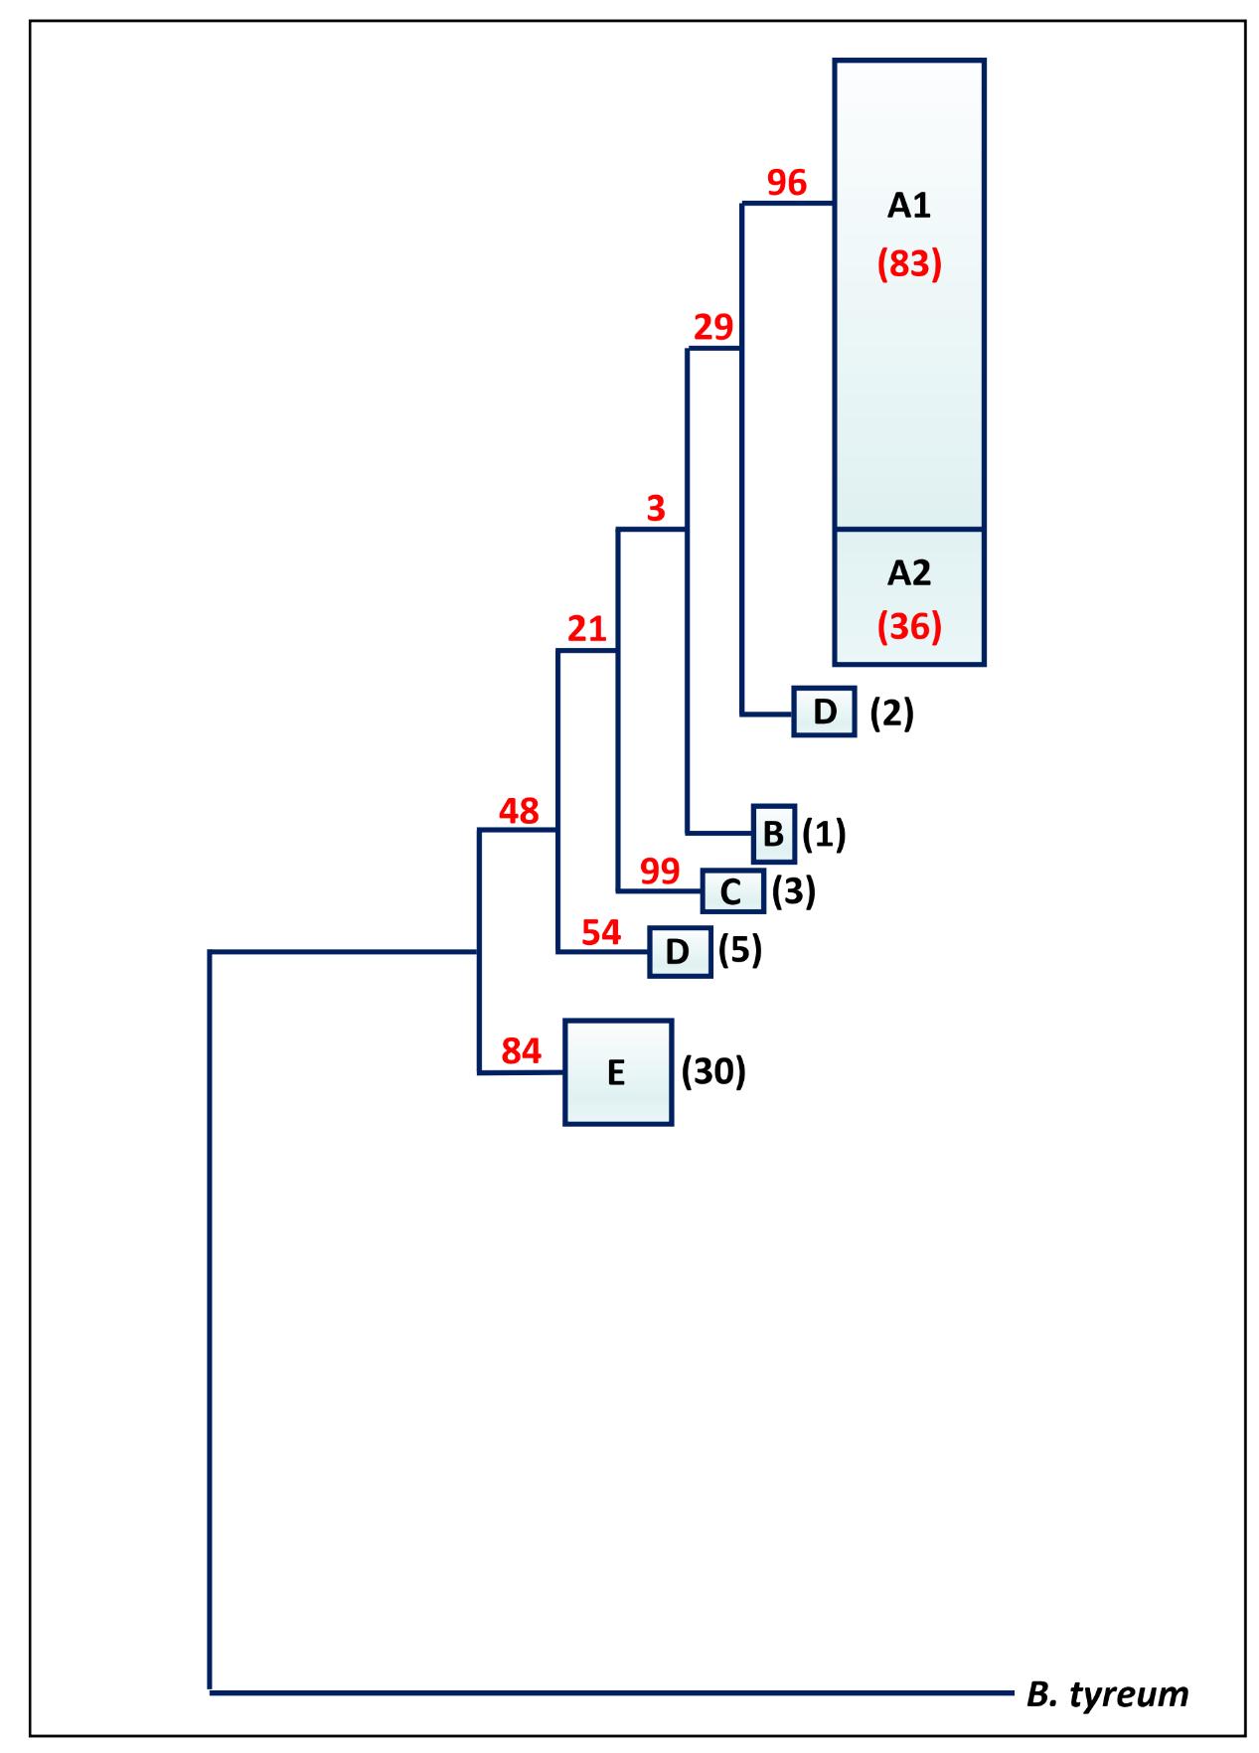**Figure SF1:** Schematic rooted ML phylogenetic tree of *Botryllus schlosseri* clades with bootstrap numbers. The numbers in brackets represent the number of haplotypes within each clade.

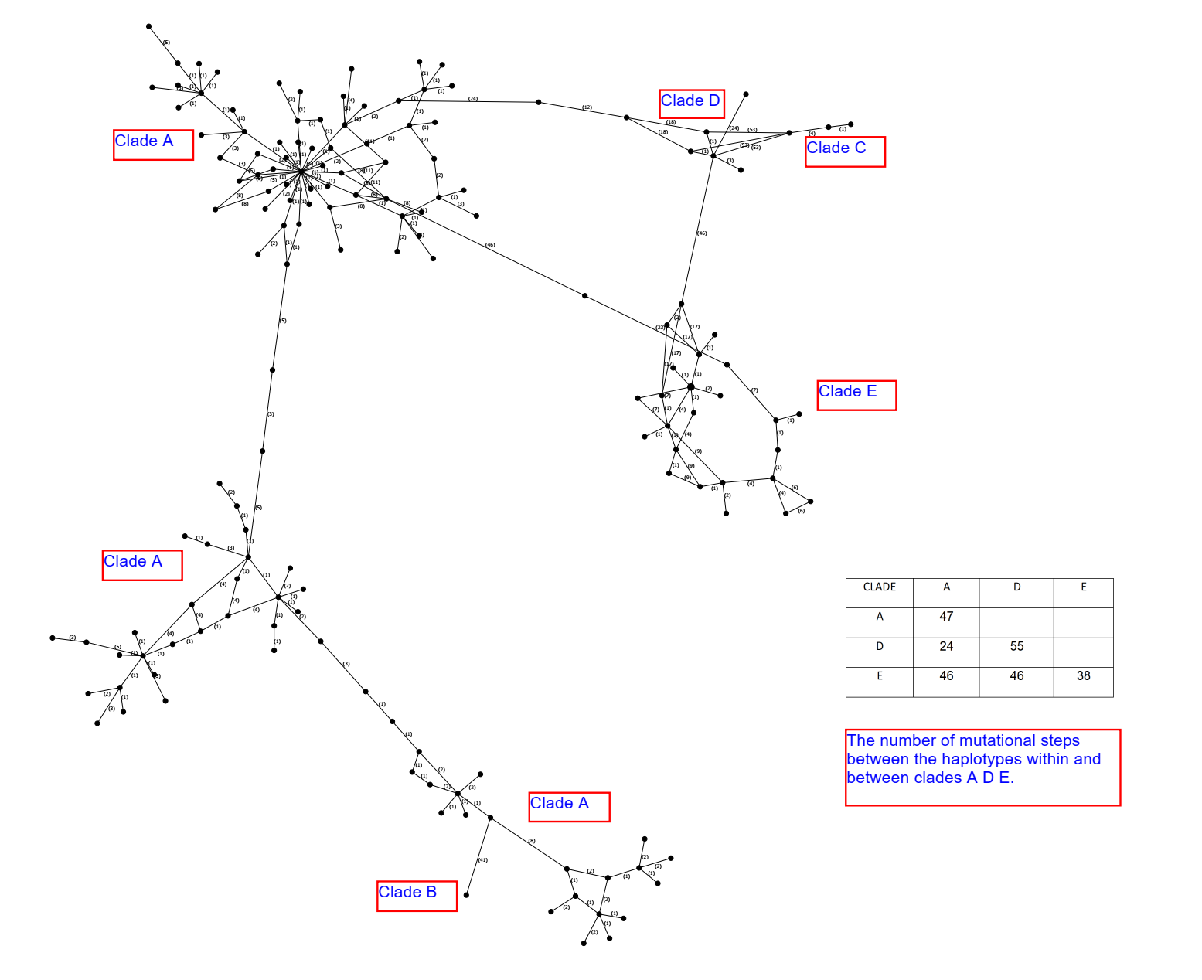**Figure SF2:** median joining network, made with PopArt software of *Botryllus schlosseri* clades with numbers (in brackets) depicting of mutational steps.

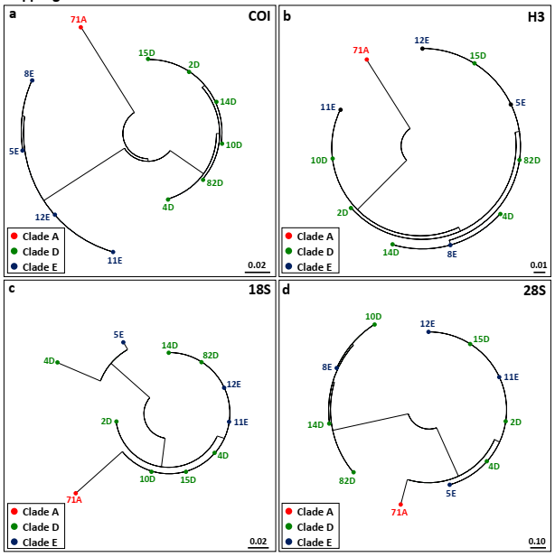**Figure SF3:** Maximum Likelihood phylogenetic trees for *COI*, H3, 18S and 28S genetic markers showing the distribution of the same eleven colonies of clades A, D and E.

**Figure SF4:** satellitemap of collection sites in the Roscoff vicinity (based on google earth).

