Supplementary Material to Microzooplankton community structure in a subtropical South-West Atlantic coastal-site

L. Sampognaro ^{1, *}, M. C. López-Abbate ², D. Calliari ¹

¹ Sección Oceanografía y Ecología Marina, Instituto de Ecología y Ciencias Ambientales, Facultad de Ciencias, Universidad de la República, Uruguay
² Instituto Argentino de Oceanografía (CONICET-UNS), Camino La Carrindanga km 7.5, 8000 Bahía Blanca, Argentina

* lajasampo@gmail.com

Table S1. Results of factorial ANOVA for microzooplankton abundance and biovolume (whole community (Microzooplankton), mixotrophic and heterotrophic dinoflagellates (MD and HD, respectively), small and large loricate (LC<40 and LC>40, respectively) and aloricate ciliates (AC<55 and AC>55, respectively)). F statistic, Df, and p value are shown; non-significant cases are indicated as ‘ns’; post hoc Tukey tests of between-group difference are shown.

Log₁₀ Abundance | Season | Df | F value | Pr (>F) | Tukey test
Microzooplankton |  | 3 | 6.657 | 0.001 | Aut > Sum & Spr
MD |  | 3 | 4.982 | 0.001 | Aut > Sum
HD |  | 3 | 5.811 | 0.001 | Aut > Sum
LC<40 |  | 3 | 0.560 | 0.643 ns
LC>40 |  | 1 | 1.369 | 0.263 ns
AC<55 |  | 3 | 4.862 | 0.004 | Sum > Win
AC>55 |  | 3 | 0.610 | 0.612 ns
Log₁₀ Abundance | Depth
Microzooplankton |  | 1 | 2.455 | 0.117 ns
MD |  | 1 | 1.553 | 0.213 ns
HD |  | 1 | 3.902 | 0.049 | 3.5 > 0 m
LC<40 |  | 1 | 2.522 | 0.118 ns
LC>40 |  | 1 | 4.317 | 0.042 | 3.5 > 0 m
AC<55 |  | 1 | 0.053 | 0.818 ns
AC>55 |  | 1 | 1.939 | 0.170 ns
Log₁₀ Biovolume | Season | Df | F value | Pr (>F) | Tukey test
Microzooplankton |  | 3 | 2.441 | 0.071 ns
MD |  | 3 | 2.160 | 0.092 ns
HD |  | 3 | 7.889 | 0.001 | Aut > Sum
LC<40 |  | 3 | 2.284 | 0.089 ns
LC>40 |  | 3 | 0.574 | 0.635 ns
AC<55 |  | 3 | 3.921 | 0.026 | Sum > Win
AC>55 |  | 3 | 2.768 | 0.051 | Win > Sum
Log₁₀ Biovolume | Depth
Microzooplankton |  | 1 | 2.263 | 0.099 ns
MD |  | 1 | 1.949 | 0.161 ns
HD |  | 1 | 3.899 | 0.050 | 3.5 > 0 m
LC<40 |  | 1 | 3.306 | 0.074 ns
LC>40 |  | 1 | 3.959 | 0.051 | 3.5 > 0 m
AC<55 |  | 1 | 0.536 | 0.466 ns
AC>55 |  | 1 | 3.640 | 0.062 ns
Fig. S1. Relative abundance (1 and 3) and biovolume (2 and 4) contribution of microzooplankton’s trophic functional groups found in Cabo Polonio (small and large loricate (LC<40 and LC>40, respectively) and aloricate ciliates (AC<55 and AC>55, respectively), and mixotrophic and heterotrophic dinoflagellates (MD and HD, respectively)) by month (from July 2019 to June 2020) and season (winter, Win; spring, Spr; summer, Sum; autumn, Aut).

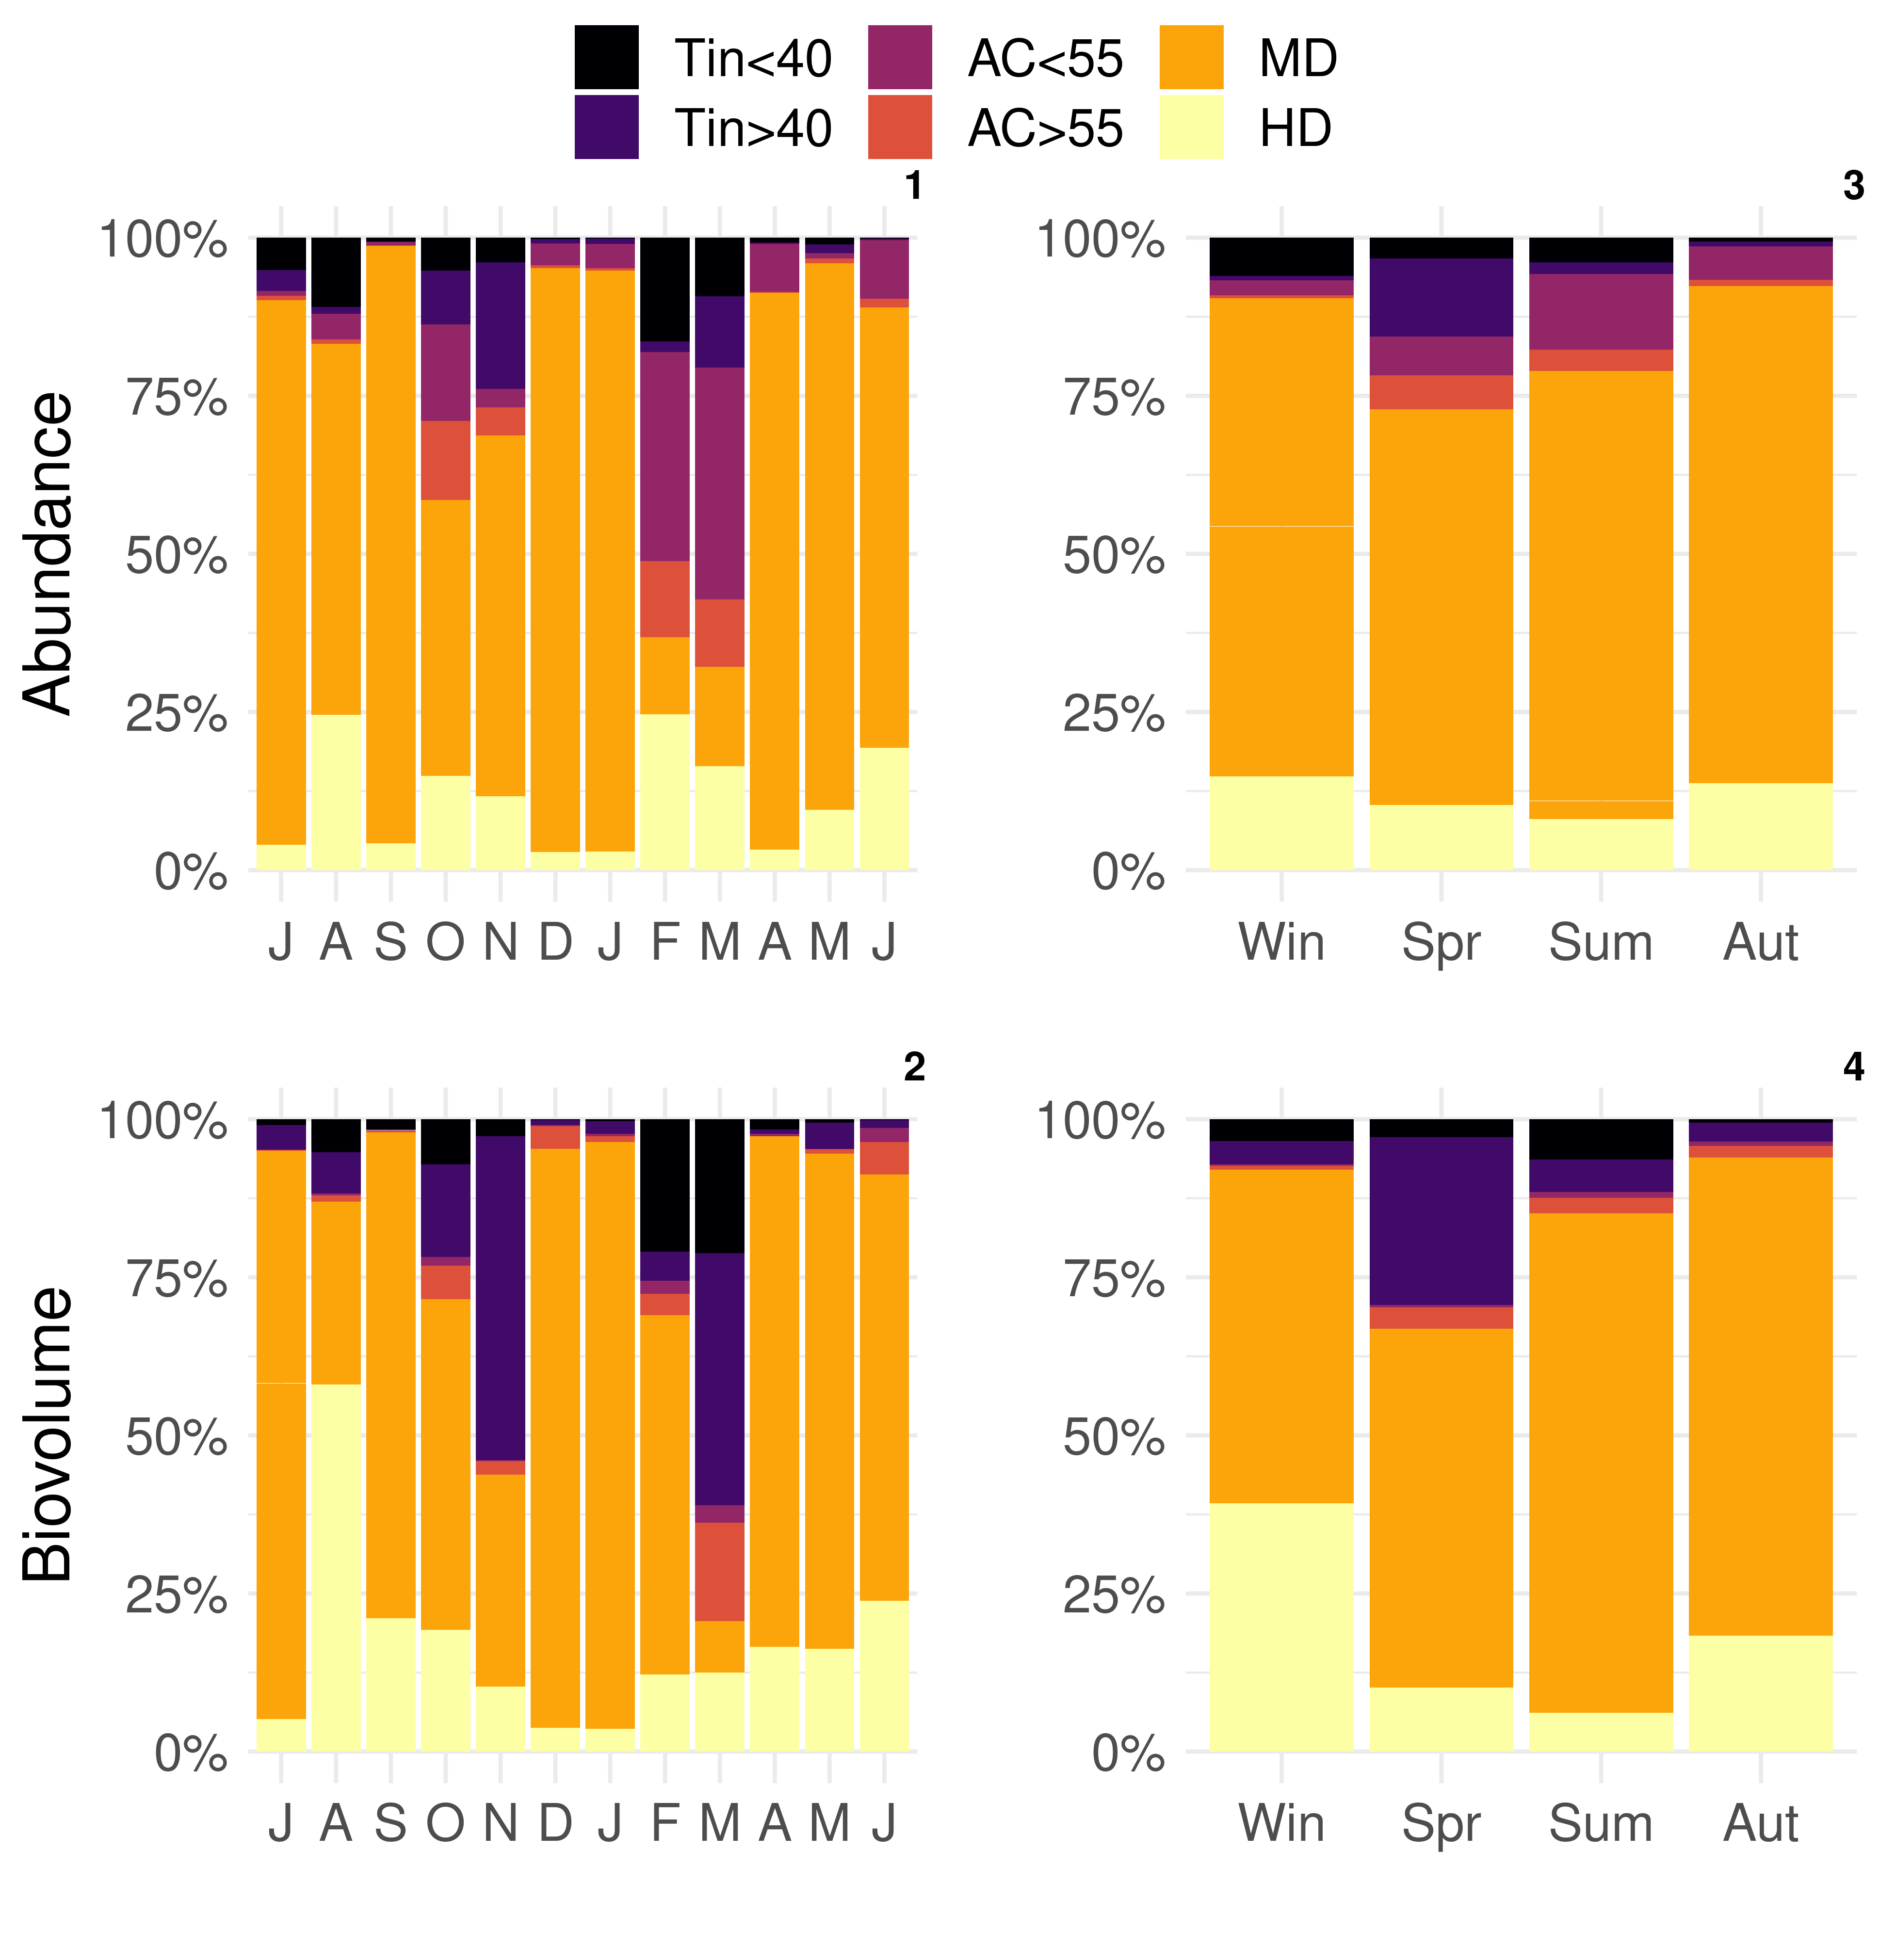
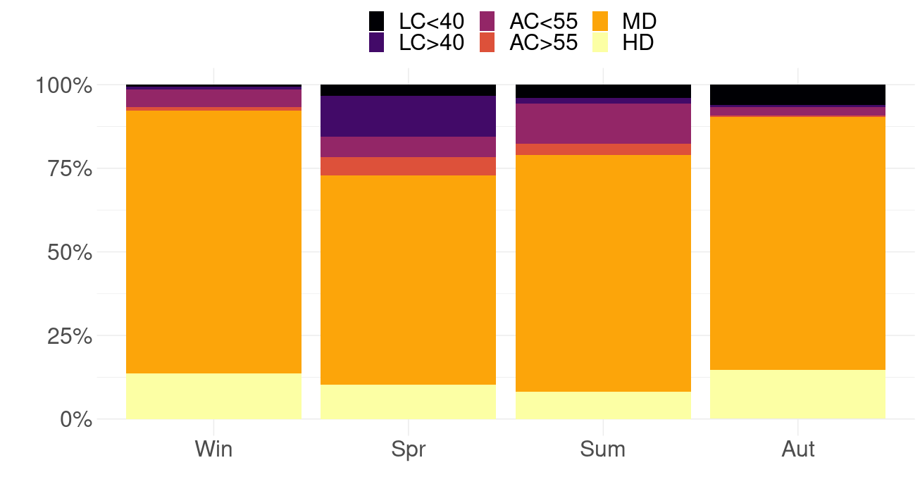
Table S2. Summary (average and standard deviation) of the taxa/species that most contributed to the dissimilarity (%C) for each pair of groups (seasons) determined by SIMPER based on density. The five most influential species for dinoflagellates and ciliates are shown.

Group | Taxa/Specie | Average | SD | C%
Winter-Spring | Kryptoperidinium cf triquetrum | 1.4E-01 | 0.12 | 17.5
 | Tripos furca | 9.3E-02 | 0.11 | 11.3
 | Scrippsiella cf acuminata | 7.2E-02 | 0.05 | 8.8
 | Tintinnopsis gracilis | 3.3E-02 | 0.05 | 4.0
 | Eutintinus sp. | 2.1E-02 | 0.03 | 2.6
Winter-Summer | Kryptoperidinium cf triquetrum | 1.6E-01 | 0.13 | 17.1
 | Scrippsiella cf acuminata | 8.6E-02 | 0.09 | 9.2
 | Akashiwo sanguinea | 7.9E-02 | 0.13 | 8.5
 | Nanociliates | 4.3E-02 | 0.07 | 4.7
 | Tintinnidium balechi | 2.3E-02 | 0.03 | 2.4
Winter-Autumn | Prorocentrum spp. | 1.6E-01 | 0.14 | 18.1
 | Kryptoperidinium cf triquetrum | 1.2E-01 | 0.11 | 14.1
 | Pseliodinium sp. | 9.5E-02 | 0.15 | 11.1
 | Nanociliates | 1.3E-02 | 0.02 | 1.6
 | Strombidium spp. | 9.9E-03 | 0.01 | 1.2
Spring-Summer | Tripos furca | 1.3E-01 | 0.14 | 14.4
 | Scrippsiella cf acuminata | 9.8E-02 | 0.08 | 11.2
 | Akashiwo sanguinea | 8.8E-02 | 0.14 | 10.0
 | Tintinnopsis gracilis | 4.3E-02 | 0.05 | 4.9
 | Ciliate 2 | 2.8E-02 | 0.03 | 3.2
Spring-Autumn | Prorocentrum spp. | 1.6E-01 | 0.11 | 19.3
 | Pseliodinium sp. | 1.1E-01 | 0.15 | 13.2
 | Tripos furca | 7.6E-02 | 0.09 | 9,4
 | Tintinnopsis gracilis | 3.0E-02 | 0.04 | 3.6
 | Ciliate 2 | 1.7E-02 | 0.02 | 2.1
Summer-Autumn | Prorocentrum spp. | 2.1E-01 | 0.13 | 23.4
 | Pseliodinium sp. | 1.2E-01 | 0.17 | 12.9
 | Akashiwo sanguinea | 7.6E-02 | 0.12 | 8.4
 | Strombidium spp. | 1.7E-02 | 0.02 | 1.9
 | Tintinnidium balechi | 1.5E-02 | 0.03 | 1.7

Fig. S2. Seasonal microzooplankton community species richness (S′), Shannon index (H′) and evenness (J′) (1 to 3 respectively) in Cabo Polonio at 0 and 3.5 m. ANOVA and post-hoc Tukey test results between seasons (p<0.05) are indicated with capital letters.

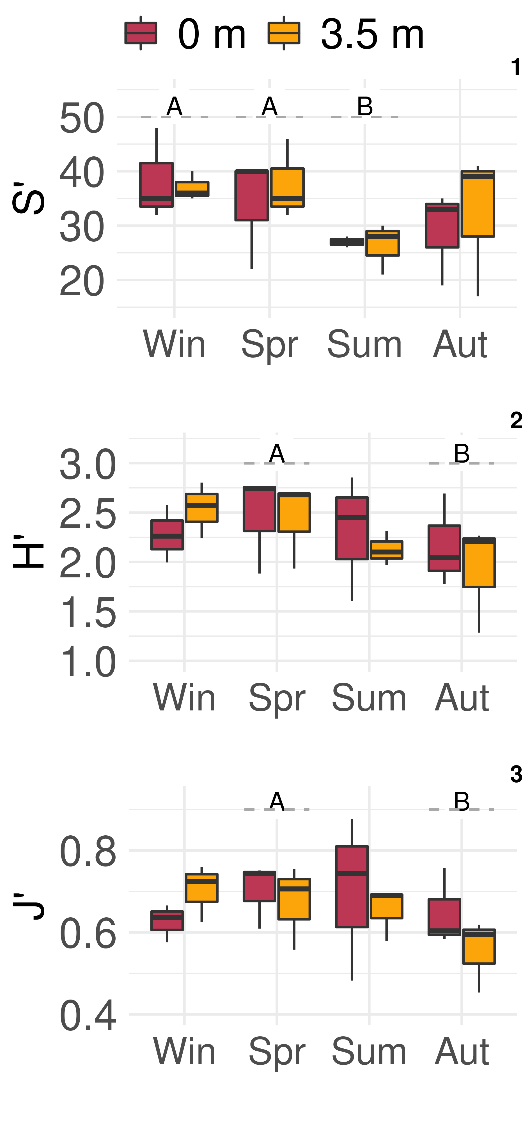
Text S1. List and systematic classification of the microzooplankton species observed in the coastal waters of Cabo Polonio during the 2019-2020 period. Species were checked as accepted valid entries in the World Register of Marine Species (WoRMS, https://www.marinespecies.org).

Dinoflagellates
Kingdom: Chromista
Infrakingdom: Alveolata
Phylum: Myzozoa
Class: Dinophyceae
Order: Dinophysiales
Family: Dinophysaceae
Genus: Dinophysis Ehrenberg, 1839
Dinophysis acuminata-complex
Dinophysis caudata Saville-Kent, 1881
Dinophysis tripos Gourret, 1883
Dinophysis spp.
Order: Ebriales
Family: Ebriaceae
Genus: Ebria Borgert, 1891
Ebria tripartita (J.Schumann) Lemmermann, 1899
Order: Gonyaulacales
Family: Ceratiaceae
Genus: Tripos Bory de Saint-Vincent, 1823
Tripos cf azoricus (Cleve) F.Gómez, 2013
Tripos cf horridum F.Gómez, 2013
Tripos cf kofoidii F.Gómez, 2013
Tripos cf lineatus F.Gómez, 2013
Tripos dens F.Gómez, 2013
Tripos furca F.Gómez, 2013
Tripos fusus F.Gómez, 2013
Tripos muelleri Bory de Saint-Vincent, 1826
Family: Gonyaulacaceae
Genus: Gonyaulax Diesing, 1866
Gonyaulax spp.
Family: Ostreopsidaceae
Genus: Alexandrium Halim, 1960
Alexandrium spp.
Order: Gymnodiniales
Family: Gymnodiniaceae
Genus: Akashiwo G.Hansen & Moestrup, 2000
Akashiwo sanguinea (K.Hirasaka) Gert Hansen & Moestrup, 2000
Genus: Gymnodinium F. Stein, 1878
Gymnodinium catenatum H.W.Graham, 1943
Genus: Gyrodinium Kofoid & Swezy, 1921
Gyrodinium sp. 1
Gyrodinium sp. 2
Family: Tovelliaceae
Genus: Katodinium Fott, 1957
Katodinium sp.
Family: Polykrikaceae
Genus: Polykrikos Bütschli, 1873
Polykrikos kofoidii Chatton, 1914
Order: Noctilucales
Family: Leptodiscaceae
Genus: Scaphodinium Margalef, 1963
Scaphodinium cf mirabile Margalef, 1963
Family: Noctilucaceae
Genus: Noctiluca Suriray, 1836
Noctiluca scintillans (Macartney) Kofoid & Swezy, 1921
Order: Peridiniales
Family: Peridiniaceae
Genus: Kryptoperidinium Lindemann, 1924
Kryptoperidinium cf triquetrum U.Tillmann, M.Gottschling, M.Elbrächter, W.H.Kusber & M.Hoppenrath, 2019
Genus: Scrippsiella Balech ex A.R.Loeblich III, 1965
Scrippsiella cf acuminata (Ehrenberg) Kretschmann, Elbrächter, Zinssmeister, S.Soehner, Kirsch, Kusber & Gottschling, 2015
Family: Protoperidiniaceae
Genus: Protoperidinium Bergh, 1881
Protoperidinium bipes (Paulsen, 1904) Balech, 1974
Protoperidinium cassum (Balech, 1971) Balech, 1974
Protoperidinium claudicans (Paulsen, 1907) Balech, 1974
Protoperidinium conicum (Gran) Balech, 1974
Protoperidinium depressum (Bailey, 1854) Balech, 1974
Protoperidinium divergens (Ehrenberg) Balech, 1974
Protoperidinium granii (Ostenfeld) Balech, 1974
Protoperidinium grande (Kofoid, 1907) Balech, 1974
Protoperidinium oviforme (Dangeard, 1927) Balech, 1974
Protoperidinium pellucidum Bergh, 1881
Protoperidinium pentagonum (Gran, 1902) Balech, 1974
Protoperidinium punctulatum (Paulsen, 1907) Balech, 1974
Protoperidinium steinii (Jørgensen, 1899) Balech, 1974
Protoperidinium spp.
Genus: Oblea Balech ex Loeblich Jr. & Loeblich III, 1966
Oblea rotunda (Lebour) Balech ex Sournia, 1973
Family: Oxytoxaceae
Genus: Oxytoxum Stein, 1883
Oxytoxum sp. 1
Oxytoxum sp. 2
Oxytoxum sp. 3
Order: Prorocentrales
Family: Prorocentraceae
Genus: Prorocentrum Ehrenberg, 1834
Prorocentrum spp.
Order: Pyrocystales
Family: Pyrocystaceae
Genus: Pyrocystis J.Murray ex Haeckel, 1890
Pyrocystis lunula (Schütt) Schütt, 1896
Class: Dinoflagellata incertae sedis
Genus: Pseliodinium Sournia, 1972
Pseliodinium sp.

Loricate ciliates
Kingdom: Chromista
Infrakingdom: Alveolata
Phylum: Ciliophora
Class: Oligotrichea
Subclass: Oligotrichia
Order: Choreotrichida
Family: Codonellidae
Genus: Codonellopsis Jörgensen, 1924
Codonellopsis lusitanica Jörgensen, 1924
Codonellopsis schabi (Brandt, 1906) Kofoid & Campbell, 1929
Codonellopsis morchella (Cleve) Jörgensen, 1924
Genus: Tintinnopsis Stein, 1867
Tintinnopsis brasiliensis Kofoid & Campbell, 1929
Tintinnopsis buetschlii var mortensenii Daday,1887/ Schmidt,1902
Tintinnopsis baltica Brandt, 1896
Tintinnopsis cylindrica Daday, 1887
Tintinnopsis fimbriata Meunier, 1919
Tintinnopsis gracilis Kofoid & Campbell, 1929
Tintinnopsis cf parvula Jörgensen, 1912
Tintinnopsis radix Imhof, 1886
Tintinnopsis tocantinensis Kofoid & Campbell, 1929
Tintinnopsis uruguayensis Balech, 1948
Tintinnopsis sp. 1
Tintinnopsis sp. 2
Tintinnopsis sp. 3
Tintinnopsis sp. 4
Family: Codonellopsidae
Genus: Stenosemella Jörgensen
Stenosemella cf avellana Meunier, 1919
Stenosemella sp. 1
Stenosemella sp. 2
Stenosemella sp. 3
Family: Metacylididae
Genus: Helicostomella Jörgensen, 1924
Helicostomella cf subulata Jörgensen, 1924
Family: Ptychocylididae
Genus: Favella Jörgensen, 1924
Favella ehrenbergii Jörgensen, 1924
Family: Tintinnida incertae sedis
Genus: Stylicauda Balech, 1951
Stylicauda platensis Balech, 1951
Family: Tintinnidae
Genus: Amphorellopsis Kofoid & Campbell, 1929
Amphorellopsis acuta Schmidt, 1902
Genus: Eutintinnus Kofoid & Campbell, 1939
Eutintinnus sp.
Genus: Salpingella Jörgensen, 1924
Salpingella sp.
Family: Tintinnidiidae
Genus: Leprotintinnus Jörgensen, 1899
Leprotintinnus nordqvistii Kofoid & Campbell, 1929
Genus: Tintinnidium Kent, 1881
Tintinnidium balechi Barría de Cao, 1981
Tintinnidium spp.

Aloricate Ciliates
Kingdom: Chromista
Infrakingdom: Alveolata
Phylum: Ciliophora
Class: Litostomatea
Subclass: Haptoria
Order: Haptorida
Family: Didiniidae
Genus: Cyclotrichium Meunier, 1910
Cyclotrichium sp.
Order: Cyclotrichiida
Family: Mesodiniidae
Genus: Mesodinium von Stein
Mesodinium rubrum Lohmann, 1908
Class: Oligotrichea
Subclass: Oligotrichia
Order: Choreotrichida
Family: Lohmanniellidae
Genus: Lohmanniella Leegaard, 1915
Lohmanniella oviformis Leegaard, 1915
Family: Strombidinopsidae
Genus: Strombidinopsis Kent, 1881
Strombidinopsis cf acuminata Fauré-Fremiet, 1924
Family: Strobilidiidae
Genus: Pelagostrobilidium Petz, Song & Wilbert, 1995
Pelagostrobilidium spirale Petz, Song & Wilbert, 1995
Order: Oligotrichida
Family: Cyrtostrombidiidae
Genus: Cyrtostrombidium Lynn & Gilron, 1993
Cyrtostrombidium sp.
Family: Strombidiidae
Genus: Strombidium Claparède & Lachmann, 1859
Strombidium cf capitatum Kahl, 1932
Strombidium cf conicum Wulff, 1919
Strombidium cf emergens Busch, 1921
Strombidium cf epidemum Lynn, Montagnes & Small, 1988
Strombidium spp.
Family: Tontoniidae
Genus: Laboea Lohmann, 1908
Laboea strobila Lohmann, 1908
Genus: Paratontonia Jankowski, 1978
Paratontonia gracillima Jankowski, 1978
Order: Oligotrichida
Ciliate 1
Ciliate 2
Ciliate 3
Nanociliate
Class: Prostomatea
Order: Prorodontida
Family: Colepidae
Genus: Tiarina Berg, 1881
Tiarina sp.

Radiolarians
Kingdom: Chromista
Infrakingdom: Rhizaria
Phylum: Radiozoa
Class: Polycystina
Order: Nassellaria
Family: Plagiacanthidae
Genus: Lophophaena Boltovskoy, 2003
Lophophaena rioplatensis Boltovskoy, 2003

Rotifers
Kingdom: Animalia
Phylum: Rotifera
Class: Eurotatoria
Order: Ploima
Family: Trichocercidae
Genus: Trichocerca Lamarck, 1801
Trichocerca sp.
Family: Synchaetidae
Genus: Synchaeta Ehrenberg, 1832
Synchaeta sp.

Arthropods
Kingdom: Animalia
Phylum: Arthropoda
Class: Hexanauplia
Order: Calanoida
Nauplii
Class: Branchiopoda
Order: Onychopoda
Family: Podonidae
Genus: Podon Lilljeborg, 1853
Podon sp.
Genus: Evadne Lovén, 1836
Evadne sp.

Table S3. Pearson's correlations (r) matrix results of microzooplankton groups (mixotrophic and heterotrophic dinoflagellates ((MD and HD, respectively), small and large loricate (LC<40 and LC>40, respectively) and aloricate ciliates (AC<55 and AC>55, respectively)) and environmental variables (T, temperature; S, salinity; Turb., turbidity; PO4, phosphate; DIN, dissolved inorganic nutrient; SiO4, silicates; Chl-a, Chlorophyll-a; Fluor., fluorescence). Only significant values are shown, p: 0.001 ‘***’, 0.01 ‘**’, 0.05 ‘*’. Confidence intervals (95% CI) and the test statistic (t) are provided.

Var 1 | Var 2 | r | 95% CI | t | p
MD | T | -0.49 | [-0.76, -0.07] | -2.42 | 0.026 *
MD | Turb | -0.65 | [-0.85, -0.31] | -3.77 | 0.001 **
MD | PO4 | -0.46 | [-0.75, -0.04] | -2.28 | 0.034 *
MD | DIN | -0.46 | [-0.74, -0.03] | -2.23 | 0.038 *
MD | Chl-a | 0.49 | [0.08, 0.76] | 2.47 | 0.023 *
MD | HD | 0.52 | [0.11, 0.78] | 2.64 | 0.016 *
HD | T | -0.48 | [-0.76, -0.07] | -2.41 | 0.026 *
HD | DIN | -0.47 | [-0.75, -0.05] | -2.31 | 0.032 *
HD | LC<40 | 0.58 | [0.20, 0.81] | 3.09 | 0.006 **
HD | AC>55 | 0.53 | [0.13, 0.78] | 2.74 | 0.013 *
LC<40 | T | -0.44 | [-0.73, -0.01] | -2.12 | 0.047 *
LC<40 | LC>40 | 0.45 | [0.02, 0.74] | 2.20 | 0.040 *
AC<55 | S | 0.56 | [0.17, 0.80] | 2.94 | 0.008 **
AC<55 | DIN | -0.45 | [-0.74, -0.02] | -2.19 | 0.041 *
AC<55 | SiO4 | -0.55 | [-0.79, -0.15] | -2.85 | 0.010 *
AC>55 | S | 0.56 | [0.17, 0.80] | 2.97 | 0.008 **
AC>55 | SiO4 | -0.56 | [-0.80, -0.17] | -2.93 | 0.009 **
AC>55 | LC<40 | 0.52 | [0.11, 0.78] | 2.63 | 0.016 *
AC>55 | LC>40 | 0.69 | [0.36, 0.86] | 4.13 | < .001 ***
AC>55 | AC<55 | 0.59 | [0.21, 0.81] | 3.15 | 0.005 **

Table S4. Pearson's correlations between the abundance of main genera found in Cabo Polonio according to Mitra et al. (2016) functional groups (i.e., microzooplankton (MZ), constitutive mixotroph (CM), generalist non-constitutive mixotroph (GNCM), and specialist non-constitutive mixotroph (SNCM)) and the environmental variables (T, temperature; S, salinity; Fluor., fluorescence; Turb., turbidity; SiO4, silicates, and Chl-a, Chlorophyll-a). Only significant values are shown, p: 0.001 ‘***’, 0.01 ‘**’, 0.05 ‘*’.

Functional Group | Genus | T | S | Fluor | Turb | PO4 | SiO4 | Chl-a
MZ | Protoperidinium  Tintinnopsis | -0.51 *
CM | Tripos |  |  | 0.72 *** | -0.49 * |  | 0.50 *
GNCM | Strombidium |  | 0.62 *** |  |  |  | -0.57 ***
SNCM | Dinophysis  Mesodinium | -0.57 ** |  | 0.45 * |  | -0.49 * |  | 0.41 *

