Table S1 A. Surface alteration experiments
Reaction conditions | NaOH concentration (mol L⁻¹) |  | Carbonate Concentration (mol L⁻¹) |  | Atmosphere
1 | 0.01 |  | 0.1 |  | Ambient
2 | 0.01 |  | 0.1 |  | Nitrogen Purged
3 | 0.01 |  | ---- |  | Ambient
4 | 0.01 |  | ---- |  | Nitrogen Purged
5 | ---- |  | 0.1 |  | Ambient
6 | ---- |  | 0.1 |  | Nitrogen Purged
7 | ---- |  | ---- |  | Ambient
8 | ---- |  | ---- |  | Nitrogen Purged
Table S1 B. Uranium sorption pH
Reaction conditions |  | pH | Uranyl Nitrate concentration  (ppb) |  | Atmosphere
1 |  | 7 | 200 |  | Ambient
2 |  | 9 | 200 |  | Ambient
3 |  | 11 | 200 |  | Ambient
4 |  | 12.5 | 200 |  | Ambient
5 |  | 13.3 | 200 |  | Ambient
6 |  | 7 | 200 |  | Nitrogen purged
7 |  | 9 | 200 |  | Nitrogen purged
8 |  | 11 | 200 |  | Nitrogen purged
9 |  | 12.5 | 200 |  | Nitrogen purged
10 |  | 13.3 | 200 |  | Nitrogen purged

Table S1 C. Uranium sorption effect of carbonate
Reaction conditions | pH | Uranyl Nitrate concentration (ppb) | Carbonate concentration  (mol L⁻¹) |  | Atmosphere
1 | 7 | 200 | 1.00E-02 |  | Ambient
2 | 7 | 200 | 1.00E-04 |  | Ambient
3 | 7 | 200 | 1.00E-06 |  | Ambient
4 | 7 | 200 | 1.00E-08 |  | Ambient
5 | 7 | 200 | 1.00E-10 |  | Ambient
6 | 13 | 200 | 1.00E-02 |  | Nitrogen purged
7 | 13 | 200 | 1.00E-04 |  | Nitrogen purged
8 | 13 | 200 | 1.00E-06 |  | Nitrogen purged
9 | 13 | 200 | 1.00E-08 |  | Nitrogen purged
10 | 13 | 200 | 1.00E-10 |  | Nitrogen purged

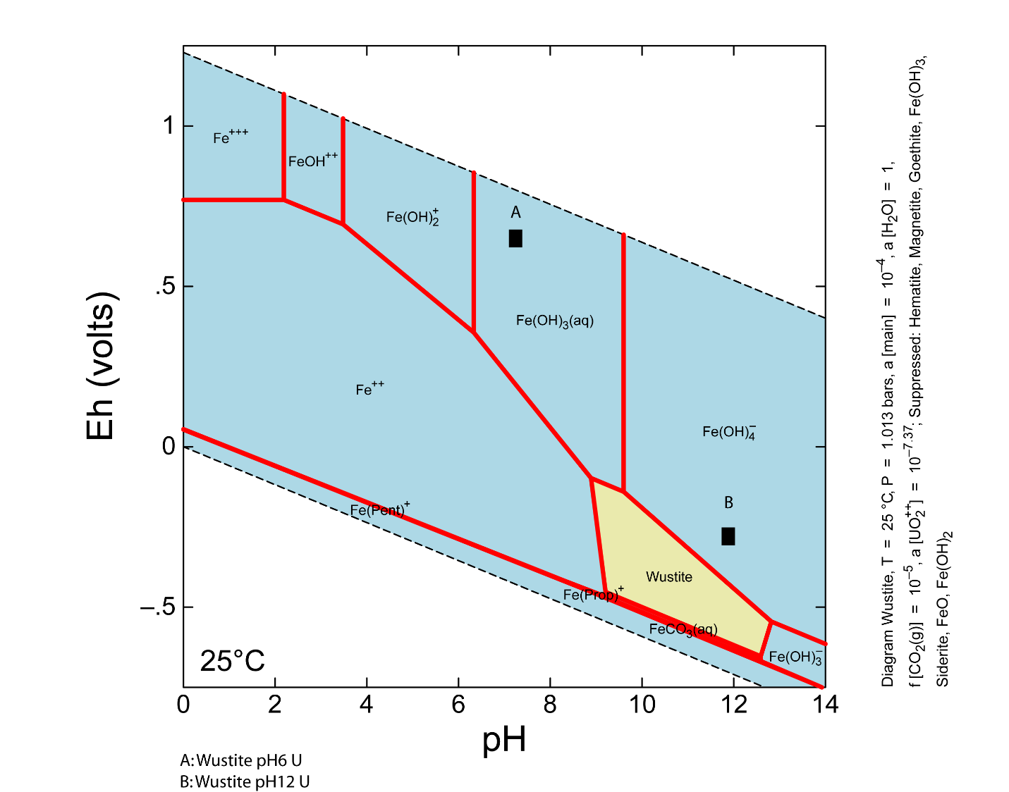
A
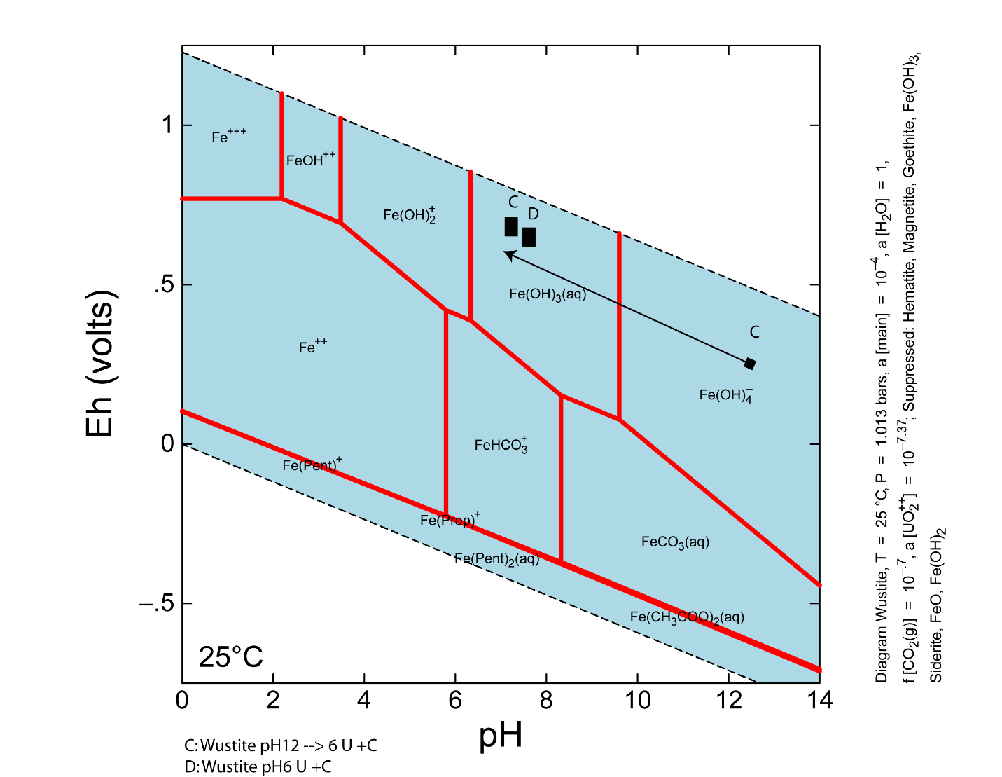
B
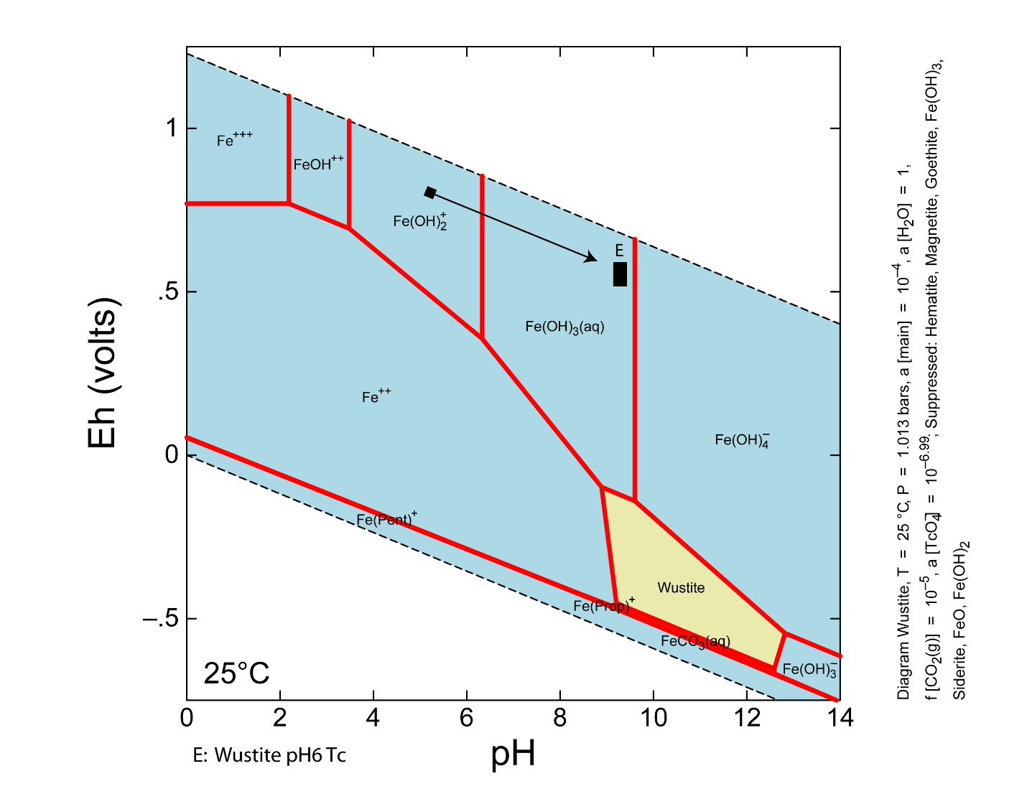
C
Figure S1. Eh-pH diagrams for: A) Reduced P_{CO2}= 10^{-5.0} with U(VI); B) increased P_{CO2}= 10^{-0.7} with U(VI); C) reduced P_{CO2}= 10^{-5.0} with Tc(VII). All diagrams have common iron phases suppressed. A and C show wüstite stability field which appears at low PCO₂ with common phases suppressed.

Table S2. Alteration experiments: elemental analyses and carbonate measurements.
Sample† | C* | H* | N* | Mass | [ CO₃²⁻ ] | [ HCO₃⁻ ]
 |  | % |  | µg | mol L⁻¹
FeO unreacted | 0 | 0.02 | 0.02 | 1691.5 | — | —
DI N₂‡ | 0.05 | 0.02 | 0.02 | 2241.6 | <0.0016 | <0.0016
DI N₂ + CO₃²⁻ | 0.01 | 0.06 | 0.05 | 1666.8 | 0.0243 | 0.0845
DI | 0.02 | 0.06 | 0.01 | 3040 | <0.0016 | <0.0016
DI + CO₃²⁻ | 0.01 | 0.12 | 0.03 | 1554.8 | 0.0257 | 0.0757
NaOH N₂ | 0.02 | 0.08 | 0.01 | 1998.9 | <0.0016 | <0.0016
NaOH N₂ + CO₃²⁻ | 0.02 | 0.09 | 0.01 | 1689.2 | 0.0337 | 0.0725
NaOH | 0 | 0.16 | 0.02 | 1297.6 | <0.0016 | <0.0016
NaOH DI + CO₃²⁻ | 0.02 | 0.08 | 0.01 | 2353.9 | 0.0323 | 0.0681
† [CO₃²⁻] and [NaOH] are 0.1 and 0.01 mol l⁻¹ respectively when present
*error ± 0.05%
‡ N₂ purged (low P_{CO2})

Table S3 Rd data
- Carbonate effect on Rd under atmospheric P_{CO2} conditions.
pH | rep. | PCO2 | [CO₃²⁻] | Mass | Solution Mass | Aliquot Mass | Aliquot Total | ppb | normalised ppb | dilution factor | Rd
 |  |  | mol L⁻¹ | (g) | (g) | (g) | (g)
7 | A | ATM | 1.00E-02 | 0.0988 | 10.2031 | 1.0011 | 2.0091 | 4.66E+01 | 4.62E+01 | 2.19E+02 | 1.00E+01
7 | B | ATM | 1.00E-02 | 0.0987 | 10.149 | 1.0015 | 2.0092 | 1.08E+02 | 1.08E+02 | 2.17E+02 | 1.09E+01
7 | C | ATM | 1.00E-02 | 0.0997 | 10.0172 | 1.0085 | 2.0141 | 1.11E+02 | 1.11E+02 | 2.22E+02 | 8.31E+00
7 | A | ATM | 1.00E-04 | 0.0991 | 10.0177 | 1.0071 | 2.0198 | 2.83E+01 | 2.85E+01 | 5.72E+01 | 2.53E+02
7 | B | ATM | 1.00E-04 | 0.1035 | 10.1052 | 1.0056 | 2.0202 | 3.29E+01 | 3.14E+01 | 6.31E+01 | 2.19E+02
7 | C | ATM | 1.00E-04 | 0.1001 | 10.1208 | 1.0054 | 2.0241 | 3.37E+01 | 3.33E+01 | 6.70E+01 | 2.01E+02
7 | A | ATM | 1.00E-06 | 0.0998 | 10.0896 | 1.0081 | 2.018 | 4.03E+01 | 4.00E+01 | 4.00E+01 | 4.88E+02
7 | B | ATM | 1.00E-06 | 0.0982 | 10.093 | 1.0059 | 2.0166 | 2.11E+01 | 2.13E+01 | 4.27E+01 | 4.51E+02
7 | C | ATM | 1.00E-06 | 0.0993 | 10.1201 | 1.0028 | 2.0185 | 2.93E+01 | 2.91E+01 | 5.86E+01 | 3.02E+02
7 | A | ATM | 1.00E-08 | 0.1059 | 10.3583 | 1.0258 | 2.0403 | 3.65E+01 | 3.33E+01 | 4.63E+01 | 4.31E+02
7 | B | ATM | 1.00E-08 | 0.1071 | 10.022 | 1.0094 | 2.0214 | 4.39E+01 | 4.09E+01 | 5.19E+01 | 3.74E+02
7 | C | ATM | 1.00E-08 | 0.1024 | 10.0217 | 1.0128 | 2.0278 | 1.78E+01 | 1.73E+01 | 3.47E+01 | 6.08E+02
7 | A | ATM | 1.00E-10 | 0.1045 | 9.9943 | 1.0069 | 2.0237 | 1.58E+01 | 1.52E+01 | 3.05E+01 | 5.65E+02
7 | B | ATM | 1.00E-10 | 0.1006 | 10.3447 | 1.0085 | 2.0292 | 2.09E+01 | 2.01E+01 | 4.05E+01 | 4.01E+02
7 | C | ATM | 1.00E-10 | 0.1059 | 10.117 | 1.0027 | 2.0168 | 1.40E+01 | 1.31E+01 | 2.63E+01 | 6.72E+02
13 | A | ATM | 1.00E-02 | 0.111 | 10.1308 | 1.0152 | 2.0347 | 1.37E+02 | 1.22E+02 | 2.44E+02 | 6.13E+01
13 | B | ATM | 1.00E-02 | 0.1012 | 10.1906 | 1.011 | 2.0251 | 1.27E+02 | 1.23E+02 | 2.47E+02 | 5.93E+01
13 | C | ATM | 1.00E-02 | 0.0998 | 10.1448 | 1.0172 | 2.0354 | 1.22E+02 | 1.20E+02 | 2.41E+02 | 6.31E+01
13 | A | ATM | 1.00E-04 | 0.096 | 10.153 | 1.0151 | 2.0355 | 1.22E+02 | 1.25E+02 | 2.51E+02 | 2.10E+01
13 | B | ATM | 1.00E-04 | 0.0993 | 10.1579 | 1.0123 | 2.0273 | 1.32E+02 | 1.31E+02 | 2.62E+02 | 1.57E+01
13 | C | ATM | 1.00E-04 | 0.0993 | 10.1017 | 1.0196 | 2.0352 | 1.17E+02 | 1.17E+02 | 2.34E+02 | 2.99E+01
13 | A | ATM | 1.00E-06 | 0.104 | 10.1807 | 1.0157 | 2.0278 | 1.34E+02 | 1.26E+02 | 2.52E+02 | 1.90E+01
13 | B | ATM | 1.00E-06 | 0.1077 | 10.1691 | 1.0146 | 2.0228 | 1.28E+02 | 1.17E+02 | 2.33E+02 | 2.89E+01
13 | C | ATM | 1.00E-06 | 0.1075 | 10.2034 | 1.0288 | 2.0384 | 1.55E+02 | 1.41E+02 | 2.80E+02 | 7.05E+00
13 | A | ATM | 1.00E-08 | 0.1032 | 10.1897 | 1.019 | 2.0359 | 1.34E+02 | 1.27E+02 | 2.54E+02 | 2.76E+01
13 | B | ATM | 1.00E-08 | 0.0994 | 10.2212 | 1.0379 | 2.0568 | 1.20E+02 | 1.18E+02 | 2.33E+02 | 3.90E+01
13 | C | ATM | 1.00E-08 | 0.0938 | 10.2013 | 1.0259 | 2.037 | 1.27E+02 | 1.33E+02 | 2.64E+02 | 2.26E+01
13 | A | ATM | 1.00E-10 | 0.1143 | 10.687 | 1.0473 | 2.0643 | 1.21E+02 | 9.88E+01 | 1.95E+02 | 6.45E+01
13 | B | ATM | 1.00E-10 | 0.1033 | 10.081 | 1.0326 | 2.0492 | 1.26E+02 | 1.21E+02 | 2.39E+02 | 3.37E+01
13 | C | ATM | 1.00E-10 | 0.1056 | 10.1481 | 1.0266 | 2.0408 | 1.25E+02 | 1.16E+02 | 2.32E+02 | 3.83E+01

- Carbonate effect on Rd under reduced P_{CO2} conditions.
pH | rep. | PCO2 | [CO₃²⁻] | Mass | Solution Mass | Aliquot Mass | Aliquot Total | ppb | normalised ppb | dilution factor | Rd
 |  |  | mol L⁻¹ | (g) | (g) | (g) | (g)
7 | A | N2 | 1.00E-02 | 0.1058 | 10.0733 | 1.0144 | 2.0414 | 4.66E+01 | 4.37E+01 | 2.19E+02 | 1.00E+01
7 | B | N2 | 1.00E-02 | 0.1063 | 10.1548 | 1.0031 | 2.0157 | 1.08E+02 | 1.00E+02 | 2.02E+02 | 1.93E+01
7 | C | N2 | 1.00E-02 | 0.1115 | 10.2066 | 1.096 | 2.1114 | 1.11E+02 | 9.77E+01 | 1.88E+02 | 2.79E+01
7 | A | N2 | 1.00E-04 | 0.1013 | 10.1725 | 1.0115 | 2.022 | 2.83E+01 | 2.75E+01 | 5.49E+01 | 2.67E+02
7 | B | N2 | 1.00E-04 | 0.0987 | 10.1389 | 1.0028 | 2.0191 | 3.29E+01 | 3.28E+01 | 6.61E+01 | 2.05E+02
7 | C | N2 | 1.00E-04 | 0.1077 | 10.149 | 1.0013 | 1.983 | 3.37E+01 | 3.08E+01 | 6.11E+01 | 2.30E+02
7 | A | N2 | 1.00E-06 | 0.101 | 10.0767 | 1.0014 | 2.0115 | 4.03E+01 | 3.96E+01 | 7.96E+01 | 1.96E+02
7 | B | N2 | 1.00E-06 | 0.1015 | 10.0236 | 1.0046 | 2.0213 | 2.11E+01 | 2.08E+01 | 4.18E+01 | 4.64E+02
7 | C | N2 | 1.00E-06 | 0.1056 | 10.1355 | 1.0007 | 2.0183 | 2.93E+01 | 2.74E+01 | 5.52E+01 | 3.27E+02
7 | A | N2 | 1.00E-08 | 0.1014 | 10.0266 | 1.0043 | 2.0206 | 3.65E+01 | 3.59E+01 | 7.23E+01 | 2.40E+02
7 | B | N2 | 1.00E-08 | 0.1003 | 10.0266 | 1.0028 | 2.0136 | 4.39E+01 | 4.36E+01 | 8.76E+01 | 1.80E+02
7 | C | N2 | 1.00E-08 | 0.1005 | 10.0974 | 1.0031 | 2.0185 | 1.78E+01 | 1.75E+01 | 3.53E+01 | 5.97E+02
7 | A | N2 | 1.00E-10 | 0.0938 | 10.459 | 1.0043 | 2.0161 | 1.58E+01 | 1.61E+01 | 3.24E+01 | 5.25E+02
7 | B | N2 | 1.00E-10 | 0.1037 | 10.151 | 1.0038 | 2.0135 | 2.09E+01 | 1.99E+01 | 3.99E+01 | 4.08E+02
7 | C | N2 | 1.00E-10 | 0.1097 | 9.9479 | 9.9981 | 2.0116 | 1.40E+01 | 1.28E+01 | 3.26E+01 | 5.22E+02
13 | A | N2 | 1.00E-02 | 0.0967 | 10.1474 | 1.0103 | 2.0224 | 1.37E+02 | 1.39E+02 | 2.79E+02 | 4.09E+01
13 | B | N2 | 1.00E-02 | 0.1093 | 10.124 | 1.0164 | 2.0269 | 1.27E+02 | 1.15E+02 | 2.29E+02 | 7.17E+01
13 | C | N2 | 1.00E-02 | 0.098 | 10.1037 | 1.0183 | 2.0262 | 1.22E+02 | 1.23E+02 | 2.45E+02 | 6.04E+01
13 | A | N2 | 1.00E-04 | 0.1049 | 10.2563 | 1.0131 | 2.0268 | 1.22E+02 | 1.13E+02 | 2.27E+02 | 3.38E+01
13 | B | N2 | 1.00E-04 | 0.146 | 10.0536 | 1.0134 | 2.0254 | 1.32E+02 | 8.99E+01 | 1.80E+02 | 6.87E+01
13 | C | N2 | 1.00E-04 | 0.0963 | 10.127 | 1.0168 | 2.0302 | 1.17E+02 | 1.20E+02 | 2.40E+02 | 2.62E+01
13 | A | N2 | 1.00E-06 | 0.1004 | 10.1221 | 1.014 | 2.0304 | 1.34E+02 | 1.32E+02 | 2.64E+02 | 1.39E+01
13 | B | N2 | 1.00E-06 | 0.1121 | 10.1378 | 1.0193 | 2.0367 | 1.28E+02 | 1.13E+02 | 2.25E+02 | 3.35E+01
13 | C | N2 | 1.00E-06 | 0.1109 | 10.2308 | 1.0142 | 2.0312 | 1.55E+02 | 1.37E+02 | 2.74E+02 | 9.55E+00
13 | A | N2 | 1.00E-08 | 0.1023 | 10.0559 | 1.0122 | 2.0328 | 1.34E+02 | 1.30E+02 | 2.61E+02 | 2.42E+01
13 | B | N2 | 1.00E-08 | 0.0988 | 9.967 | 1.0112 | 2.0449 | 1.20E+02 | 1.21E+02 | 2.45E+02 | 3.20E+01
13 | C | N2 | 1.00E-08 | 0.1142 | 10.1978 | 1.0118 | 2.0452 | 1.27E+02 | 1.09E+02 | 2.21E+02 | 4.65E+01
13 | A | N2 | 1.00E-10 | 0.11 | 10.115 | 1.0125 | 2.0376 | 1.21E+02 | 1.08E+02 | 2.18E+02 | 4.68E+01
13 | B | N2 | 1.00E-10 | 0.1006 | 10.0565 | 1.0143 | 2.0424 | 1.26E+02 | 1.24E+02 | 2.50E+02 | 2.81E+01
13 | C | N2 | 1.00E-10 | 0.1144 | 10.0327 | 1.0132 | 2.0397 | 1.25E+02 | 1.09E+02 | 2.19E+02 | 4.63E+01

- pH effect on Rd.
pH | rep. | PCO2 | Mass | Solution Mass | Aliquot Mass | Aliquot total | ppb | Normalised ppb | dilution factor | sorbed | Rd
 |  |  | (g) | (g) | (g) | (g) |  |  |  | (%)
7 | A | ATM | 0.1069 | 10.2646 | 2.4668 | 5.0951 | 7.52E+00 | 6.85E+00 | 1.42E+01 | 9.10E-01 | 1.01E+03
7 | B | ATM | 0.1023 | 9.9815 | 1.834 | 3.6831 | 1.10E+01 | 1.08E+01 | 2.17E+01 | 8.62E-01 | 6.25E+02
7 | C | ATM | 0.0992 | 9.9547 | 2.6889 | 5.39889 | 6.36E+00 | 6.44E+00 | 1.29E+01 | 9.18E-01 | 1.12E+03
9 | A | ATM | 0.1004 | 10.07 | 2.0553 | 4.6887 | 2.83E+00 | 2.80E+00 | 6.39E+00 | 8.28E-01 | 2.67E+02
9 | B | ATM | 0.105 | 9.9972 | 2.1361 | 4.2225 | 6.45E+00 | 6.15E+00 | 1.22E+01 | 6.73E-01 | 2.06E+02
9 | C | ATM | 0.1018 | 9.9244 | 2.2621 | 4.4112 | 4.99E+00 | 4.94E+00 | 9.63E+00 | 7.41E-01 | 2.86E+02
12 | A | ATM | 0.1002 | 9.9858 | 1.5916 | 3.2143 | 8.88E+01 | 8.88E+01 | 1.79E+02 | 1.50E-01 | 1.76E+01
12 | B | ATM | 0.1016 | 10.0189 | 2.742 | 5.4616 | 8.57E+01 | 8.42E+01 | 1.68E+02 | 2.05E-01 | 2.58E+01
12 | C | ATM | 0.1043 | 9.9877 | 2.2481 | 4.548 | 9.57E+01 | 9.18E+01 | 1.86E+02 | 1.19E-01 | 1.36E+01
11 | A | ATM | 0.1044 | 9.9552 | 2.3313 | 4.6911 | 9.92E+01 | 9.54E+01 | 1.92E+02 | 1.86E-01 | 2.28E+01
11 | B | ATM | 0.1061 | 9.9196 | 2.5304 | 5.2562 | 9.79E+01 | 9.30E+01 | 1.93E+02 | 1.81E-01 | 2.21E+01
11 | C | ATM | 0.0993 | 10.079 | 2.5014 | 5.0364 | 8.31E+01 | 8.30E+01 | 1.67E+02 | 2.92E-01 | 4.12E+01
13 | A | ATM | 0.1114 | 10.1359 | 2.3055 | 4.7531 | 1.22E+02 | 1.08E+02 | 2.22E+02 | 1.28E-01 | 1.47E+01
13 | B | ATM | 0.0976 | 10.2021 | 2.6438 | 5.3342 | 1.14E+02 | 1.15E+02 | 2.31E+02 | 9.11E-02 | 1.00E+01
13 | C | ATM | 0.1014 | 10.195 | 2.6955 | 5.3422 | 1.05E+02 | 1.01E+02 | 2.01E+02 | 2.10E-01 | 2.66E+01
9 | A | N2 | 0.1083 | 9.9821 | 2.4027 | 5.034 | 3.43E+00 | 3.18E+00 | 6.65E+00 | 8.21E-01 | 4.59E+02
9 | B | N2 | 0.1033 | 9.95 | 2.6784 | 5.0777 | 3.78E+00 | 3.68E+00 | 6.97E+00 | 8.13E-01 | 4.34E+02
9 | C | N2 | 0.1147 | 9.9435 | 2.4489 | 5.0473 | 4.20E+00 | 3.68E+00 | 7.58E+00 | 7.96E-01 | 3.91E+02
7 | A | N2 | 0.0999 | 9.9547 | 2.178 | 4.6734 | 6.45E+00 | 6.49E+00 | 1.39E+01 | 9.11E-01 | 1.03E+03
7 | B | N2 | 0.105 | 9.8906 | 2.7474 | 5.5183 | 5.72E+00 | 5.50E+00 | 1.11E+01 | 9.30E-01 | 1.32E+03
7 | C | N2 | 0.1112 | 9.9618 | 2.5623 | 5.201 | 7.86E+00 | 7.10E+00 | 1.44E+01 | 9.08E-01 | 9.92E+02
11 | A | N2 | 0.0985 | 9.9764 | 1.8715 | 3.9634 | 8.15E+01 | 8.29E+01 | 1.76E+02 | 1.68E-01 | 2.02E+01
11 | B | N2 | 0.1124 | 9.9532 | 2.8137 | 5.8047 | 8.08E+01 | 7.22E+01 | 1.49E+02 | 2.94E-01 | 4.16E+01
11 | C | N2 | 0.1005 | 9.9385 | 2.6782 | 4.9093 | 7.80E+01 | 7.81E+01 | 1.43E+02 | 3.22E-01 | 4.74E+01
12 | A | N2 | 0.1084 | 9.9324 | 1.5824 | 3.1908 | 1.15E+02 | 1.07E+02 | 2.16E+02 | 8.49E-02 | 9.28E+00
12 | B | N2 | 0.108 | 10.0438 | 2.8704 | 4.7374 | 1.00E+02 | 9.26E+01 | 1.53E+02 | 3.52E-01 | 5.43E+01
12 | C | N2 | 0.1007 | 9.9016 | 2.1392 | 4.6104 | 9.63E+01 | 9.66E+01 | 2.08E+02 | 1.17E-01 | 1.33E+01
13 | A | N2 | 0.1088 | 10.2807 | 2.4543 | 5.1924 | 1.11E+02 | 9.88E+01 | 2.09E+02 | 1.79E-01 | 2.19E+01
13 | B | N2 | 0.1 | 10.2434 | 2.2312 | 4.4064 | 1.20E+02 | 1.17E+02 | 2.31E+02 | 9.26E-02 | 1.02E+01
13 | C | N2 | 0.1065 | 10.0343 | 2.4017 | 4.7474 | 1.03E+02 | 9.62E+01 | 1.90E+02 | 2.53E-01 | 3.39E+01

