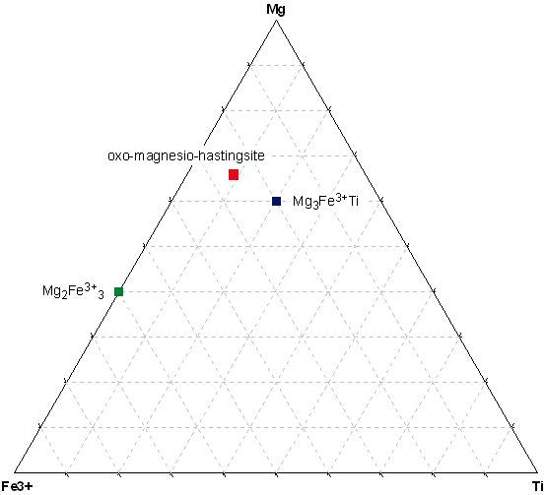

Triangle plot for cations at the B site.

(Na_{0.67}K_{0.33})_{∑1.00}(Ca_{1.87}Na_{0.14}Mn_{0.01})_{∑2.02}(Mg_{3.27}Fe³⁺_{1.25}Ti_{0.44}Al_{0.08})_{∑5.04}(Al_{1.80}Si_{6.20}O₂₂)(O_{1.40}OH_{0.60}) _{∑2.00}

Site |  | apfu | 1 | 2 | 3 | 4 | 5 | 6 | unassigned
A | Na | 0.67 | 0.44 | 0.23
A | K | 0.33 |  |  | 0.03 | 0.03 | 0.08 | 0.17 | 0.02
B | Сa | 1.87 | 0.88 | 0.46 | 0.06 | 0.03 | 0.08 | 0.34 | 0.02
B | Na | 0.14 |  |  |  | 0.03 | 0.08 |  | 0.03
B | Mn | 0.01 |  |  |  |  |  |  | 0.01
C | Mg | 3.27 | 1.32 | 0.46 | 0.06 | 0.12 | 0.32 | 0.85 | 0.14
C | Fe³⁺ | 1.25 | 0.44 | 0.69 | 0.09 | 0.03
C | Ti | 0.44 | 0.44
C | Al^{VI} | 0.08 |  |  |  |  | 0.08
T | Al^{IV} | 1.80 | 0.88 | 0.46 | 0.06 | 0.03 | 0.08 | 0.17 | 0.12
T | Si | 6.20 | 2.64 | 1.38 | 0.18 | 0.21 | 0.56 | 1.19 | 0.04
 | O | 22.00 | 9.68 | 5.06 | 0.66 | 0.66 | 1.76 | 3.74 | 0.44
Y | O | 1.40 | 0.88 | 0.46 | 0.06
Y | OH | 0.60 |  |  |  | 0.06 | 0.16 | 0.34 | 0.04
Total |  |  | 17.6 | 9.2 | 1.2 | 1.2 | 3.2 | 6.8 | 0.86 | 40.06
Total mol.% |  |  | 44 | 23 | 3 | 3 | 8 | 17 | 2 | 100

1. NaCa₂(Mg₃Fe³⁺Ti)_{∑5}(Al₂Si₆O₂₂)O₂ 2. NaCa₂(Mg₂Fe³⁺₃)_{∑5}(Al₂Si₆O₂₂)O₂
3. KCa₂(Mg₂Fe³⁺₃)_{∑5}(Al₂Si₆O₂₂)O₂ 4. K(NaCa)_{∑2}(Mg₄Fe³⁺)_{∑5}(AlSi₇O₂₂)(OH)₂
5. K(NaCa)_{∑2}(Mg₄Al)_{∑5}(AlSi₇O₂₂)(OH)₂ 6. KCa₂Mg₅(AlSi₇O₂₂)(OH)₂

(Na_{0.67}K_{0.33})_{∑1.00}(Ca_{1.87}Na_{0.14}Mn_{0.01})_{∑2.02}(Mg_{3.27}Fe³⁺_{1.25}Ti_{0.44}Al_{0.08})_{∑5.04}(Al_{1.80}Si_{6.20}O₂₂)_{∑5.04}(O_{1.40}OH_{0.60}) _{∑2.00}

Site |  | apfu | 1 | 2 | 3 | 4 | 5 | unassigned
A | Na | 0.67 | 0.42 | 0.25
A | K | 0.33 |  |  | 0.03 | 0.14 | 0.15 | 0.01
B | Сa | 1.87 | 0.83 | 0.51 | 0.06 | 0.14 | 0.30 | 0.03
B | Na | 0.14 |  |  |  | 0.14
B | Mn | 0.01 |  |  |  |  |  | 0.01
C | Mg | 3.27 | 0.83 | 1.01 | 0.12 | 0.56 | 0.75
C | Fe³⁺ | 1.25 | 1.25
C | Ti | 0.44 |  | 0.25 | 0.03 | 0.14 |  | 0.02
C | Al^{VI} | 0.08 |  |  |  |  |  | 0.08
T | Al^{IV} | 1.80 | 0.83 | 0.25 | 0.03 | 0.28 | 0.15 | 0.25
T | Si | 6.20 | 2.50 | 1.77 | 0.18 | 0.84 | 0.90 | 0.01
 | O | 22.00 | 9.17 | 5.57 | 0.66 | 3.08 | 3.30 | 0.23
Y | O | 1.40 | 0.83 | 0.51 | 0.06
Y | OH | 0.60 |  |  |  | 0.28 | 0.30 | 0.02
Total |  |  | 16.66 | 10.12 | 1.17 | 5.60 | 5.85 | 0.66 | 40.06
Total mol.% |  |  | 42 | 25 | 3 | 14 | 15 | 2 | 100

1. NaCa₂(Mg₂Fe³⁺₃)_{∑5}(Al₂Si₆O₂₂)O₂ 2. NaCa₂(Mg₄Ti)_{∑5}(AlSi₇O₂₂)O₂
3. KCa₂(Mg₄Ti)_{∑5}(AlSi₇O₂₂)O₂ 4. K(NaCa)_{∑2}(Mg₄Ti)_{∑5}(Al₂Si₆O₂₂)(OH)₂
5. KCa₂Mg₅(AlSi₇O₂₂)(OH)₂

