Supplemental material:

New minerals tsangpoite Ca₅(PO₄)₂(SiO₄) and matyhite Ca₉(Ca_{0.5}□_{0.5})Fe(PO₄)₇ from angrite D’Orbigny
S.-L. HWANG, P. SHEN, H.-T. CHU, T.-F. YUI, M.-E. VARELA AND Y. IIZUKA

Table S1a. Chemical compositions of major phases from D’Orbigny
(after Kurat et al., 2004)
 | Olivine |  |  | Kirschsteinite |  | Augite |  |  | Plagioclase
 | core | rim |  |  |  | core | rim
SiO₂ | 37.60 | 30.40 |  | 32.20 |  | 47.50 | 42.10 |  | 43.70
TiO₂ | < 0.02 | 0.15 |  | 0.02 |  | 1.19 | 4.60 |  | < 0.02
Al₂O₃ | 0.09 | 0.04 |  | 0.05 |  | 7.60 | 4.30 |  | 34.70
Cr₂O₃ | < 0.02 | 0.12 |  | 0.04 |  | 0.10 | 0.21 |  | < 0.02
FeO | 31.20 | 57.10 |  | 48.10 |  | 12.60 | 26.80 |  | 0.76
MnO | 0.34 | 0.85 |  | 0.75 |  | 0.21 | 0.28 |  | < 0.02
MgO | 31.80 | 0.53 |  | 0.64 |  | 8.80 | 0.07 |  | 0.27
CaO | 0.85 | 10.40 |  | 19.00 |  | 23.20 | 22.20 |  | 20.30
Total wt% | 101.88 | 99.59 |  | 100.80 |  | 101.20 | 100.56 |  | 99.73
X_{Mg} | 63.7 | 1.3 |  | 1.6 |  | 27.0 | 0.2
X_{Fe} | 35.1 | 80.0 |  | 65.5 |  | 21.6 | 48.4
X_{Ca} | 1.2 | 18.7 |  | 33.0 |  | 51.3 | 51.4

Table S1b. Chemical compositions of ulvöspinel and Al-spinel from
D'Orbigny (after Mittlefehldt et al., 2002)
 | Ulvöspinel |  |  | Al-spinel
 |  |  |  |  | core | rim |  | core | rim
TiO₂ | 27.00 | 26.42 | 24.79 |  | 0.26 | 1.85 |  | 0.33 | 0.36
SiO₂ | 0.09 | 0.12 | 0.14 |  | 0.11 | 0.13 |  | 0.12 | 0.11
Cr₂O₃ | 0.00 | 0.00 | 0.00 |  | 8.35 | 11.40 |  | 10.80 | 8.72
Al₂O₃ | 2.08 | 2.88 | 3.35 |  | 54.40 | 42.60 |  | 51.90 | 52.20
V₂O₃ | - | - | - |  | 0.17 | 0.31 |  | 0.19 | 0.20
Fe₂O₃ | 12.30 | 12.30 | 14.90 |  | 2.30 | 6.24 |  | 2.20 | 2.60
FeO | 55.30 | 54.90 | 53.52 |  | 19.85 | 29.60 |  | 20.60 | 22.80
MnO | 0.29 | 0.22 | 0.23 |  | 0.13 | 0.20 |  | 0.13 | 0.14
MgO | 0.07 | 0.01 | 0.00 |  | 13.55 | 6.78 |  | 12.82 | 11.20
CaO | 0.05 | 0.13 | 0.17 |  | 0.00 | 0.10 |  | 0.05 | 0.14
Total wt% | 97.19 | 96.99 | 97.10 |  | 99.12 | 99.23 |  | 99.14 | 98.48
Numbers of ions on the basis of 4O
Ti | 0.773 | 0.756 | 0.707 |  | 0.005 | 0.042 |  | 0.007 | 0.008
Si | 0.004 | 0.005 | 0.005 |  | 0.003 | 0.004 |  | 0.003 | 0.003
Cr | - | - | - |  | 0.181 | 0.269 |  | 0.237 | 0.194
Al | 0.094 | 0.129 | 0.15 |  | 1.752 | 1.494 |  | 1.693 | 1.726
V | - | - | - |  | 0.004 | 0.007 |  | 0.004 | 0.005
Fe⁺³ | 0.353 | 0.351 | 0.426 |  | 0.048 | 0.14 |  | 0.045 | 0.055
Fe⁺² | 1.761 | 1.747 | 1.698 |  | 0.454 | 0.736 |  | 0.477 | 0.535
Mn | 0.009 | 0.007 | 0.007 |  | 0.003 | 0.005 |  | 0.003 | 0.003
Mg | 0.004 | 0.001 | - |  | 0.552 | 0.301 |  | 0.529 | 0.468
Ca | 0.002 | 0.005 | 0.007 |  | - | 0.003 |  | 0.002 | 0.004

Figure S1. SEM-BEI micrographs (a) showing the D’Orbigny microstructure consisting of interlocking tabular/columnar anorthite (An)-olivine (Ol) domains (black, grey with white border) and the interstitial large augite (Aug) crystals (grey), (b, c) the complex Ca-rich fayalite (Fa)+kirschsteinite (Kir) overgrowth layers over anorthite-olivine domains, the Al, Ti-bearing hedenbergite (Hd) rim of augite, and Fe-sulfide (FeS, arrowed), and (d) the fine Fa-Kir symplectite surrounding resorbed FeS.

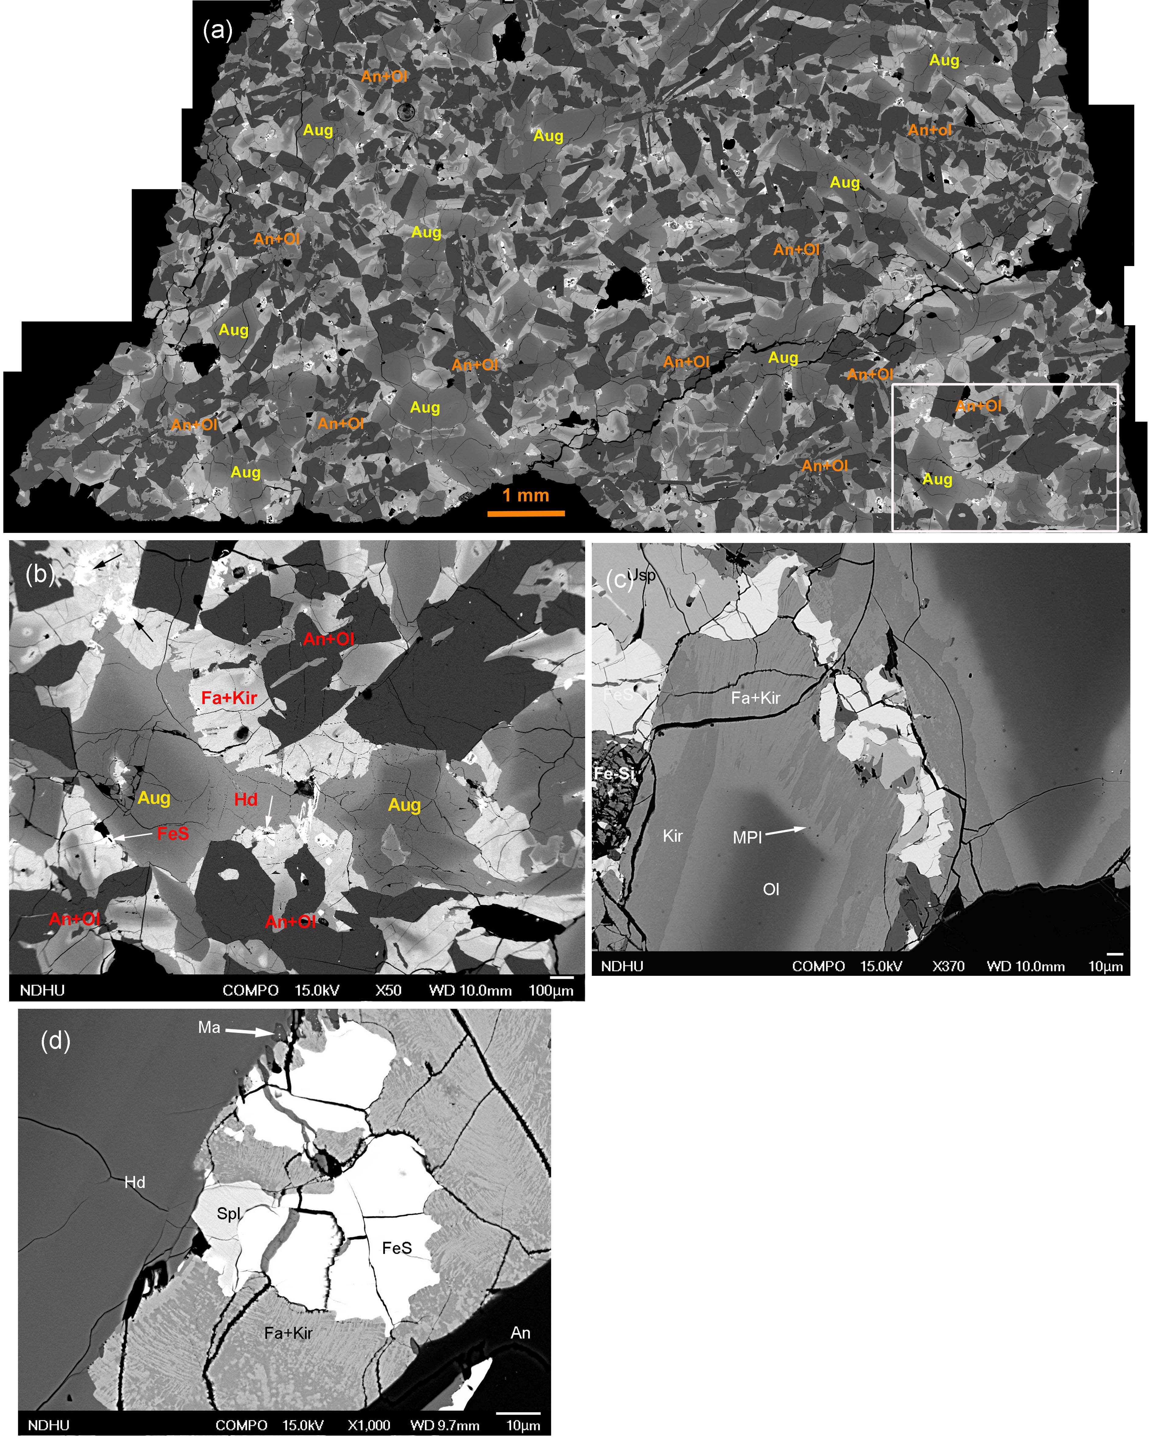

Figure S2. OM observations showed that tsangpoite crystals (1, 2, 3) with hexagonal cross-sections on petrographic thin section surface under reflective light can be traced back to the resorbed Fe-sulfide by through focus under transmitted light.

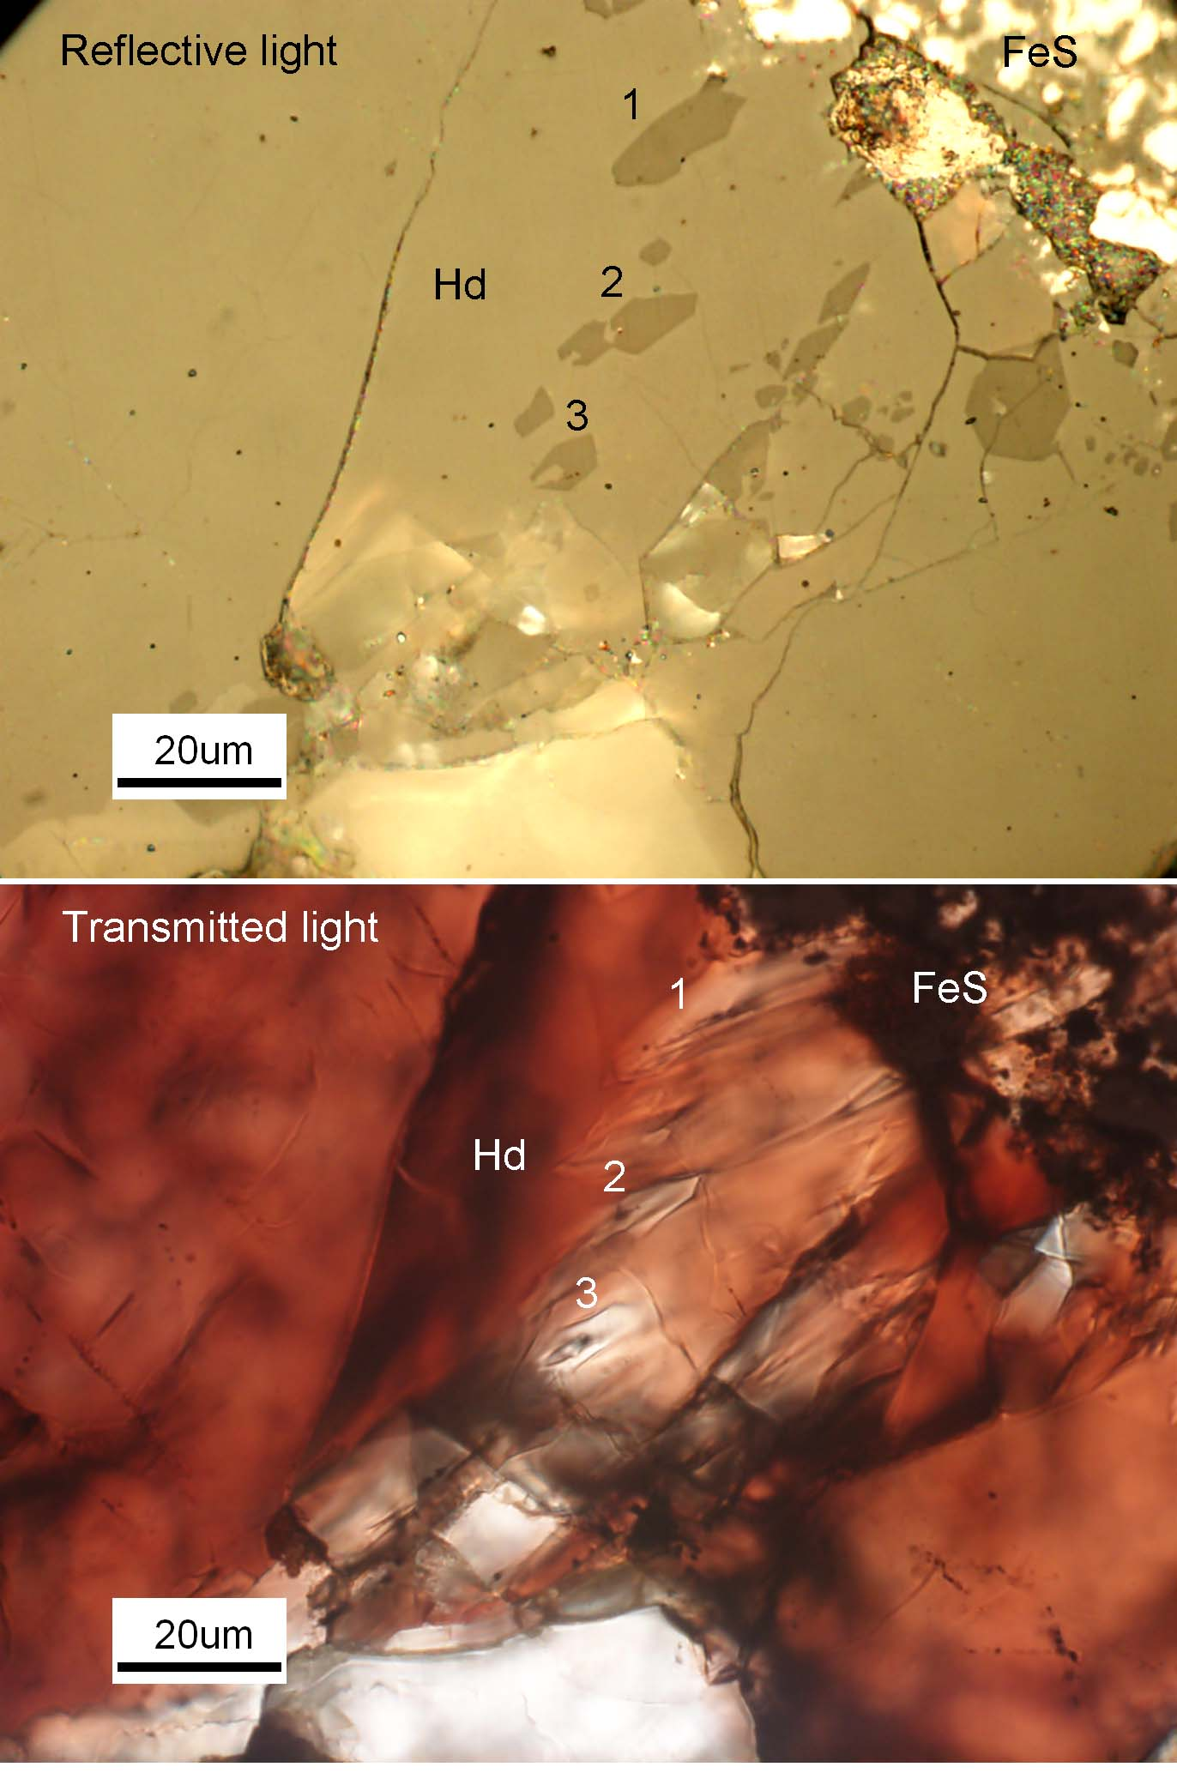

Figure S3. Additional electron diffraction patterns of tsangpoite showing strong specific reflections.

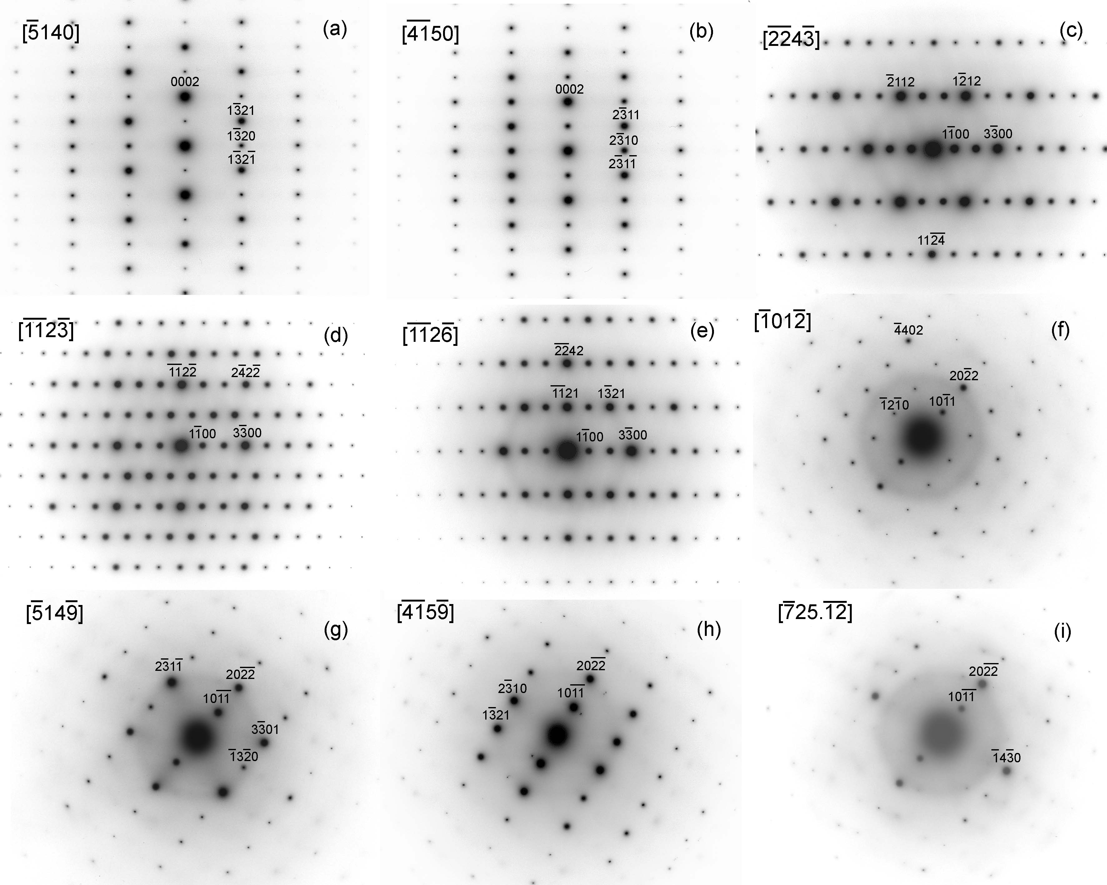

Figure S4. Additional electron diffraction patterns of matyhite showing strong specific reflections.

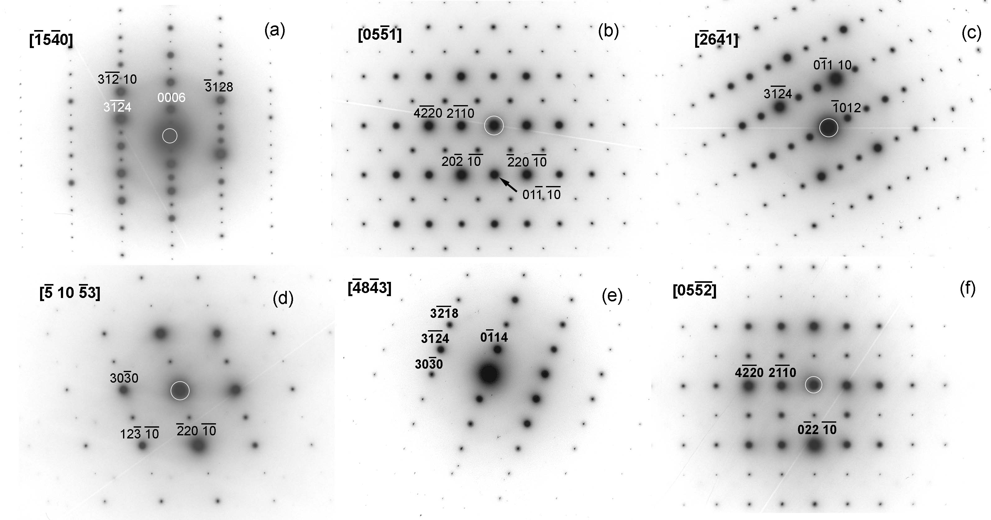

Figure S5. [0001] projection of α-Ca₂SiO₄ structure with the tsangpoite, nagelschmidtite and silicocarnotite unit-cells outlined.

