Genetic evidence indicates the occurrence of the Endangered Kashmir musk deer Moschus cupreus in Uttarakhand, India
Ajit Kumar, Bhim Singh, Subhashree Sahoo, Kumudani Bala Gautam and Sandeep Kumar Gupta

Supplementary Table 1 Details of samples used for the analysis of the genetic relationship of musk deer Moschus spp.
Sample ID | Locality | District, State | Sample type | Year of collection | Collected by
MDUK1 | Kedarnath Forest Division, Gopeshwar | Gopeshwar, Uttarakhand, India | Tissue | 2005 | State Forest Department
MDUK2 | Kedarnath Forest Division, Gopeshwar | Gopeshwar, Uttarakhand, India | Tissue | 2005 | State Forest Department
MDUK3 | Kedarnath Forest Division, Gopeshwar | Gopeshwar, Uttarakhand, India | Tissue | 2006 | State Forest Department
MDUK4 | Kedarnath Forest Division, Gopeshwar | Gopeshwar, Uttarakhand, India | Tissue | 2007 | State Forest Department
MDUK5 | Kanchulakharak, Kedarnath Forest Division, Mandal | Gopeshwar, Uttarakhand, India | Tissue | 2010 | State Forest Department
MDUK6 | Mehalchauri, Gairsain | Chamoli, Uttarakhand, India | Musk pod | 2006 | Kedarnath Forest Division
MDUK7 | Mehalchauri, Gairsain | Chamoli, Uttarakhand, India | Musk pod | 2007 | Kedarnath Forest Division
MDUK8 | Mehalchauri, Gairsain | Chamoli, Uttarakhand, India | Musk pod | 2007 | Kedarnath Forest Division
MDUK9 | Mehalchauri, Gairsain | Chamoli, Uttarakhand, India | Musk pod | 2007 | Kedarnath Forest Division
MDUK10 | Mehalchauri, Gairsain | Chamoli, Uttarakhand, India | Musk pod | 2007 | Kedarnath Forest Division
MDUK11 | Mehalchauri, Gairsain | Chamoli, Uttarakhand, India | Musk pod | 2007 | Kedarnath Forest Division
MDUK12 | Mehalchauri, Gairsain | Chamoli, Uttarakhand, India | Musk pod | 2007 | Kedarnath Forest Division
MDUK13 | Mehalchauri, Gairsain | Chamoli, Uttarakhand, India | Musk pod | 2007 | Kedarnath Forest Division
MDUK14 | Mehalchauri, Gairsain | Chamoli, Uttarakhand, India | Musk pod | 2007 | Kedarnath Forest Division
MDUK15 | Mehalchauri, Gairsain | Chamoli, Uttarakhand, India | Musk pod | 2007 | Kedarnath Forest Division
MDUK16 | Mehalchauri, Gairsain | Chamoli, Uttarakhand, India | Musk pod | 2007 | Kedarnath Forest Division
MDUK17 | Mehalchauri, Gairsain | Chamoli, Uttarakhand, India | Musk pod | 2007 | Kedarnath Forest Division
MDUK18 | Kedarnath Wildlife Division, Gopeshwar | Chamoli, Uttarakhand, India | Tissue | 2006 | State Forest Department
MDUK19 | Nandadevi Biosphere Reserve | Chamoli, Uttarakhand, India | Skin piece | 2009 | Wildlife Institute of India
MDJK1 | Wildlife Range Ganderbal, Jammu & Kashmir | Ganderbal, Jammu & Kashmir, India | Tissue | 2016 | State Forest Department

Supplementary Table 2 Details of the GenBank accession number used in phylogenetic analysis of Moschus spp.
Species | Locality | Accession number | Reference
M. moschiferus | Republic of Korea | FJ469675 | Jang et al., 2010
M. moschiferus | Paris | JN632662 | Hassanin et al., 2012
M. chrysogaster | China | KC425457 | Wang et al., 2013
M. chrysogaster | China | KP684123 | Pan et al., 2015
M. chrysogaster | China | JQ608470 | Yang et al., 2013
M. anhuiensis | China | KC013352 | Zhu et al., 2012
M. leucogaster | Nepal | MK363293 | Singh et al., 2019
M. leucogaster | Nepal | MK363294 | Singh et al., 2019
M. leucogaster | Nepal | MK363295 | Singh et al., 2019
M. leucogaster | Nepal | MK363296 | Singh et al., 2019
M. leucogaster | Nepal | MK363297 | Singh et al., 2019
M. leucogaster | Nepal | MK363298 | Singh et al., 2019
M. leucogaster | Nepal | MK363299 | Singh et al., 2019
M. leucogaster | Nepal | MK363300 | Singh et al., 2019
M. leucogaster | Nepal | MK363301 | Singh et al., 2019
M. leucogaster | Nepal | MK363302 | Singh et al., 2019
M. leucogaster | Nepal | MK363303 | Singh et al., 2019
M. leucogaster | Nepal | MK363304 | Singh et al., 2019
M. leucogaster | Nepal | MK363305 | Singh et al., 2019
M. leucogaster | Nepal | MK363306 | Singh et al., 2019
M. leucogaster | Nepal | MK363307 | Singh et al., 2019
M. leucogaster | Nepal | MK363308 | Singh et al., 2019
M. leucogaster | Nepal | MK363309 | Singh et al., 2019
M. leucogaster | Nepal | MK363310 | Singh et al., 2019
M. leucogaster | Nepal | MK363311 | Singh et al., 2019
M. leucogaster | Nepal | MK363312 | Singh et al., 2019
M. berezovskii | China | EU370748 | Peng et al., 2009
M. berezovskii | China | EU370751 | Peng et al., 2009
M. berezovskii | China | EU370753 | Peng et al., 2009
M. berezovskii | China | EU370754 | Peng et al., 2009
M. berezovskii | China | EU370755 | Peng et al., 2009
M. berezovskii | China | EU370756 | Peng et al., 2009
M. berezovskii | China | EU370757 | Peng et al., 2009
M. berezovskii | China | EU370758 | Peng et al., 2009
M. berezovskii | China | EU370759 | Peng et al., 2009
M. berezovskii | China | EU370760 | Peng et al., 2009
M. berezovskii | China | EU370762 | Peng et al., 2009
M. berezovskii | China | EU370763 | Peng et al., 2009
M. berezovskii | China | EU370764 | Peng et al., 2009
M. berezovskii | China | EU370765 | Peng et al., 2009
M. berezovskii | China | EU370768 | Peng et al., 2009
M. berezovskii | China | EU370769 | Peng et al., 2009
M. berezovskii | China | EU370770 | Peng et al., 2009
M. berezovskii | China | EU370773 | Peng et al., 2009
M. berezovskii | China | EU370774 | Peng et al., 2009
M. berezovskii | China | KJ000681 | Yang et al., 2014
M. berezovskii | China | KJ000688 | Yang et al., 2014
M. berezovskii | China | KY792714 | Su et al., 2018
M. berezovskii | China | MH047347 | Yang et al., 2018
M. berezovskii | China | EU043465 | Peng et al., 2009
M. cupreus | Nepal | MK363313 | Singh et al, 2019
M. cupreus | Nepal | MK363314 | Singh et al, 2019
M. cupreus | Nepal | MK363315 | Singh et al, 2019
M. cupreus | Nepal | MK363316 | Singh et al, 2019
M. cupreus | Nepal | MK363317 | Singh et al, 2019

Supplementary Table 3 Mitochondrial DNA (mtDNA) control region haplotypes identified for the Kashmir musk deer M. cupreus. Numbers (vertical) show the variable positions of nucleotides among Kashmir musk deer haplotypes. N represents the frequency of the sequence in the haplotype.

Haplo-types |  | 2 | 3 | 3 | 3 | 4 | 4 | 4 | 4 | 4 | 4 | 4 | 5 | 5 | 5 | 4 | 6
Haplo-types |  | 6 | 5 | 7 | 8 | 0 | 1 | 2 | 2 | 3 | 5 | 6 | 5 | 5 | 9 | 1 | 5
Haplo-types | N | 2 | 1 | 3 | 2 | 8 | 0 | 6 | 8 | 2 | 3 | 2 | 2 | 3 | 8 | 0 | 0 | Accession number | Region
Hap.1 | 10 | A | A | T | C | T | A | A | T | G | T | C | G | A | G | T | A | MK363313,MK363314, MK363316,MT822698 | Nepal (3), Uttarakhand India (MDUK1–3, 7–10)
Hap.2 | 2 | G | G | C | T | . | . | G | . | . | . | . | . | G | . | . | G | MK363315,MK363317 | Nepal (2)
Hap.3 | 3 | . | . | . | T | . | . | . | C | A | . | . | . | . | A | A | . | MT822697 | Uttarakhand India (MDUK4-6)
Hap.4 | 1 | . | . | . | T | . | . | . | C | A | . | T | . | . | A | A | . | MT822699 | Uttarakhand India (MDUK11)
Hap.5 | 1 | G | . | . | T | . | G | . | C | . | . | . | . | . | . | . | . | MT822700 | Uttarakhand India (MDUK19)
Hap.6 | 4 | G | . | C | T | . | G | . | C | . | . | . | . | . | . | . | . | MT822701 | Uttarakhand India (MDUK12-15)
Hap.7 | 3 | . | . | . | T | . | . | . | . | . | . | . | . | . | . | . | . | MT822702 | Uttarakhand India (MDUK16-18)
Hap.8 | 1 | G | G | . | T | C | . | . | . | . | C | . | A | . | . | . | . | MT822703 | Jammu & Kashmir (MDJK1)

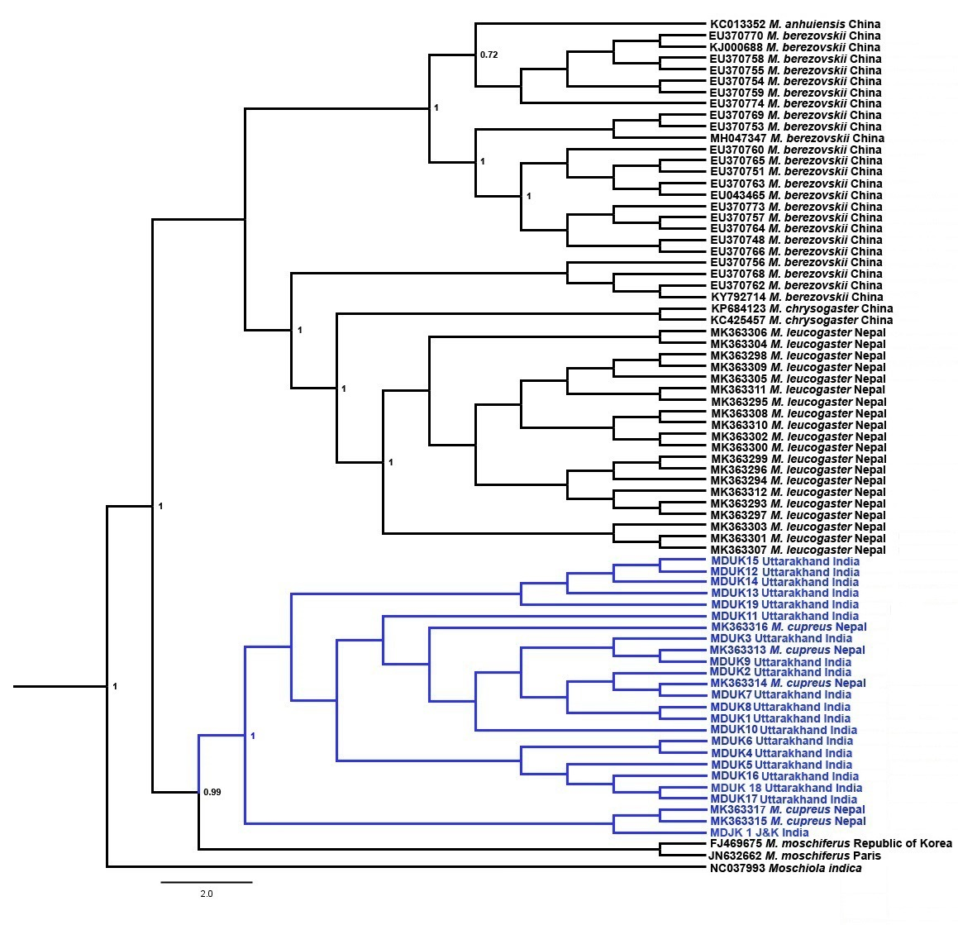
Supplementary Fig. 1 Musk deer phylogenetic tree inferred by Bayesian analysis (BEAST) based on the mtDNA control region. The blue clade represents the sequences of Kashmir musk deer M. cupreus of known origin and seized musk pods. Posterior probability values are provided at their respective nodes. The Indian mouse deer Moschiola indica (NC037993) was used as the outgroup.

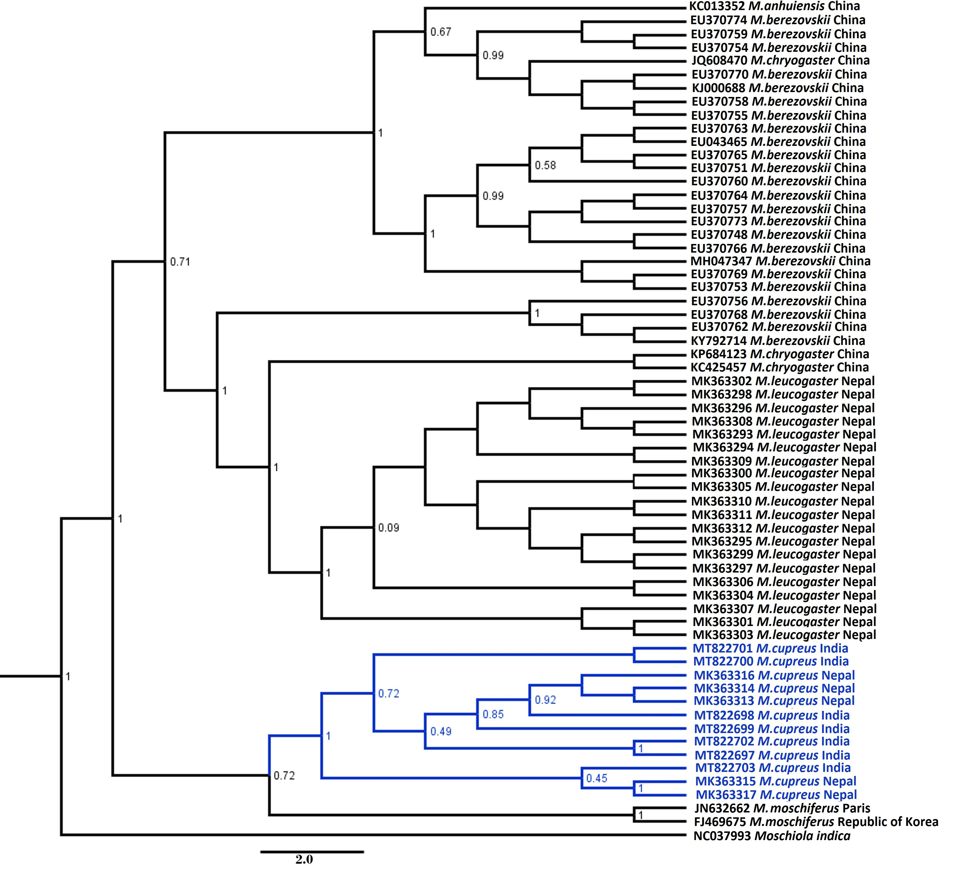

Supplementary Fig. 2 Musk deer phylogenetic tree inferred by Bayesian analysis (BEAST) based on the mtDNA control region. The blue clade represents the Kashmir musk deer M. cupreus from this study in the context of previously published musk deer sequences. Posterior probability values are provided at their respective nodes. The Indian mouse deer Moschiola indica (NC037993) was used as the outgroup.

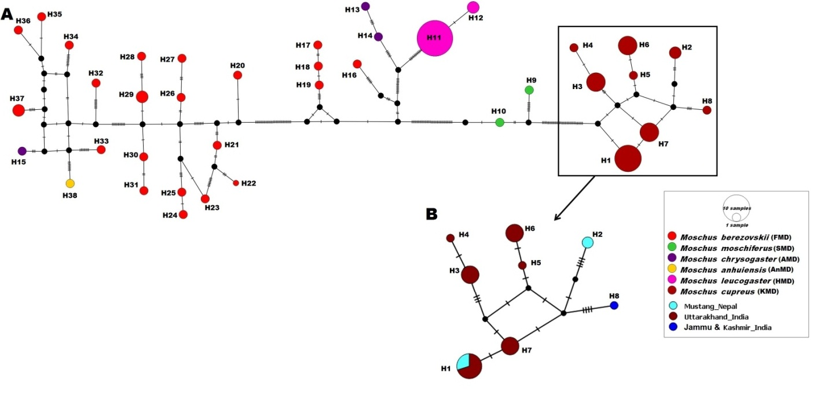
Supplementary Fig. 3 Median-joining network based on the mtDNA control region of musk deer. The part in the square represents the haplotypes (H1–H8) of Kashmir musk deer M. cupreus from Nepal, and from Jammu and Kashmir and Uttarakhand, India.

