Restoring the orangutan in a Whole- or Half-Earth context

Erik Meijaard, Douglas Sheil, Julie Sherman, Liana Chua, Safwanah Ni’matullah, Kerrie Wilson, Marc Ancrenaz, Darmawan Liswanto, Serge A. Wich, Benoit Goossens, Hjalmar S. Kühl, Maria Voigt, Yaya Rayadin, Yuyun Kurniawan, Agus Trianto, Dolly Priatna, Graham L. Banes, Emily Massingham, John Payne and Andrew J. Marshall

Supplementary Table 1 Areas of orangutan habitat under different land uses.

|  |  |  |  |  |  |
| --- | --- | --- | --- | --- | --- |
| **Region** | **Orangutan habitat in formally protected areas (ha)** | **Orangutan habitat in watershed protection forests (ha)** | **Orangutan habitat in production forests and restoration concessions (ha)** | **Orangutan habitat in community forests (ha)** | **Orangutan habitat in forest areas in agricultural landscapes and conversion forests (ha)** |
| Sabah | 1,716,263 |  | 925,078 |  | 181,811 |
| East Kalimantan | 147,225 | 352,541 | 914,128 | 21,576 | 90,916 |
| Central Kalimantan | 978,083 | 561,870 | 4,035,635 | 25,807 | 551,026 |
| West Kalimantan | 740,476 | 836,645 | 1,290,739 | 37,641 | 149,818 |
| *Total* | 3,582,047 | 1,751,056 | 7,165,580 | 85,024 | 973,571 |

Supplementary Fig. 1 Theory of change (draft) for (A) Half-Earth-type and (B) Whole-Earth-type approaches to orangutan conservation.

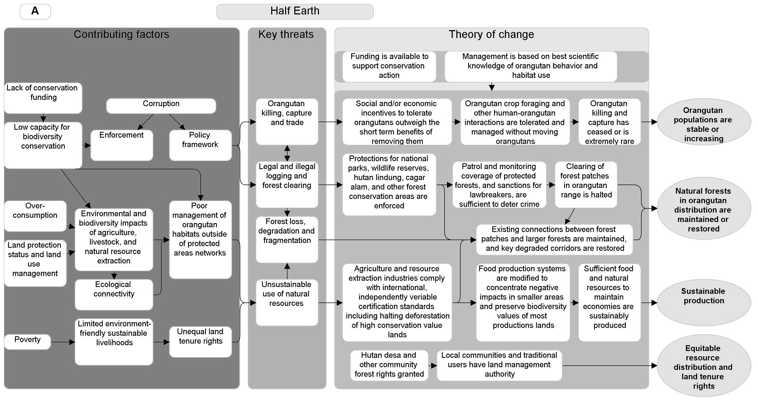

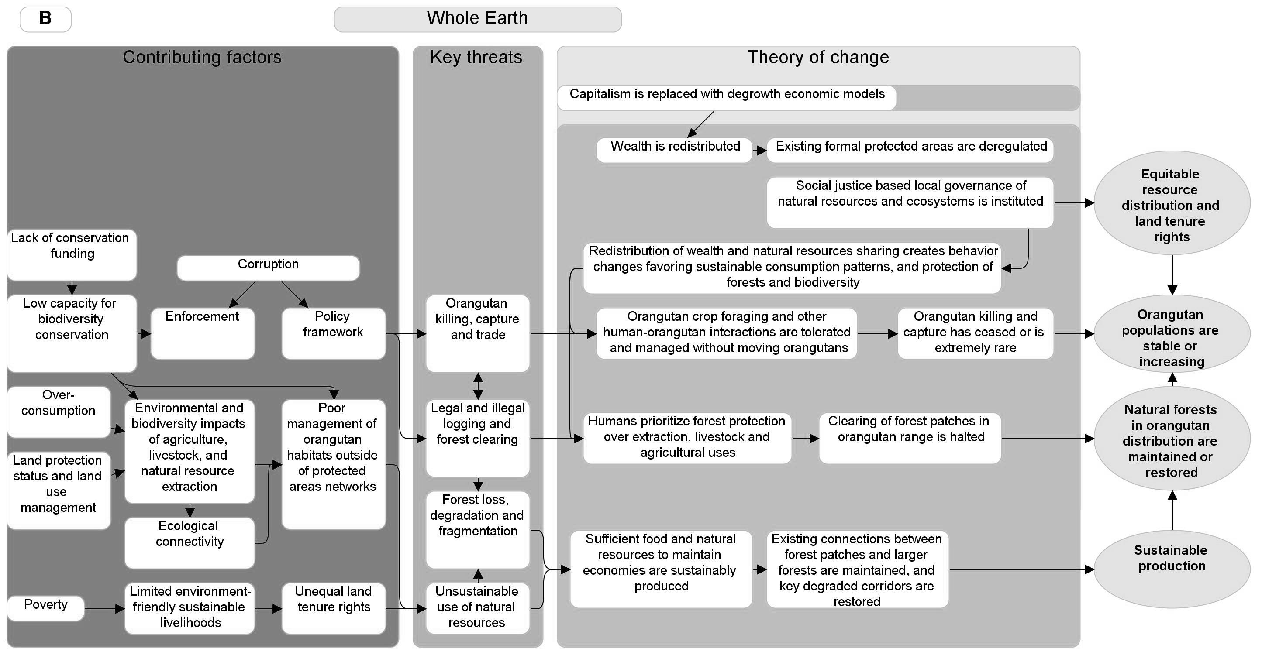

Supplementary Fig. 2 Offtake rates under Half-Earth, Current Conditions and Whole-Earth scenarios, as estimated by experts. Individual experts’ responses are differentiated by colour and each expert’s responses are connected across the three scenarios by a line. The x-axis has been jittered (i.e. a small random number added to each x-axis value) to differentiate among expert estimates more easily.

Supplementary Material 1

## Scenario description

Our Current Conditions scenario assumes a continuation of the approach to orangutan conservation between 2000 and 2019, and is based on the financial and strategic analysis by Santika et al. (2022), which reflected the legacy of conservation activities compared to the counterfactual of no conservation action. For each of these activities, Santika and colleagues were able to estimate the relative occupancy and density changes. There are two other studies to inform our estimates of likely outcomes: a projection of the availability of orangutan habitat by 2032 based on predicted deforestation (Voigt et al., 2022) and a study of the effects of deforestation and fragmentations predicted effects on orangutan metapopulation dynamics (Seaman et al., 2022), but not all consulted experts would likely have read these recent studies. None of our scenarios explicitly included anticipated effects of climate change on orangutan survival (Struebig et al., 2015) and on climate driven fires and forest loss (McAlpine et al., 2018; Chapman et al., 2020).

To represent the second scenario – Half-Earth – we added areas under different management strategies to the current network of protected areas to estimate the effect of having at least 50% of the regions in which orangutans occur managed as protected areas or sustainably managed forests by 2032. The sequence of adding areas was based on the legal status of new areas and the associated political effort required to add these areas to Half-Earth, as well as the effectiveness of different land uses in preventing forest loss (Runting et al., 2015; Santika et al., 2015; Carlson et al., 2018; Runting et al., 2019; Meijaard et al., 2020). In the scenario description provided to the experts, we assumed that better forest protection would reduce forest loss, reduce displacement of orangutans from their home ranges and reduce crop raiding and conflict-related harm to orangutans.

We mapped the Whole-Earth scenario by building on the suggested “increase of the amount of land in which people can live and work, but which is off limits to resource extraction and drastic land use change” (Büscher et al., 2017). Under current Indonesian and Malaysian laws there are no land uses that allow people to live and work on the land but fully prohibit resource extraction and land use change. Some land uses, however, approximate this. Watershed protection forests (*Hutan Lindung*) in Indonesia, for example, allow community use of non-timber resources, such as rattan, but do not allow deforestation. This is also the case for a range of community forest areas (for an overview, see Meijaard et al., 2020). Non-State Forest land (*Areal Penggunaan Lain*) where land use change has already happened would likely also qualify. We excluded selected watershed protection forests and national parks from the scenario with high rural community use needs for products such as timber and mining, because the harvest of these is not in line with current regulations for these areas. High community use needs were determined based on previous analyses by Abram et al. (2014). We also excluded production forest used for commercial timber extraction, as these are associated with resource extraction, which is not in line with the Whole-Earth objectives. Finally, we included community-managed forests in existing agricultural areas with orangutan habitat, and community forests and restoration concessions. We recognize that many types of land use change following Whole-Earth objectives are currently not possible under Indonesian and Malaysian law, but such radical legal and economic change is indeed foreseen by Whole-Earth proponents (Büscher et al., 2017). In our scenario description we assumed that deregulation would result in a regulatory vacuum similar to that following the fall of President Soeharto. Rapid decentralization and devolution of powers in the early 2000s resulted in a significant increase in deforestation (Ardiansyah & Jotzo, 2013). In the scenario, we provided information about these events and asked experts to judge whether such dynamics could again occur following deregulation of commercial timber and strict conservation areas, resulting in increased deforestation. Also, we indicated that reduced government income from (degazetted) forestry areas would result in reduced funding for conservation and forest management.

The fourth scenario models the recovery potential of orangutans, which is linked to the levels of historical biodiversity loss (Maron et al., 2021), based on recovery relative to past conditions, as per the IUCN Green Status of Species (Akçakaya et al., 2018). We set a 100-year aspirational target with a view to re-establishing orangutans in all parts of their historic range where this is ecologically possible, with a focus on the parts of Borneo where the species currently doesn’t occur. We base this scenario on a recently published model by Seaman et al. (2022) which shows the recovery potential under zero or very low orangutan offtake rates.

## Spatial context and data

The geographic context of the four scenarios is the orangutan range in the Indonesian part of the island of Borneo, Kalimantan, and the Malaysian State of Sabah (Figure 1a). We do not include Sarawak in our analysis, as its orangutan population is small and nearly 100% included in protected areas. Furthermore, because of a lack of financial data, Sarawak was excluded from the analysis by Santika et al. (2022). The orangutan range extent, which formed the basis of this analysis, resulted from a combination of the 2016 PHVA Orangutan Habitat for Kalimantan (Utami-Atmoko et al., 2016), recent distribution data from Sabah (Simon et al., 2019) and a recent orangutan occupancy model for Borneo (Santika et al., 2022). The distribution range was further refined by authors Meijaard and Ancrenaz based on recent local knowledge. We then compared the final range polygons to current forest cover boundaries (Vancutsem et al., 2021) which led to some adjustments assuming only forest provides suitable habitat.

Under the different scenarios we used existing land use categories in Malaysia and Indonesia and determined their overlap with the orangutan range. Many of these different land use categories match IUCN Protected Area Categories (IUCN, 2012) according to their local legal definition. For example, Indonesian watershed Protection Forests (*Hutan Lindung*) and Malaysian Class III Domestic Forest Reserves are wilderness areas primarily protected for maintaining watershed services but allowing human non-timber use. IUCN characterizes such areas as Protected Areas Ib (Wilderness Area), with the specific provision “to enable indigenous communities to maintain their traditional wilderness-based lifestyle and customs, living at low density and using the available resources in ways compatible with the conservation objectives” (IUCN, 2012). Non-timber uses of watershed Protection Forests are allowed under Indonesian law if this does not harm protected species. Similarly, Malaysian Forest Reserves and Indonesian production forests (*Hutan Produksi Terbatas* and *Hutan Produksi Biasa*) are forests that are legally required to be sustainably managed for timber production through the selective harvest of naturally occurring timber species. Such areas coincide with IUCN Protected Area Category VI: Protected area with sustainable use of natural resources. Finally, the IUCN Protected Area category matching the Indonesian community forest designations (*Hutan Desa*, *Hutan Kemasyarakatan*) depends on the land use status over which these community forest management rights are designated and the landscape context, but most often coincides with IUCN Protected Area Categories VI (Dudley, 2008).

## Statistical analysis of expert input

We conducted analyses and produced figures in R 4.1.3 (R Core Development Team, 2022) implemented in the RStudio 2022.02.1"Prairie Trillium" Release for macOS (RStudio Team, 2022). As we were primarily interested in assessing relative predicted differences among our four scenarios, we present expert predictions relative to each expert’s estimates of current orangutan population size and current offtake rates. Thus, we calculated estimates of percent changes in population size under scenario X as 100 * population size under scenario X / current population size and calculated offtake rates under scenario X as 100 * offtake under scenario X / current population size. To reduce the effects of extreme outliers we present median rather than mean estimates, but also report the full range of responses and the 25th and 75th percentiles. Each expert provided responses to every question with one exception; expert 21 did not provide an estimate of current offtake rates. All data (anonymized expert responses) and code necessary to replicate our results and Figs. 2, 3 and S2 are available at https://github.com/andrewjohnmarshall/restoring_red_apes.

Supplementary Material 2

Below is the questionnaire text as it was shared in 2021 with 63 orangutan experts. Text in bold font is as it was in the original.

## Questionnaire text

Your name:

I would like to be a co-author: Yes No

### Preamble

With this, I would like to ask you to estimate the orangutan population size for Kalimantan and Sabah combined under a number of different sets of assumptions and scenarios. I will also ask you to estimate annual offtake rates. Your most likely reaction will be, “I don’t know that”. The point is that you know something (e.g., you “know” that there are fewer than 1,000,000 orangutans on Borneo, and more than 10). Combining our best guesses will give us an idea of the means and errors and also what informs the outliers in these estimates. So, please give it your best-informed guesses.

### Baseline

We developed a new distribution map based on Santika et al. (2022) and the 2019 PHVA. Geographic focus is Kalimantan and Sabah (Sarawak is excluded).

The total current area of orangutan presence in our analysis in Sabah and Kalimantan is 13,891,525 ha or 138,915 km2 (Figure 1), of which ~25.6% is within protected areas, ~14.2% within protection forests, ~51.4% in production forests and restoration concessions, 0.7% in community forests, and 6.7% in forest areas within agricultural landscapes or conversion forest areas. An additional 201,517 ha is outside the State Forest areas without an association with the above land uses.

Current (2021) orangutan distribution range with 2019 forest cover map (Vancutsem et al., 2021).

**Question 1**: What is your best estimate for the **total population size in 2021** for the Bornean orangutan in Kalimantan and Sabah (combined) based on the above distribution range estimate and anything else you know about variation in orangutan densities?

Your answer:

**Question 2**: What is your best estimate of the **current** **number of orangutans that are killed or otherwise removed** **annually** from the wild population across the range in Sabah and Kalimantan.

Your answer:

### Scenario 1: Current Conditions

Our Current Conditions scenario assumes a continuation of the current approach to orangutan conservation and is based on the financial and strategic analysis by Santika et al. (2021), which reflected the legacy of conservation activities between 2000 and 2019 compared to the counterfactual of no conservation action. Habitat protection, patrolling and community engagement strategies were estimated to provide large benefits in slowing down the decline in orangutan numbers across the three regions, especially in Kalimantan. For each of these strategies, Santika and colleagues were able to estimate the relative occupancy and density changes. By extrapolating these changes over the 10 years between 2021 and 2032, we estimate what will happen to individual orangutan populations based on knowledge of past trends, current protection strategies and predicted threats. To further inform this scenario, we use a predicted deforestation model for Borneo to predict what is likely to happen to the forest habitat of Bornean orangutan (*Pongo pygmaeus*) by 2032 (Voigt et al., 2022), and how this likely affects orangutan metapopulation dynamics (Seaman et al., 2022).

**Question 3**: What is your best estimate for **the total population size in 2032** for the Bornean orangutan in Kalimantan and Sabah based on the **business-as-usual scenario** assumptions, an **unchanged mortality** **rate**, **predicted deforestation**, and other factors that determine the orangutan population size?

Your answer:

### Scenario 2: Half-Earth

For our second scenario – **Half-Earth** – we added areas under different management strategies (protection forest, logging concession, community forest areas) to the current network of protected areas to achieve the goals of having at least 50% of the regions in which orangutans occur managed as permanently protected areas or sustainably managed forests by 2032. We analysed what would be needed to reduce killing rates by 50% compared to the previous decade based on the conservation legacy analysis by Santika et al. (2021) and recent studies by Massingham et al. (2021). We also estimated that that the investment needed to effectively implement Half Earth would be larger than the annual investment in 2019.

Map showing the allocation of different land uses under the Half Earth scenario.

Sabah has formally adopted this goal (Sabah Forestry Department, 2020) which aims for full protection of 30% of the landmass and sustainable certified management of 20% of the landmass of the State. This covers ~94.6% of remaining orangutan habitat. Our spatial analysis indicates that Indonesia is already formally protecting ~37% of remaining orangutan habitat in national parks, nature reserves, wildlife reserves, and watershed protection forest (~3,926,217 ha). By additionally committing to the permanent protection or sustainable management of production forest, restoration concessions and community forest areas, another 56% (6,050,026 ha) of remaining orangutan habitat can be protected, at least on paper. This leaves 760,394 ha of habitat, mostly in agricultural areas (*Areal Penggunaan Lain*) and conversion forest (*Hutan Konversi*). To ensure permanent protection of these orangutan habitats, specific government regulations, or voluntary company commitments would be required to maintain these critical forest patches and ecological networks. With 67.9% of Kalimantan’s land mass covered by state forest land, Indonesia would significantly exceed the **Half-Earth** goal of locking in 50%, although we recognize that not all of this land is currently forested (but could be restored). With forest loss reduced under this scenario, **displacement of orangutans from their home ranges would be reduced**, likely resulting in **reduced crop raiding and conflict-related harm** to orangutans which are mostly associated with areas of land cover change (Abram et al., 2015).

**Question 4**. What is your best estimate of the **annual** **number of orangutans that would be killed or otherwise removed** from the wild population across the range in Sabah and Kalimantan **under the Half-Earth scenario** (annual average for the period from 2021 to 2032) in which forest loss within the orangutan range, and thus displacement of orangutans, would be **reduced**, and there would be **increased investment in patrolling and other measures that reduce mortality rates**?

Your answer:

**Question 5.** What is your best estimate for **the total population size in 2032** for the Bornean orangutan in Kalimantan and Sabah based on the **Half-Earth** scenario assumptions, a **reduced mortality rate, reduced deforestation**, and other factors that determine the orangutan population size?

Your answer:

### Scenario 3: Whole-Earth

We assume that the **Whole-Earth** approach relies on **deregulation** of the protected area network (Büscher et al., 2017). We modelled this approach by building on the suggested “increase of the amount of land in which people can live and work, but which is off limits to resource extraction and drastic land use change” (Büscher et al., 2017). Under the **Whole-Earth** scenario, 32.9% of the Bornean orangutan’s range would have some sort of protection that legally requires permanently forested conditions, and which we assumed was supported by communities in and around those areas (Figure 3). A further 7.1% would be in existing agricultural areas and plantations, where, similar to the Half-Earth scenario, new regulations would be needed to formally protect the remaining orangutan forest patches. Finally, orangutan habitat in production forests, and nature and wildlife reserves (8,221,058 ha or 60.0% of total) would be **legally unprotected** and thus require new management structures, ideally under community management. We estimate that these areas requiring new management structures overlap with 997 villages where community forest management would need to be developed. Bringing these lands under community management could take several decades, because of the need to build management capacity, set up forest management structures, develop plans and obtain government approval, which is currently happening at a rate of ca. 200,000 ha per year in Kalimantan (Meijaard et al., 2020).

The regulatory vacuum could mirror the situation that existed in Indonesia following the fall of President Soeharto when rapid decentralization and devolution of powers resulted in a significant increase in deforestation rates (Ardiansyah & Jotzo, 2013). We expect that such dynamics would again occur following deregulation of commercial timber and strict conservation areas, resulting in increased deforestation. What would also play a role is that reduced government income from forestry areas and without the management input from forestry companies there would be less funding available to finance conservation measures such as the development of effective community forest management.

**Question 6.** What is your best estimate of the **annual** **number of orangutans that would be killed or otherwise removed** from the wild population across the range in Sabah and Kalimantan **under the Whole Earth scenario** (annual average for the period from 2021 to 2032) in which **forest loss is expected to increase**, resulting in **displacement of orangutans**? There would also be **reduced investment in forest and wildlife management**.

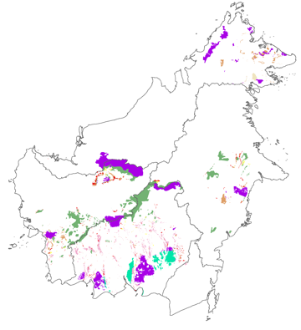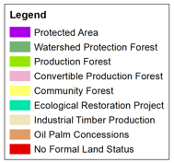

Your answer:

Map showing the allocation of different land uses under the Whole Earth scenario.

**Question 7.** What is your best estimate for the **total population size in 2032** for the Bornean orangutan in Kalimantan and Sabah based on the **Whole-Earth scenario assumptions, an increased mortality rate, increased deforestation rates**, and other factors that determine the orangutan population size?

Your answer:

### Scenario 4: Recovery potential

The fourth scenario models the recovery potential of orangutans, which is linked to the levels of historical biodiversity loss (Maron et al., 2021), based on recovery relative to past conditions. We set a 100-year aspirational target with a view to re-establishing orangutans in all parts of their historic range where this is ecologically possible, with a focus on the parts of Borneo where the species currently doesn’t occur. We base this scenario on a recent model by Seaman et al. (in prep.) which shows the recovery potential under zero or very low orangutan offtake rates.

**Question 8**. What is your best estimate for the **total population size in 2122** for the Bornean orangutan in Kalimantan and Sabah based on the ecological recovery scenario assumptions **of zero or very low orangutan offtake rates and no further loss of forest areas and smaller forest fragments**?

Your answer:

**References**

Abram, N.K., Meijaard, E., Ancrenaz, M., Runting, R.K., Wells, J.A., Gaveau, D.L.A., et al. (2014) Spatially explicit perceptions of ecosystem services and land cover change in forested regions of Borneo. *Ecosystem Services,* **7,** 116–127.

Abram, N.K., Meijaard, E., Wells, J.A., Ancrenaz, M., Pellier, A.-S., Runting, R.K., et al. (2015) Mapping perceptions of species' threats and population trends to inform conservation efforts: the Bornean orangutan case study. *Diversity and Distributions,* **21,** 487-499.

Akçakaya, H.R., Bennett, E.L., Brooks, T.M., Grace, M.K., Heath, A., Hedges, S., et al. (2018) Quantifying species recovery and conservation success to develop an IUCN Green List of Species. *Conservation Biology,* **32,** 1128-1138.

Ardiansyah, F. & Jotzo, F. (2013) Decentralization and Avoiding Deforestation. The Case of Indonesia. In *Federal Reform Strategies: Lessons from Asia and Australia* (eds S. Howes & M.G. Rao), Oxford University Press, Oxford, UK.

Büscher, B., Fletcher, R., Brockington, D., Sandbrook, C., Adams, W.M., Campbell, L., et al. (2017) Half-Earth or Whole Earth? Radical ideas for conservation, and their implications. *Oryx,* **51,** 407-410.

Carlson, K.M., Heilmayr, R., Gibbs, H.K., Noojipady, P., Burns, D., Morton, D.C., et al. (2018) Effect of oil palm sustainability certification on deforestation and fire in Indonesia. *Proceedings of the National Academy of Sciences,* **115,** 121-126.

Chapman, S., Syktus, J., Salazar, A., Thatcher, M., Watson, J., Meijaard, E., et al. (2020) Compounding impact of deforestation on Borneo’s climate during El Niño events. *Environmental Research Letters,* **15,** 084006.

Dudley, N. (ed.) (2008) *Guidelines for Applying Protected Area Management Categories. Recognising Protected Areas and Assigning Management Categories and Governance Types, Best Practice Protected Area Guidelines Series No. 21, Gland, Switzerland,* IUCN, Gland, Switzerland.

IUCN (2012) *IUCN Protected Area Management Categories.* [*http://www.iucn.org/about/work/programmes/pa/pa_products/wcpa_categories/*](http://www.iucn.org/about/work/programmes/pa/pa_products/wcpa_categories/)*. Accessed 1 December 2021*. International Union for Conservation of Nature, Gland, Switzerland.

Maron, M., Juffe-Bignoli, D., Krueger, L., Kiesecker, J., Kümpel, N.F., ten Kate, K., et al. (2021) Setting robust biodiversity goals. *Conservation Letters,* **n/a,** e12816.

Massingham, E., Dean, A.J., Possingham, H., Meijaard, E., Sherman, J., Ancrenaz, M., et al. (2021) Working with communities to understand the killing of orangutans. Presented at 30th International Congress for Conservation Biology.

McAlpine, C.A., Johnson, A., Salazar, A., Syktus, J., I. , Wilson, K., Meijaard, E., et al. (2018) Forest loss and Borneo's climate. *Environmental Research Letters,* **13,** 044009.

Meijaard, E., Santika, T., Wilson, K.A., Budiharta, S., Kusworo, A., Law, E.A., et al. (2020) Toward improved impact evaluation of community forest management in Indonesia. *Conservation Science and Practice,* **3,** e189.

R Core Development Team (2022) *R: A language and environment for statistical computing. R Foundation for Statistical Computing.* [*http://www.R-project.org/*](http://www.R-project.org/)*.* Vienna, Austria.

RStudio Team (2022) *RStudio: Integrated Development Environment for R. RStudio, PBC, Boston, MA, USA.* [*http://www.rstudio.com/*](http://www.rstudio.com/).

Runting, R.K., Meijaard, E., Abram, N.K., Wells, J.A., Gaveau, D.L.A., Ancrenaz, M., et al. (2015) Alternative futures for Borneo show the value of integrating economic and conservation targets across borders. *Nature Communications,* **6**.

Runting, R.K., Ruslandi, Griscom, B.W., Struebig, M.J., Satar, M., Meijaard, E., et al. (2019) Larger gains from improved management over sparing–sharing for tropical forests. *Nature Sustainability,* **2,** 53-61.

Sabah Forestry Department (2020) *Annual Report 2020*. Sandakan, Sabah.

Santika, T., Meijaard, E. & Wilson, K.A. (2015) Designing multifunctional landscapes for forest conservation. *Environmental Research Letters,* **10,** 114012.

Santika, T., Sherman, J., Voigt, M., Ancrenaz, M., Wich, S., Wilson, K.A., et al. (2021) Effectiveness of 20 Years of Conservation Investments in Protecting Orangutans. *preprint Sneak Peek*.

Santika, T., Sherman, J., Voigt, M., Ancrenaz, M., Wich, S.A., Wilson, K.A., et al. (2022) Effectiveness of 20 years of conservation investments in protecting orangutans. *Current Biology*.

Seaman, D.J.I., Voigt, M., Ancrenaz, M., Bocedi, G., Meijaard, E., Palmer, S.C.F., et al. (2022) Small fragments improve connectivity for Bornean orangutans, but only if offtake is minimised.

Simon, D., Davies, G. & Ancrenaz, M. (2019) Changes to Sabah’s orangutan population in recent times: 2002–2017. *PLOS ONE,* **14,** e0218819.

Struebig, M.J., Fischer, M., Gaveau, D.L.A., Meijaard, E., Wich, S.A., Gonner, C., et al. (2015) Anticipated climate and land-cover changes reveal refuge areas for Borneo's orang-utans. *Global Change Biology***,** n/a-n/a.

Utami-Atmoko, S., Traylor-Holzer, K., Rifqi, M.A., Siregar, P.G., Achmad, B., Priadjati, A., et al. (2016) *Orangutan Population and Habitat Viability Assessment: Final Report (unpublished)*. IUCN/SSC Conservation Breeding Specialist Group, Apple Valley, MN.

Vancutsem, C., Achard, F., Pekel, J.F., Vieilledent, G., Carboni, S., Simonetti, D., et al. (2021) Long-term (1990–2019) monitoring of forest cover changes in the humid tropics. *Science Advances,* **7,** eabe1603.

Voigt, M., Kühl, H.S., Ancrenaz, M., Gaveau, D., Meijaard, E., Santika, T., et al. (2022) Deforestation projections imply range-wide population decline for critically endangered Bornean orangutan. *Perspectives in Ecology and Conservation*.