Additional material: Spatial analysis of Leishmania donovani exposure in humans and domestic animals in a recent kala azar focus in Nepal
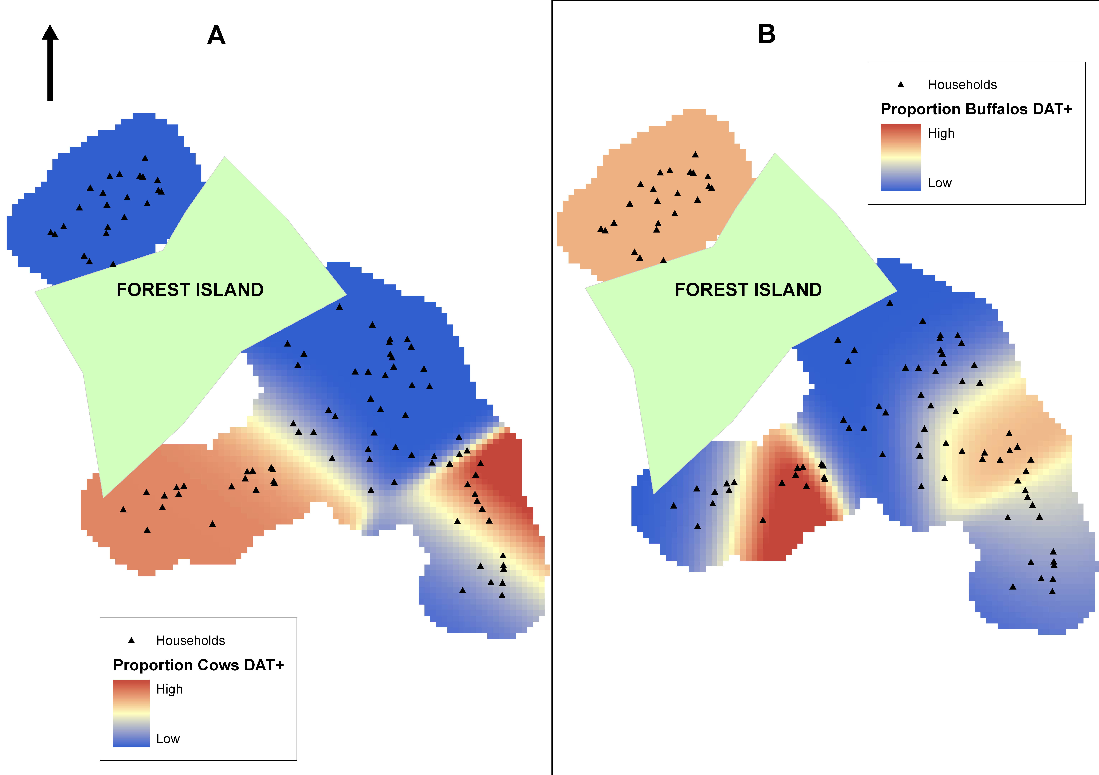
Map of households in Dharan-17 and the extraction maps presenting the excess risk areas (colour gradient) of DAT-positive cows (A) and DAT-positive buffaloes (B) using a bandwidth of 38 meters. No spatial clusters were detected by SaTScan.

