SUPPLEMENTAL DATA
Figure S1. Geographic positions of six districts in Uganda where A. variegatum were collected.
Locations of six districts where tick samples were collected are shown by black dots.
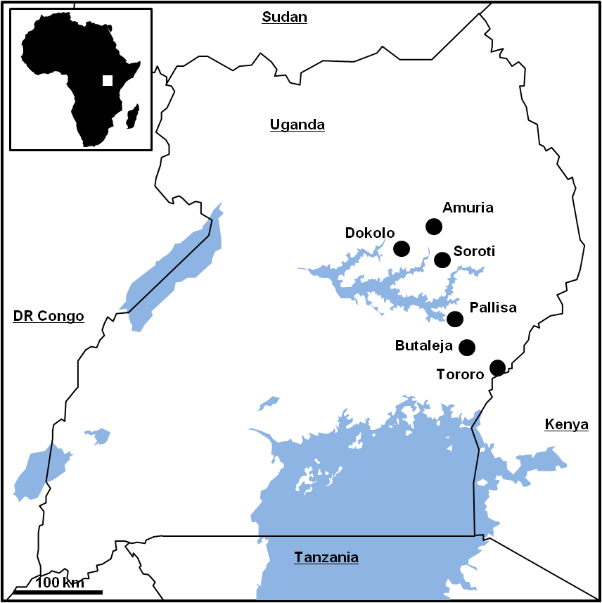

Table S1. Primers used for initial screening of potential VNTRs.
Genome positionª | Forward primer (5' to 3') | Reverse primer (5' to 3') | Amplicon size (bp)^{b}
31558-31587 | TGTTGTATTGTTCATGATGTTGGT | AATCAAGAGTTCGATGATGAAAA | 110
34831-34884 | GACTGTGAAAAATCATCTACTGCTT | TGGCAGCATATTAACCTCCAC | 228
83825-83872 | GGAAAAATTATTGTTTGCGAATC | TCAAAGGTATCACATTTTTGGA | 388
97499-97540 | CAATCATTGTTCATTTTGGAATGT | TCAAGTTTTTGATTTAGCATGTG | 227
124367-124609 | CCATAGCATTTTAACAAATAACAGAA | AGTTTTTAAATTTTGAGATATGTGC | 559
222334-222377 | ACCACTTACTTCAATCAGCCTTA | CAGACATAAAAATCAAACAACAGCA | 151
332733-332777 | TCTGTTGTTGTAGTTTGTAATGTTGA | AATCACAACATACGTGATAATATGC | 163
411844-412019 | CCAGTGGATTATTTTTGCATCTT | TTGTACATGTTCATTAACTTCATTGTT | 435
458703-458755 | ATTAATTGAGTAAAAGCAATCTTGAA | CTGAAATTACGTATTGTGGTTATTTT | 356
489760-489800 | GGTGTGTCAAATAATCCTTCG | GGCTTTGTTATAGCTTTAGTTGCT | 300
493722-493751 | TTCCCTAGTTCTTCTGGATCATT | TGCCACAGGGATATGTATCGT | 168
566548-566582 | AACTCCTATAAATGGGTATTGGAT | AGATGAAGTCTTTGTGCTAAATACA | 323
619459-619496 | CCGTTGGATGTAATTGATACG | CCTCTAGCAACCTGCTCACC | 212
624642-624841 | AAGCTGTCATATAATAACTCTGGATCT | TCAGATGATAACCCTCGATTTTG | 284
640331-640373 | GTCTAGAGAATTCTGCATCAGAGAA | GGAGAGTCAGGAAGTGTTAGCTTT | 236
652889-652951 | CGTCGAAAACACTAAACTTTGCT | TTTCAGGTGGTGGTTGTTCA | 190
654790-655014 | GAACATGAATTAGAAAATGTAAATGAA | ACCAGGTGCTTCCATATGCT | 394
730104-730145 | GCATCAGTGTGTAATGCTGAAA | ATTTTGTATTTCTTCGGCTGTT | 250
779362-779411 | GATTAAAACGTGAATGCCAGAA | TAAGCTGGTAAAACATGTAAGAGC | 192
796148-796177 | TTACAGGTCGAATAATTTCAGACA | TGATTTTTGTTGTGCAGAAGTG | 435
853307-853356 | TCCTCGAACATTAGGAACAGC | TGCAGTAGTGAGTGGCCAAG | 229
855095-855134 | TGGAAGGACAACTGATTTCTCA | TGGTGCTTATCGTCCAGTTTT | 194
864452-864507 | AGAGTATGAACTAGTAACCTGCAACA | GGGTTAGTAATATTCCTGATGCACT | 478
953483-953536 | CGTAGATTAACATCATCCCCATA | TTTGCTACGATAATCTTTTCTTTGT | 245
1224826-1224871 | TGAGGCATTAGTAGTTTACAAAAAGG | CCAACTTTTGTAAGTTTGAACTTTTG | 395
1286740-1286771 | TTGTCAATCAACAAAGCAACATAA | CATGGTGAATTTTTCTTGAAATTG | 234
1310740-1310774 | GCTTATGGAGATACTGCTCCTTT | TTGTCAACAAGCATGGTTCAG | 457
1363295-1363333 | ACCATATGCAAGCACACAGA | TGTAAATTCGTGATGATGTAAGCA | 240
1403693-1403727 | CCATCAATTAAAGTAAAATTCTCAAA | AGGGTGCTGGGTATGGTAGA | 397
1474500-1474526 | ACAGACAATAAAACATCTGTCAGC | AAGTGCAAACCCTAAACATGAAA | 350
1495856-1495950 | CTCAGCCCAGGATTACCTGA | GCAAATAGCAGATGTTAGCTCAT | 569
1510222-1510266 | CGATTTTTCAACAGACCACATT | GCATGAGGTCCACGACATAA | 244
ªLocation on the genome sequence of Welgevonden (Erwo) strain.
^{b}PCR amplicon size in Welgevonden (Erwo) strain.

