Supplementary Methods
2DSA GA-MC analysis
In order to estimate hydrodynamic shapes of individual species, SV data were also analyzed by two-dimensional spectrum analysis (2DSA) and then by a genetic algorithm with a Monte Carlo simulation (GA-MC) using the program UltrascanII version 9.9 . We performed 50 iterations. In all the analyses, time-invariant noise and radian-invariant noise were removed. Additional parameters for the analysis included partial specific volumes calculated from the amino acid composition (0.7328 cm³/g), and buffer density (ρ=1.0122 g/cm³) and viscosity (η=1.0101 centipoises) calculated using the program UltraScanII version 9.9.

CD measurement of TbIMPDH
All CD measurements were performed using a J-820 spectropolarimeter (JASCO, Tokyo, Japan). The path lengths were 1 mm for far-UV to visible range at 200 to 260 nm and 10 mm for near-UV to visible range at 250 to 350 nm, respectively. TbIMPDH concentration were 2 μM for far-UV CD and 13 μM for near-UV CD. The measurements were performed at 25 ˚C in the following buffers: 50 mM Tris/Cl (pH 7.5-9.0) and 50 mM carbonate (pH 9.0-10.0). The ionic strengths of these buffers were adjusted at 0.25 by adding NaCl. The data were expressed as molar residue ellipticity (θ).

REFERENCE
Demeler, B. (2005). Modern Analytical Ultracentrifugation: Techniques and Methods., Royal Society of Chemistry (UK).

Supplementary Fig. S1
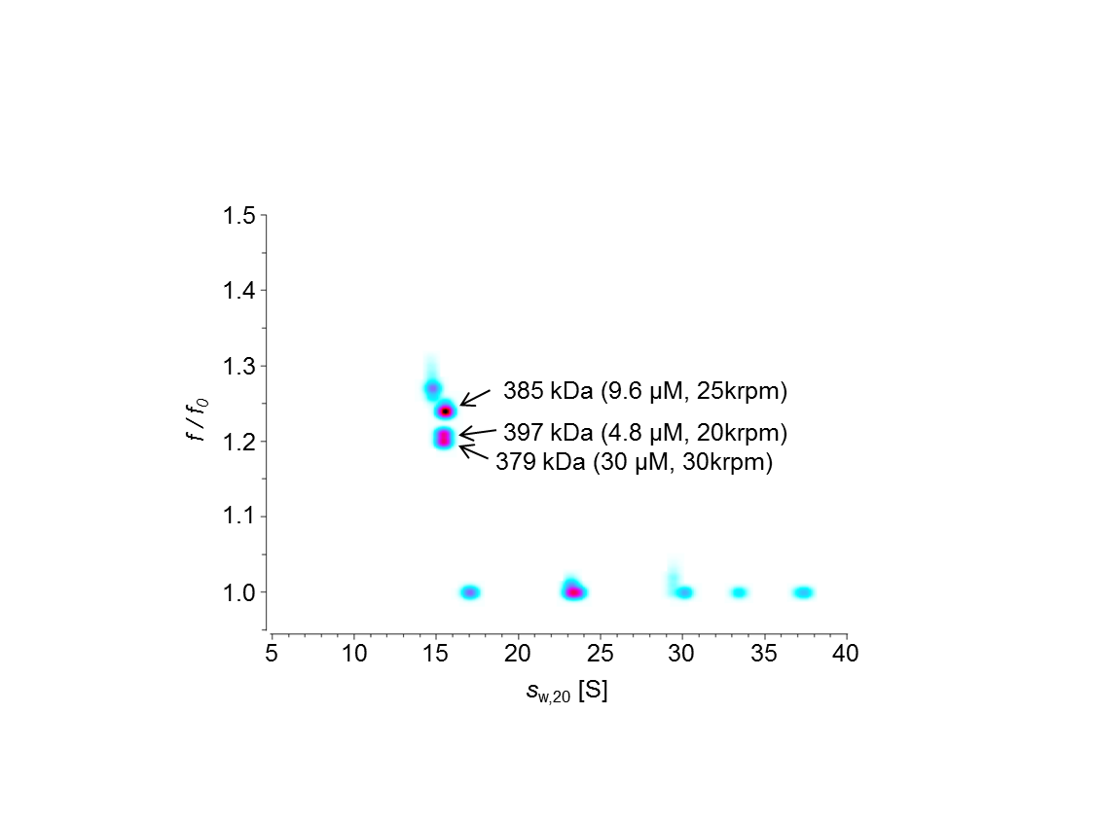
Supplementary Fig. S2
