SUPPLEMENTARY MATERIAL
RESULTS
Biomass of trophically transmitted parasites
In general, relationships between parasite biomass and proportions of intermediate hosts in the diet of fish hosts were similar to the relationships with parasite abundances described above (Fig. S1).
The main distinction was that, unlike the abundance of H. spinigera in A. forsteri, the biomass of the parasite did not vary significantly with the proportion of P. excavatum in the fish’s diet, and there was no significant interaction with the size of A. forsteri (<β₂> = 758, P = 0.607; <β₃> = -560, P = 0.456). As such, host diet did not affect the biomass of H. spinigera for A. forsteri of any size (Fig. S1A; Table S2).
Also unlike abundance, the biomass of Eustrongylides sp. in G. cotidianus increased with the proportion of intermediate hosts in the fish’s diet (<β₂> = 2.96, P < 0.001). However, there was no significant interaction with fish host size (<β₃> = 0.009, P = 0.874) and the high degree of variance associated with this interaction meant that, overall, the biomass of Eustrongylides sp. did not vary with the diet of G. cotidianus (Fig. S1C).
More similarly, neither the biomass of C. parvum in P. fluviatilis nor the biomass of C. parvum in G. cotidianus varied with the proportion of intermediate hosts in the fishes’ diets (<β₂> = -2.80x10⁻⁴, P = 0.960 and <β₂> = -0.029, P = 0.557; <β₃> = -0.048, P = 0.434, respectively). Further, there were no significant interactions between proportions of intermediate hosts and fish host size (<β₃> = 2.09x10⁻⁶, P = 0.999 and <β₄> = 0.038, P = 0.906; <β₅> = 0.134, P = 0.676). Therefore there was no overall effect of the proportion of either intermediate host on C. parvum biomass (Fig. S1B, D; Table S2).

Fig. S1. Marginal effects of the proportion of intermediate host prey in the diet of fish hosts on the total biomass of trophically-transmitted parasites in individual hosts in the four parasite-fish host taxon combinations for which models could be fitted; (A) Hedruris spinigera in Aldrichetta forsteri, (B) Coitocaecum parvum in Perca fluviatilis, (C) Eustrongylides sp. in Gobiomorphus cotidianus and (D) C. parvum in G. cotidianus. Intermediate host prey taxa are also identified within each panel. Marginal effects are obtained by summing the effect of proportion of intermediate host with the effect of the interaction between fish host mass and proportion of intermediate hosts across the observed range of fish host masses. We show mean marginal effects (black lines) with 95% confidence intervals (grey). See Fig. 1 for details about the interpretation of marginal effects.

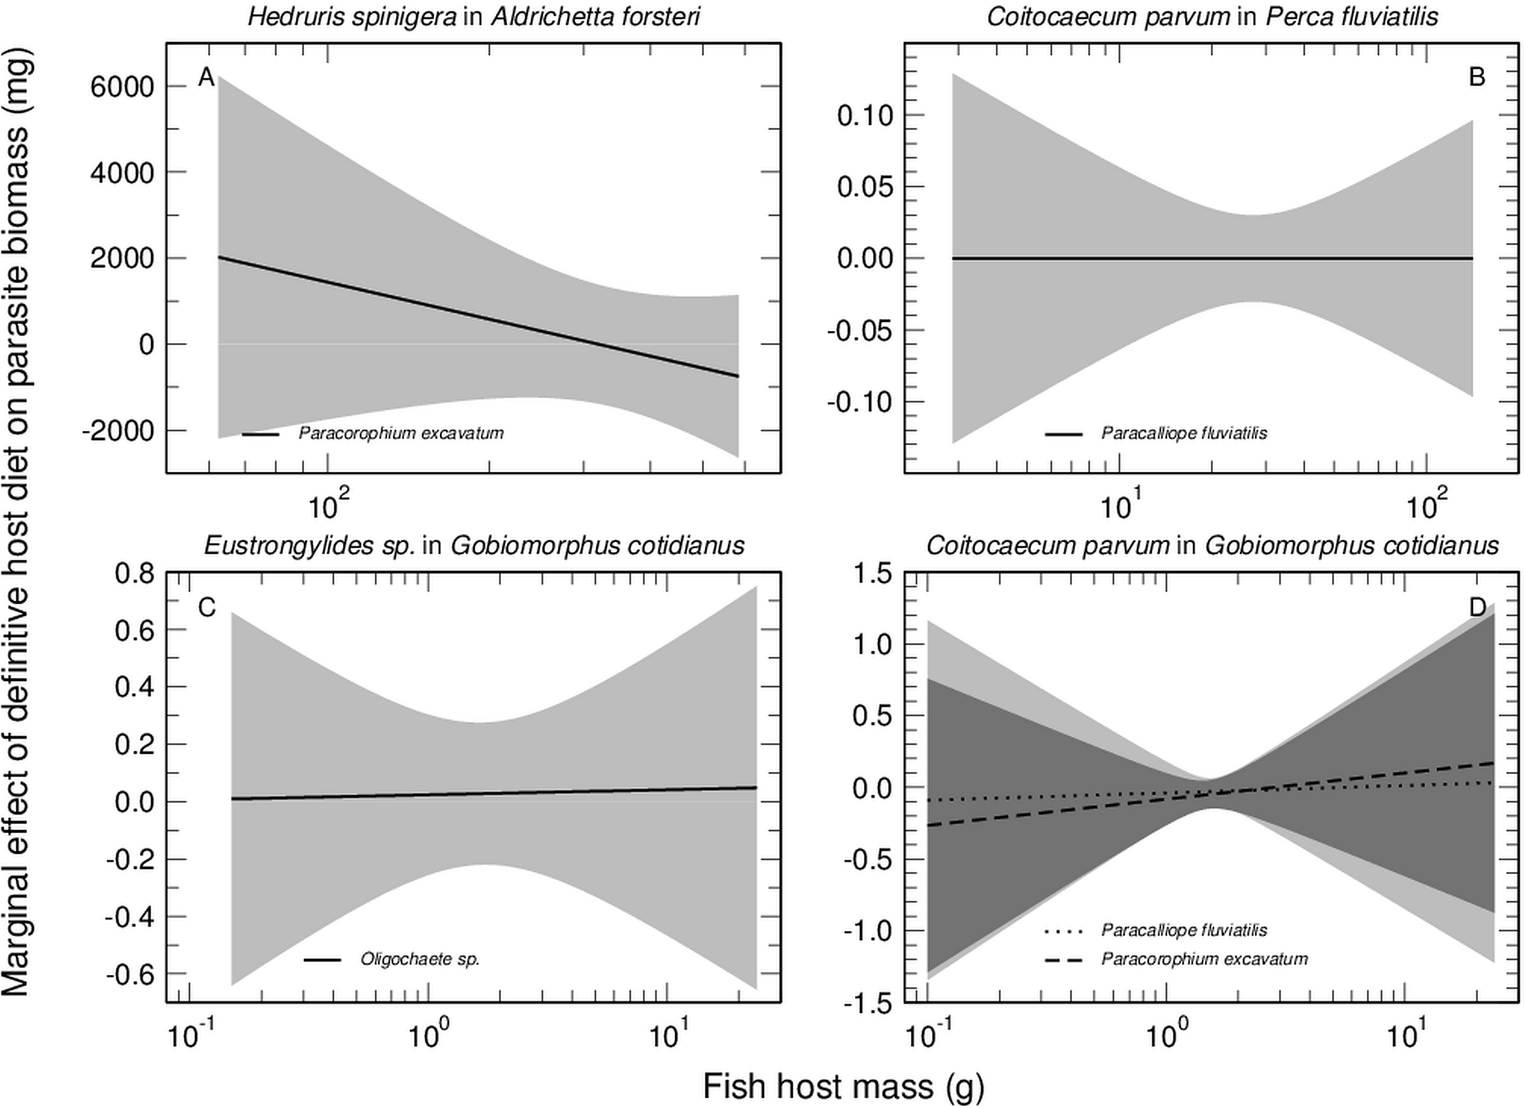

Table S1. Geographical locations and characteristics of the four lakes sampled for G. cotidianus (South Island of New Zealand).
Lake | GPS coordinates | Surface area (km²) | Depth (m)  Mean – Max | Altitude (m) | Trophic status | Tidal
Hayes | 44°58'59.4"S  168°48'19.8"E | 2.76 | 3.1 – 33 | 329 | Mesotrophic | No
Tuakitoto | 46°13'42.5"S  169°49'29.2"E | 1.32 | 0.95 – 3 | 5 | Mesotrophic | Yes
Waihola | 46°01'14.1"S  170°05'05.8"E | 6.35 | 1.3 – 2.2 | 4 | Eutrophic | Yes
Tomahawk Lagoon | 45°54'06.0"S  170°33'02.2"E | 0.096 | 1.0 – 1.2 | 15 | Eutrophic | No

Table S2. Estimated fixed effects in equation 3 (with P-values in parentheses). β₁ indicates the effect of fish host mass on the biomass of the parasite, β₂ and β₃ the effects of the proportions of two intermediate hosts in the diet of the fish host, and β₄ and β₅ the effects of the interaction between proportion of intermediate host and fish host mass. NA indicates that only one intermediate host was found in the gut contents of the fish host. Estimates are based on averages over the full equation 2 and all possible reduced models, weighted by AIC.
Fish host | Parasite | β₁ | β₂ | β₃ | β₄ | β₅
Aldrichetta forsteri | Hedruris spinigera | 14.0  (0.224) | 758  (0.607) | NA | -560  (0.456) | NA
Perca fluviatilis | Coitocaecum parvum | 0.003  (0.823) | -2.80x10⁻⁴  (0.960) | NA | 2.09x10⁻⁶  (0.999) | NA
Gobiomorphus cotidianus | Eustrongylides sp. | 2.96  (<0.001) | 0.036  (0.775) | NA | 0.009  (0.874) | NA
Gobiomorphus cotidianus | Coitocaecum parvum | 0.004  (0.948) | -0.029  (0.557) | -0.048  (0.434) | 0.038  (0.906) | 0.134  (0.676)

Table S3. Estimated fixed effects in equation 2 (with P-values in parentheses) where proportions of intermediate hosts were determined using masses of intermediate hosts. β₁ indicates the effect of fish host mass on the abundance of the parasite, β₂ and β₃ the effects of the proportions of two intermediate hosts in the diet of the fish host, and β₄ and β₅ the effects of the interaction between proportion of intermediate host and fish host mass. NA indicates that only one intermediate host was found in the gut contents of the fish host. Estimates are based on averages over the full equation 2 and all possible reduced models, weighted by AIC.
Fish host | Parasite | β₁ | β₂ | β₃ | β₄ | β₅
Aldrichetta forsteri | Hedruris spinigera | 0.208  (<0.001) | 44.6  (0.002) | NA | 0.991  (0.898) | NA
Perca fluviatilis | Coitocaecum parvum | 0.113  (0.839) | 0.007  (0.991) | NA | 0.024  (0.964) | NA
Gobiomorphus cotidianus | Eustrongylides sp. | 0.438  (<0.001) | 0.287  (0.075) | NA | 0.028  (0.725) | NA
Gobiomorphus cotidianus | Coitocaecum parvum | 0.131  (0.191) | -0.847  (0.358) | 1.07  (0.229) | 6.10  (0.250) | -4.41  (0.405)

Table S4. Estimated fixed effects in equation 3 (with P-values in parentheses) where proportions were determined based on the masses of each intermediate host. β₁ indicates the effect of fish host mass on the biomass of the parasite, β₂ and β₃ the effects of the proportions of two intermediate hosts in the diet of the fish host, and β₄ and β₅ the effects of the interaction between proportion of intermediate host and fish host mass. NA indicates that only one intermediate host was found in the gut contents of the fish host. Estimates are based on averages over the full equation 2 and all possible reduced models, weighted by AIC.
Fish host | Parasite | β₁ | β₂ | β₃ | β₄ | β₅
Aldrichetta forsteri | Hedruris spinigera | 10.4  (0.415) | 2.88x10³  (0.632) | NA | 3.45x10²  (0.287) | NA
Perca fluviatilis | Coitocaecum parvum | 0.003  (0.823) | -2.62x10⁻⁴  (0.962) | NA | 1.79x10⁻⁶  (0.998) | NA
Gobiomorphus cotidianus | Eustrongylides sp. | 3.27  (<0.001) | 5.19  (<0.001) | NA | 1.49  (0.138) | NA
Gobiomorphus cotidianus | Coitocaecum parvum | 0.042  (0.571) | -0.273  (0.694) | 0.442  (0.516) | 4.83  (0. 320) | -4.38  (0.365)

Table S5. Estimated fixed effects in equation 2 (with P-values in parentheses) using absolute counts of intermediate hosts consumed rather than proportions. β₁ indicates the effect of fish host mass on the abundance of the parasite, β₂ and β₃ the effects of the counts of two intermediate hosts in the diet of the fish host, and β₄ and β₅ the effects of the interaction between number of intermediate host individuals consumed and fish host mass. NA indicates that only one intermediate host was found in the gut contents of the fish host. Estimates are based on averages over the full equation 2 and all possible reduced models, weighted by AIC.
Fish host | Parasite | β₁ | β₂ | β₃ | β₄ | β₅
Aldrichetta forsteri | Hedruris spinigera | 0.130  (<0.001) | 1.18  (<0.001) | NA | 0.549  (0.002) | NA
Perca fluviatilis | Coitocaecum parvum | 0.095  (0.922) | 5.76  (0.885) | NA | -2.77  (0.993) | NA
Gobiomorphus cotidianus | Eustrongylides sp. | 0.411  (<0.001) | 0.007  (0.842) | NA | -0.009  (0.889) | NA
Gobiomorphus cotidianus | Coitocaecum parvum | 0.891  (<0.001) | 0.842  (0.187) | -0.156  (<0.001) | 4.59  (0.013) | -0.423  (0.015)

Table S6. Estimated fixed effects in equation 3 (with P-values in parentheses) using absolute counts of intermediate hosts consumed rather than proportions. β₁ indicates the effect of fish host mass on the biomass of the parasite, β₂ and β₃ the effects of the abundance of two intermediate hosts in the diet of the fish host, and β₄ and β₅ the effects of the interaction between intermediate host diet and fish host mass. NA indicates that only one intermediate host was found in the gut contents of the fish host. Estimates are based on averages over the full equation 2 and all possible reduced models, weighted by AIC.
Fish host | Parasite | β₁ | β₂ | β₃ | β₄ | β₅
Aldrichetta  forsteri | Hedruris  spinigera | 8.43  (0.212) | 78.9  (0.076) | NA | 48.5  (0.222) | NA
Perca  fluviatilis | Coitocaecum parvum | 0.003  (0.824) | 0.025  (0.933) | NA | -9.42 x10⁻⁴  (0.999) | NA
Gobiomorphus cotidianus | Eustrongylides  sp. | 2.91  (<0.001) | 0.106  (0.809) | NA | -0.225  (0.823) | NA
Gobiomorphus cotidianus | Coitocaecum parvum | 0.081  (0.388) | 0.017  (0.903) | -9.14 x10⁻⁴  (0.911) | 0.003  (0.974) | 2.16 x10⁻⁴  (0.974)

