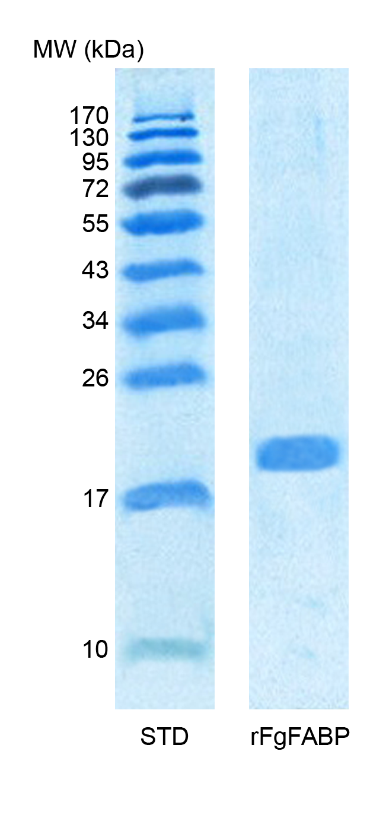

Fig. S1. Supplementary figure S1. Coomassie blue staining of SDS-PAGE shows the recombinant F. gigantica fatty acid binding protein (rFgFABP) at molecular weight (MW) of approximately 20 kDa. STD is the lane containing standard protein molecular weight markers.

