Appendix
Fig. A1. A comparison of the ‘true’ and estimated values of the Acrophase parameter from the cosinor analysis between the traditional least-squares (LS) method and the generalized linear model (GLM) approach. The filled gray circles are the LS estimates while the open circles are the GLM estimates. Each plot represents a different simulation with specified values of the MESOR (M) and the Amplitude (Amp).

Fig. A2. A comparison of the ‘true’ and estimated values of the MESOR parameter from the cosinor analysis between the traditional least-squares (LS) method and the generalized linear model (GLM) approach. The filled gray circles are the LS estimates while the open circles are the GLM estimates. Each plot represents a different simulation with specified values of the Acrophase (Acro) and the Amplitude (Amp).

Fig. A3. Sensitivity of cosinor parameter estimates to variation in samples size (from 1 to 100 snail hosts). (a) Difference between the ‘true’ and estimated values of MESOR for LS and GLM. (b) Difference between the ‘true’ and estimated values of Amplitude for LS and GLM.
(c) Difference between the ‘true’ and estimated values of Acrophase for LS and GLM. Dark circles and light triangles represent estimates from the GLM and LS approaches, respectively. The dashed horizontal line references the point at which the estimated and ‘true’ values are identical (difference of zero).

Fig. A1.

Fig. A2.
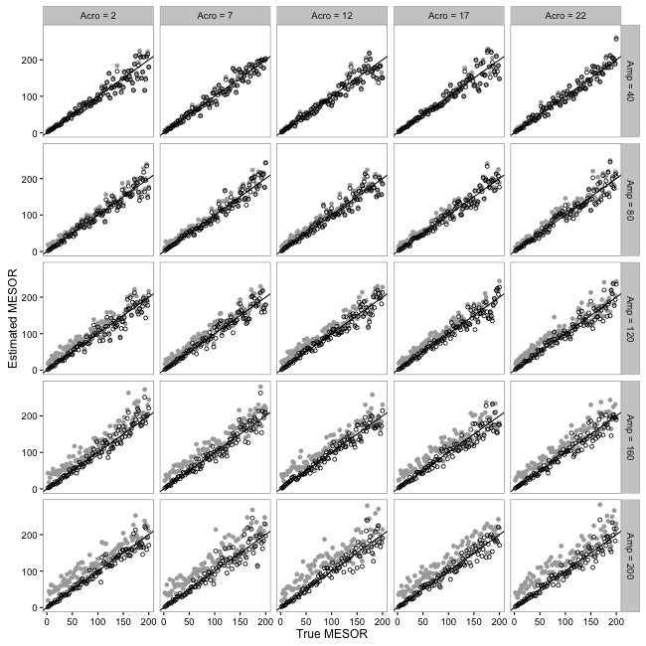

Fig. A3.

