SUPPLEMENTARY INFORMATION

- Questionnaire Data
Severity of depression was assessed in both groups using the Beck Depression Inventory (BDI, Beck et al. 1961). Depressed patients were also administered the Montgomery–Asberg Depression Rating Scale (MADRS; Montgomery & Asberg, 1979). The Beck Anxiety Inventory (BAI; Beck et al. 1988) was administered in order to assess the level of anxiety symptoms. The Snaith-Hamilton Pleasure Scale (SHAPS; Snaith et al. 1995) was used as a measure of anhedonia, though two patients’ SHAPS scores were missing. The data from the questionnaires and psychological paradigm were obtained during the same 2-hour testing session. Patients scoring below 10 on the BDI and/or 12 or below on the MADRS were excluded, while controls scoring 9 or over on the BDI were excluded.
It might be noted that the SHAPS scores are relatively high (40.27) given the patients’ level of depression severity (as measured by BDI). We performed a brief summary of relevant and available data on the relationship between SHAPS and BDI, comparing our patient data with existing data in the literature from a variety of studies (see Supplementary Fig. 1). Both data sets are dominated by powerful relationships between BDI and SHAPS (present study, patients only: r=-0.580, p=0.006, n=21; published data: r=-0.895, p<0.001, n=14). However, inspection of the data suggests that the present data set might diverge slightly from other data sets in that the gradient of the relationship is slightly flatter. In other words, the moderate or severely depressed patients are somewhat less anhedonic that might be expected from their BDI. It is not clear which procedural difference may have caused this discrepancy.
We are bringing this discrepancy to light as it may have reduced our power to observe a group difference in training phase learning rates. Although our sample size and the magnitude of the effect of SHAPS on these variables compares favourably with Steele and colleagues’ data (Steele et al. 2007), we only observed a marginally significant main effect of group and a modest effect size. We would expect this to be more likely if the difference between the SHAPS scores in the patient and control groups were larger (as was the case in Steele et al. 2007).

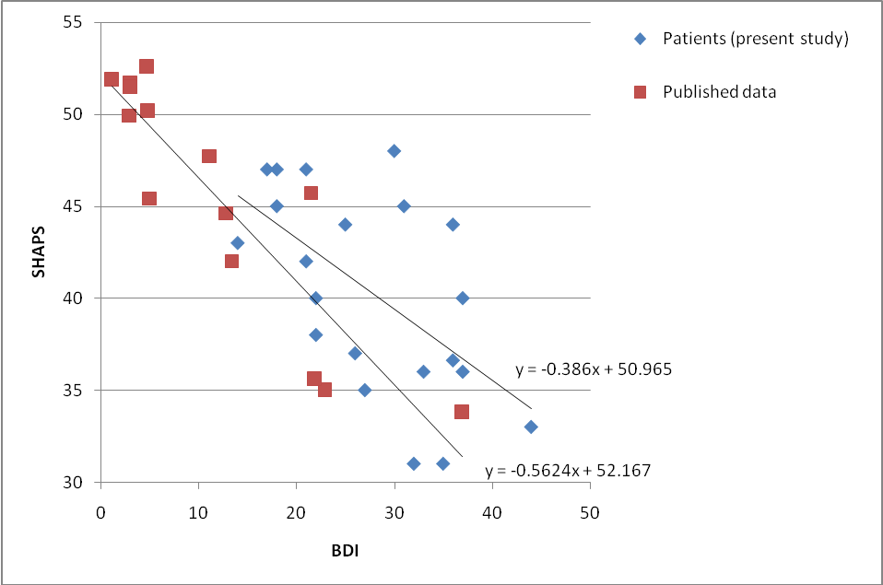
Supplementary Fig. 1. Comparison of the relationship between SHAPS and BDI for individual data in the present study (blue) and published SHAPS/BDI data of different patient and control groups from the following studies (red: Franken et al. 2007; Kumar et al. 2008; Steele et al. 2007; Stevens et al. 2007). Gradient and intercepts describing the relationship are included on the graph.

- Q-learning Algorithm
An approach to data analysis using a Q-learning algorithm, similar to that employed by Frank and colleagues (2007), was performed. Separate models were fitted to training phase and test phase data. In both cases, the Q-value (associative strength) of the selected stimulus is updated with new information using the following rule:

Q_{A}(t+1) = Q_{A}(t) + m1*αG*δ+ m2*αL*δ,

where δ is the prediction error (outcome(t) – Q_{A}(t)), α is the learning rate, t is the current trial, m1 is 1 and m2 is 0 if positive feedback is obtained, m1 is 0 and m2 is 1 if negative feedback is obtained. αG is the positive learning rate and αL is the negative learning rate for the training phase. These are replaced with αG’ for the positive learning rate and αL’ for the negative learning rate when modelling test phase performance.
The relative Q values of the two presented stimuli (here A and B) are used to compute the probability of selecting one of the stimuli (here A) using the following equation:

P(A)=exp(Q_{A}(t)/EE)/(exp(Q_{A}(t)/EE)+exp(Q_{A}(t)/EE)),

where EE is the exploration/exploitation parameter for the training phase. This is replaced with EE’ for the exploration/exploitation parameter when modelling test phase performance.
Individual learning rate parameters were determined for each subject by optimizing the fit of the model, by maximizing the model’s estimation of the probability of selecting the outcome that the subject picks on each trial using the nonlinear, unconstrained Nelder–Mead simplex method implemented in Matlab 6.5 (MathWorks, Natick, MA). The optimization algorithm was run from different starting points to ensure that the presence of local minima did not influence accurate estimation of the parameter.
In the case of the model used to fit the training data, parameters are selected to maximise the probability of selecting the stimulus that was chosen during the training phase. Likewise, in the model used to fit the test phase data, Q values were assumed to have been acquired during the training phase, so Q-values for each stimulus were assumed to have been updated in the same way as the train phase model. However, model parameters were selected that best fit discrimination performance during the test phase, rather than training phase performance.
As a means of confirming that these learning rate parameters reflected subjects’ behavioural data, the Q-values of each stimulus were determined by running the model on the training data using the best fitting parameters. These were then entered as dependent measures into a multiple regression model, and used to predict avoid B or select A scores in separate models. Of all the stimuli, only the magnitude of the Q-value of stimulus B significantly predicted avoid B performance (beta=-0.909, p=0.041); likewise, only the Q-value of stimulus A predicted select A performance (beta=1.364, p=0.041). We therefore conclude that the model represents an acceptable approximation of test phase performance, and that model parameters are similar between the groups.

References
Beck AT, Epstein N, Brown G, Steer RA (1988). An inventory for measuring clinical anxiety: psychometric properties. Journal of Consulting and Clinical Psychology 56, 893-897.
Beck AT, Ward C, Mendelson M (1961). Beck Depression Inventory (BDI). Archives of General Psychiatry 4, 561-571.
Franken IH, Rassin E, Muris P (2007). The assessment of anhedonia in clinical and non-clinical populations: further validation of the Snaith-Hamilton Pleasure Scale (SHAPS). Journal of Affective Disorders 99, 83-89.
Kumar P, Waiter G, Ahearn T, Milders M, Reid I, Steele JD (2008). Abnormal temporal difference reward-learning signals in major depression. Brain 131, 2084-2093.
Montgomery SA, Asberg M (1979). A new depression scale designed to be sensitive to change. British Journal of Psychiatry 134, 382-389.
Snaith RP, Hamilton M, Morley S, Humayan A, Hargreaves D, Trigwell P (1995). A scale for the assessment of hedonic tone the Snaith-Hamilton Pleasure Scale. British Journal of Psychiatry 167, 99-103.
Steele JD, Kumar P, Ebmeier KP (2007). Blunted response to feedback information in depressive illness. Brain 130, 2367-2374
Stevens A, Peschk I, Schwarz J (2007). Implicit learning, executive function and hedonic activity in chronic polydrug abusers, currently abstinent polydrug abusers and controls. Addiction 102, 937-946.

