SUPPLEMENTARY MATERIAL

Supplementary Fig 1. Insular activation positive>neutral in the comparison depressed>healthy. FMRI data of the left insula of the condition exp ps>nt and group comparison of beta weights for this region for different conditions. The depressed patients show increased activation during positive expectation, unlike the healthy subjects. This is also underlined by the activity during negative expectation in healthy subjects different to activity during positive, unlike in depressed patients. However, both groups show comparable activation during negative versus neutral expectation, indicating that the different pattern during positive expectation might be specific for depression.

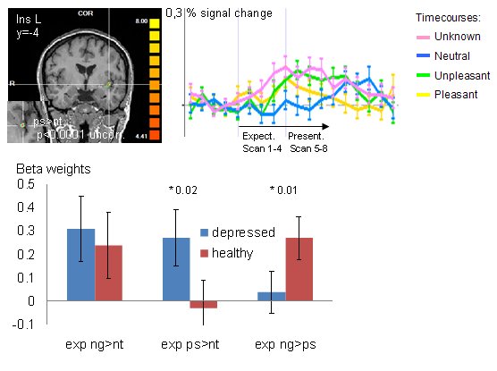

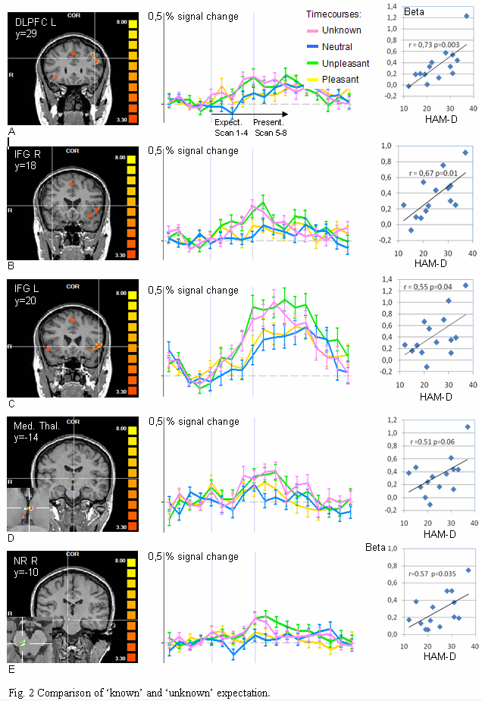
Supplementary Fig. 2. For legend see Fig. 2 in main paper.

