ONLINE SUPPLEMENT

Clinical and anatomical heterogeneity in Autistic Spectrum Disorder: an sMRI study

Figures with corresponding Tables providing; location of each three dimensional cluster in Talariach co-ordinates (x, y, z, mm); n = number voxels in each cluster; BA = Broadmann area and putative anatomical labels, are provided below.

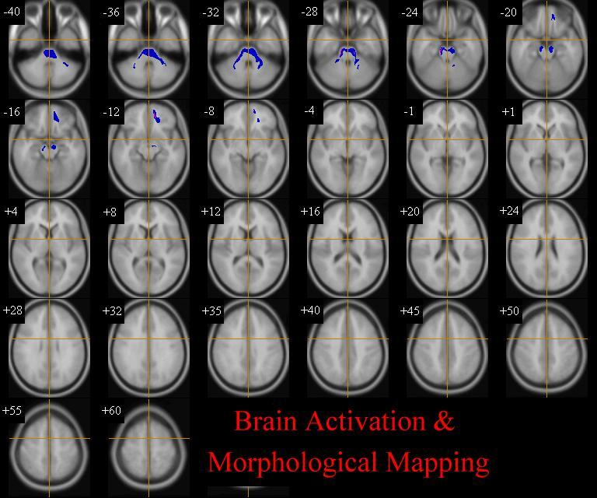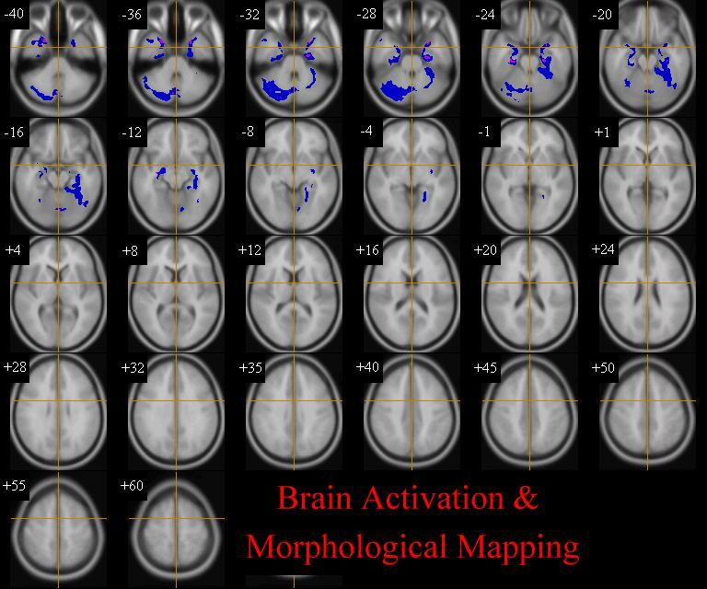
Fig 1: All ASD versus Controls
grey white

Fig. 1. All people with ASD versus controls
Relative deficits (blue) and excesses (red) in grey and white matter volume in ASD participants compared with healthy controls (clusteR p= 0.003 grey, p=0.01 white). (corrected for total grey /white volume) The maps are oriented with the right side of the brain shown on the left side of each panel.

Table 1. Whole group versus controls

Cluster Location BA Cluster Centre Side
x y z N

Grey Matter
Decreases

Cerebellum 24.2 -71.4 -30.2 1525 Right
(extending from the parahippocampal gyrus into the hippocampus and fusform gyrus)

Inferior temporal gyrus (20) 28.2 -6.8 -28.1 687 Right
(extending from the superior temporal gyrus to the middle temporal gyrus

Parahippocampal gyrus (35,36) -27.3 -30.2 -22.4 1645 Left
(extending from superior temporal and inferior temporal gyrus into parahippocampal gyrus, hippocampus, fusiform gyrus and cerebellum)

White Matter
Decreases

Brain stem -3.2 -27.8 -31.2 1024 Left
(extending into cerebellum bilaterally)

Sup frontal gyrus white matter -13.7 43.8 -13.8 179 Left
(extending into middle frontal gyrus and orbital gyrus white matter)

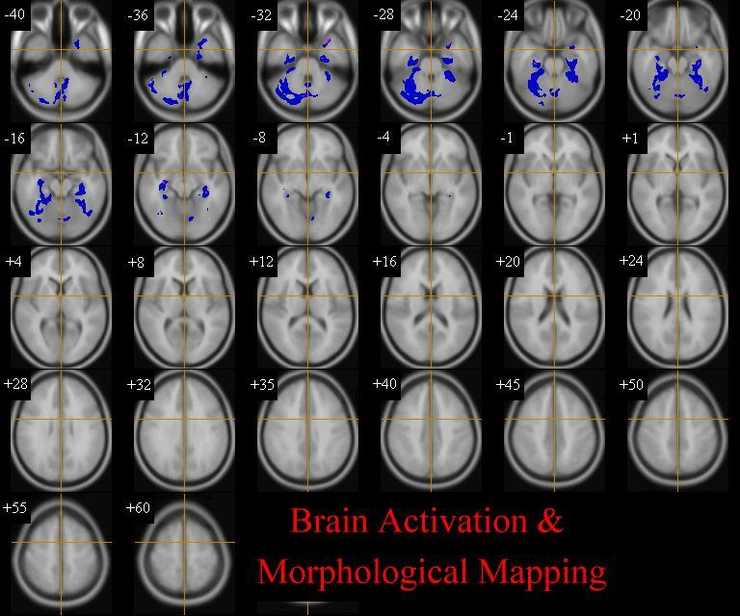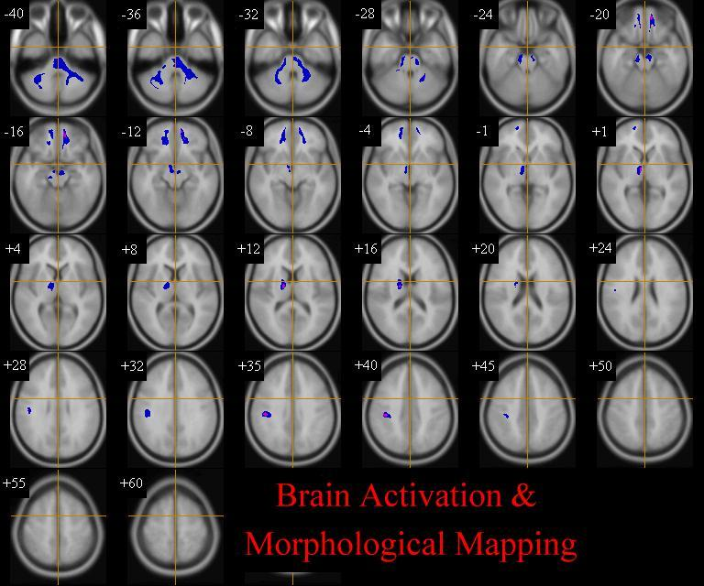
Fig 2: Asperger syndrome versus Controls
grey white

Fig. 2. People with Asperger Syndrome versus controls
Relative deficits (blue) and excesses (red) in grey and white matter volume in Asperger participants compared with healthy controls (cluster P = 0.003, grey P=0.01, white (corrected for total grey /white volume).

Table 2. People with Asperger Syndrome versus controls

Cluster Location BA Cluster Centre Side
x y z N

Grey Matter
Decreases

Cerebellum 22.9 -55.8 -27.1 2686 Right
(extending into left cerebellum and bilaterally into inferior temporal gyrus, parrahippocampal gyrus, hippocampus and fusiform gyrus)

White Matter
Decreases

Brain stem -13.3 -34.5 -34.1 818 Left
(extending into left cerebellum)

Cerebellum 23.5 -41.6 -32.7 397 Right
(extending from brainstem)

Med frontal gyrus white matter 14.9 46.0 -10.8 282 Right
(extending into right superior frontal gyrus right sub-gyral white matter,
right anterior cingulate white matter)

Med frontal gyrus white matter -13.0 44.1 -13.6 274 Left
(extending into left superior frontal gyrus white matter and left frontal
lobe, sub- gyral white matter)

Right cerebrum, sub-lobar 12.1 -7.2 4.0 339 Right
extra-nuclear white matter

Supramarginal gyrus white matter 42.6 -24.7 35.2 179 Right
(extending into right frontal lobe, precentral gyrus white matter,
sub-gyral white matter, right parietal lobe, sub-gyral white matter
right inferior parietal lobule white matter)

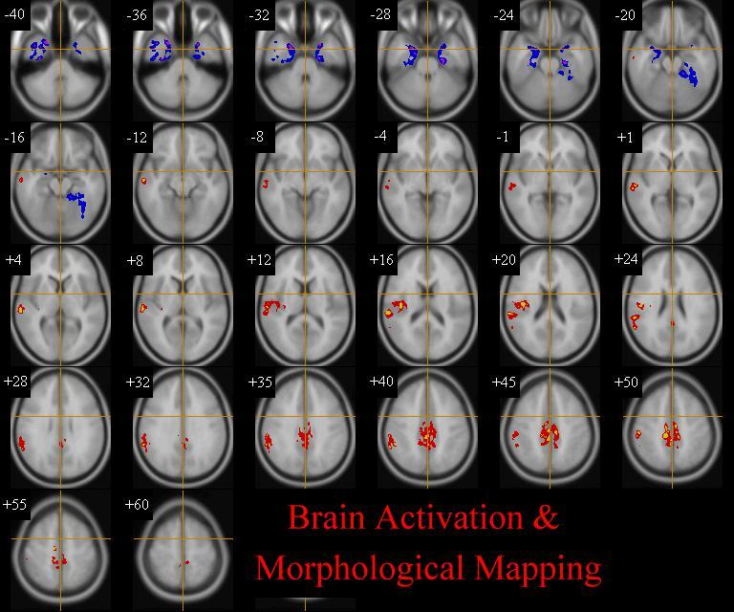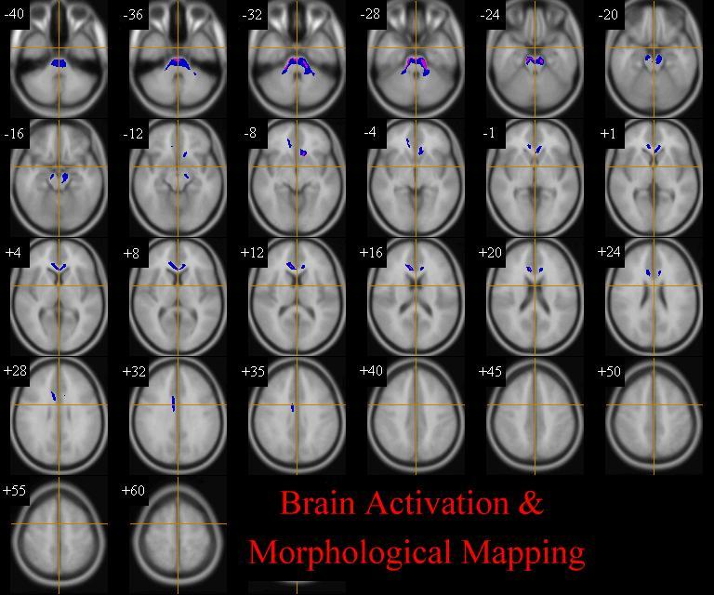
Fig 3: Autism versus Controls
grey white

Fig. 3. People with autism versus controls
Relative deficits (blue) and excesses (red) in grey and white matter volume in Autism participants compared with healthy controls (cluster P = 0.003, grey, P = 0.01, white), (corrected for total grey /white volume).

Table 3. People with autism versus controls

Cluster Location BA Cluster Centre Side

x y z N

Grey Matter
Decreases

Inferior temporal gyrus (20) 30.0 -4.9 -31.6 896 Right
(extending from superior temporal gyrus into parahippocampal gyrus, hippocampus and fusiform gyrus)

Parrahippocampal gyrus (28) -25.1 -25.3 -24.8 818 Left
(extending into the superior and inferior temporal gyrus, parrahippocampal gyrus, fusiform, and cerebellum)

Increases

Sup temporal gyrus (42) 55.9 -28.1 19.3 1227 Right
(extending into middle temporal lobe, inferior parietal lobe and
supramarginal gyrus)

Cingulate gyrus (31) 0.5 -31.1 43.3 1148 Right
(Extending into left cingulate gyrus and bilaterally into the med frontal, pre central and postcentral gyrus, paracentral lobule)

White Matter
Decreases

Brain stem -2.4 -25.0 -29.7 1008 Left
(extending into cerebellum)

Right cerebrum, corpus callosum 2.2 25.0 9.6 584 Right
(extending into right frontal lobe sub-gyral extra nuclear white matter
and right limbic lobe, anterior cingulate white matter)

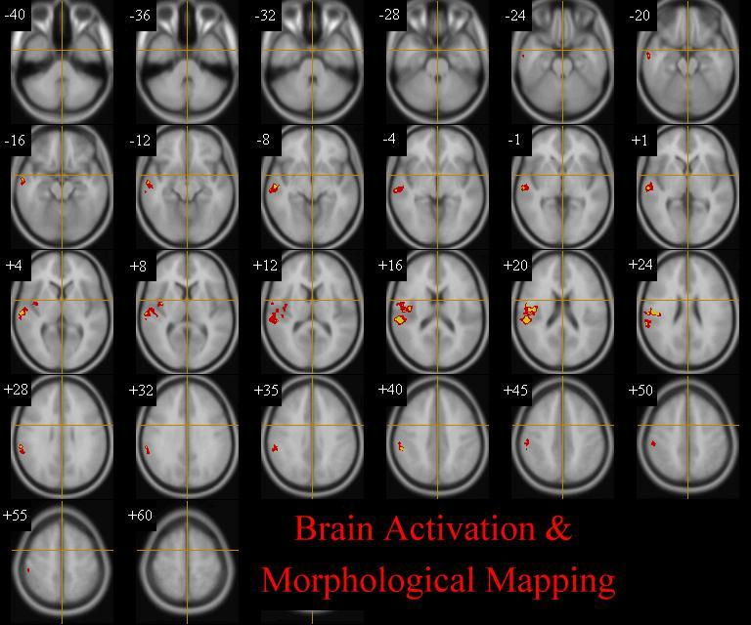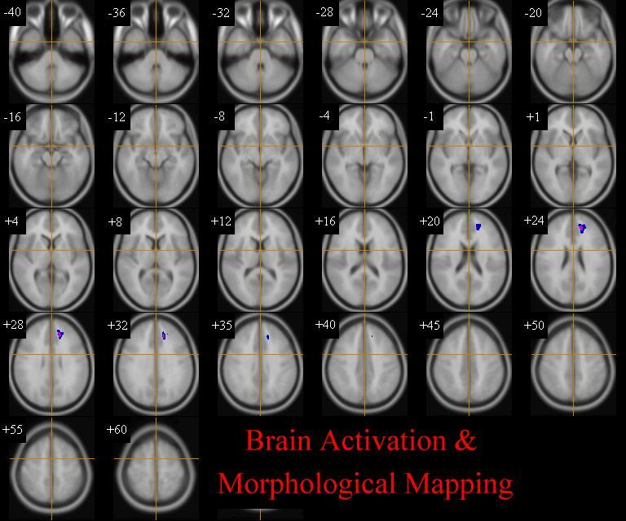
Fig 4: Diagnostic heterogeneity
Differences within ASD
Asperger syndrome versus Autism
grey white

Fig. 4. People with autism versus people with Asperger Syndrome
Relative deficits (blue) and excesses (red) in grey and white matter volume in Autism participants compared with those with Asperger syndrome (cluster P = 0.003, grey, P = 0.01, white corrected for total grey /white volume).

Table 4. Autism versus Asperger Syndrome

Cluster Location BA Cluster Centre Side

x y z n

Grey Matter
Increases

Sup temporal gyrus 40,41,42 55.8 -21.5 12.8 1248 Right
(extending into the mid temporal gyrus, inferior parietal gyrus and supramarginal gyrus)

White Matter
Decreases

Medial frontal gyrus white matter -15.6 39.1 26.3 212 Right

