SUPPLEMENTARY MATERIAL
Parameterized Bayesian reinforcement learning model
We added extra parameters to the ideal observer model to account for potential biases in the way participants integrated positive and negative feedback. This model contained two extra parameters that allowed us to model weighting of positive and negative feedback. For rewarded trials, the reward value was calculated as:

(4)

whereas for unrewarded trials it was calculated as

(5)

The variables α and β were fit as free parameters in the model. The parameter α measured the amount that positive feedback was weighted. For the ideal observer, positive feedback was valued at 1, so α = 0.5. The parameter β measured the amount that negative feedback was weighted. For the ideal observer, negative feedback is valued at 0, so again β = 0.5 for the ideal observer model. Therefore, values of α and β below (above) 0.5 measure the amount that feedback is under (over) weighted and values of α and β near zero indicate that positive or negative feedback is ignored.
The total reward in the block under this model for face i up to trial T was then calculated as:

(6)

Thus, the total reward for each face, up to trial T in the current block, was the sum of the biased reward values.
We next maximized the likelihood of predicting the individual participant’s sequence of decisions by adjusting the parameters α and β. The likelihood was given by:

(7)

where if the participant selected face i (e.g. the happy face) and if the participant selected face j (e.g. the angry face). Here, D* is the series of decisions of the participant, as opposed to the series of outcomes, which is collected in D in the previous equations. We maximized the likelihood using fminsearch in Matlab. We started from several initial conditions to avoid local minima.
We compared two models to examine fit. The first model fit separates α and β parameters (2 degrees of freedom per participant), whereas the second model fit a single parameter (1 degree of freedom for each participant). The log-likelihood of the first model [given by equation (7)] for the patients was 2422 and the log-likelihood of the second model was 2591. The difference between these was significant (likelihood ratio test, χ² = 337, df = 39, p < 0.001). For the controls, the log-likelihood for the first model was 2288 and the log-likelihood for the second model was 2406. The difference between these was significant (likelihood ratio test, χ² = 236, df = 38, p < 0.001). Thus, the two-parameter model provided a better fit to the data for both groups.
A mixed-effects ANOVA model was used to analyse differences in model parameters (α and β) between groups. A random effect of participant was nested under a fixed effect of group. Valence of outcome (positive versus negative) was treated as a fixed, repeated measure.

Carryover effects across blocks
To see whether there were residual carryover effects, we carried out two analyses. First, we examined how often, in blocks 2–4, participants chose the emotion that had been most often rewarded in the previous block (Fig. S1A). This would be a carryover effect specific to the emotion, as the identities alternated across blocks. Of interest, in the first few trials of the block there was no difference between groups. However, in trials 3 and 4, patients were more likely to pick the emotion that had been rewarded in the previous block, relative to controls. A repeated-measures mixed-effects ANOVA with group and trial (repeated measure) as fixed effects and participant as a random effect had no significant effect of group [F(1, 7) = 1.48, p = 0.263] but did have a marginally significant trial by group interaction [F(7, 527) = 2.04, p = 0.049]. Of note, this effect was driven as much by a decrease in controls as by an increase in patients in trials 3 and 4. When compared to chance (0.5) using simple t tests, the patient selection probabilities only approached significance in trial 4 (t₁₁₅ = 1.9, p = 0.063) and were non-significant in the other trials (all p > 0.05), and the control selection probabilities were only significantly below chance in trial 3 (t₁₁₃ = 2.1, p = 0.039) and approached significance in trial 4 (t₁₁₃ = 1.9, p = 0.061) and were non-significant in the other trials (all p > 0.05). These effects suggest that neither group specifically showed a carryover effect between blocks, but there was a small between-group difference.
Next we examined whether or not there were carryover effects from the block with the same identity by comparing choices in block 3 with the emotion that had been best in block 1, because these blocks had the same identity, and comparing the choices in block 4 with the emotion that had been best in block 2, again because these blocks had the same identity. We found that there were no differences between groups (Fig. S1B). A repeated-measures mixed-effects ANOVA showed no significant effect of group [F(1, 7) = 0.07, p = 0.793] and no group-by-trial interaction [F(7, 527) = 0.98, p = 0.446].

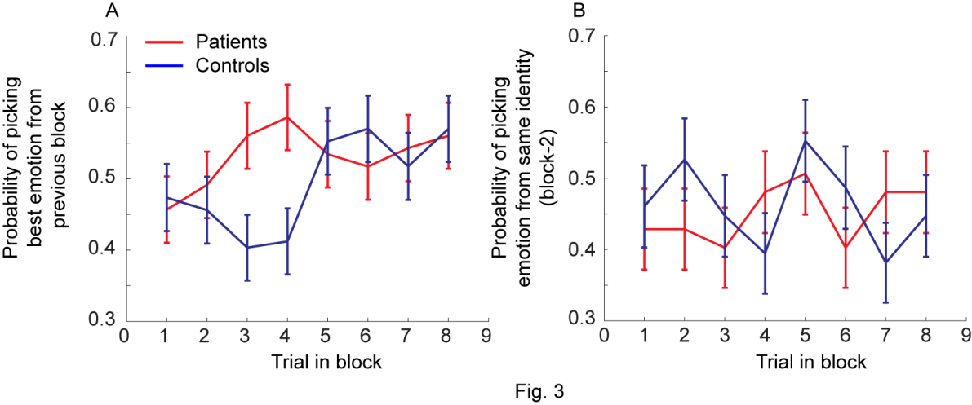
Fig. S1. Reversal effects across blocks. (A) Probability of picking the best emotion from the previous block for the first eight trials of the new block. This is a comparison between different identities for the same emotion, as identities always alternated between adjacent blocks. (B) Probability of picking the emotion that had been rewarded most often in the previous block of the same identity. For identity 1, this comparison is calculated in block 3 and for identity 2, this comparison is calculated in block 4.

