SUPPLEMENTARY MATERIAL

Supplementary Fig. S1: Single Visit LASSO Diagram. Top: Depressed Visit Features; Bottom: Well Visit Features
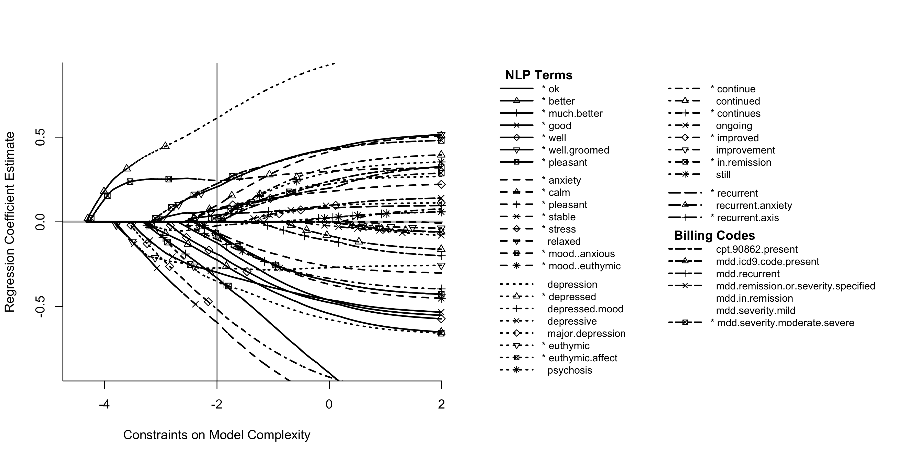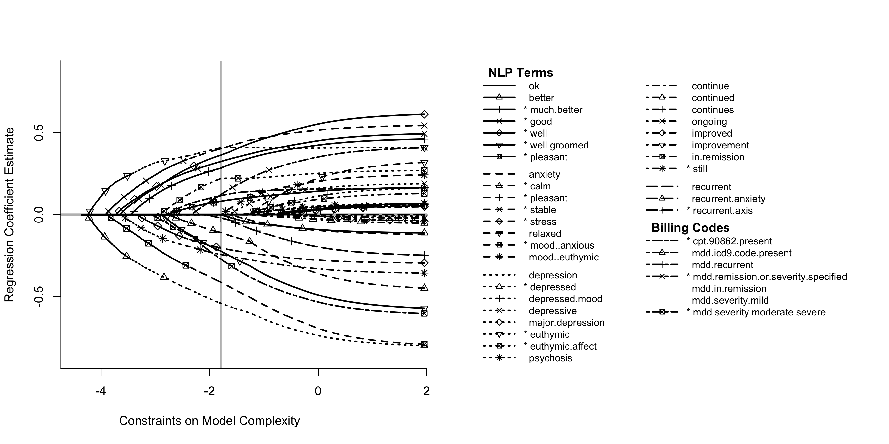

Supplementary Table S1: Single Visit Model Variables
Feature | Source | Depressed Visit beta coefficient | Well Visit  beta coefficient
anxiety | NLP | -0.110 | 0
better | NLP | -0.548 | 0
calm | NLP | 0.307 | -0.3444
continue | NLP | -0.043 | 0
continues | NLP | -0.266 | 0
depressed | NLP | 1.694 | -1.4976
energy | NLP | 0.931 | -2.1361
euthymic | NLP | -0.931 | 1.4011
euthymic affect | NLP | -1.804 | 1.1302
good | NLP | -0.589 | 0.6394
improved | NLP | -1.446 | 0
in remission | NLP | 0.136 | 0
mood anxious | NLP | 1.236 | -2.0938
much better | NLP | -1.808 | 1.5444
mood euthymic | NLP | -0.357 | 0
ok | NLP | -0.407 | 0
pleasant | NLP | -0.353 | 0.406
recurrent | NLP | 0.202 | 0
recurrent axis | NLP | 0.141 | -0.072
stable | NLP | -1.785 | 1.209
still | NLP | 0 | -0.696
stress | NLP | 0.273 | -0.719
well | NLP | -0.388 | 0.740
well groomed | NLP | 0.671 | -0.722
CPT4 90862 | CPT4 Procedures | 0 | 0.335
ICD9_MDD  remission or severity specified | ICD9 Diagnosis | 0 | 0.354
ICD9_MDD  severity moderate/severe | ICD9 Diagnosis | 0.818 | -0.982
Cutoff |  | 1.125 | 1.889

Supplementary Fig. S2: i2b2 workbench timeline view of a TRD (case) and treatment-responsive patient (control)

