ONLINE SUPPLEMENTARY MATERIAL

Table S1. Model fit indices of the exploratory and confirmatory factor models that examined the structure of the psychotic-like experience (PLE) and Strengths and Difficulties Questionnaire (SDQ; Goodman, 1997) items.
 | Model Fit indices
 | k | CFI | TLI | RSMEA
Exploratory analyses
1-factor | 29 | .53 | .69 | .10
2-factor | 57 | .71 | .83 | .08
3-factor | 84 | .90 | .95 | .04
4-factor | 110 | .94 | .97 | .03
5-factor | 135 | .95 | .97 | .03
Confirmatory analyses
Model 1: 1-factor | 87 | .53 | .69 | .10
Model 2: 6-factor first-order model ¹ | 93 | .87 | .92 | .05
Model 3: 8-factor hierarchical model ² | 92 | .87 | .92 | .05
Model 4: 4-factor first-order model ³ | 90 | .86 | .92 | .05
Note: k = number of estimated parameters; CFI = comparative fit index; TLI = Tucker Lewis; RMSEA = root mean square error of approximation. TLI and CFI values close to .90 indicate acceptable model fit and values ≥ .95 indicate very good fit (Hu and Bentler, 1998, Bentler and Bonett, 1980). RMSEA values ≤ .05, .05 to .08, and >.08 indicate close, fair, and poor/mediocre fits, respectively (Browne and Cudeck, 1993, MacCallum et al., 1996).
¹ Model 2: The six factors included the psychotic-like construct (PSY), which explained the co-occurrence of the PLE items, and the Emotional Symptoms, Peer Relationship Problems, Conduct Problems, Hyperactivity-Inattention, and Prosocial Behaviour subscales of the SDQ.
² Model 3 assumed the same factor loadings as Model 2, but the correlations between the Emotional Symptoms and Peer Relationship Problems subscales of the SDQ, and between the Conduct Problems and Hyperactivity-Inattention subscales, were explained using two hierarchical latent variables that were conceptualized as Internalizing and Externalizing psychopathology.
³ Model 4 assumed the same factor loadings as Model 2, but the correlations between the Emotional Symptoms and Peer Relationship Problems subscales of the SDQ, and between the Conduct Problems and Hyperactivity-Inattention subscales, were explained using two first-order latent variables that were conceptualized as Internalizing and Externalizing psychopathology.

Fig. S1. Test Information Function for the psychotic-like experiences questionnaire in children aged 9 to 11 years. The horizontal axis indicates the distribution of the latent construct (θ_{j}) in scale scores (ranging from -3 to 3); the left vertical axis indicates the total test information available at a specific scale score.

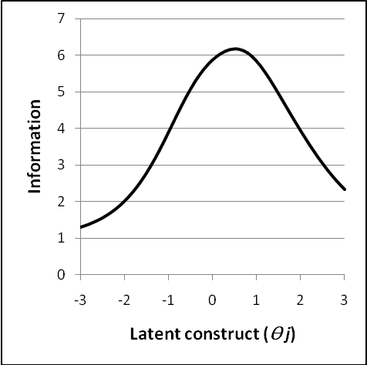

References
Bentler PM, Bonett DG (1980). Significance tests and goodness of fit in the analysis of covariance structures. Psychological Bulletin 88, 588-606.
Browne MW, Cudeck R (1993). Alternative ways of assessing model fit. Sociol Methods Res, 21, 230-258.
Goodman R (1997). The strengths and difficulties questionnaire: A research note. Journal of Child Psychology and Psychiatry 38, 581-6.
Hu L, Bentler PM (1998). Fit indices in covariance structure modeling: Sensitivity to underparamterized model misspecification. Psychological Methods 3, 424-453.
MacCallum RC, Browne MW, Suguawara HM (1996). Power analysis and determination of sample size for covariance structure modeling. Psychological Methods 1, 130-149.

