SUPPLEMENTARY MATERIAL
Appendix S1: Raw scores of neuropsychological tests
Values presented are: mean ± standard deviation. Where applicable, maximum scores are presented in brackets. Abbreviations –HVLT-R: Hopkin’s verbal learning test revised; RCF: Rey-Osterrieth complex figure; TMT: trail making test.

 | Control | LLD
Executive Function  Digit Span Forward (14)  Digit Span Backward (14)  Letter Fluency  TMT B | 10.08 ± 1.73  8.32 ± 2.46  16.36 ± 4.91  83.60 ± 35.69 | 8.11 ± 2.07  6.42 ± 2.05  15.19 ± 5.43  103.34 ± 35.55
Processing Speed  Digit Symbol  TMT A  CANTAB: Simple Reaction Time  CANTAB: 5-Choice Reaction Time  CANTAB: Simple Movement Time  CANTAB: 5-Choice Movement Time | 59.04 ± 17.52  39.08 ± 8.83  337.85 ± 50.33  388.52 ± 70.45  468.49 ± 137.10  415.87 ± 102.39 | 51.11 ± 14.29  51.08 ± 16.28  369.32 ± 83.20  420.98 ± 91.14  559.81 ± 178.91  507.06 ± 139.21
Episodic Memory  RCF: Immediate (36)  RCF: Delay (36)  HVLT-R: Total Recall (36)  HVLT-R: Delayed Recall (12)  HVLT-R: Recognition (12) | 21.70 ± 7.22  20.66 ± 7.34  23.92 ± 6.12  8.60 ± 3.15  10.36 ± 1.73 | 15.83 ± 8.16  15.83 ± 7.66  21.97 ± 5.20  7.97 ± 2.31  10.36 ± 1.46
Language Skills  Category Fluency  Graded Naming Test (30) | 20.96 ± 5.63  15.12 ± 5.99 | 18.36 ± 5.63  10.14 ± 5.84
Visuospatial Skills  Copied Drawings (3)  Clock Drawing (5)  RCF: Copy (36) | 2.80 ± 0.50  4.72 ± 0.46  34.88 ± 1.67 | 2.61 ± 0.73  4.67 ± 0.59  32.51 ± 5.12

Appendix S2: Z scores of neuropsychological tests
Mean z score ± two standard errors of the LLD group. By definition, z scores for control group are zero. Abbreviations – GNT: graded naming test; HVLT-R: Hopkin’s verbal learning test revised; MT: movement time; RCF: Rey-Osterrieth complex figure; RT: reaction time; TMT: trail-making test.
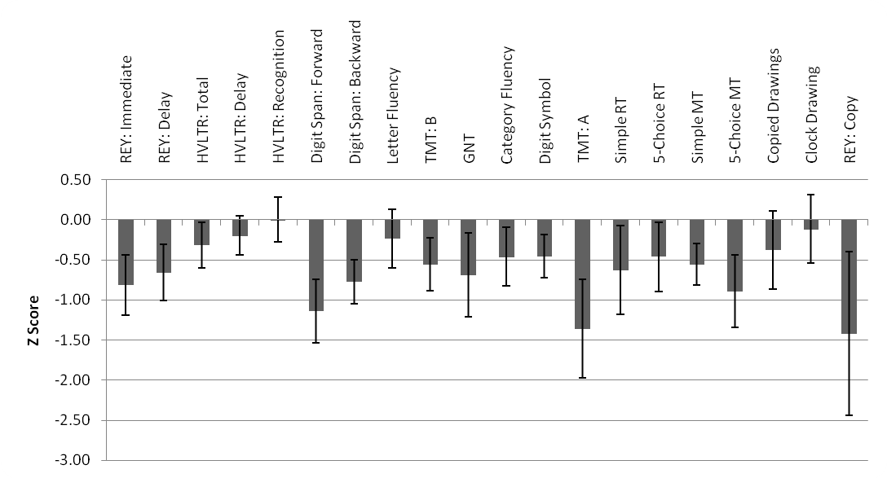
Appendix S3: Z scores of neuropsychological domains
Mean z score ± two standard errors of the LLD group. By definition, z scores for control group are zero.
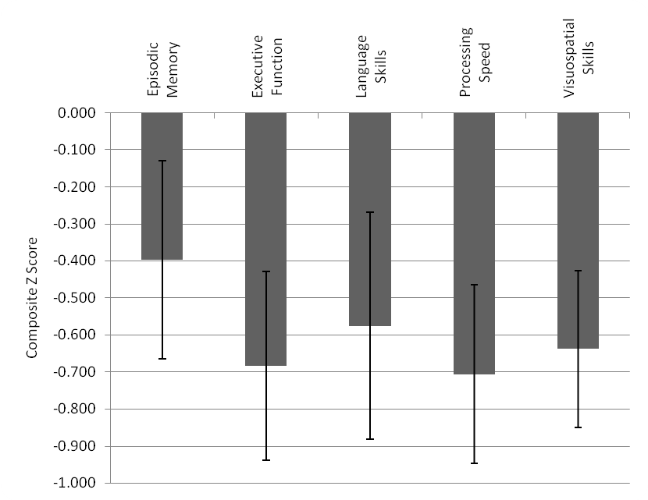

Appendix S4: Correlations between fractional anisotropy (FA) and neuropsychological impairment in late-life depression
Graphs illustrating correlations within the LLD group between FA of the anterior thalamic radiation and executive function (r = 0.428, p = 0.012); FA of the genu of the corpus callosum and processing speed (r = 0.422, p = 0.013); and FA of the fornix and episodic memory (r = 0.424, p = 0.013). r and p values were obtained after covarying for age and gender.

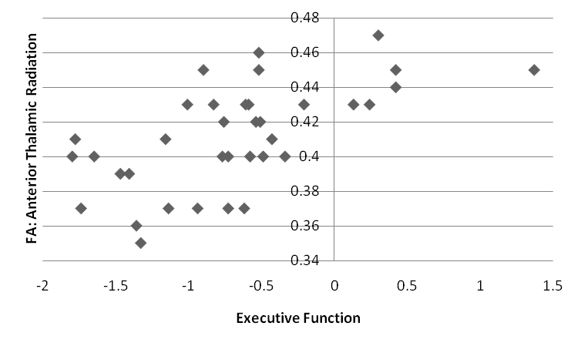
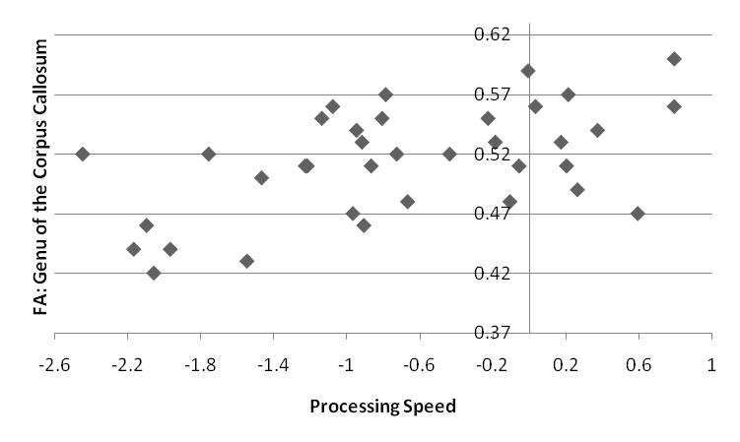
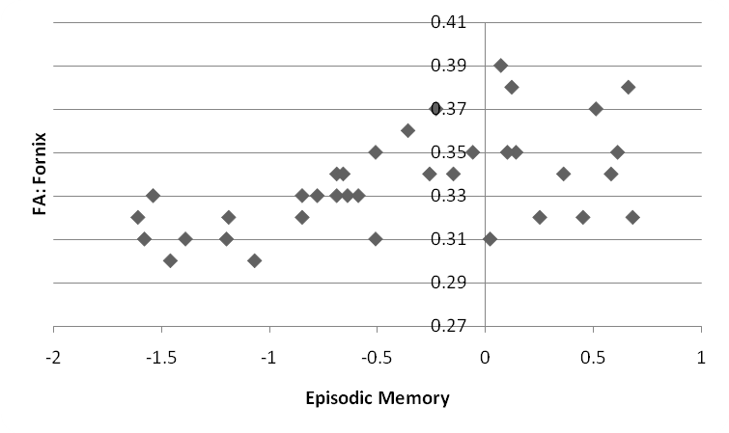
Appendix S5: Correlations between hippocampal volume and episodic memory in late-life depression
Graphs illustrating correlations within the LLD group between hippocampal volume and episodic memory (left: r = 0.281, p = 0.113; right: r = 0.381, p = 0.029). r and p values were obtained after covarying for age and gender.
