SUPPLEMENTARY MATERIAL

METHODS

Figure S1. Task design.
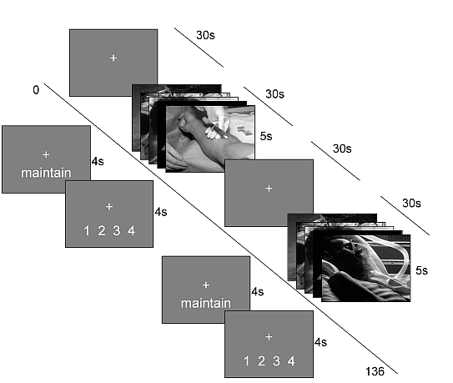

RESULTS

Table S1. Personality and affect ratings.
 | Low Neuroticism  (Mean ± SD) | High Neuroticism  (Mean ± SD) | Sig. (p)
ERQ - reappraisal | 30.25 ± 5.83 | 27.85± 5.87 | .257
ERQ - suppression | 12.75± 4.179 | 12.85±4.48 | .950
DAS - total score | 114.05±22.93 | 140.31±29.89 | .008
DAS - perfectionism | 35.85±10.54 | 48.38±14.11 | .006
DAS - approval | 35.85±10.33 | 43.31±9.578 | .046
BDI | 1.675±1.66 | 8.115±0.25 | .000
State Anxiety | 28.50±5.14 | 38.7±9.47 | .000
Trait Anxiety | 28.85±5.17 | 46±1.61 | .000
VAS - happiness | 9.2±1.3 | 6.6±2.4 | .001
VAS - sadness | 0.81±0.6 | 3.2±2.7 | .001
VAS - hostility | .38±.4 | 1.6±2.4 | .027
VAS - alertness | 7.5±3.6 | 6.9±2.7 | .603
VAS - anxiety | 1.3±1.7 | 4.4±2.7 | .000
VAS - calmness | 8.7±2.2 | 7.2±2.9 | .108

Table S2. RTs and affect ratings during emotion regulation.

 | Low Neuroticism  (Mean ± SD) | High Neuroticism  (Mean ± SD) | Sig. (p)
Affect rating after Maintain | 2.60±0.54 | 2.42±0.64 | .421
Affect rating after Suppress | 1.69±0.37 | 1.66±0.48 | .835
Rating RT after Maintain | 1926.4±668.6 | 1945.9±429.3 | .926
Rating RT after Suppress | 1965.5±543.9 | 2029.8±409 | .718

LFs measures analysis
No significant interaction was found in the Repeated measures Anova on LF-HRV with pre-task LF-HRV as covariate (LF-HRV task condition x group Anova: main effect of group, F(1,31)=.000, p=.986, task condition x group, F(1,31)= 2.254, p=.144). No significant interaction was found in the Repeated measures Anova on normalised frequency values with pre-task LF_{n} as covariate (LF_{n} task condition x group Anova: main effect of group, F(1,31)=1.704, p=.202, task condition x group, F(1,31)=.249, p=.622).

LF/HF measures analysis
No significant interaction was found in the Repeated measures Anova on LF/HF with pre-task LF/HF as covariate (LF/HF task condition x group Anova: main effect of group, F(1,31)=1.191, p=.285, task condition x group, F(1,31)= . 355, p=.556).

HR measures analyses
Mean heart rate measures were also compared, but no significant between groups difference was present (HR task condition x group Anova with pre-task HR as covariate, main effect of group, F(1,31)=3.863, p=.059, task condition x group, F(1,31)=1.249, p=.273; HR: task condition x group Anova, main effect of group, F(1,31)= 184, p=.671, task condition x group, F(1,31)= 980, p=.330).

Further exploratory analyses
For exploratory purposes repeated measures Anovas with group (high vs. low neuroticism) as the between-subject variable and task condition (Maintain vs. Suppress) as the within-subjects variable were also repeated on all HRV measures without entering pre-task HRV values as covariates.
On HF-HRV a significant task x condition interaction was found (HF-HRV: task condition x group Anova, main effect of group, F(1,31)=.260, p=.613, task condition x group, F(1,31)=4.163, p=.050); while no differences where found on LF-HRV (LF-HRV: task condition x group Anova main effect of group, F(1,31)=.014, p=.908, task condition x group, F(1,31)=1.818, p=.187).
On normalised values, a main effect of group was observed for both HF_{n} and LF_{n}, due to subjects with high neuroticism presenting lower HF_{n} and higher LF_{n} levels compared to subjects with low neuroticism across both task conditions (HF_{n}: task condition x group Anova, main effect of group, F(1,31)=4.292, p=.047, task condition x group, F(1,31)=.153, p=.699; LF_{n}: task condition x group Anova, main effect of group, F(1,31)=5.783, p=.022, task condition x group, F(1,31)=.132, p=.719). A tendency for a main effect of group was observed and no significant interaction between task condition and group was found on LF/HF measures (LF/HF task condition x group Anova: main effect of group, F(1,31)=3.923, p=.057, task condition x group, F(1,31)= 1.303, p=.262).

