Supplemental Material

Fig. S1. Plots of individual trajectories in cognitive ability in (a) NC and (b) BD subjects.
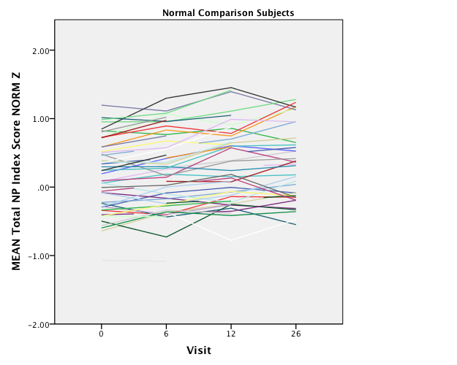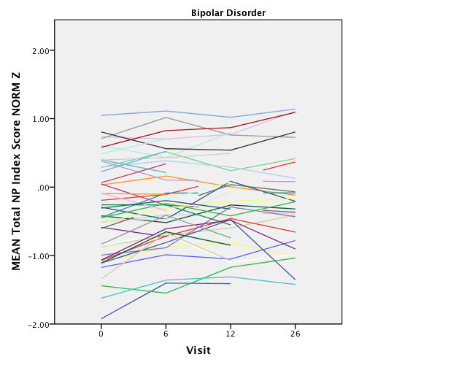

(a) (b)

