SUPPLEMENTARY FIGURES

Fig. S1

Fig. S2

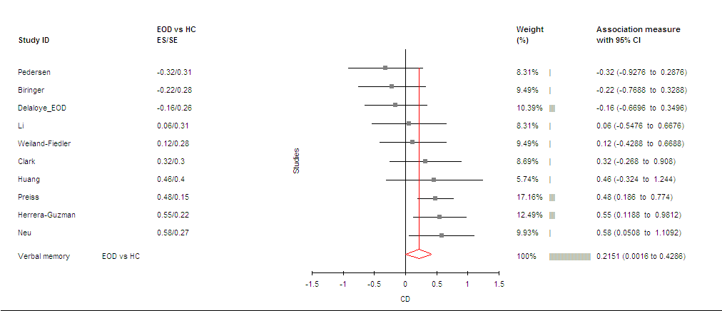

Fig. S3

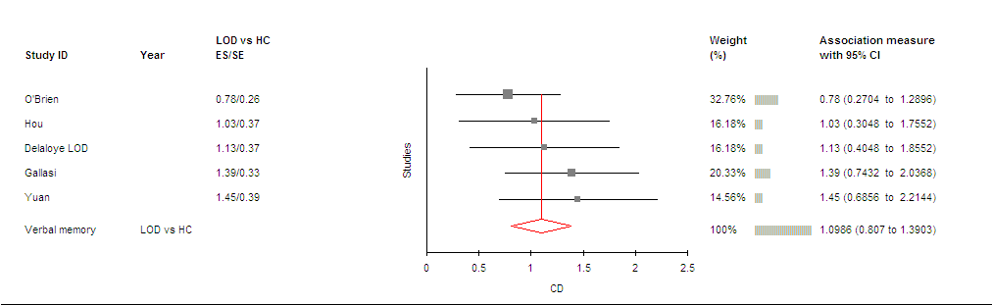

Fig. S4

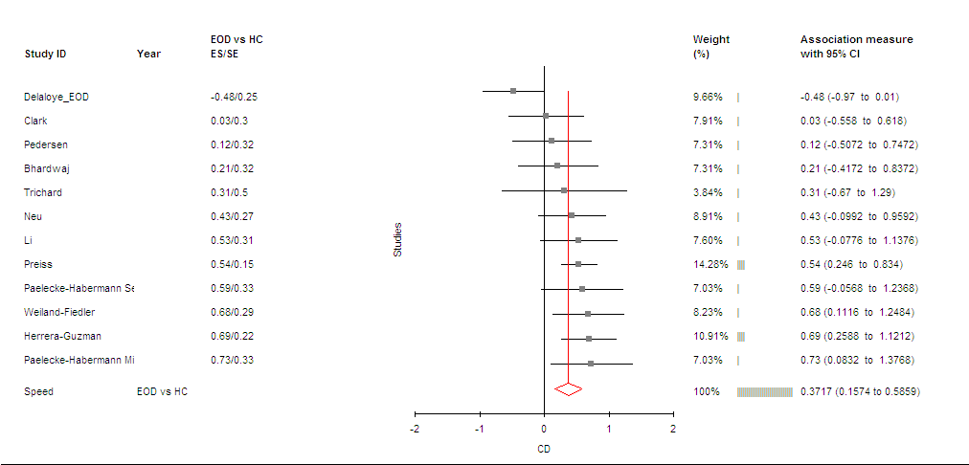

Fig. S5

