SUPPLEMENTARY MATERIAL

DATA ANALYSIS
P3a and P3b calculation
Generation of ERP Grand Averages across montage and subsequent topographic EEG magnitude analyses were automatically performed using Brain Vision Software ¹.
P3 amplitude corresponded to the averaged amplitude in the interval 300-400 ms following tones onsets. The P3a and P3b waveforms were extracted respectively from the distracter-related and target-related Grand Averages.
Spline-interpolated topographical maps of scalp voltage and current source density (CSD) were automatically calculated at the respective P300 interval to distracter and target stimuli.
Signal to Noise Ratio calculation by the Brain Vision software package ¹
The SNR provides a measure of the quality of the EEG signal. Since neither the signal nor the noise in the EEG is known exactly, average noise power must be estimated with statistical methods.
In this process it is assumed that noise will be eliminated by averaging. Thus average noise power for each channel is calculated from the total of the squares of the differences between the EEG value and the average value, divided by the number of points minus 1:

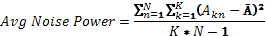

where N is the number of segments, K is the data point number in the segment, A_{kn} is the amplitude of each point, and Ā is the average total amplitude (separately for each channel):

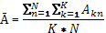

The average total power of a channel is a result of the mean of the squares for all data points of the channel before averaging:

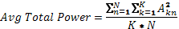

It can be assumed that the signal and noise are uncorrelated. Consequently the average power of the signal is equal to the difference between the average total power and the average noise power:

The SNR is then calculated from the quotient of the average signal power divided by average noise power.

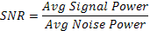

REFERENCES
1. Brain Vision Analyzer: User Manual. Brain Products GmbH; 2006, pp. 55-56.

 | Gamma Fp1 | Gamma Fp2 | Gamma F3 | Gamma F4 | Gamma C3 | Gamma C4 | Gamma P3 | Gamma P4 | Gamma O1 | Gamma O2 | Gamma F7 | Gamma F8 | Gamma T5 | Gamma T6 | Gamma Fz | Gamma Pz | Gamma Cz
Gamma Fp1 | 1.000
Gamma Fp2 | 0.732 | 1.000
Gamma F3 | 0.526 | 0.522 | 1.000
Gamma F4 | 0.459 | 0.558 | 0.722 | 1.000
Gamma C3 | 0.451 | 0.464 | 0.790 | 0.524 | 1.000
Gamma C4 | 0.389 | 0.470 | 0.726 | 0.703 | 0.679 | 1.000
Gamma P3 | 0.617 | 0.519 | 0.553 | 0.545 | 0.539 | 0.486 | 1.000
Gamma P4 | 0.589 | 0.535 | 0.631 | 0.553 | 0.555 | 0.617 | 0.809 | 1.000
Gamma O1 | 0.149 | 0.233 | 0.178 | 0.439 | 0.127 | 0.188 | 0.373 | 0.285 | 1.000
Gamma O2 | 0.331 | 0.340 | 0.228 | 0.425 | 0.143 | 0.204 | 0.562 | 0.497 | 0.512 | 1.000
Gamma F7 | 0.387 | 0.426 | 0.831 | 0.605 | 0.595 | 0.572 | 0.309 | 0.406 | 0.106 | 0.125 | 1.000
Gamma F8 | 0.379 | 0.414 | 0.731 | 0.752 | 0.479 | 0.543 | 0.347 | 0.394 | 0.109 | 0.183 | 0.698 | 1.000
Gamma T5 | 0.544 | 0.441 | 0.441 | 0.421 | 0.425 | 0.329 | 0.622 | 0.473 | 0.296 | 0.318 | 0.314 | 0.355 | 1.000
Gamma T6 | 0.390 | 0.334 | 0.377 | 0.318 | 0.320 | 0.375 | 0.408 | 0.556 | 0.178 | 0.257 | 0.235 | 0.257 | 0.443 | 1.000
Gamma Fz | 0.592 | 0.596 | 0.632 | 0.621 | 0.523 | 0.531 | 0.790 | 0.819 | 0.359 | 0.432 | 0.399 | 0.430 | 0.502 | 0.436 | 1.000
Gamma Pz | 0.562 | 0.509 | 0.506 | 0.494 | 0.469 | 0.464 | 0.807 | 0.823 | 0.239 | 0.413 | 0.293 | 0.338 | 0.457 | 0.390 | 0.792 | 1.000
Gamma Cz | 0.626 | 0.582 | 0.663 | 0.595 | 0.572 | 0.571 | 0.759 | 0.828 | 0.272 | 0.357 | 0.415 | 0.422 | 0.480 | 0.477 | 0.878 | 0.825 | 1.000

Table S1. Noise power correlation matrix in gamma noise power measures for all participants

 | Component
 | 1 | 2 | 3 | 4
Gamma Fp1 | 0.100 | 0.213 | 0.876 | 0.066
Gamma Fp2 | 0.199 | 0.048 | 0.738 | 0.077
Gamma F3 | 0.911 | 0.159 | 0.093 | 0.015
Gamma F4 | 0.887 | 0.226 | 0.130 | 0.140
Gamma C3 | 0.746 | 0.114 | 0.305 | 0.163
Gamma C4 | 0.762 | 0.095 | 0.196 | 0.164
Gamma P3 | 0.236 | 0.723 | 0.332 | 0.333
Gamma P4 | 0.366 | 0.587 | 0.197 | 0.467
Gamma O1 | -0.044 | 0.719 | -0.074 | 0.076
Gamma O2 | 0.058 | 0.766 | 0.071 | 0.046
Gamma F7 | 0.881 | 0.066 | 0.055 | 0.006
Gamma F8 | 0.868 | 0.124 | 0.050 | 0.101
Gamma T5 | 0.322 | 0.288 | 0.182 | 0.671
Gamma T6 | 0.002 | 0.093 | 0.031 | 0.887
Gamma Fz | 0.371 | 0.599 | 0.116 | -0.009
Gamma Pz | 0.159 | 0.650 | 0.408 | 0.215
Gamma Cz | 0.460 | 0.533 | 0.462 | 0.194

Table S2. Rotated components matrix for gamma noise power measures according to the Eigenvalue higher than the unit criterium for healthy controls and first-degree relatives

 | Minimally-treated patients (n=29) | All patients  (n=54) | First-degree relatives (n=23) | Healthy controls  (n=27)
Gamma Fp1 | 0.012 (0.007) | 0.019 (0.014) | 0.011 (0.010) | 0.011 (0.006)
Gamma Fp2 | 0.011 (0.005) | 0.018 (0.013) | 0.014 (0.013) | 0.012 (0.006)
Gamma F3 | 0.009 (0.007) | 0.014 (0.012) | 0.009 (0.008) | 0.009 (0.014)
Gamma F4 | 0.010 (0.011) | 0.014 (0.011) | 0.010 (0.008) | 0.009 (0.009)
Gamma C3 | 0.010 (0.015) | 0.013 (0.014) | 0.007 (0.006) | 0.008 (0.007)
Gamma C4 | 0.009 (0.008) | 0.013 (0.013) | 0.009 (0.008) | 0.009 (0.010)
Gamma P3 | 0.011 (0.007) | 0.014 (0.008) | 0.007 (0.005) | 0.007 (0.004)
Gamma P4 | 0.010 (0.005) | 0.014 (0.009) | 0.007 (0.005) | 0.007 (0.004)
Gamma O1 | 0.048 (0.054) | 0.049 (0.045) | 0.026 (0.027) | 0.029 (0.038)
Gamma O2 | 0.037 (0.039) | 0.041 (0.036) | 0.022 (0.016) | 0.029 (0.028)
Gamma F7 | 0.021 (0.019) | 0.027 (0.026) | 0.022 (0.035) | 0.024 (0.032)
Gamma F8 | 0.019 (0.014) | 0.023 (0.016) | 0.023 (0.025) | 0.019 (0.028)
Gamma T5 | 0.025 (0.014) | 0.026 (0.014) | 0.019 (0.012) | 0.015 (0.009)
Gamma T6 | 0.019 (0.012) | 0.024 (0.015) | 0.017 (0.012) | 0.021 (0.023)
Gamma Fz | 0.007 (0.003) | 0.011 (0.007) | 0.006 (0.005) | 0.005 (0.003)
Gamma Pz | 0.008 (0.005) | 0.010 (0.007) | 0.005 (0.004) | 0.006 (0.004)
Gamma Cz | 0.006 (0.003) | 0.009 (0.006) | 0.004 (0.003) | 0.005 (0.003)

Table S3. Noise power values (µV²) for gamma band in all electrodes

 | Mean (sd) | Z (p)
Gamma noise power P3. Basal  Gamma noise power P3. Halop | 0.007(0.007)  0.004(0.002) | -1.43(0.14)
Gamma noise power T5. Basal  Gamma noise power T5. Halop | 0.014(0.011)  0.009(0.005) | -2.02(0.04)
Gamma noise power Fz. Basal  Gamma noise power Fz. Halop | 0.006(0.005)  0.005(0.003) | -0.14(0.89)
p3b amplitude Pz. Basal  p3b amplitude Pz. Halop | 2.894(1.995)  3.008(1.56) | -0.67 (0.50)

Table S4. Noise power (µV²) and P300 amplitude (µV) values in healthy controls (n=5) before and 24 hours after receiving 2 mg of haloperidol following the procedure undergone by the patients (Wilcoxon signed-rank test)

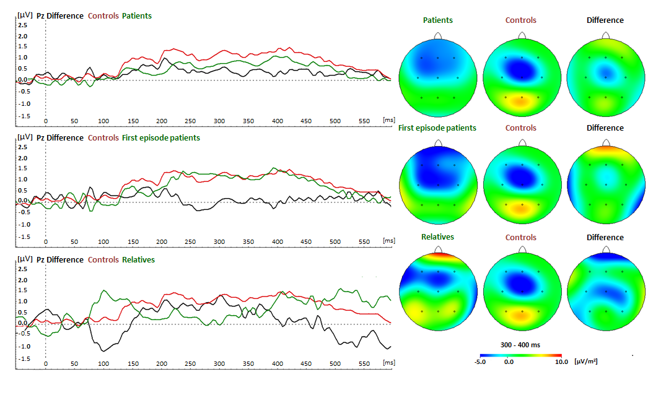
Fig. S1. P3a waveform at Pz electrode site. Overall amplitude map (µV). On top all patients versus healthy controls. In the middle first-episode patients versus healthy controls. On bottom first-degree relatives versus healthy controls. Windows displayed up to 600 ms for distracter stimulus tone (1000 Hz).
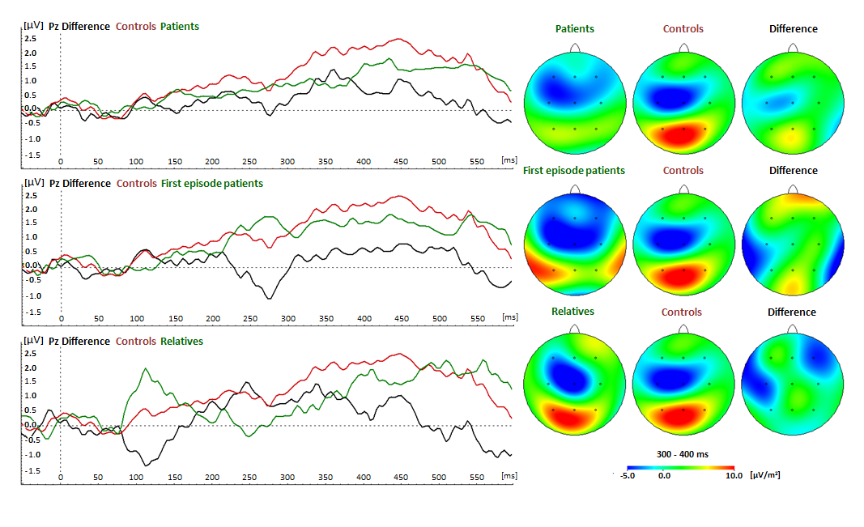
Fig. S2. P3b waveform at Pz electrode site. Overall amplitude map (µV). On top all patients versus healthy controls. In the middle minimally-treated patients versus healthy controls. On bottom first-degree relatives versus healthy controls. Windows displayed up to 600 ms for target stimulus tone (500 Hz).

