Supplementary Table S1. Standardized effect sizes of psychotherapy for adult depression compared with control conditions: Hedges’ g separated for each type of psychotherapyª

Therapy | Study | g | 95% CI |  | I² | 95% CI
 |  |  |  | 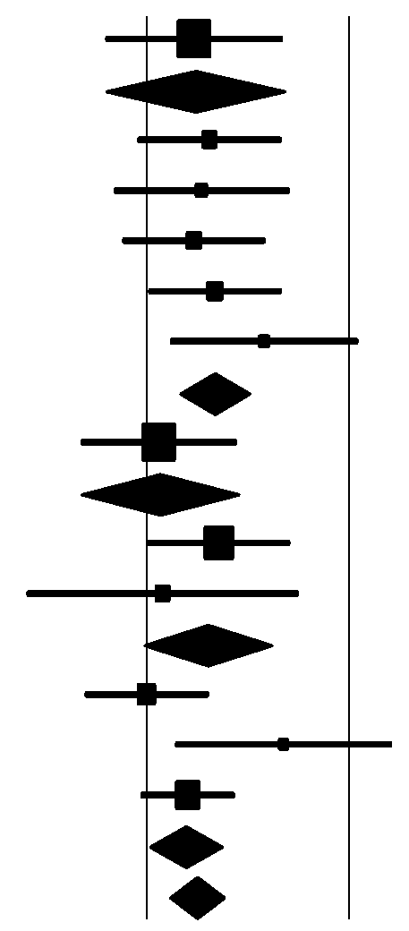
Behav, Activation | Dimidjian, 2006 BA | 0.23 | -0.20~0.67
 | Total BA | 0.23 | -0.20~0.67 |  | 0 | ª
Cogn behav ther | DeRubeis, 2005 | 0.31 | -0.05~0.67
 | Dimidjian, 2006 CT | 0.27 | -0.17~0.71
 | Elkin, 1990 CBT | 0.23 | -0.12~0.59
 | Hegerl, 2009 | 0.34 | 0.01~0.67
 | Jarett, 1999 | 0.58 | 0.11~1.05
 | Total CBT | 0.33 | 0.16~0.50 |  | 0 | 0~79
Psychodynamic | Barber, 2011 | 0.06 | -0.33~0.45
 | Total dynamic | 0.06 | -0.33~0.45 |  | 0 | ª
Interpersonal th | Elkin, 1990 IPT | 0.36 | 0.00~0.71
 | Sloane, 1985 | 0.08 | -0.59~0.75
 | Total IPT | 0.30 | -0.02~0.61 |  | 0 | ª
Problem-solving th | Barrett, 2001 | 0.00 | -0.31~0.31
 | Mynors-Wallis, 1995 | 0.68 | 0.14~1.21
 | Williams, 2000 | 0.20 | -0.03~0.44
 | Total PST | 0.19 | 0.01~0.36 |  | 57 | 0~88
 | Overall | 0.24 | 0.11~0.37 |  | 0 ^{b)} | 0~79

ª 95% CI: can not be calculated when N<3
^{b} this indicates between-group heterogeneity

