SUPPLEMENTARY MATERIAL

Supplementary Fig. S1. Summary of exclusion criteria used in finding suitable studies to be included in our meta-analysis
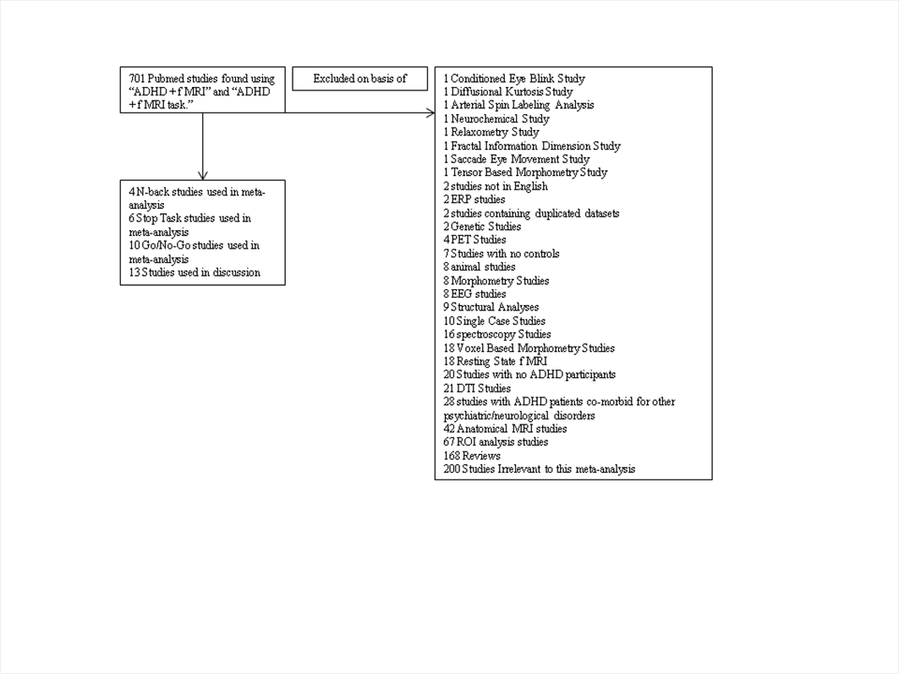

Supplementary Table A.

Demographic and clinical characteristics of the 4 N-Back functional MRI studies included in our meta-analysis
Characteristics | Bayerl et al., 2010 | Valera et al., 2010 | Valera et al., 2005 | Kobel et al., 2009
Number of patients | 30 | 44 | 20 | 14
Number of controls | 30 | 49 | 20 | 14
Mean age of patients, years | 30.9 | 36.6 | 34.0 | 10.43
Mean age of controls, years | 31.2 | 32.5 | 33.0 | 10.92
Patient sex, % Males | 53 | 52 | 60 | 100
Control sex, % Males | 53 | 46 | 60 | 100
Treatment, % patients with a history of treatment | 0 | 61 | 50 | 100
% Frequency of 2-Back condition | NA | 26 | 26 | 33
ADHD Instrument | Brown Adult ADHD scale, WURS | Parental Interviews, DSM-IV ADHD Questionnaire | Parental Interviews, DSM-IV ADHD Questionnaire | Conners Parent Report, Conners Teacher Report
Psychiatric Trait Instrument | DSM-IV Interview | SCID 1 | SCID 1 | DSM-IV Interview
ADHD IQ | NA | 118 | 118 | 100
Control IQ | NA | 114 | 118 | 90
Combined Type | 30 | 13 | 20 | 9
Inattentive Type | NA | 17 | NA | 1
Hyperactive/Impulsive Type | NA | 1 | NA | NA
ADHD not otherwise specified | NA | 13 | NA | NA
NA, not applicable. WURS, Wender Utah Rating Scale; DSM-IV, Diagnostic Statistics Manual – IV.

Supplementary Table B.
Demographic and clinical characteristics of the 6 Stop Task functional MRI studies included in our meta-analysis
Characteristics | Cubillo et  al., 2010 | Rubia et  al., 1999 | Rubia et  al.,2011 | Passarotti et  al., 2011 | Rubia et al.,2010 | Rubia et al., 2005
Number of patients | 10 | 7 | 12 | 11 | 18 |  | 16
Number of controls | 14 | 9 | 13 | 25 | 20 |  | 21
Mean age of patients, years | 29 | 15.71 | 13 | 13.09 | 13.9 |  | 13
Mean age of controls, years | 28 | 15.01 | 13 | 14.13 | 14.5 |  | 14
Patient sex, % Males | 100 | 100 | 100 | 54 | 100 |  | 100
Control sex, % Males | 100 | 100 | 100 | 46 | 100 |  | 100
Treatment, % patients with a history of treatment | NA | NA | 100 | 60 | 0 |  | 0
% Frequency of Stop Trials | 20 | 50 | 20 | 50 | 20 |  | 20
ADHD Instrument | AHI | Conners Parent Report, Conners Teacher Report | DSM-IV ADHD Interview | Parental ADHD Rating Scale IV | MDI |  | DSM-IV ADHD Interview
Psychiatric Trait Instrument | APFA, SADS | DSM-IV Interview | MDI | DSM-IV Interview, YMRS, CDRS-R | CY-BOCS, SDQ, R-CMAS, CBC |  | SDQ, DSM-IV, MDI
ADHD IQ | 110 | 90 | 91 | 101.20 | 99 |  | 100
Control IQ | 113 | 100 | 100 | 107.60 | 104 |  | 100
Combined Type | 8 | 7 | 12 | 11 | 18 |  | 16
Inattentive Type | 1 | NA | NA | NA | NA |  | NA
Hyperactive/Impulsive Type | 1 | NA | NA | NA | NA |  | NA
ADHD not otherwise specified | NA | NA | NA | NA | NA |  | NA
NA, not applicable; MDI, Maudsley Diagnostic Interview; DSM-IV, Diagnostic Statistics Manual – IV; CBC, Child Behaviour Checklist; SDQ, Strengths and Difficulties Questionnaire; R-CMAS, Revised Children Manifest Anxiety Scale; CY-BOCS, Children’s Yale Brown Obsessive Compulsive Scale; APFA, Adult Personality Functioning Assessment; SADS, Schedule of Affective Disorders and Schizophrenia; YMRS, Young Mania Rating Scale; CDRS-R, Child Depression Rating Scale Revised.

Supplementary Table C.
Demographic and clinical characteristics of the 10 Go/No-Go Task functional MRI studies included in our meta-analysis
Characteristics | Mulligan et al., 2011 | Dibbets et al., 2009 |  | Kooistra et al., 2010 |  | Dillo et al., 2010 | Schneider et al., 2010 | Tamm et al., 2004 | Suskauer et al., 2008 |  | Durston et al., 2006 |  | Booth et al., 2004 |  | Smith et al., 2006
Number of patients | 12 | 16 | 11 |  | 15 |  | 19 | 14 |  | 25 | 11 |  | 12 |  | 14
Number of controls | 12 | 17 | 11 |  | 15 |  | 17 | 12 |  | 25 | 11 |  | 12 |  | 27
Mean age of patients, years | 31.6 | 28.9 | 21.5 |  | 28.1 |  | 32.6 | 16 |  | 10.7 | 13.97 |  | 11.0 |  | 10.0
Mean age of controls, years | 29.9 | 28.6 | 22.3 |  | 28.8 |  | 29.4 | 15.58 |  | 10.6 | 15.27 |  | 10.9 |  | 10.0
Patient sex, % Male | 100 | 100 | 95 |  | 68 |  | 100 | 60 |  | 100 | 100 |  | 72 |  | 100
Control sex, % Male | 100 | 100 | 95 |  | 65 |  | 100 | 56 |  | 100 | 100 |  | 63 |  | 100
Treatment, % patients with a history of treatment | 100 | 88 | 100 |  | 100 |  | 0 | 35 |  | 48 | 54 |  | 100 |  | 0
% Frequency of No-Go Trials | 17 | 5 | 25 |  | 50 |  | 50 | 17 |  | 25 | 25 |  | 50 |  | 11
ADHD Instrument | SCID-I/DSM-IV Interview | WURS | Conners’ Self Report |  | WURS, Conners Self Report |  | WURS, ADHD | Conners Parent Report |  | Conners Parent Report, ConnersTeacher Report | DSM-IV ADHD Interview |  | DBRS |  | Conners Parent Report, Conners Teacher Report, SDQ
Psychiatric Trait Instrument | SCID-I/DSM-IV Interview | CSS, CCSS | DSM-III-R Criteria |  | DSM-IV Interview |  | SCID-I Interview | CBC, DSM-IV Interview |  | DICA-IV | DISC-P, CBC |  | DSM-IV Interview |  | MDI
ADHD IQ | 105.6 | NA | 110 |  | NA |  | NA | 109 |  | 120 | 100 |  | 112.4 |  | 90
Control IQ | 116.1 | NA | 125 |  | NA |  | NA | 111 |  | 130 | 106 |  | 113.6 |  | 90
Combined Type | 12 | 16 | 9 |  | 15 |  | 11 | 14 |  | 17 | 10 |  | 8 |  | 14
Inattentive Type | NA | 36 | NA |  | NA |  | NA | NA |  | 6 | 1 |  | 4 |  | NA
Hyperactive Impulsive Type | NA | NA | NA |  | NA |  | NA | NA |  | 2 | NA |  | NA |  | NA
ADHD Not otherwise specified | NA | NA | NA |  | NA |  | NA | NA |  | NA | NA |  | NA |  | NA
ADHD Partial Remission | NA | NA | 2 |  | NA |  | 8 | NA |  | NA | NA |  | NA |  | NA
NA, not applicable; DSM-IV, Diagnostic Statistics Manual – IV; CBC, Child Behaviour Checklist; DICA-IV, Diagnostic Interview for Children and Adolescents; WURS, Wender Utah Rating Scale; DISC-P, Diagnostic Interview Schedule for Children; DBRS, Disruptive Behaviour Rating Scale; MDI, Maudsley Diagnostic Interview; SDQ, Strengths and Difficulties Questionnaire; CSS, Current Symptoms Scale; CCSS, Childhood Symptoms Scale

Supplementary Table S1. N-back Task Meta-Regression Results
Peak voxel in Region | Talairach coordinates | SDM value | Uncorrected  P value | Voxel number | Breakdown  (number of voxels)
Regression of gender difference in activation
1.2 The more males the less difference to controls in these regions
Left declive | 26,-62,-22 | -3.799 | 0.00002 | 61 | L cerebellum, posterior lobe (39)  L cerebellum, anterior lobe (22)
Left inferior occipital gyrus | -32,-86, -8 | -3.684 | 0.00012 | 19 | L inferior occipital gyrus (16)  L middle occipital gyrus (3)
Regression of percentage of previously treated subjects on differences in activation
1.3 More previous treatment resulted in a decreased activation difference between ADHD and controls within this region
Right middle temporal gyrus | 50,-70, 20 | 3.091 | 0.00007 | 77 | R middle temporal gyrus (72)  R middle occipital gyrus (4)  R superior occipital gyrus (1)
1.4 Samples with less previous treatment are associated with a greater reduction in activity within these regions
Left middle frontal gyrus | -14, 40, 10 | -1.152 | 0.00017 | 13 | L MFG (8)  L ACC (5)
Left superior frontal gyrus | -22, 50, 20 | -1.152 | 0.00017 | 11 | L SFG(6)  L MFG(5)
Right superior frontal gyrus | 32, 50, 30 | -1.145 | 0.00019 | 45 | R SFG(36)  R MFG(9)
Regression of percentage of combined type on differences in activation
1.5 Higher percentage of combined type ADHD is associated with more difference in ADHD compared to controls within this region
Right pyramis | 12,-70,-26 | 1.170 | 0.00077 | 19 | Right cerebellum (19)
1.6 Controls linked to more activation in these areas than the percentage of combined type ADHD.
Left declive | -26,-62,-22 | -2.348 | 0.00020 | 55 | Left cerebellum (55)
Left inferior occipital gyrus | -32,-84, -8 | -2.341 | 0.000231 | 19 | Left inferior occipital gyrus (19)
Signed Differential Mapping (SDM), Inferior Frontal Gyrus (IFG), Middle Frontal Gyrus (MFG), Precentral Gyrus (PCG), Anterior Cingulate Cortex (ACC), Right Superior Frontal Gyrus (R SFG). Voxels are in parentheses.

Supplementary Table S2. Stop Task Meta-Regression Results
Region | Talairach coordinates | SDM value | Uncorrected  P value | Voxel number | Breakdown  (number of voxels)
Differences in activation associated with older children and younger children
2.2 Older Children > Younger children
Right inferior frontal gyrus | 42, 28,-12 | 1.112 | 0.00001 | 49 | R IFG (38)  R MFG (11)
Regression of percentage of previously treated child subjects on differences in activation
2.3 Less previous treatment in ADHD is associated less activity compared to controls and those with ADHD who had more previous treatment within this region
Right superior frontal gyrus | 22, 56, -8 | -2.199 | 0.00002 | 309 | R SFG (219)  R medial frontal gyrus (52)  R MFG (29)  R SFG (65)  R ACC (9)
2.4 More previous treatment associated with more difference to controls within this region
Left cerebellum | -4,-64, -6 | 1.082 | 0.0001 | 63 | L cerebellum (40)  L occipital lobe (8)  L limbic lobe (4)  R cerebellum (11)
Differences in activation related to combined type ADHD and non-combined type ADHD
2.5 Lower Percentage of combined type associated with differences in ADHD compared to controls within these regions
Right insula | 38, 16, 6 | -2.893 | 0.00001 | 287 | R insula (167)  R IFG (94)  R precentral gyrus (15)  R claustrum (18)
Right middle frontal gyrus | 46, 18, 24 | -2.073 | 0.00001 | 122 | R MFG (89)  R IFG (9)  R precentral gyrus (24)
Right medial frontal gyrus | 12, 30, 42 | -1.764 | 0.00014 | 52 | R medial frontal gyrus (20)  R superior frontal gyrus (32)
Left thalamus | -10,-10, 14 | -1.598 | 0.00037 | 56 | L anterior nucleus (18)  L ventral lateral nucleus (17)  L thalamus (18)  L medial dorsal nucleus (2)  L lentiform nucleus (1)
2.6 More control activation within these regions across studies with a higher percentage of combined type ADHD
Right superior frontal gyrus | 22, 54, -8 | -2.010 | 0.00001 | 151 | R superior frontal gyrus (112)  R MFG (16)  R medial frontal gyrus (20)  R ACC (3)
Right inferior frontal gyrus | 40, 18,-12 | -1.480 | 0.00003 | 40 | R IFG (39)  R superior temporal gyrus (1)
Differences in activation related to the difference in mean IQ score in ADHD participants and control participants
2.7 Studies with lower mean IQ scores for ADHD participants were linked to more differences to controls within these regions
Right superior parietal lobule | 32,-58, 46 | -2.197 | 0.00011 | 20 | R superior parietal lobule (16)  R inferior parietal lobule (4)
Right medial frontal gyrus | 14, 10, 52 | -2.189 | 0.00025 | 11 | R medial frontal gyrus (6)  R superior frontal gyrus (5)
Left medial frontal gyrus | -4, 42, 18 | -2.188 | 0.00025 | 10 | L medial frontal gyrus (10)
Signed Differential Mapping (SDM), Inferior Frontal Gyrus (IFG), Middle Frontal Gyrus (MFG), Precentral Gyrus (PCG), Right Superior Frontal Gyrus (R SFG). Voxels are in parentheses.

Supplementary Table S3. Go/No-go Task Meta-Regression Results

Region | Talairach coordinates | SDM value | Uncorrected  P value | Voxel number | Breakdown  (number of voxels)
Differences in activation amongst older ADHD adults and younger ADHD adults relative to controls
3.5 Older ADHD adults have higher activation in the regions below to younger ADHD adults and controls.
Left lingual gyrus | -14,-88,-12 | 1.176 | 0.00015 | 32 | L occipital lobe, lingual gyrus (9)  L cerebellum, posterior lobe, declive, (6)  L occipital lobe, fusiform gyrus (2)  L occipital lobe, middle occipital gyrus (7)  L occipital lobe, inferior occipital gyrus (8)
Left fusiform gyrus | -54,-60,-12 | 1.175 | 0.00028 | 12 | L temporal lobe, fusiform gyrus (2)  L occipital lobe, middle occipital gyrus (7)  L temporal lobe, inferior temporal gyrus (1)  L temporal lobe, middle temporal gyrus (2)
Right lingual gyrus | 8,-92, 2 | 1.173 | 0.00043 | 31 | R occipital lobe, lingual gyrus (14)  R occipital lobe, cuneus (7)  L occipital lobe, lingual gyrus (3)  L occipital lobe, cuneus (4)  Left cerebrum, occipital lobe, lingual gyrus (3)
3.6 Older ADHD adults have lower activation relative to younger ADHD adults and control adults in the region below
Right thalamus | 8,-18, 12 | -2.685 | 0.00029 | 54 | R sub-lobar, thalamus, medial dorsal nucleus: (49)  R sub-lobar, thalamus, lateral dorsal nucleus (4)  R sub-lobar, thalamus, anterior nucleus (1)
Differences in activation amongst older children and younger children
3.7 Older ADHD children have more positive differences in activation in the regions below to younger ADHD children and controls.
Left inferior temporal gyrus | -52,-34,-16 | 2.360 | 0.00002 | 52 | L temporal lobe, IFG (13)  L cerebrum, temporal lobe, middle temporal gyrus (17)  L IFG (11)  L fusiform gyrus (11)
Left inferior frontal gyrus | -34, 28,-18 | 2.107 | 0.00060 | 12 | L IFG (12)
Regression of percentage of previously treated adult subjects on differences in activation
3.8 More previous treatment associated with less difference can be seen between ADHD and controls
Right caudate | 12, 16, 2 | 3.238 | 0.00005 | 40 | R caudate head (36)  R caudate body (4)
Right superior frontal gyrus | 6, 40, 48 | 3.156 | 0.00021 | 12 | R SFG (12)
3.9 Less previous treatment is associated with more difference to controls in the following region
Left fusiform gyrus | -20,-82,-12 | -3.743 | 0.00001 | 67 | L occipital lobe, fusiform gyrus (18)  L occipital lobe, lingual gyrus (3)  L occipital lobe, middle occipital gyrus (6)  Left cerebellum posterior lobe, declive (10)  L occipital lobe, inferior occipital gyrus (3)
Differences in activation amongst longer and shorter wash-out periods
3.10 Longer wash-out means more difference to controls in this area
Right precuneus | 26,-70, 42 | 5.092 | 0.00002 | 78 | R precuneus (41)  R superior parietal lobule ( 20)  R cuneus (8)  R precuneus (9)
3.11 Shorter wash-out means less difference to controls in this area
Left medial frontal gyrus | -4, -4, 48 | -3.973 | 0.00002 | 68 | L medial frontal gyrus (43)  L cingulate (25)
Differences in activation associated with percent of combined type ADHD and non-combined type ADHD compared to controls
3.12 Controls linked to more activation in these areas than the percentage of combined type ADHD
Right caudate | 12, 12, 4 | 3.089 | 0.00001 | 152 | Right cerebrum, sub-lobar, caudate, caudate head: 94 voxels  Right cerebrum, sub-lobar, caudate, caudate body: 43 voxels  Right cerebrum, sub-lobar, lentiform nucleus, putamen: 15 voxels
3.13 Controls linked to less activation in these areas than the percentage of combined type ADHD
Left Fusiform Gyrus | -20,-82,-12 | -2.755 | 0.00003 | 70 | L fusiform gyrus (19)  L lingual gyrus (26)  L middle occipital gyrus (9)  L declive (13)  L inferior occipital gyrus (3)
Right lingual gyrus | 2,-88, -2 | -2.355 | 0.00062 | 10 | R lingual gyrus (10)
Percentage of IQ associated with changes between ADHD and controls
3.14 Studies with lower mean IQ scores for ADHD were linked to higher activation relative to controls in the following regions
Left fusiform gyrus | -20,-82,-12 | 1.246 | 0.00038 | 242 | L occipital lobe, fusiform gyrus (25)  L occipital lobe, lingual gyrus (54)  L occipital lobe, middle occipital gyrus (33)  L cerebellum, posterior lobe, declive (68)  L occipital lobe, fusiform gyrus (43)  L inferior occipital gyrus (18)  L occipital lobe, cuneus (26)
Right lingual gyrus | 2,-88, -2 | 1.224 | 0.00095 | 80 | R occipital lobe, lingual gyrus (46)  L occipital lobe, lingual gyrus (17)  R occipital lobe, cuneus (11 )  L occipital lobe, cuneus (2)
Left fusiform gyrus | -48,-58,-12 | 1.183 | 0.00209 | 41 | L temporal lobe, fusiform gyrus (15)  L occipital lobe, middle occipital gyrus (15)  L temporal lobe, middle temporal gyrus (8)  L temporal lobe, inferior temporal gyrus (3)
3.15 Studies with lower mean IQ scores for ADHD participants showed less activity relative to controls in the following regions.
Left superior frontal gyrus | -6, 62, -2 | -2.069 | 0.00017 | 229 | L frontal lobe, superior frontal gyrus, (58)  L frontal lobe, medial frontal gyrus (158)  L ACC ( 7)  R medial frontal gyrus (6)
Right caudate | 12, 14, 2 | -1.515 | 0.00175 | 211 | R caudate (192)  R putamen (19)
Differences in activation associated with the variance between both groups’ mean IQ scores
3.16 Unmatched IQ scores were linked to higher activation of this region for ADHD participants than controls
Right thalamus | 8,-18, 14 | 1.795 | 0.00053 | 33 | R thalamus (33)
3.17 Unmatched IQ scores were linked to lower activation for ADHD participants compared to controls in the regions below
Right inferior parietal lobule | 52,-54, 38 | -1.953 | 0.00007 | 22 | R inferior parietal lobule (15)  R supramarginal gyrus (7)
Left precuneus | -22,-62, 52 | -1.680 | 0.00068 | 11 | L precuneus (5)  L superior parietal lobule (6)
Signed Differential Mapping (SDM), Inferior Frontal Gyrus (IFG), Middle Frontal Gyrus (MFG), Precentral Gyrus (PCG), Anterior Cingulate Cortex (ACC). Voxels are in parentheses.

